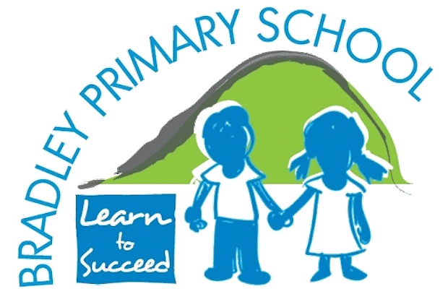 | History Overview  2025-2026
 | Autumn | Spring | Summer
EYFS | Family Tree  Childhood | Welcome  Migration | Significant People Who Help Us  Achievement & Legacy
Year 1 | Great Fire of London  Achievement & Legacy | Bradley  Childhood | Queen Elizabeth II  Achievement & Legacy
Year 2 | Learie Constantine  Migration | Explorers  Achievement & Legacy | Victorians  Childhood
Year 3 | Stone Age  Civilizations | Castles  Civilizations | Romans  Migration
Year 4 | Ancient Egypt  Civilizations | The Lancashire Cotton Industry  Achievement & Legacy | Early Islamic Study – Baghdad  Civilizations
Year 5 | Tudors  Achievement & Legacy | Mayans  Civilizations | Anglo Saxons and Vikings  Migration
Year 6 | WWII  Childhood | Black & British  Migration | Ancient Greece  Civilizations

