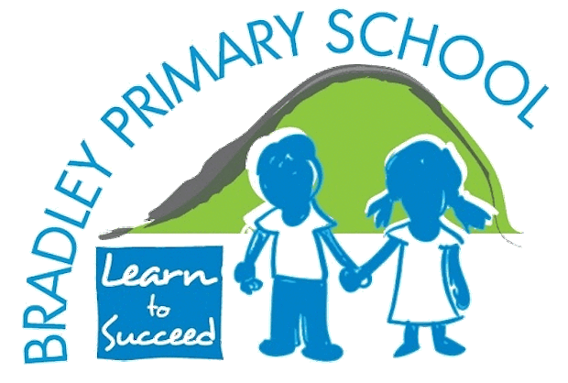 | Music Overview  How our Music Curriculum supports British Values  In our music lessons at Bradley Primary, children from a very young age learn about the need to establish a clear set of rules when listening, performing and composing: working together as a team, taking turns with the instruments, listening when someone is playing and deciding on whose ideas are going to be used in a composition (Rule of Law and Democracy).  Children are encouraged to make choices about the music they like to listen to or choose to perform and are respected for their individual preferences (Mutual Respect and Individual Liberty).  Children are encouraged to appreciate the fact that music from all cultures and traditions around the world develops and contributes positively to British music (Tolerance).
 | Autumn 1 | Autumn 2 | Spring 1 | Spring 2 | Summer 1 | Summer 2
EYFS | Chant to the Animals | Creative Moves | Lilting Lullaby | Number Time | Wellbeing Matters | Rhythm Adventure
Year 1 | Rhyming in Time | Let’s Start Singing | Music Inspired by the World Around Us | Exploring Rhythm and Patterns | Sound and Pictures | Highs and Lows
Year 2 | Questions and Answers | Let’s Keep Singing | Sound and Symbol 1 | Sound and Symbol 2 | Around the World | The Power of Communication
Year 3 | A Shining Performance | Sing and Move | Music and Video | You Gotta Try | Music and Sound | Sound Exploration
Year 4 | Create and Notate | Singing and Traditions | Recycling Songs | Exploring Musical Contrasts | FX Sound Effects | Round and Round
Year 5 | Year 5 pupils are taught by a specialist music teacher from Lancashire Music Service. Lessons focus on developing musical knowledge, understanding and performance skills through learning to play the clarinet.
Year 6 | Discovering Grime | Express, Inspire and Perform | Music Reimagined | Musical Sketches | Music Remixed | The Grand Finale

