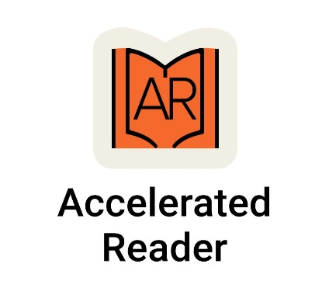
Reading at Bramcote College - How to do Reading Practice (Book Quizzes) from home?
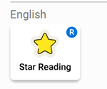 | Your child will take the Star Reading Test four times a year at school. This test will determine their current book level, helping them select appropriate books from the library and boosting their reading success. Each term, your child will have a specific reading target, which you can find on their Reading Expectations Sheet in their Student Planner and Accelerated Reader Account.  Your support at home is crucial. Encouraging your child to read for 30 minutes daily as homework will greatly enhance their success in school and life.
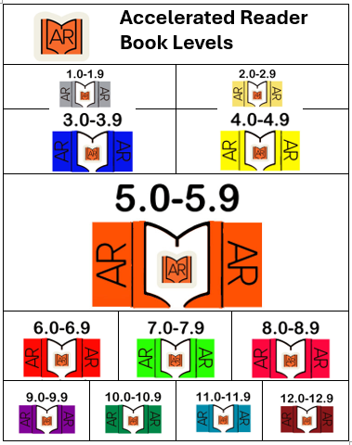 | Our School Library features books that are part of the Accelerated Reader Programme, allowing students to complete a Book Quiz after finishing a book.  Your child will select a book from the library that matches their Book Level. Each book has a coloured Accelerated Reader tab on the spine indicating its level. The details for the Accelerated Reader Book Quiz can be found at the front or back of the book  Book Level  (This indicates the level of difficulty. it’s broken down from 0.1-0.9 for each level. i.e if Level 3 (BLUE) – 3.1)  Points  (The maximum number of points earnt if they get all questions right on the book quiz)  Quiz Number  (All books have a 6 digit number so it can be found easily on AR.)
www.arbook.co.uk | Reading a book from home? You can check if it’s on the Accelerated Reader (AR) Programme. This will provide the book level and the number of points that can be earned. Please note that the school librarian will be monitoring what students are reading during library lessons.
When you child has finished reading a book on AR, they will be able to do a Book Quiz.
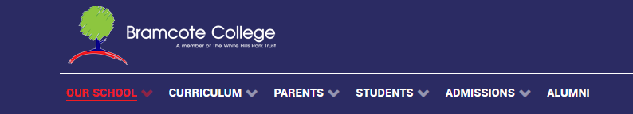 |  | If you can’t use the QR Code, visit the school website at https://bramcote.college/. (Please note: Access the Accelerated Reader through the school links page only. A Google search for Accelerated Reader will not allow your child to log in.)
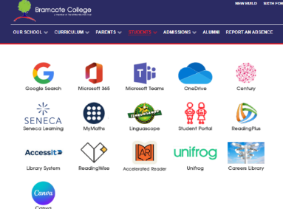  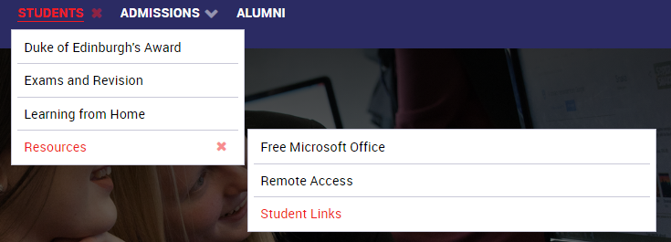 |  | - Select the STUDENT tab.  - Select Resources  - Student Links and click on Accelerated Reader
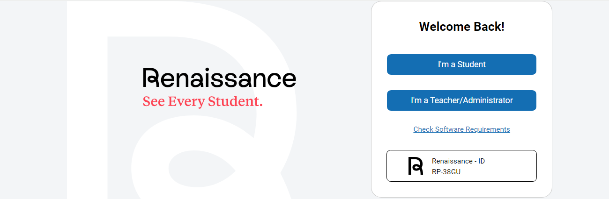 |  | - A new page will open, Click on I’m a student
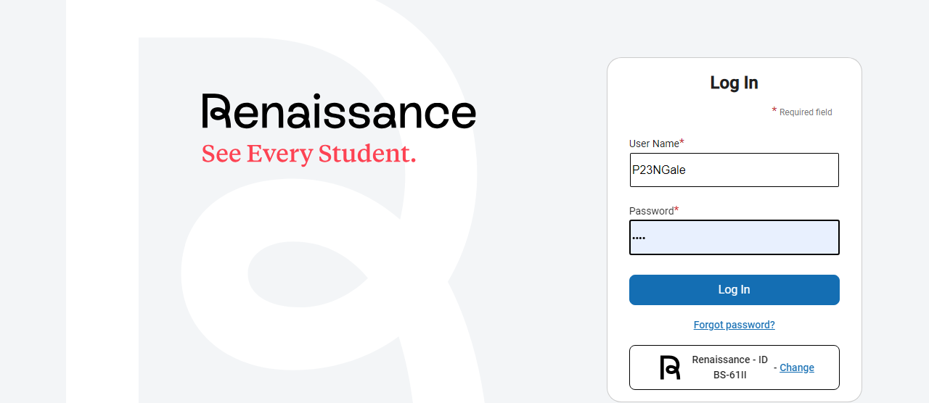 |  | - Log in – your child should use their username and password.  This is the same username and password used in Computer Science
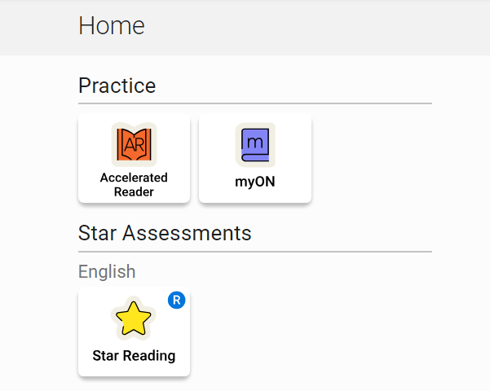 |  | - Click on AR Accelerated Reader.  DO NOT CLICK on STAR READING – This section is used for assessing students during their Termly Reading Tests at school. If you accidentally click on it, please close the window and start again.
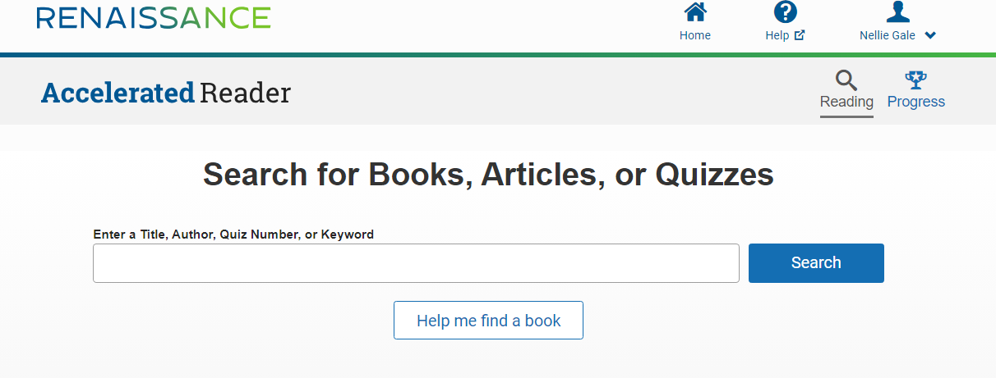 |  | - To find a Book Quiz, enter either into the  Search Box the Book Title or the  easiest and quickest way is by  entering the quiz number (this  can be found in the front or  back of library book) and then  click on Search.
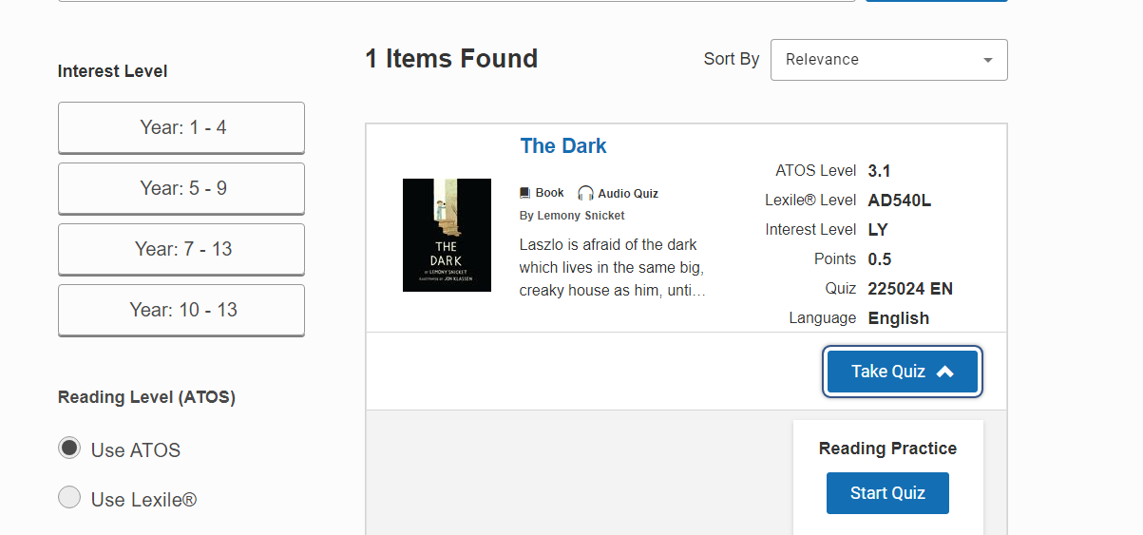 |  | - The book will appear on the screen. Click on Take Quiz.  Next, select Reading  Practice and click Start Quiz.  Please note that for some  books, options for Literacy and  Vocabulary Practice will also be  available. Your child can  complete these quizzes too.
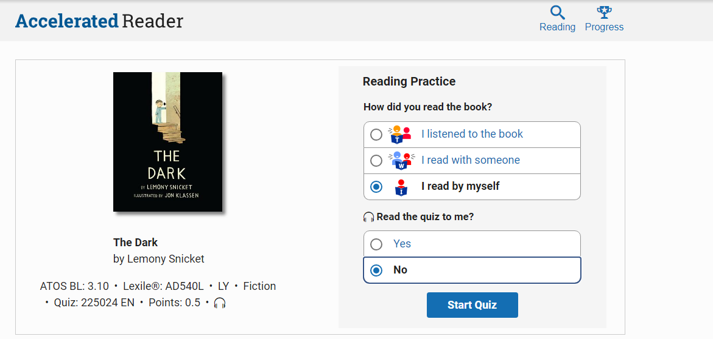 |  | Select one of the following options:  - I listened to the book  - I read with someone  - I read to myself  Then, choose:  Read Quiz with me? Yes / No
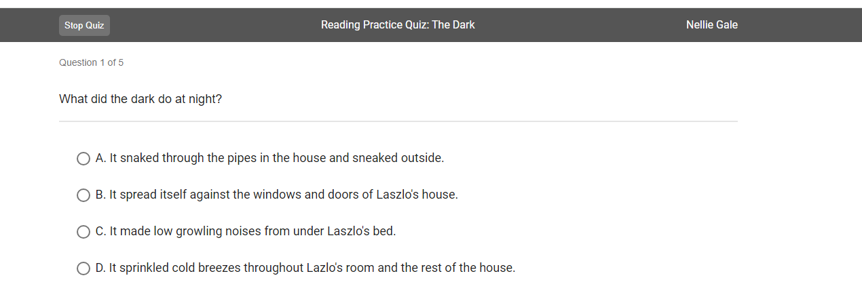 |  | The Book Quiz will begin. Depending on the length of the book, there will be either 5, 10, or 20 multiple-choice questions.  Click on the circle to select your answer.
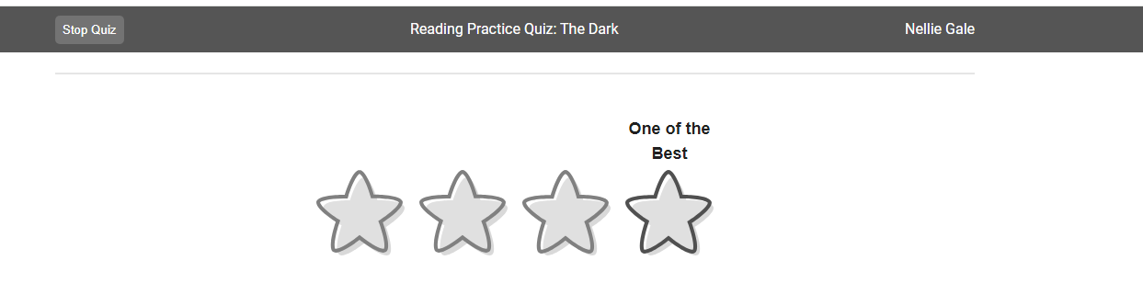 |  | Four stars will appear for you to rate the book. Click on one of the stars to select your rating, which will then be displayed above the star.
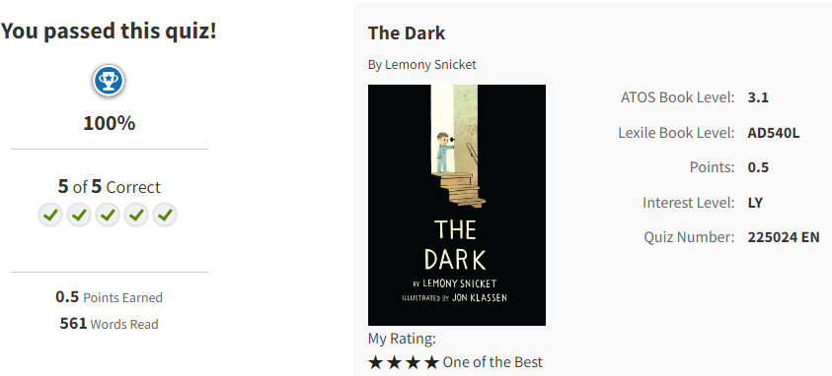 |  | Finally a results page will be displayed with their score.  Book Title  Author  Quiz Number  Score out of /5; /10; /20  Points  Word Count.
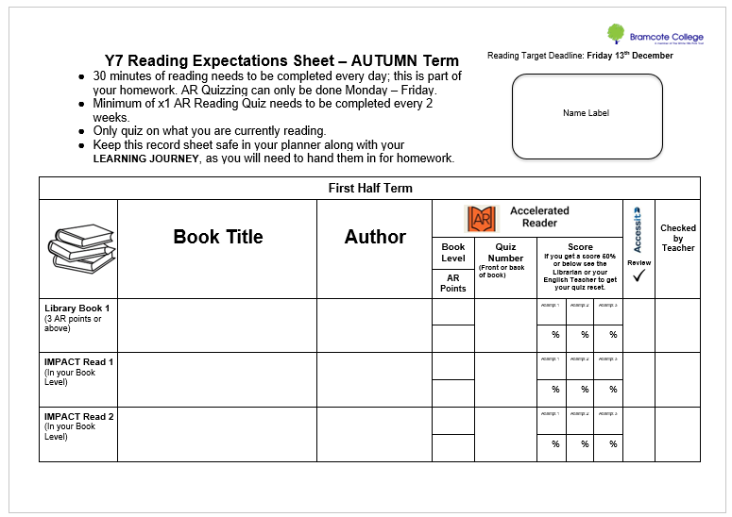 |  | Ther above details need to record on their Reading Expectations Sheet. This will be handed in for Homework.  If your child does not pass a Book Quiz, they will not earn points or word count. It will need to be reactivated and they can retake the quiz up to three times and should record each attempt on their Reading Expectation Sheet.  Reacticating a Book Quiz:  - Library Lesson by libriarian/ teacher  - See the librarian during Lunch 2  - email library@bramcote.college
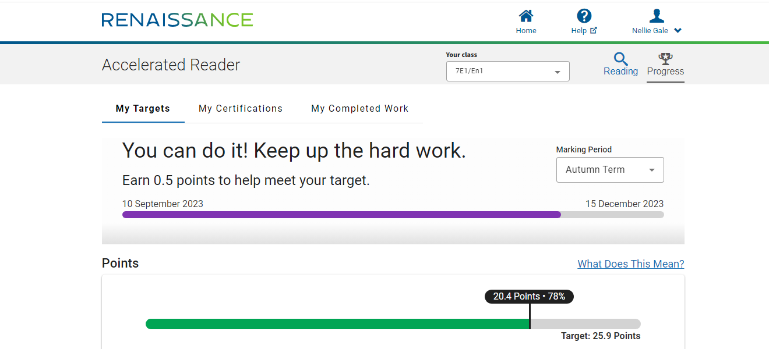  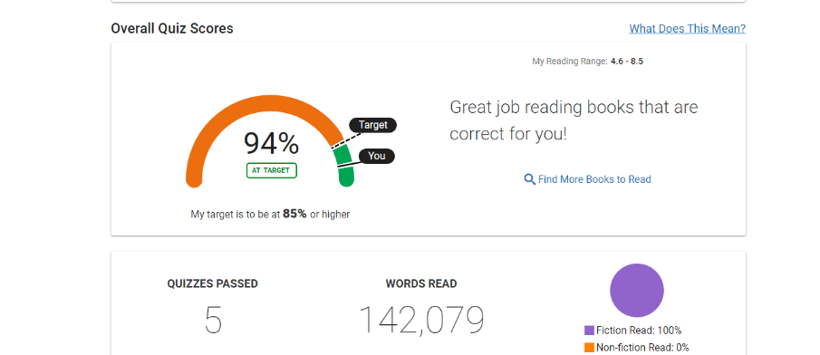 |  | To see your child’s progress , you can click on the cup icon.  To see the different terms, click on marking period and a dropdown box will appear to select a term or whole year.  This shows the date for when they need to reach their reading target for the term.  Points Target  - Current Score  - Target Points  This is reset for each term after their Star Reading Test.  Reading Range – Book Level  Number of Quizzes Passed and Completed.  Words Read  Percentage of fiction and non-fiction books read.
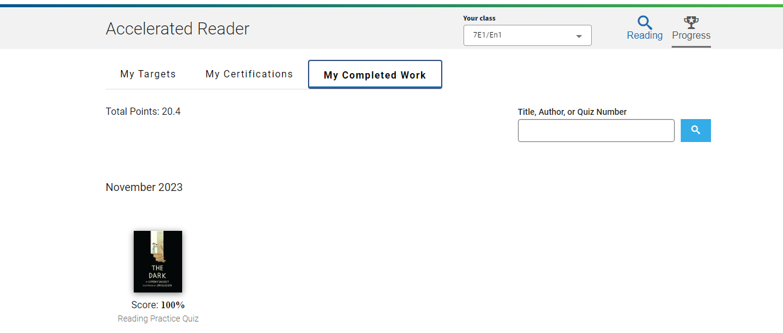 |  | To see the books your child has read, click on the tab My Completed Work.  It is broken down into months. Click on the book icon and you will be able to see the breakdown of your childs quiz scores and word count for that book.
 |  | Reading Incentives  ‘Bramcote Journey to Brilliance’- Your child will receive stickers once they reach certain targets.  Reading Targets - Once your child reaches their reading target for the term they get a treat and be entered into the prize draw to win a book. This is drawn during the academic celebration assembly. They will also receive a certificate and Bramcote Points.  Million Words - When they reach a million words they will earn their Millionare’s Badge and receive a certificate and Bramcote Points .

