**Bramcote College Admissions Policy**

**2026-2027**

Bramcote College is a member of The White Hills Park Trust.

**Special consideration for all year groups**

Special consideration may be given to applications that are supported by written evidence from a doctor, social worker or other relevant professional giving reasons why the school is the only school which could cater for the child’s particular needs. This might include medical needs, mobility support needs, special educational needs or other social circumstances. The evidence must be presented at the time of application. The Governors will consider the written evidence provided to decide whether the application may be processed as special circumstances. Admission under special circumstances will have priority over all but the first numbered criterion.

The White Hills Park Trust have adopted Nottinghamshire’s Fair Access Protocols. Local Authorities are required to have Fair Access Protocols in order to make sure that unplaced children who live in the home local authority, especially the most vulnerable, are offered a place at a suitable school as quickly as possible. This includes admitting children above the published admissions number to schools that are already full.

**Standard admission Criteria for Year 7**

Applications must be made through your home local authority. For Nottinghamshire residents, this can be found on the Nottinghamshire County Council website <https://www.nottinghamshire.gov.uk/education/school-admissions/hub> - applications should be completed by the closing date for applications as stated in the Nottinghamshire Coordinated scheme.

**Oversubscription Criteria**

**In the event of oversubscription, the following criteria will be applied, in priority order, to decide which applications will be granted once places have been allocated to pupils who have an Education, Health and Care Plan which names the school, provided that the school can meet their needs:**

1. Looked after children[1] and those children who have been previously looked after, including those who ceased to be looked after through adoption[2] or special guardianship order.[3]  This includes children adopted from state care outside England.[4]
2. Children who live in the catchment area at the closing date for applications and who, at the time of admission, will have a brother or sister attending the school.
3. Other children who live in the catchment area at the closing date for applications.
4. Children who live outside the catchment area but who are attending a linked primary phase school on the closing date for applications and who, at the time of admission, will have a brother or sister attending the preferred secondary school.
5. Children who live outside the catchment area and who, at the time of admission, will have a brother or sister attending the preferred secondary school.
6. Children who live outside the catchment area but who are attending a linked primary phase school on the closing date for applications preceding admission to secondary school.
7. Other children.

In the event of oversubscription, within any criterion, preference will be given to children who live nearest to the school as the crow flies. Distances are measured from the main administrative point at the school campus to an address point (using eastings and northings as defined by Ordnance Survey) to the child’s home using the local authority’s computerised distance measuring software.

**Looked after children or previously looked after children**

"The School Admissions Code 2021 states that all admission authorities must give the highest priority to LAC and PLAC. It states:

*"All schools must have oversubscription criteria for each ‘relevant age group’ and the highest priority must be given, unless otherwise provided in this Code, to looked after children and all previously looked after children, including those children who appear (to the admission authority) to have been in state care outside of England and ceased to be in state care as a result of being adopted. Previously looked after children are children who were looked after but ceased to be so because they were adopted (or became subject to a child-arrangements order or special guardianship order). All references to previously looked after children in this Code mean such children who were adopted (or subject to child arrangements orders or special guardianship orders) immediately following having been looked after and those children who appear (to the admission authority) to have been in state care outside of England and ceased to be in state care as a result of being adopted."*

**Home Address**

The child’s place of residence is taken to be the parental home, other than in the case of children fostered by a local authority, where either the parental address or the foster parent address may be used. Where a child spends part of the week in different homes, their place of residence will be taken to be their parent or parents’ address. If a child’s parents live at separate addresses, the address where the child permanently spends at least three ‘school’ nights (i.e. Sunday, Monday, Tuesday, Wednesday or Thursday) will be taken to be the place of residence. Addresses of other relatives or friends will not be considered as the place of residence, even if the child stays there for all or part of the week. Evidence that a child’s place of residence is permanent may also be sought and this should prove that a child lived at the address at the time of the application.

Informal arrangements between parents will not be taken into consideration. The Governors may also seek proof of residence from the courts regarding parental responsibilities in this matter.

For families of service personnel with a confirmed posting to the area or crown servants returning from overseas to live in the area, the Governors will allocate a place in advance of a family moving to the area (providing one is available) so long as the application is accompanied by an official letter and relocation date. The Governors will not refuse to allocate a place due to a lack of intended address for such children and will use an intended address or a unit or quartering address as the home address when applying oversubscription criteria for such children, where requested by parents.

In the event of two distances being equal, lots will be drawn and independently verified.

In all cases all those with parental responsibility must be in agreement with the preferences made.

**How do I appeal?**

The appeals process for Bramcote College is run by Nottinghamshire County Council. Please contact them at <https://www.nottinghamshire.gov.uk/education/school-admissions/appeal-a-school-admission-decision>

**Waiting lists**

Waiting lists are held where the number of applications received is greater than the number of available places in the intake year group. The order of places on a waiting list is decided by the admission oversubscription criteria for the school. No reference will be made to the date we receive your application or whether you have chosen to appeal. Your position on a waiting list may change if any late applications are received which have a higher priority within the admission oversubscription criteria. These applications will be placed higher than those who have been on the list for some time, this is in line with the coordinated scheme. If your child is offered a place at a higher preferred school, their name will be removed from any waiting lists for lower preferences. The waiting list will be maintained until 31st May.

The White Hills Park Trust will notify the LA when to write to offer a place to the applicant at the top of the waiting list if the number of allocated places falls below the published admission number for the school. Children’s names will only be added to a school’s waiting list if they are refused a place.

**Late applications**

Late applications received from the closing date up to the date specified within Nottinghamshire’s coordinated arrangements will be dealt with in accordance with the scheme. They will be considered as on time if the applicant can provide evidence that there were exceptional reasons for missing the closing date, for example family bereavement, hospitalisation or family trauma. Applications received after that date will be considered as late and processed after the national offer date.

**In-year Admissions**

The White Hills Park Trust participates in Nottinghamshire County Council's in-year coordinated scheme.

**Application for Places outside the normal age group**

Parents may seek a place for their child outside of their age group. For both primary to secondary transfer and in year admissions parents should submit a request in writing to the Admissions Authority as early as possible. In all cases decisions will be made based on the circumstances of each case and in the best interests of the child concerned.

**Parents**

* The mother of the child.
* The father of the child where he was married to the mother either when the child was born or at a later date.
* The father of the child if (since 1 December 2003) he was registered as the father on the birth certificate.
* An adoptive parent.
* Any other person who has acquired ‘parental responsibility’ through the courts. We may require evidence of this.

The person making the application must hold parental responsibility.

**Siblings (brothers or sisters)**

* A brother or sister who shares the same parents.
* A half-brother, half-sister or legally adopted child living at the same address.
* A child looked after by a local authority placed in a foster family with other school-age children.
* A stepchild or children who are not related but live as a family unit, where parents both live at the same address as the child.

**Catchment Area**

The catchment area for Bramcote College is shown in the shaded area north of the A52 in the map below:  
  
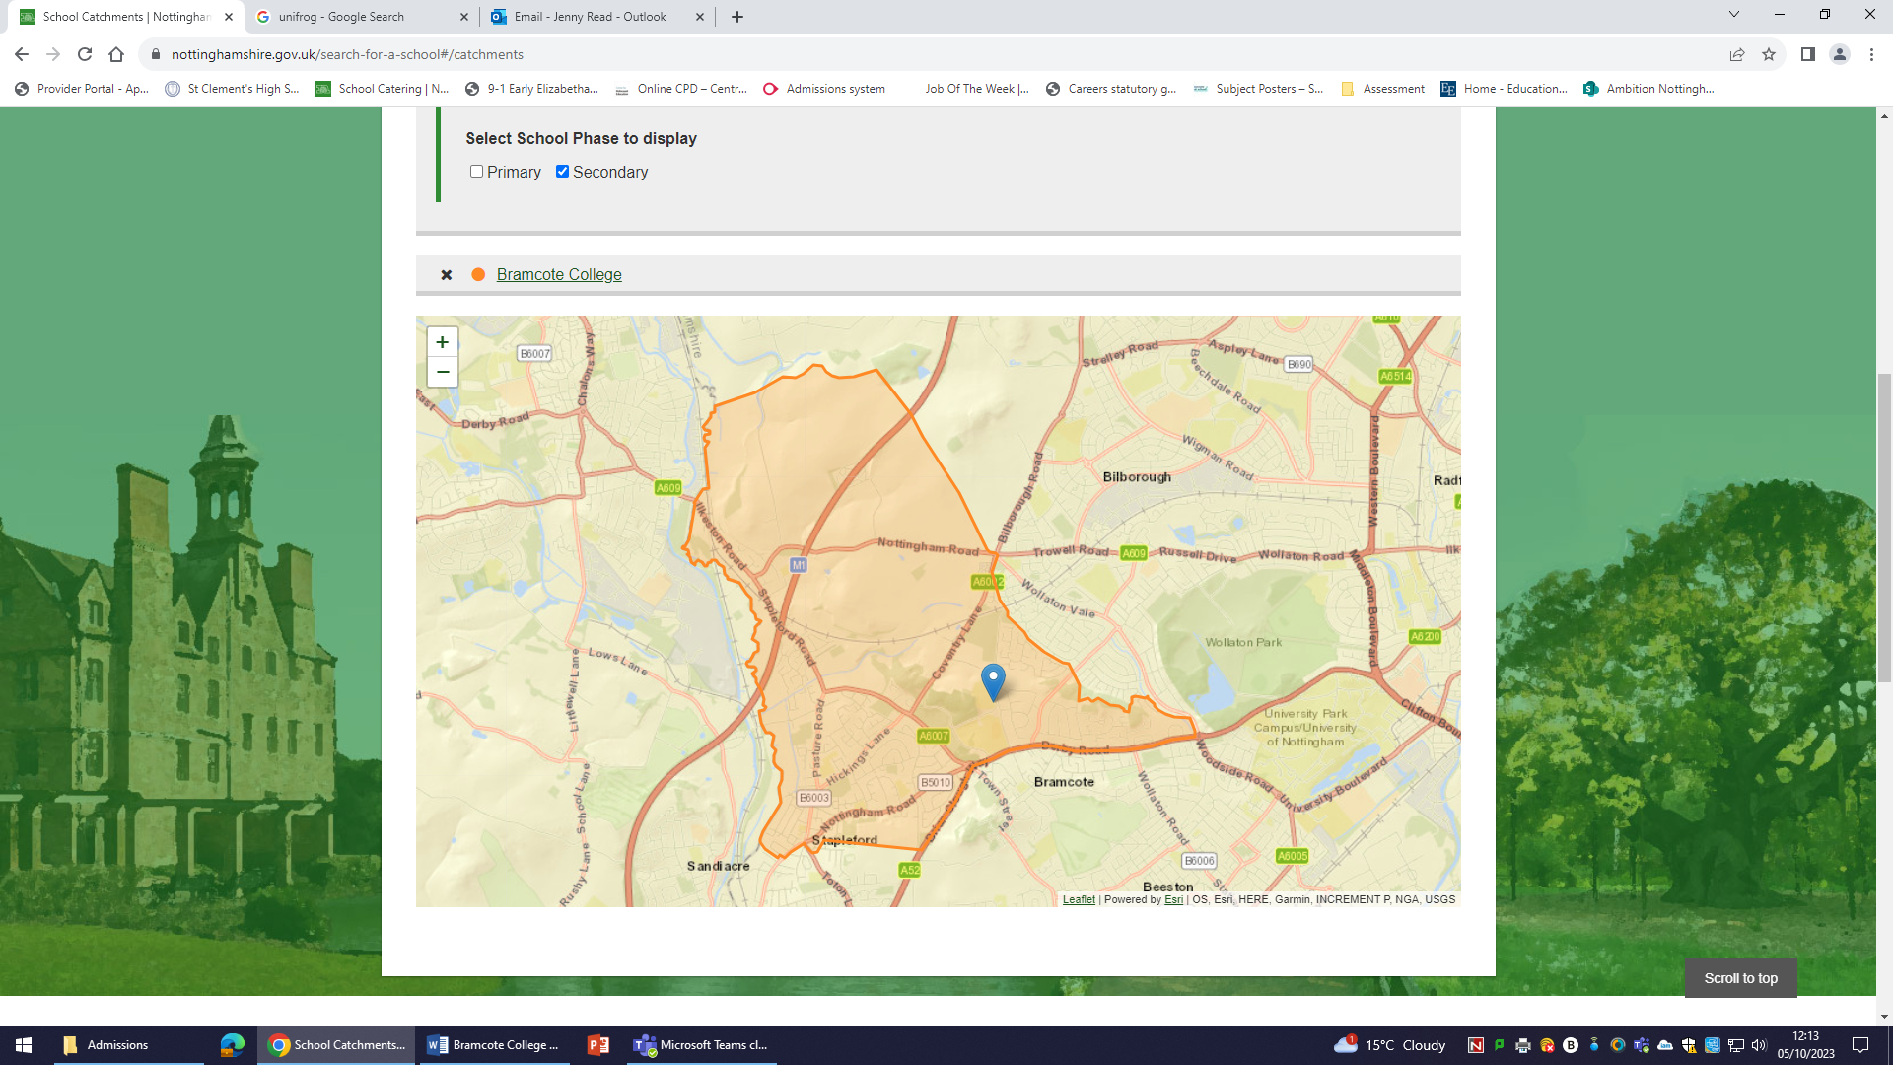

**Linked Primary Schools**

* Albany Junior School
* Bramcote Hills Primary School
* St Johns C of E Primary School
* Trowell C of E Primary School
* Wadsworth Fields Primary School

**Multiple Births**

Where one child of a multiple birth can be admitted, the other child/children will also be admitted.  
The Trust works with the LA for in year applications. Applications should be made through Nottinghamshire County Council.

The PAN for Bramcote College is 150 for Year 7 intake 2026.

**Standard admission criteria for Year 12**

**General entry requirements**

There are no general entry requirements to join Bramcote College Sixth Form. However, for study at Level 3 (A level and its equivalents), at least a minimum of 5 GCSEs of grade 5 or above is required, usually including English and Maths. The Published Admission Number for entry into Year 12 from beyond the school is 20, this is in addition to any applicant who applies from Bramcote College having studied here in Year 11.

**Additional entry requirements**

Some subjects have additional entry requirements.

* Students will have achieved at least grade 5 at GCSE in any subject they intend to study at A Level. Students may be able to study an A Level subject they did not take at GCSE, if they meet other entry criteria.
* Students studying English Literature and / or Government & Politics will have achieved at least a grade 5 in English GCSE.
* Students studying French, German or Spanish will have achieved at least a grade 7 in the higher paper.
* Students studying Mathematics at advanced level will have achieved at least grade 7 on the higher paper for Mathematics GCSE.
* Students studying Biology at advanced level will have achieved at least grade 77 for dual award Science GCSE or at least a grade 7 on the higher paper for Biology GCSE.
* Students studying Physics at advanced level will have achieved at least grade 77 for dual award Science GCSE or at least a grade 7 on the higher paper for Physics GCSE. In addition, students will have achieved at least grade 7 on the higher paper for GCSE Mathematics.
* Students studying Chemistry at advanced level will have achieved at least grade 77 for dual award Science GCSE or at least a grade 7 on the higher paper for Chemistry GCSE. In addition, students will have achieved at least grade 7 on the higher paper for GCSE Mathematics.

Up to 60 places are offered to students who would be joining the Trust in Year 12.  In the event of over-subscription, the following criteria for admission into Year 12 will apply:

1. Looked after children and those children who have been previously looked after, including those who ceased to be looked after through adoption or special guardianship order.  This includes children adopted from state care outside England.
2. Children who live in the catchment area and who at the time of admission will have a brother or sister attending the school.
3. Other children who live in the catchment area.
4. Children who live outside the catchment area and who, at the time of admission, will have a brother or sister attending the preferred secondary school.
5. Children who live outside the catchment area.

In the event of oversubscription, within any criterion, preference will be given to children who live nearest to the school as the crow flies. Distances are measured from the entrance to the child’s home to the principal entrance of the main administrative building of the school, using the County Council’s distance measuring software.

The appeal system and waiting list will also apply.

1. A 'looked after child' is a child who is (a) in the care of a local authority, or (b) being provided with accommodation by a local authority in the exercise of their social services functions (see the definition in Section 22(1) of the Children Act 1989) at the time of making an application to a school.
2. This includes children who were adopted under the Adoption Act 1976 and children who were adopted under the Adoption and Children Act 2002
3. .See Section 14A of the Children Act 1989 which defines a ‘special guardianship order’ as an order appointing one or more individuals to be a child’s special guardian (or special guardians).
4. A child is regarded as having been in state care outside of England if they were in the care of or were accommodated by a public authority, a religious organisation, or any other provider of care whose sole or main purpose is to benefit society.