
Frequently asked questions
How can I support my child to complete their homework?
Supporting your child in their educational journey is crucial for their success. To help them stay on top of their homework and daily reading, we recommend encouraging them to regularly access Microsoft Teams to check for any assignments. Downloading the Teams app on their phone can make this even more convenient.
The Seneca app and Sentence Builder platforms, both compatible with multiple devices, are excellent resources for enhancing their learning experience.
Ensuring your child completes their recommended daily reading will build their confidence and help them meet their reading targets.
Should I accept the invitation to link to my child’s Seneca account?
Parents can link to their child’s Seneca account by accepting the invitation to connect. This feature allows you to monitor your child’s engagement and progress on the platform. By linking accounts, you can see how often your child is using Seneca, which topics they are studying, and how well they are performing. This insight can help you support and encourage your child more effectively, ensuring they make the most of the resources available to them.
If you need any assistance with linking the accounts or have any questions, please don’t hesitate to reach out to the school for support. Your involvement is key to your child’s success!
How can I track their progress?
In your child’s planner, you will find two important documents: the Bramcote Journey to Brilliance and the Reading Expectations sheet. These will help you track and monitor your child’s engagement with reading and the online platforms. Your involvement and encouragement can make a significant difference in their progress.

What is the Bramcote Journey to Brilliance?
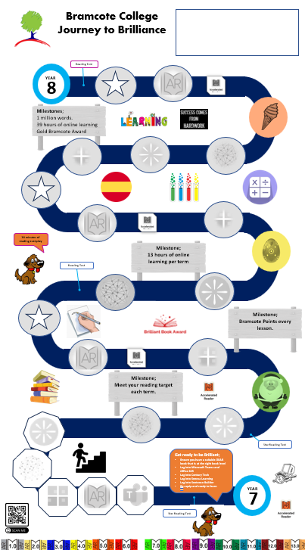
The Bramcote Journey to Brilliance is a framework designed to support and track students’ progress throughout the year. This document outlines key milestones and expectations for students, helping them to achieve academic excellence and personal growth. It includes:
- Academic Goals: Clear targets for each year group, ensuring students know what they need to achieve to progress.
- Personal Development: Emphasis on building resilience, confidence, and other essential life skills.
- Engagement with Learning: Encouraging regular use of online learning platforms like Microsoft Teams, Seneca and Sentence Builder to enhance their educational experience.
- Reading Expectations: Specific daily reading targets to help students improve their literacy skills and meet their reading goals.
Parents can use this document to monitor their child’s engagement and progress, ensuring they are on track to achieve their full potential. If you have any further questions or need more detailed information, please feel free to reach out to the school.
Why is it important to meet their reading targets each term?
Meeting reading targets is crucial for several reasons:
- Improved Literacy Skills: Regular reading helps students enhance their vocabulary, comprehension, and overall literacy skills, which are fundamental for all subjects.
- Critical Thinking: Engaging with diverse texts encourages students to think critically, analyse information, and form their own opinions, which are essential skills for academic success.
- Confidence Building: Achieving reading targets boosts students’ confidence in their abilities, making them more likely to participate in class discussions and take on challenging tasks.
- Academic Performance: Strong reading skills are linked to better performance across all subjects, as students can understand and interpret information more effectively.
- Lifelong Learning: Developing a habit of regular reading fosters a love for learning and curiosity, which are important for personal and academic growth.
By ensuring your child meets their reading targets, you are helping them build a strong foundation for success in school and beyond. Encouraging daily reading and monitoring their progress can make a significant difference in their educational journey.
What is a book level?
In the Accelerated Reader (AR) program, a book level indicates the difficulty of a book, while the Zone of Proximal Development (ZPD) is a range of book levels that are just right for a student’s reading ability. Reading within their book level is crucial because it ensures:
- Optimal Learning: Books are challenging enough to promote growth without causing frustration.
- Skill Development: Enhances comprehension, vocabulary, and critical thinking.
- Confidence Building: Boosts confidence by achieving success with appropriately challenging books.
- Engagement: Keeps students interested and enjoying reading.
Encouraging your child to read within their ZPD/Book level helps them improve academically and develop a love for reading.
My child is a reluctant reader, how can I encourage them to read more?
Some tips to help encourage a reluctant reader:
- Find Interests: Choose books on topics your child is passionate about, whether it’s sports, animals, or fantasy.
- Set a Routine: Establish a regular reading time each day, making it a part of their daily routine.
- Read Together: Spend time reading together. You can take turns reading aloud or discuss the book as you go.
- Use Technology: Incorporate e-books or audiobooks to make reading more engaging and accessible.
- Celebrate Progress: Praise and reward your child for their reading efforts and achievements, no matter how small.
- Incorporate Reading into Daily Activities: Encourage reading through everyday activities, like following a recipe, reading instructions for a game, or exploring informational texts about hobbies.
- Stay Patient and Positive: Encourage your child without pressure. Celebrate their efforts and progress to build their confidence and enjoyment of reading.
How do I check the level of a book I have bought myself?
You can check the book levels of the books you have at home to ensure they are appropriate for your child’s reading ability. By visiting www.arbook.co.uk This website will allow you to quickly find out the book level of any book. This should help you select books that are within your child’s Zone of Proximal Development (ZPD), ensuring they are challenged just enough to make progress without becoming frustrated. Encouraging your child to read books at the right level will support their literacy development and boost their confidence. If you need any assistance with using the tool, please don’t hesitate to reach out.

