Microsoft Teams

Computer Powered Learning.

Microsoft Office 365 and Teams.

Bramcote College is a Microsoft School. Students will use Office 365, Microsoft Teams and One Note each week.

Student guide to Microsoft Teams <https://youtu.be/aO9LE6ZKnUM>

Once they have logged into Office 365 or directly into Microsoft Teams. They will be able to see all their class teams. To access them simply click on the icon. Graphical user interface, application, Teams

Post section

Every Class Team has a post section where the teacher can communicate with the group. This is for them to communicate with the group about deadlines, revision suggestions or home learning tasks. It is not a discussion forum for the class. No personal or private messages should be posted in this area. (See acceptable use policy). If they have a question, they should see the teacher in person or send them an email.

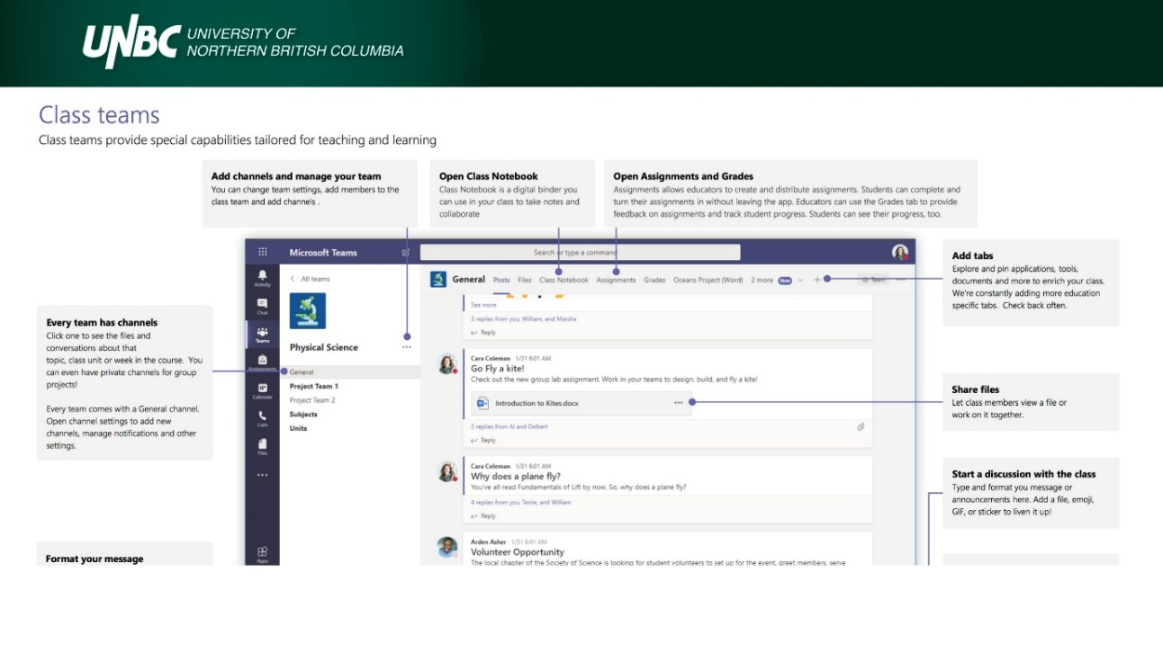The teacher may add direct links to a file on the post section. Alternatively, they should look within the Assignments or Class notebook tabs. These can appear at the top or side of the page. **Revision materials are often available in the files section**

Assignments

The teacher will set assignments for the student to complete. These can be accessed via the assignments or activity tabs.

To open click on the task.

Many teachers will have attached a page for them to write on directly. If used with a good internet connection, then this work will be automatically saved.

If it is a Seneca assignment then they can click on the link and it will automatically load Seneca.

Assignment details

Within each assignment there should be details of the work required along with any relevant reference material. Click on the student work attachment to complete the task. The rubric will provide assessment criteria.

To upload new work

Click on the add work button. Select whether they want to upload a new file or an existing file. If new, select whether it is a PowerPoint, Word document etc and give it a suitable name. If it is an existing file, then click on the location the document is save in and upload.

Hand In

Students need to remember to hand in their work/document at the end to indicate to the teacher that they have finished, and it is ready for assessment.

