Online Learning Platforms: Seneca
We use a range of online learning platforms to support students at home and in school. Students will have some specific tasks set on these by teachers however they can also use them independently to boost their learning.
Seneca learning
All students at Bramcote College will have access to a Seneca learning account. Seneca is an online platform can be thought of as an effective and engaging interactive revision guide with course written by senior examiners at the major exam boards. It provides summaries, notes, videos, and lots of different types of practice questions. The system is also completely adaptive so your child's learning experience will be tailored to suit their needs.
Seneca Learning will work on any device, simply visit senecalearning.com on your mobile, iPad, tablet or laptop computer and log in. Seneca will automatically adapt to the size of your screen. There is also a Seneca app. Students should use their school log in to access Seneca.
Free Homework & Revision for A Level, GCSE, KS3 & KS2 (senecalearning.com)
Seneca - KS3, GCSE & A Level – Apps on Google Play
Seneca on the App Store (apple.com)
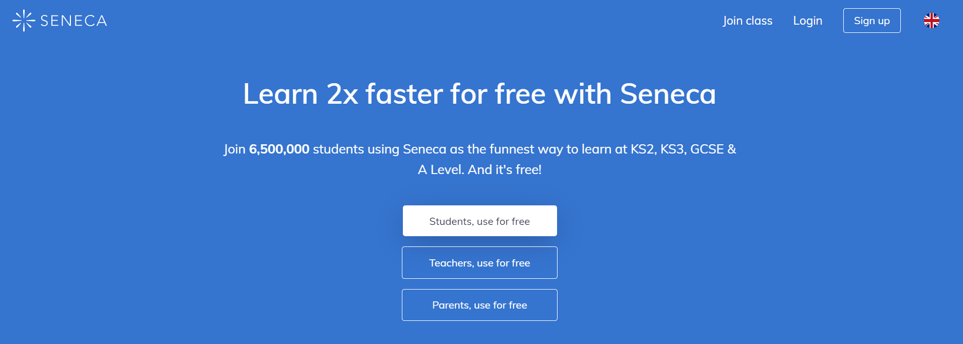

- Log into Seneca – Students can log in with Microsoft or Google for automatic single sign on
- Click on to Classes and Assignments
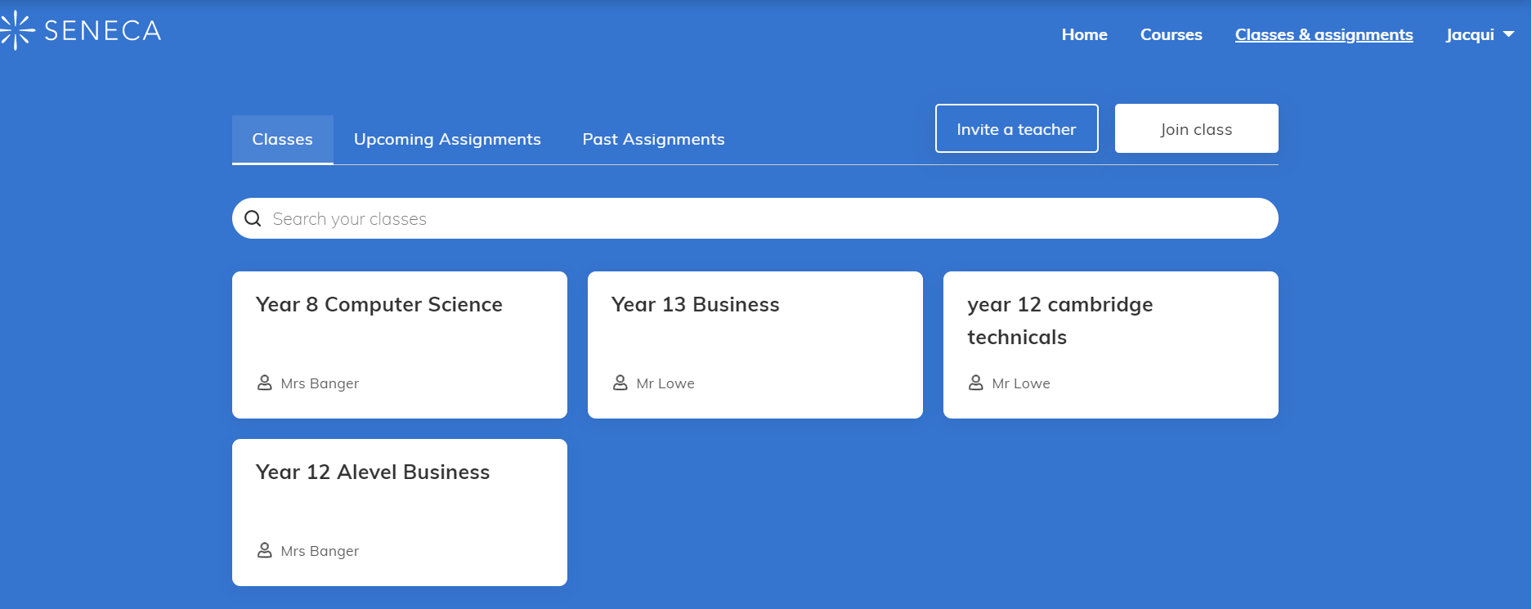

- Click on the subject they want to study or their class
- They can then select the topic that they wish to revise or can open one of the assignments that has been set.
- Select the subject and topic they want to study then click on start learning

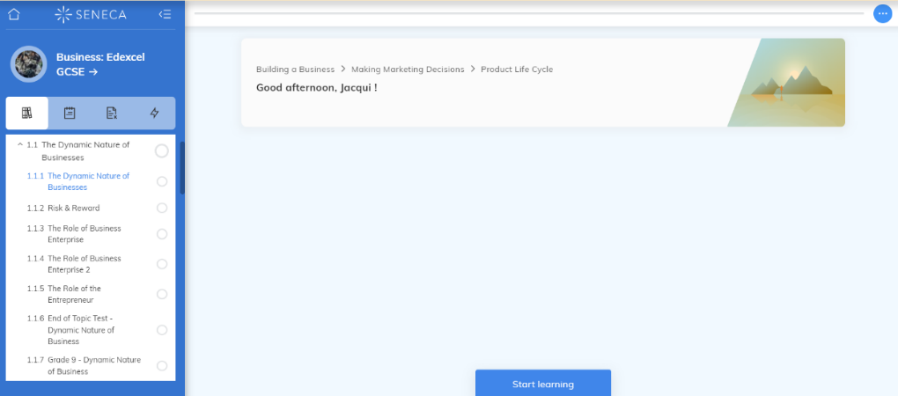
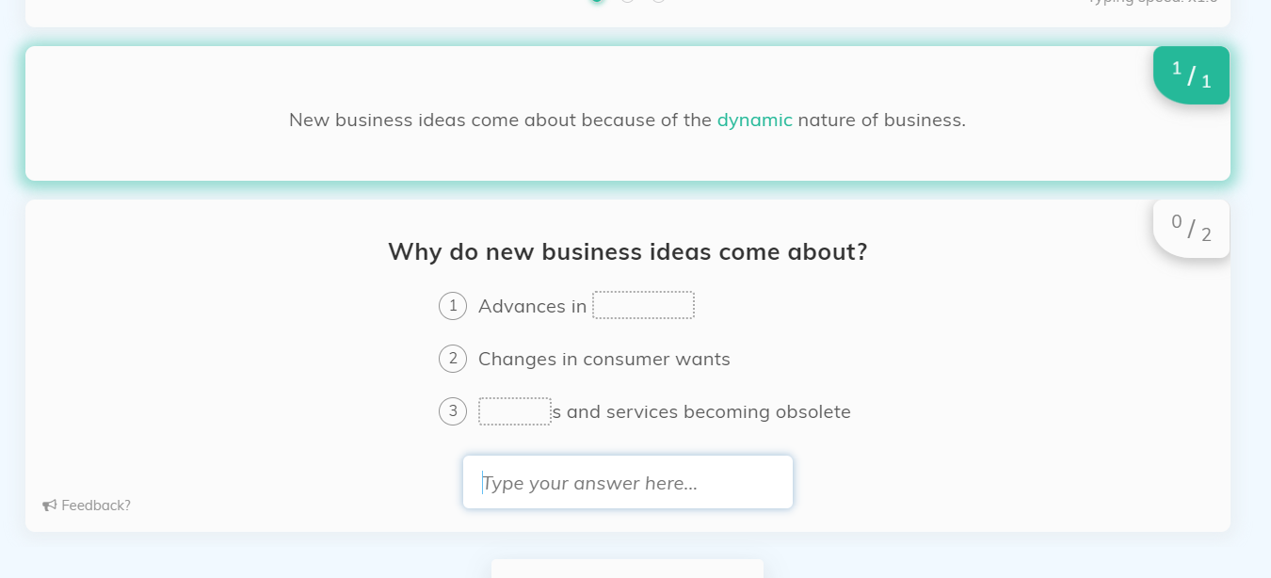
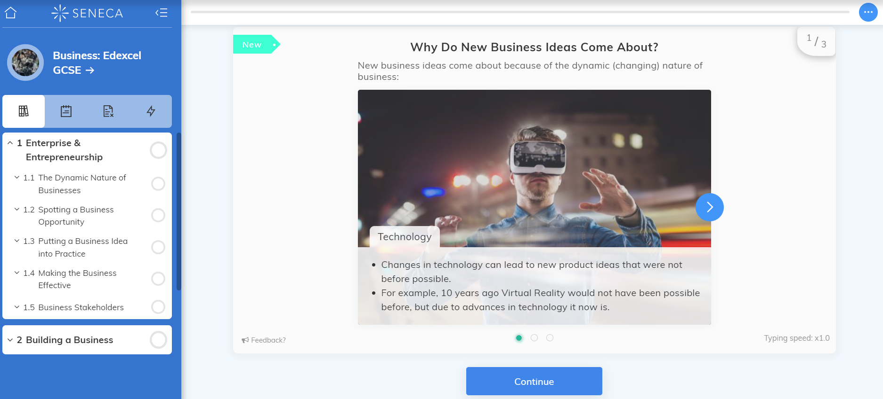
Read the text and then answer the questions.
Example Biology GCSE on Seneca Learning - YouTube

