**Computer Powered Learning: Microsoft Office 365 and Teams.**

Bramcote College is a Microsoft School. You will use Office 365, Microsoft Teams and One Note each week.

Student guide to Microsoft Teams <https://youtu.be/aO9LE6ZKnUM>

Once you have logged into Office 365 or directly into Microsoft Teams. You will be able to see all your class teams. To access them simply click on the icon. Graphical user interface, application, Teams

Post section

Every Class Team has a post section where your teacher can communicate with the group. This is for them to communicate with the group about deadlines or home learning tasks. It is not a discussion forum for the class. No personal or private messages should be posted in this area. (See acceptable use policy). If you have a question, please see the teacher in person or send them an email.

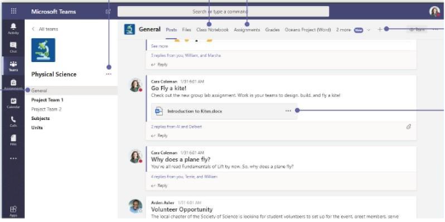

Your teacher may add direct links to a file on the post section. Alternatively, you should look within the Assignments or Class notebook tabs. These can appear at the top or side of the page.

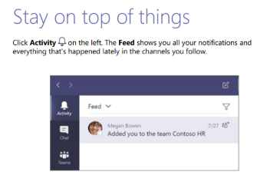Keep up to date

Assignments

Your teacher will set assignments for you to complete. These can be accessed via the assignments or activity tabs.

To open click on the task.

Many teachers will have attached a page for you to write on directly. If used with a good internet connection, then this work will be automatically saved.

Assignment details

Within each assignment there should be details of the work required along with any relevant reference material. Click on the student work attachment to complete the task. The rubric will provide assessment criteria.

To upload new work



Click on the add work button. Select whether you want to upload a new file or an existing file. If new select whether it is a PowerPoint, Word document etc and give it a suitable name. If it is an existing file, then click on your One Drive or the location the document is save in and upload.

Hand In

**Don’t forget to hand in your document at the end to indicate to your teacher that you have finished, and it is ready for assessment.**

Feedback

Microsoft Team app

It is also possible to **download the Microsoft Teams App** from the Apple App store or Android provider. This can be used on a mobile phone or tablet.

Sign in using your school email account and password.

[Download Microsoft Teams Desktop and Mobile Apps | Microsoft Teams](https://www.microsoft.com/en-gb/microsoft-teams/download-app#office-CustomSpacingTemplate-uoh60pc)

Handing in an assignment on your mobile phone or tablet

It is possible to view, open and hand in your homework using your mobile phone or tablet.