2022-23 KS2 SATs Headline Analysis
National % of children meeting expected standard
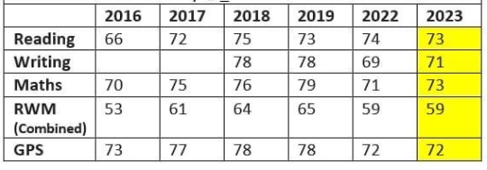
Bramham
29 Children (3.4%) *2 children did not sit tests
Maths
% | All | Girls | Boys
EXS | 38 (75.9) | 60 (80) | 26.3 (73.7)
GDS | 37.9 | 20 | 47.3
WTS | 24.1 | 20 | 26.3

Reading
% | All | Girls | Boys
EXS (inc GDS) | 27.7 (82.8) | 30 (90) | 27 (79)
GDS | 55.1 | 60 | 52
WTS | 17.2 | 10 | 21

Writing
% | All | Girls | Boys
EXS (inc GDS) | 58.8 (86.3) | 70 (90) | 58 (89.5)
GDS | 27.5 | 20 | 31.5
WTS | 13.7 | 10 | 10.5

GPS
% | All | Girls | Boys
EXS (inc GDS) | 31.2 (79.4) | 40 (80) | 27 (79)
GDS | 48.2 | 40 | 52
WTS | 20.6 | 20 | 21

RWM Combined
% | All | Girls | Boys
EXS (inc GDS) | 55.2 (75.8) | 60 (80) | 42.1 (68.4)
GDS | 20.6 | 20 | 26.3

