2024-25 KS2 SATs Headline Analysis - Bramham
National % of children meeting expected standard
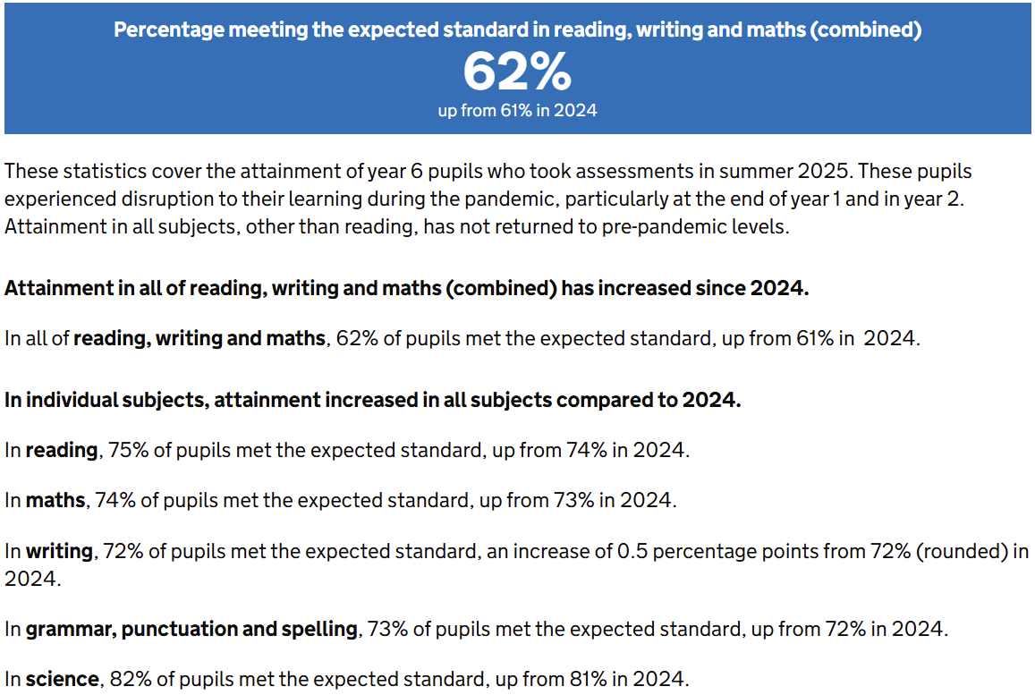
29 Children (3.4%) (10 girls, 19 boys), 1 child did not sit tests – working at PKS
Maths
% | All | Girls | Boys
EXS | 79.3% (23) | 80% (8) | 79% (15)
GDS | 26% (6) | 10% (1) | 33% (5)
WTS | 21% (5) | 20%(2) | 21% (4)

Reading
% | All | Girls | Boys
EXS (inc GDS) | 90% (26) | 80% (8) | 95% (18)
GDS | 38% (10) | 40% (4) | 33% (6)
WTS | 10% (3) | 20% (2) | 5% (1)

Writing
% | All | Girls | Boys
EXS (inc GDS) | 86% (25) | 90% (9) | 85% (19)
GDS | 12% (3) | 22% (2) | 5% (1)
WTS | 14% (4) | 10% (1) | 15% (3)

GPS
% | All | Girls | Boys
EXS (inc GDS) | 72% (21) | 70% (7) | 74% (14)
GDS | 28% (8) | 20% (2) | 43% (6)
WTS | 28% (8) | 30% (3) | 26% (5)

RWM Combined
% | All | Girls | Boys
EXS (inc GDS) | 73% (21) | 80% (7) | 79% (15)
GDS | 10% (2) | 14% (1) | 7% (1)
WTS | 27% (8) | 20% (2) | 21% (4)

2024-25 KS2 SATs Headline Analysis - Shadwell
National % of children meeting expected standard
26 Children (3.8%) (10 girls, 16 boys) 1 child working at PKS (Did not sit?)
Maths
% | All | Girls | Boys
EXS (inc GDS) | 85% (22) | 90% (9) | 81% (13)
GDS | 27% (7) | 20% (2) | 31% (5)
WTS | 15% (4) | 10% (1) | 19% (3)

Reading
% | All | Girls | Boys
EXS (inc GDS) | 81% (21) | 90% (9) | 75% (12)
GDS | 31% (8) | 40% (4) | 25% (4)
WTS | 19% (5) | 10% (1) | 25% (4)

Writing
% | All | Girls | Boys
EXS (inc GDS) | 81% (21) | 100% (10) | 73% (11)
GDS | 10% (3) | 20% (2) | 7% (1)
WTS | 19% (5) | 0 | 27% (4)

GPS
% | All | Girls | Boys
EXS (inc GDS) | 85% (22) | 90% (9) | 81% (13)
GDS | 31% (8) | 40% (4) | 25% (4)
WTS | 15% (4) | 10% (1) | 19% (3)

RWM Combined
% | All | Girls | Boys
EXS (inc GDS) | 77% (20) | 90% (9) | 63% (10)
GDS | 8% (2) | 10% (1) | 6% (1)
WTS | 23% (6) | 10% 1() | 31% (5)

