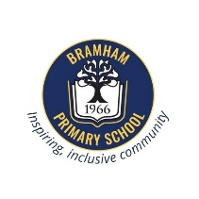
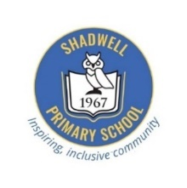
Bramham and Shadwell Federation
Curriculum Newsletter: Class 1 September-November
English | Maths | Science | Geography
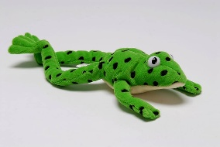  Children will be working in their RWI groups this half term to recap their Set 2 phonics sounds. They will have a speeds sounds lesson each day, where they will recap known Set 2 sounds and read and write real and nonsense words with these sounds in. The children will then read a sound matched book with their reading partner and at the end of the third session they will answer comprehension questions. The children will also engage in writing activities around the books they are reading in the RWI sessions. These writing activities will focus on the skills of remembering a sentence, using correct letter formation and focusing on the accurate use of capital letters and full stops. | 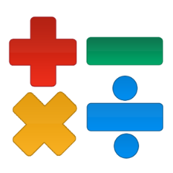  This half term the children will explore the numbers 1-10 using one-to-one correspondence and use tens frames to represent numbers. They will then write numbers using both numerals and words. Children will compare numbers using the terms ‘greater than’ and ‘less than’. Children will then learn different ways of making numbers using number bond diagrams. They will explore their understanding of number bonds to create number bond stories. We will then explore different ways of adding to 10, looking at the part-whole diagram as well as beginning to make their own addition questions to support a deeper understanding of the process of addition. | 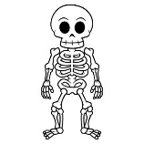  Children in this half term will be exploring the human body and the five senses. Children will learn to label their key important body parts and understand their uses. They will also explore their 5 senses in a range of exciting ways. The children will be able to actively use their knowledge and understanding in the Health Centre role play area during continuous provision – exploring their skills as doctors, dentists, optemtrists, audiologists and first aiders. | This half term in Geography the children will be focusing on the topic ‘how does where I live help me be happy?’ Within this topic we will look at the different communities the children are part of, from their families to the school and wider community. Children will talk about their families and how all families and communities differ however they are all based on love, kindness and respect.  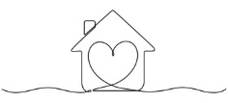  The children will take a walk around the village of Bramham to see what makes a village and a village community as well as having the opportunity to compare houses and homes in the UK to those in other countries.
Art: Vincent Van Gogh’s Starry Night | P.E:  Throwing and catching | Computing: Technology Around Us | PSHE: Myself and my feelings | Music: Hear my Voice | RE: Why are Festivals important in a community?
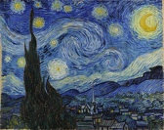  This half term in Art children will be focusing on the painting ‘Starry Night’ by Vincent Van Gogh. They will be focusing on the skill of drawing. The children will identify line types, understand repeating patterns, be able to identify and create the foreground and background in their own final piece of ‘Starry night’ inspired artwork. | The focus will be on travelling safely around a large space in a variety of ways with control and co-ordination. The children will also focus on using their gross motor skills to throw and catch a variety of different sized balls. They will also focus on working together in a team to play some competitive ball games. | Children will develop their understanding of technology and how it can help them in their everyday lives. They will start to become familiar with the different components of a computer by developing their keyboard and mouse skills. Children will also consider how to use technology responsibly and who to ask for help if they see anything online that makes them feel uncomfortable. | 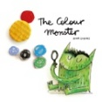  This half terms PSHE topic focus’ on the children settling into their new class family. We will spend time learning about different types of feelings, how to manage these feelings and how we can show empathy and understanding towards others. The children will be exploring emotions in different ways including through the use of the colour monster story and an introduction to the Zones of Regulation. | 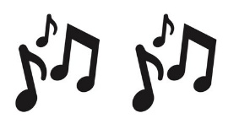  This half term children will learn to join in with class singing time, sing songs in different voices, move to the pulse of the music and follow cards/objects to play a pattern. They will also learn the names of percussion instruments and investigate their timbre and tap rhythms of words in songs. | 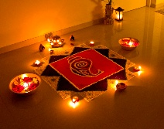  In this unit of work children will explore the festivals celebrated in a range of cultures and religions from Christianity to Hinduism and Buddhism. Children will get to share their knowledge and understanding of key festivals and develop their understanding of why key festivals are important in different religious communities.
Helping at Home | Dates for the Diary and any other information
Here are some helpful reminders of the resources you can access at home to support your child’s learning and key vocabulary that we would encourage you to explore with your child to help them with their learning.  English Children’s reading books will be sent home once they have finished reading them in class each week. Children will be sent home with a RWI book they have read in school and a home book to accompany this. They also have the opportunity to take home a book to read for joy on a Friday from the class library.  Maths Online access Numbots.  Science Key vocabulary: arm, foot, neck, leg, head, shoulders, knees, toes, hips, smell, taste, touch, hear, see, senses.  Geography Key vocabulary: house, home, address, key, community, family, village, landmarks, map  Art Key vocabulary: lines, drawing, starry night, Vincent Van Gogh, foreground, background.  PE Key vocabulary: throw, catch, teamwork, overarm, underarm, ball.  Computing Key vocabulary: technology, e-safety, computer, keyboard, mouse, screen, passwords.  PSHE Key vocabulary: feelings, emotions, happy, sad, scared, worried, excited, angry, zones of regulation, family.  Music Key vocabulary: pulse, timbre, pattern, percussion instruments, drums, triangle, tambourine, xylophone, rhythms.  RE Key vocabulary: Christianity, Sikhism, Buddhism, Hinduism, Muslim, Islam, festivals, community.  Other ways to support at home:  - Play simple number games, like counting objects around the house, or using everyday items to practice addition and subtraction. You can also use board games that involve counting or matching numbers.  - Set up opportunities for your child to play independently be it with a puzzle, an art activity or Lego. This not only nurtures creativity but also helps children to feel more confident in their abilities. | Wednesday 10th September – Welcome to Class One Presentations – 2:10 and 2:40pm.  Tuesday 23rd September – Flu Vaccinations  Monday 29th September – Class Photos  Wednesday 8th October – Class Walk around the village  Tuesday 21st and Thursday 23rd October – Parent Consultations  Friday 24th October – Last Day of the Half Term.  Please ensure that your child has a named water bottle in school every day. They must remember to take it home every evening to wash the bottle and bring it in to school already full. This will ensure that the bottles are kept clean and germ-free for the children’s use each day.  Our PE day this term is a Monday. Please ensure your child is wearing their house team t-shirt alongside appropriate PE kit. The majority of sessions this term will be outside so please ensure your child is wearing suncream and has a water bottle in school.

