Curriculum Newsletter
Bramham Shadwell Federation
Class 5 January – February 2022
All our learning in class this half term will be focused around the question:
What does Freedom mean to someone?
English | Maths
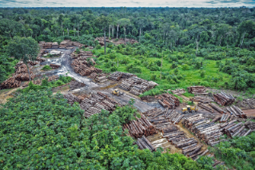  - The focus will be on developing speaking and listening skills through a whole class debate with the motion of “Deforestation should be banned” which is linked to our geography topic of South America.  - Children will explore opposing and proposing arguments before forming their own opinion and building a persuasive verbal and written argument.  - Children will also explore the use of expression, emphasis and tone to engage and interact with their listeners.  - Grammar, spelling and punctuation activities will focus on consolidating skills learnt in the autumn term including the accurate use of apostrophes for possession and omission.  - Editing and improving their own work as they respond to their targets will be a continued focus.  - The focus in reading will be on inference skills through a range of texts linked to our South America topic. The children will be exploring using their retrieval skills to find evidence from the text and their own knowledge to infer what is happening in the text.  The outcome will be: to write and take part in a persuasive debate, showcasing speaking and listening skills. | - The focus will be learning about graphs and fractions.  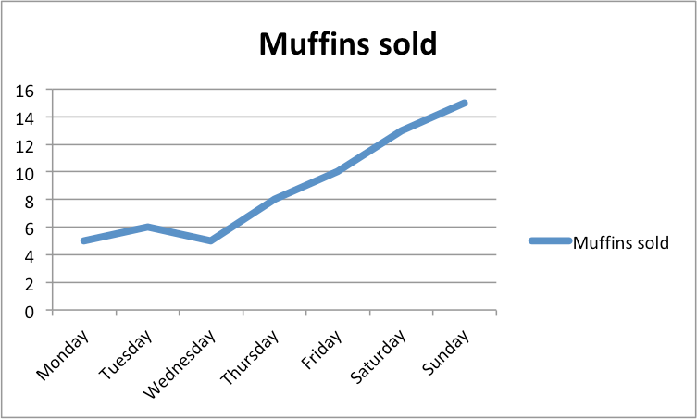  - There will be an emphasis on reading and interpreting information in tables and line graphs. Children will be required to use data to answer questions.  - Children will look at the representation of amounts as fractions using concrete resources before advancing on to more complex problems including multiplying and dividing fractions by whole numbers.  - It is expected that all of the children will know multiplication and division facts up to the 12 times table for use in calculations. Each week, there will be a times tables test; children will then be given a target to improve the speed at which they do the times table or to learn the next one.  - They will continue to solve problems and learn to explain, convince others and justify their findings using specific vocabulary: I am certain that…, I think…. because…., I know that …. so … must be …..  - Additionally, the KIRF target is outlined below; please help your child to achieve this target.
How can I help / information for helping  What debating language should my child be confident in using?  Motion: a question, statement or suggestion that can be debated.  Opposition: the side which argues against the motion.  Proposition: the side which argues in favour of the motion.  Rebuttal: providing evidence and reasoning to weaken the other team’s argument.  Why are apostrophes used?  To signify possession (the dog’s tail, the boy’s trousers). When the owners of the item are plural, the apostrophe goes AFTER the plural s (the dogs' tails, the boys' trousers).  To show that a letter has been omitted – so can’t (instead of cannot), don’t (instead of do not).  Apostrophes are never used to indicate plurals, so you would write ‘two skirts’, not ‘two skirt’s’, and ‘all my books’ not ‘all my book’s’. | How can I help / information for helping  Please help your child to learn their times tables as this increases mathematical confidence and accuracy.  Look at different representations of data such as bus or train timetables and interpret the information. | KIRF Target – Spring Term 1  I can identify prime numbers up to 20.  - Children should know the following facts:  - A prime number is a number with no factors other  than itself and one.  - A composite number is divisible by a number other than 1 or itself.  - Children should be able to explain how they know that a number is composite. E.g. 15 is composite because it is a multiple of 3 and 5.

Topic – (Geography) | SITE | P.E
Focus: Our geography topic is South America. Children will explore the cultures and lives of people living in different parts of the continent including comparing and contrasting the tribes living in the Amazon Rainforest with those who live in the favelas of Rio De Janeiro.  As a class, we will then compare our own lives to those living in different locations in South America and consider the meaning of freedom to different people, in line with our SMSC statement this half term.  Skills / Knowledge to be developed:  Human and physical geography in considering the development of different settlements in South America over time and the impacts this has on the lives of those who live there including those in the Amazon Rainforest. Mapping the distribution of natural resources across a continent and understanding the implications on land use in different areas.  Applied through:  Topic lessons, English lessons (through our deforestation debate). | Focus: Properties of materials.  The outcome will be through our SITE project where the children will choose suitable materials when designing and creating Greek Sandals ready for our Spring 2 history topic on the Ancient Greeks.  Skills / knowledge to be developed:  Children will compare and group together everyday materials on the basis of their properties including their hardness, solubility, transparency, conductivity (electrical and thermal) and their response to magnets. Use knowledge of solids, liquids and gases to decide how mixtures might be separated, including through filtering, sieving and evaporation.  DT links:  Our SITE project will build on our understanding of reversible and irreversible changes through creating a weather system. The weather system will visually show the processes of evaporation, precipitation and condensation which in turn will enable the children to explain their understanding of these state changes to others.  Computing links:  To use Microsoft Excel to record evidence of our findings from our SITE project in tables and graphs. This will be an extension of our work on graphs and tables in maths. | Focus:  P.E this half term will focus on Gymnastics.  Skills / knowledge to be developed:  In Gymnastics, we will complete different types of rolls, focusing on the technique, look at different balances and create routines in pairs and groups. The routines will be improved upon and performed to the rest of the class which will allow us to become confident in performing to an audience. Children will learn to give constructive feedback which can be used in all areas of learning.  Applied through:  Children will develop their techniques through structured P.E lessons.  P.E. this term will be on a Friday afternoon.  Children should bring their P.E. kit each Friday.  Swimming this term will be on a Monday afternoon. Children should bring their swimming kit to school each Monday.
How can I help / information for helping  Discuss key vocabulary for our topic e.g. deforestation, biome, sustainable, conservation.  Make an information leaflet on the advantages and disadvantages of deforestation.  Choose an animal that lives in the Amazon Rainforest to create a fact file about. | How can I help / information for helping  Discuss key vocabulary and how these terms are used in everyday life e.g. permeable, transparent, soluble, absorbent.  Explore the different uses of Microsoft Excel and how it can be used to display data. | How can I help / information for helping  Please ensure that children have both an outdoor and indoor kit in school (including trainers) for the whole week as other indoor and outdoor sessions might take place at alternative times.

French | Music | PSHE / MindMate | R.E.
Focus: Numbers and colours.  Skills / knowledge to be developed: Explain different Mathematical vocabulary in French learning how to say numbers up to 100.  Applied through: Using the ‘Jolie Ronde’ scheme of work, playing games and singing songs. | Focus is: “Livin’ On A Prayer” – Bon Jovi  Skills / knowledge to be developed: developing the children’s understanding of the dimensions of music (pulse, rhythm, pitch etc); identifying instruments in a song and playing instruments.  Applied through: This is a fun unit of work about classic Rock music. Using ‘Charanga’, learning takes place through games, | Focus: Stereotypes, discrimination and prejudice.  Skills / knowledge to be developed: developing the children’s understanding of what stereotypes, discrimination and prejudice are and why it is important to challenge these daily.  Applied through:  Discussion, PSHE lessons, circle time.  Mindmate Lesson:  This term our Mindmate lesson will be about identifying and challenging stereotyping in the media (advertising). | Focus is: What values are shown in codes for living?  Skills / knowledge to be developed:  developing the children’s understanding of what matters most to different believers. This enables children to identify values in human life and think about their own values considering what is important to them.  Applied through: Circle time/ discussion/ debate/ lesson tasks.
How can I help / information for Helping  Discuss what the children have learnt and get them to teach someone else in their family. | How can I help / information for helping  Encourage your child to practise singing at home.  Ask your child if they can explain the inter-related dimensions. | How can I help / information for Helping  Discuss why we must continue to challenge stereotypes, discrimination and prejudice.  Encourage your child to have an open mind in terms of widening their views on stereotypes, discrimination and prejudice. | How can I help / information for helping  Discuss the importance of values and how a wide range of people from all over the world have different perspectives based on the religion they choose to follow.  Encourage them to be aware of alternative religions and beliefs and the idea that some people choose a scientific belief instead.

Homework | Any Other Information / Dates for the Diary
Ongoing Homework  - Reading: a minimum of 15 minutes reading every night (logged by the children and noted in their reading record).  - KIRF target: See maths section  - Times Tables: see Homework Log Sheet  - Mathletics: practise times tables, and objectives we are covering in class. Mathletics teaches objectives, tests and has games for all the objectives in Year 5. It is a brilliant tool for consolidation and practise. Earn points and certificates on Mathletics. Can you get 1000 points each week?  - Spellings: learn the lists sent home and words outlined as common errors in their Homework Log Sheet. Please see the class teacher if your child has not logged information on the sheet.  Please continue to log children’s progress with these activities on the weekly homework sheet – children earn House Points for each part that is fully completed.  Maths / English Homework  This year, there will be two pieces of homework each week. Homework is given out on a Thursday, to be returned the following Tuesday.  There will be an English based task on either comprehension or grammar once each week, and a maths based task. These will be pre-teaching of a new objective or consolidation of class work in class.  Please encourage your child to discuss their homework at home in order that they develop the skills of explanation and reasoning. Children will be set a Learning Log activity once during every half term. This will be related to the Enriched Curriculum. On weeks when this is set, it will replace Maths and English homework. | W/C 7th February – Online Safety Week  Thursday 3rd March – World Book Day  Friday 18th March – Red Nose Day  Please ensure that your child has a water bottle in school every day. They must remember to take it home every evening to wash the bottle and bring it in to school already full. This will ensure that the bottles are kept clean and germ-free for the children’s use each day.  We encourage you to follow our school Twitter account @BramhamShadwell. We post regular updates and photographs of what your children are learning in class alongside other important school information, reminders and updates.

Thank you, as always, for your continuous help and support. If you have any queries please do not hesitate to contact us or make an appointment at the office to arrange a meeting after school.

Miss Alexandra

