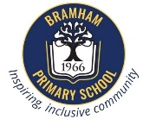
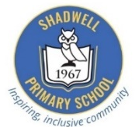
Bramham and Shadwell Federation
Curriculum Newsletter: Class 2 September – October 2026
English | Maths | Science | Geography
Focus: We are so excited to continue our Read Write Inc journey this term! Alongside our daily phonics and reading, our Year 2 class will also be taking part in whole-class writing lessons.  Here is what we'll be getting up to:  - In phonics, we will be reviewing all the sounds we already know and learning some of those trickier, unusual spelling sounds.  - In reading, the groups will have a new focus book every week. Each day, the children will read the books for fluency and expression, answer comprehension questions and write sentences relating to the story.  - In writing, while we will continue to focus on handwriting accuracy and consistency, we are focusing on conjunctions, noun phrases and consolidating the writing features from Year 1 (capital letters, full stops and finger spaces)  - In spelling, we will be practicing and mastering our Year 2 high-frequency words as well as spellings relating to our focus sounds each week. | Focus: Place Value  Children will be identifying the number of tens and ones within a given number to 100 and represent numbers in different ways, such as, 34 = 30+4, 34 = 20+14, 34 = 10+24  Problem solving: continuing learning how to explain, convince others and justify, such as, I know that…, I think…. because….  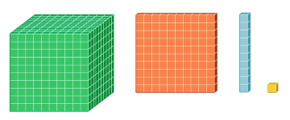  By the end of Year 2, it is an expectation that all children will be fluent in multiplication and division facts for the 2, 5 and 10 times table for use in calculations. This term we will be beginning by counting in 2s and 10s before moving onto more formal multiplication calculations. | Focus: Living Things and Their Habitats  Children will learn how to describe UK habitats and understand how they provide for the basic needs of different kinds of animals and plants. We will find out how we know if something is living, no longer living or never lived and investigate food chains.  We will also investigate some of the contrasting habitats around the world too.  We enjoy carrying out lots of practical investigations to predict and answer scientific questions  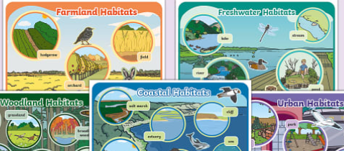 | Focus: What are the continents and oceans of the world, and where are they?  Children will learn the 7 continents and 5 oceans of our planet. They will understand how the continents are very different: in size, location, temperature, animals and culture.  We will also explore the 5 oceans surrounding these continents and learn about their size and the animals that swim beneath their surfaces.  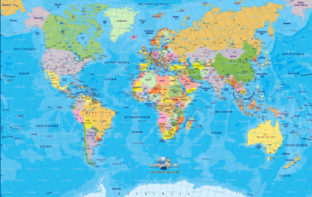  To explore all these ginormous places, we will be following Paddington to see where he visits each lesson.

Art:  Painting – colour mixing  Ted Harrison | P.E:  Agility, Balance and Coordination | Computing:  Typing Skills | PSHE:  Mental Health and Wellbeing | Music:  Rhythm and Pulse | RE:  How can we make good choices?
Our first art focus is colour. Children will explore how to use and mix paint. We will start with the colour wheel: learning our primary and secondary colours. Then, the children will progress to experimenting with mixing colours and creating different gradients. With their new skills, they will create a final piece inspired by Ted Harrison. | This half term in PE, pupils will be developing their Agility, Balance and Coordination (ABC) through fun games, challenges and movement activities. These fundamental movement skills build confidence, improve fitness and provide the foundations for success in all sports and physical activities. | This half term the children will be developing their typing skills when using a keyboard to ensure they are confident with using Caps lock, backspace, shift, control, enter, space bar and know where to locate numbers and different punctuation. | As a class, we will reintroduce the Zones of Regulation and how these can support us in and out of the classroom.  Our topic then focuses on friendship, how we make friends, what makes and good friend and how we can resolve conflicts when we do fall out. | This half term, we are practising our rhythm and pulse skills. We will be following along to music as well as making our own sounds with different tempos. Alongside this, our half term music focus is ‘World Music’. We will be learning about musicians from different cultures all over the world. | Children explore how people always face moral choices, and why rules are important. They will then study moral codes from Christianity, Judaism and Islam and the ways in which Sikhs, Buddhists and Hindus make good choices.
Helping at Home | Dates for the Diary and any other information
Here are some helpful reminders of the resources you can access at home to support your child’s learning and key vocabulary that we would encourage you to explore with your child to help them with their learning. | September  Wednesday 9th September – 2:10pm/2:40pm – Welcome to Class 2 Presentation  October  Wednesday 21st October – Flu Vaccines  Wednesday 21st October/Thursday 22nd October - Parents Evening  November  Tuesday 24th November/Wednesday 25th November – Progress Café  Friday 27th November – INSET DAY  December  Friday 4th December - Whole School Theatre Trip – The Grinch  Other ways to support at home:  Please help us by making sure that all school jumpers and cardigans are named so that those we find can be reunited easily with their owners.  Water Bottles  Please ensure that your child has a named water bottle in school every day. They must remember to take it home every evening to wash the bottle and bring it in to school already full. This will ensure that the bottles are kept clean and germ-free for the children’s use each day.  Fruit  There is a fruit/vegetable snack for every child at school during break time. Children are of course welcome to bring their own fruit snack if they prefer, however this should just be fruit or vegetables.  PE (Thursday afternoon)  PE may take place outside so please ensure that you send your child with appropriate kit, this needs to include a plain, black hoodie, plain black or grey shorts, leggings or joggers, coloured house T-shirt and trainers. Please refer to uniform policy if unsure.
  English | We would encourage all children to read for 15 minutes regularly.  (Please log what they have read in their reading record)  Reading at Home  Children will bring home three types of books to support their reading:  Core Read Write Inc. books – Practised at least three times in school before being sent home. Re-reading at home builds confidence and fluency while also giving them the chance to show off their reading success and celebrate with you.  Book Bag books – Matched to the Core Read Write Inc. book. They give children extra practice with the same sounds and themes.  Reading for Joy books – Chosen by your child to share and enjoy with you. Your child may not be able to read all the words yet, but these books help develop a love of reading through talking about the story, pictures, and ideas together.  Please note: Core books and Book Bag books must be brought to school ready to be changed on a Thursday. Reading for Joy books can stay at home until your child is ready to swap them.
  Maths | Online access to Numbots & Times Table Rock Stars - log in information inside reading record  value, digit, 2-digit, tens, ones
  Science | Living, non-living, never lived, food chains, habitats, shelter, alive, suitable.
  Computing | Identify types of IT beyond school and discuss how it is used. Discuss using IT safely and responsibly. Practise typing on a computer/ keyboard.
  Geography | Oceans and continent (including their names), hot, cold, desert, forest, ice
  Art | Colour wheel, ferrule, primary/secondary/complimentary colours, contrast, landscape, portrait, still life, colour palette.
  PE | Coordination, agility, pathway, control, sequence.
  PSHE | Zones of Regulation, Friend, kindness, special, feelings, trust, trusted adult, respect
  Music | Pitch, stave, pulse, rest, crotchet, quaver, rhythm, timbre
  RE | Choices, influences, consequences, rules, guidelines

It has been a delight to welcome your children to Class 2; they are settling well into the new routines of the school day and are very enthusiastic about their learning!

If you have any queries, please do not hesitate to contact us.

Miss Alexandra

