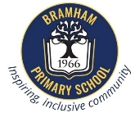
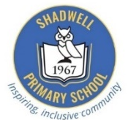
Bramham and Shadwell Federation
Curriculum Newsletter: Class 2 November – December 2025
English | Maths | Science | History
Focus Units:  We are continuing the Read Write Inc Scheme in Year 2 for phonics, reading and writing.  - In phonics, the children will be consolidating the sounds they know already and learning unusual spelling sounds.  - In reading, the groups will have a new focus book every week. Each day, the children will read the books for fluency and expression, answer comprehension questions and write sentences relating to the story.  - In writing, while we will continue to focus on handwriting accuracy and consistency, we are focusing on conjunctions, noun phrases, prefixes and suffixes and consolidating the writing features from Year 1 (capital letters, full stops and finger spaces)  - We will be practising the spelling of Year 2 high frequency words. | Focus:  - 2, 5 and 10-times tables. They will learn to recall and apply the multiplication and division facts related to these.  - Strategies to support them in understanding of multiplication and division.  - Measuring length in cm and m including comparing the length of lines and objects.    - The children will solve problems and learn to explain, convince others and justify their findings using mathematical vocabulary: I know that…, I think…. because  KIRF:  - I know my number bonds to 20.  e.g. 17+3 9+11 24 + 6 | Focus: Living Things and their habitats  Children will continue to learn about habitats both locally and around the world. They will learn about microhabitats and locate them in their school environment. They will investigate food chains and design their own investigations to answer their own questions.  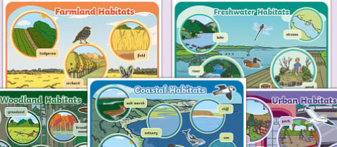 | Focus: What were the effects of the Great Fire of London?  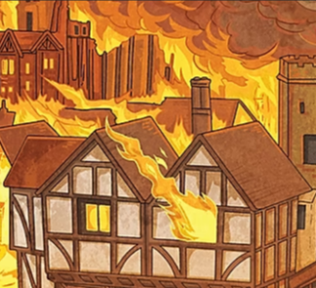  For our first history topic of Year 2, we will be focussing on the Great Fire of London! The children will learn all there is to know about how it started, what caused it and the impact of the fire. They will do this through engaging practical activities, as well as comparing life in the present to life in the 1600s.  We are also going on a school trip!
DT:  Cooking and Nutrition:  Breadmaking | P.E:  Agility, Balance and Coordination | Computing:  Digital Photography | PSHE:  Relationships | Music:  Whole class Singing and Performing | RE:  Light
The children will be making their own bread roll. They will learn about the history, where bread comes from and the process of making bread. They will learn the cooking skills that are needed for making a simple bread recipe, such a kneading and the hygiene involved. At the end of our unit, the children will get making and baking! | 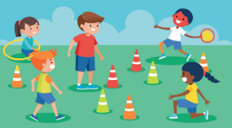  This half term we will be using balls and other equipment to develop hand-eye coordination, accuracy, and spatial awareness through games and working as a team. | Children will learn that devices can be used to capture photographs and will experience capturing, editing and improving photographs. Finally, they will use this knowledge to recognise that images they see may not be real | Children will develop their understanding of the importance of respectful relationships and think about what family means. They will explore how families can look different. They will think about how to be respectful and empathetic towards differences and how speaking to trusted adults when we have a worry. | Children will be learning to sing songs together, leading to a performance at the end of the half term. | In R.E this half term we will explore Light and how the Christians celebrate Christmas as a time for reflection.  The children will learn the Christmas story through video clips and discussions around the Christmas story and how this impacts Christians around the world today.
Helping at Home | Dates for the Diary and any other information
Here are some helpful reminders of the resources you can access at home to support your child’s learning and key vocabulary that we would encourage you to explore with your child to help them with their learning. | November  Monday 10th November – Odd Socks Day  Friday 14th November – Children in Need and World Diabetes Day  Wednesday 12th November 9.15am - Coffee Morning drop in with local support services  Friday 21st November – Bramham lights switch on choir  Tuesday 25th November - Progress Cafes (Y1,2,3) AM  Friday 28th November - INSET day - school closed to children.  December  Thursday 4th December – Year 2 History School Trip to Temple Newsam  Monday 8th December – KS1 dress rehearsals AM  Tuesday 9th December – KS1 Performance PM  Wednesday 10th December – KS1 Performance AM  Monday 15th December – Y1&2 Christmas party PM  Friday 19th December – last day of term - return Monday 5th January  Other ways to support at home:  Please help us by making sure that all school jumpers and cardigans are named so that those we find can be reunited easily with their owners.  Water Bottles  Please ensure that your child has a named water bottle in school every day. They must remember to take it home every evening to wash the bottle and bring it in to school already full. This will ensure that the bottles are kept clean and germ-free for the children’s use each day.  Fruit  There is a fruit/vegetable snack for every child at school during break time. Children are of course welcome to bring their own fruit snack if they prefer, however this should just be fruit or vegetable.  PE Wednesday afternoon.  PE may take place outside so please ensure that you send your child with appropriate kit, this needs to include a plain, black hoodie, plain black or grey shorts, leggings or joggers, coloured house T-shirt and trainers. Please refer to uniform policy if unsure.
  English | We would encourage all children to read for 15 minutes regularly.  (Please log what they have read in their reading record)  Reading at Home  Children will bring home three types of books to support their reading:  Core Read Write Inc. books – Practised at least three times in school before being sent home. Re-reading at home builds confidence and fluency while also giving them the chance to show off their reading success and celebrate with you.  Book Bag books – Matched to the Core Read Write Inc. book. They give children extra practice with the same sounds and themes.  Reading for Joy books – Chosen by your child to share and enjoy with you. Your child may not be able to read all the words yet, but these books help develop a love of reading through talking about the story, pictures, and ideas together.  Please note: All Read Write Inc books must be brought to school every day, as they are changed on weekly depending on when your child is ready for a new one. Reading for Joy books can stay at home until your child is ready to swap them.
  Maths | Online access to Numbots & Times Table Rock  Practise KIRF (key instant recall facts) at home: see above.
  Science | Living, non-living, never lived, food chains, habitats, shelter, alive, suitable.
  Computing | Portrait, landscape, focus, flash, camera, capture edit
  History | Fire, event, timeline, century, past, present, diary, source, eyewitness, evidence, architect, public health, monument, legacy.
  DT | Wheat, seed, harvest, grain, flour, dough, yeast, proof, knead, product, taste, design, hygiene, recipe, prepare, mix, shape, measuring, flavour
  PE | Teamwork, balance, hand eye coordination, agility
  PSHE | Resilience, empathy, differences, similarities, family
  Music | Pulse, rhythm, pitch, tempo
  RE | Light of the World, Advent, Advent Candles

Miss Alexandra

