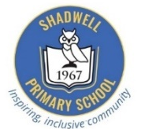
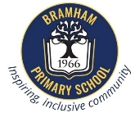
Bramham and Shadwell Federation
Curriculum Newsletter: Class 3 October – December 2025.
English | Maths | Science | History
Focus Units:  - Writing: Instruction Writing  To be able to produce their own instruction text, children will  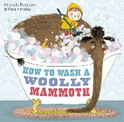  learn how to use features of instruction writing  such as:  - Imperative verbs  - Time conjunctions  - Prepositions  - Adverbs  Our focus text will be ‘How to Wash a Woolly Mammoth’ by Michelle Robinson, which links to our History topic ‘How did Britain change from the Stone Age to the Iron Age?’  - Writing: Grammar  Children will also take part in focused grammar lessons to consolidate Year 2 objectives and build confidence with new Year 3 concepts.  - Reading: Retrieval  Children will develop their comprehension of fiction and non-fiction texts, focusing on retrieving and inferring key information.  - Speaking and Listening:  Children will build confidence in speaking and listening through group discussions, presentations, and collaborative tasks. | Focus Units:  Addition and Subtraction:  The children will continue to develop their understanding of addition and subtraction using 2-digit and 3-digit numbers.  - Add and subtract numbers up to 3-digits  - Solve missing number problems and word problems  - Use inverse operations to check answers  Multiplication and Division:  The children will develop their understanding and confidence in multiplication and division by:  - Building fluency in multiplication and division facts for 2, 5, 10, 3, 4 and 8-times tables.  - Solve problems involving multiplication and division, including missing number calculations.  - Use arrays, number lines, and bar models to support understanding of multiplication and division concepts.  KIRF: To double and halve even numbers up to and including 100.  Encourage through questioning:  What is double… What is half of …  Divide by 2… Multiply by 2… | Focus: Rocks  Children will discuss the rock cycle, identifying how rocks are created and the different types of rocks.  We will take part in scientific experiments to name and categorise rocks using observations and will take part in practical investigations.  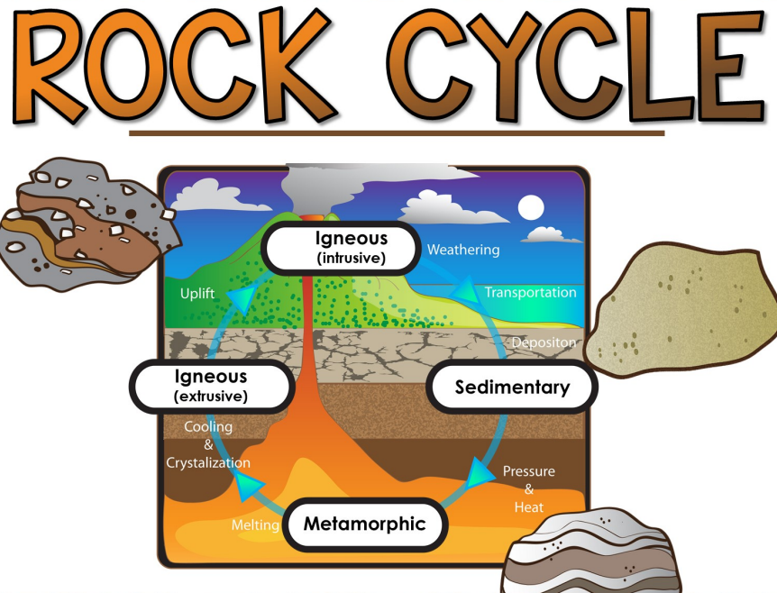 | Focus: How did Britain change from the Stone Age to the Iron Age?  This half term, children will be exploring the Stone Age, Bronze Age and Iron Age. Children will learn about these periods of history through role play and by exploring a range of historical sources, including a Stone Age themed launch! We will be learning what life was like in each time period, the difference and similarities between each, and how Britain changed in this time.

DT:  Structures - Pavillion | P.E: Agility, balance and coordination. | French: Classroom Instructions and Colours | Computing:  Creating media | PSHE:  Relationships and Sex Education | Music:  Singing and performing | RE:  How do Jews use stories to remember God’s covenant?  Advent
This half-term in DT, we are learning about structures and pavilions. We’ll explore existing designs, learn how to join and strengthen materials, and understand cladding and stability. Children will plan, design, and build their own pavilion, focusing on creativity, teamwork, and problem-solving. | Children will develop their skills with agility, balance and coordination through a variety of activities. This includes building hand-eye coordination and spatial awareness using different equipment. Through these exercises, children will gain better coordination, body awareness, and the ability to move safely. | Children will continue their learning by developing their understanding of classroom instructions in French. We will practice basic classroom instructions and try to integrate this into our day-to-day instructions. The children will also learn their French colours! | This half-term in Computing, we are learning how to create stop frame animations. Children will explore how a series of still images can be combined to make moving pictures. They will plan, capture, and edit their own short animation using digital tools, focusing on creativity, sequencing, and attention to detail. | We are learning about important people in our lives, building healthy friendships and family relationships, and respecting boundaries and consent. We will explore how to handle disagreements kindly, stay safe, and care for ourselves and others with respect, kindness, and confidence. | This half-term, children will explore singing and performance, developing their confidence and expression through a variety of songs. They will learn to use their voices, rhythms, and gestures to perform individually and in groups. These activities will also help improve listening skills, memory, and teamwork. | Children will continue to explore key customs and beliefs of the Jewish faith and how ideas about God are expressed in stories, celebrations and action.  Later in the half term, children will also learn about Advent. They will be deepening their understanding of the Christmas story and the traditions of advent.
Helping at Home | Dates for the Diary and any other information
Here are some helpful reminders of the resources you can access at home to support your child’s learning and key vocabulary that we would encourage you to explore with your child to help them with their learning.  Homework is given out on a Thursday to be returned the following Tuesday. Please encourage your child to discuss their homework at home in order to help them develop their explanation and reasoning skills. Children will be set an optional Learning Log activity once during every half term. This will be related to the Enriched Curriculum. On weeks when this is set, it will replace the Maths and English homework.  Other ways to support at home:  - Storytelling and Plays: Encourage children to act out stories or put on little plays using different voices. This builds comprehension, creativity, and understanding.  - Organising Tasks: Let children organise their toys, books, or clothes. This helps them build independence and learn to plan. | Our PE day will be on a Thursday. Please could children come into school in their PE kit on this day.  Monday 10th November – Odd Socks Day  W/c 10th November – Anti-bullying Week  Friday 14th November – Children in Need  Wednesday 12th November- 9.15am - Coffee Morning drop in with local support services.  Friday 21st November – Bramham lights switch on choir.  Tuesday 25th November AM - Progress Cafes (Y1,2,3) · Wednesday 26th November AM - Progress Cafes (Y4,5,6) Friday 28th November - INSET day.  Friday 12th December – KS2 Carol Concert at the Church  Wednesday 17th December – Y3 Christmas Party  Friday 19th December – Last day of term.  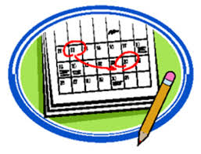
  English | Weekly English homework  Please support your child in reading for 15-minutes at least three days a week.  Key vocabulary: instructions, imperative verbs, adverbs, time conjunctions, chronological order. Handwriting – ascender, descender, line orientation, posture.
  Maths | Weekly maths homework  Online access to TT Rockstars– Times Tables Rock Stars – Times Tables Rock Stars  Key Vocabulary: Digit, Hundreds, Tens, Ones, multiply, times, product, groups of, array, divide, sharing, equally, factor, multiple, commutative.
  Science | Key vocabulary: Igneous, sedimentary, metamorphic, mineral, fossil, sediment, erosion, weathering, permeable, impermeable, durability.
  Geography | Key vocabulary: prehistory, archaeologist, artefact, nomad, settlement, palaeolithic, neolithic, Mesolithic, tribe, hillfort, domesticate, farming, Skara Brae, Stonehenge.
  DT | Key vocabulary: design, product, function, stability, purpose, joint, measure, construct.
  PE | Key vocabulary: agility, coordination, speed, reaction, timing, control, centre of gravity.
  French | Key vocabulary: French Colours BBC Bitesize Link  What are the different colours in French? - BBC Bitesize.
  Computing | Key vocabulary: animation, sequence, transition, storyboard, capture, stop frame, edit, playback, software.
  PSHE | Key vocabulary: emotion, empathy, cooperation, consent, comfortable, conflict, trusted adult, bullying, apology, reconciliation.
  Music | Key vocabulary: pitch, tune, melody, breathing, dynamics, tempo, unison.
  RE | Key vocabulary: customs, beliefs, stories, understanding, advent, tolerance, celebrations.

