Newsletter Autumn 1:1
We will be thinking about what this means and what in our lives, we need for friendship.
Attendance: 99% - Target 96%
Value of the Month – Friendship
Dear Parents and Guardians,
We are delighted to welcome you and your children back to Bredenbury for the start of a new academic year. We hope you enjoyed a restful break, and we are pleased to share that our students have settled into their new classes with enthusiasm and confidence.
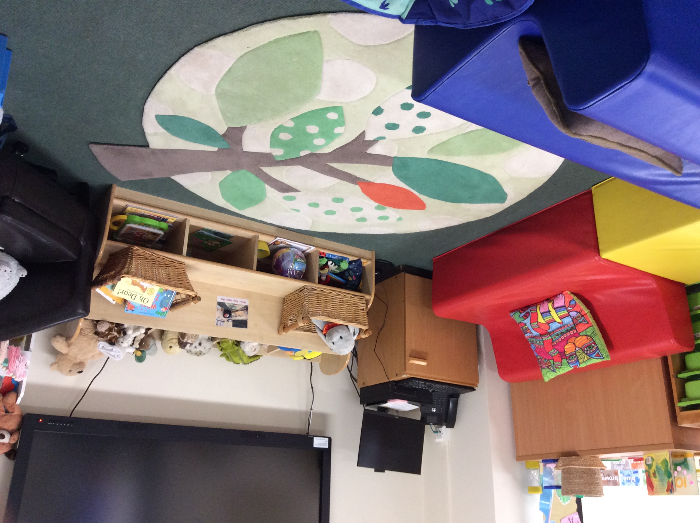
We are also very pleased to announce that our new Nursery for 3 and 4 year olds will be opening on Monday. We are awaiting confirmation for the start date for 2 year olds but it will be very soon. We are greatly looking forward to welcoming the youngest members of our school community and supporting them as they take their very first steps in their education
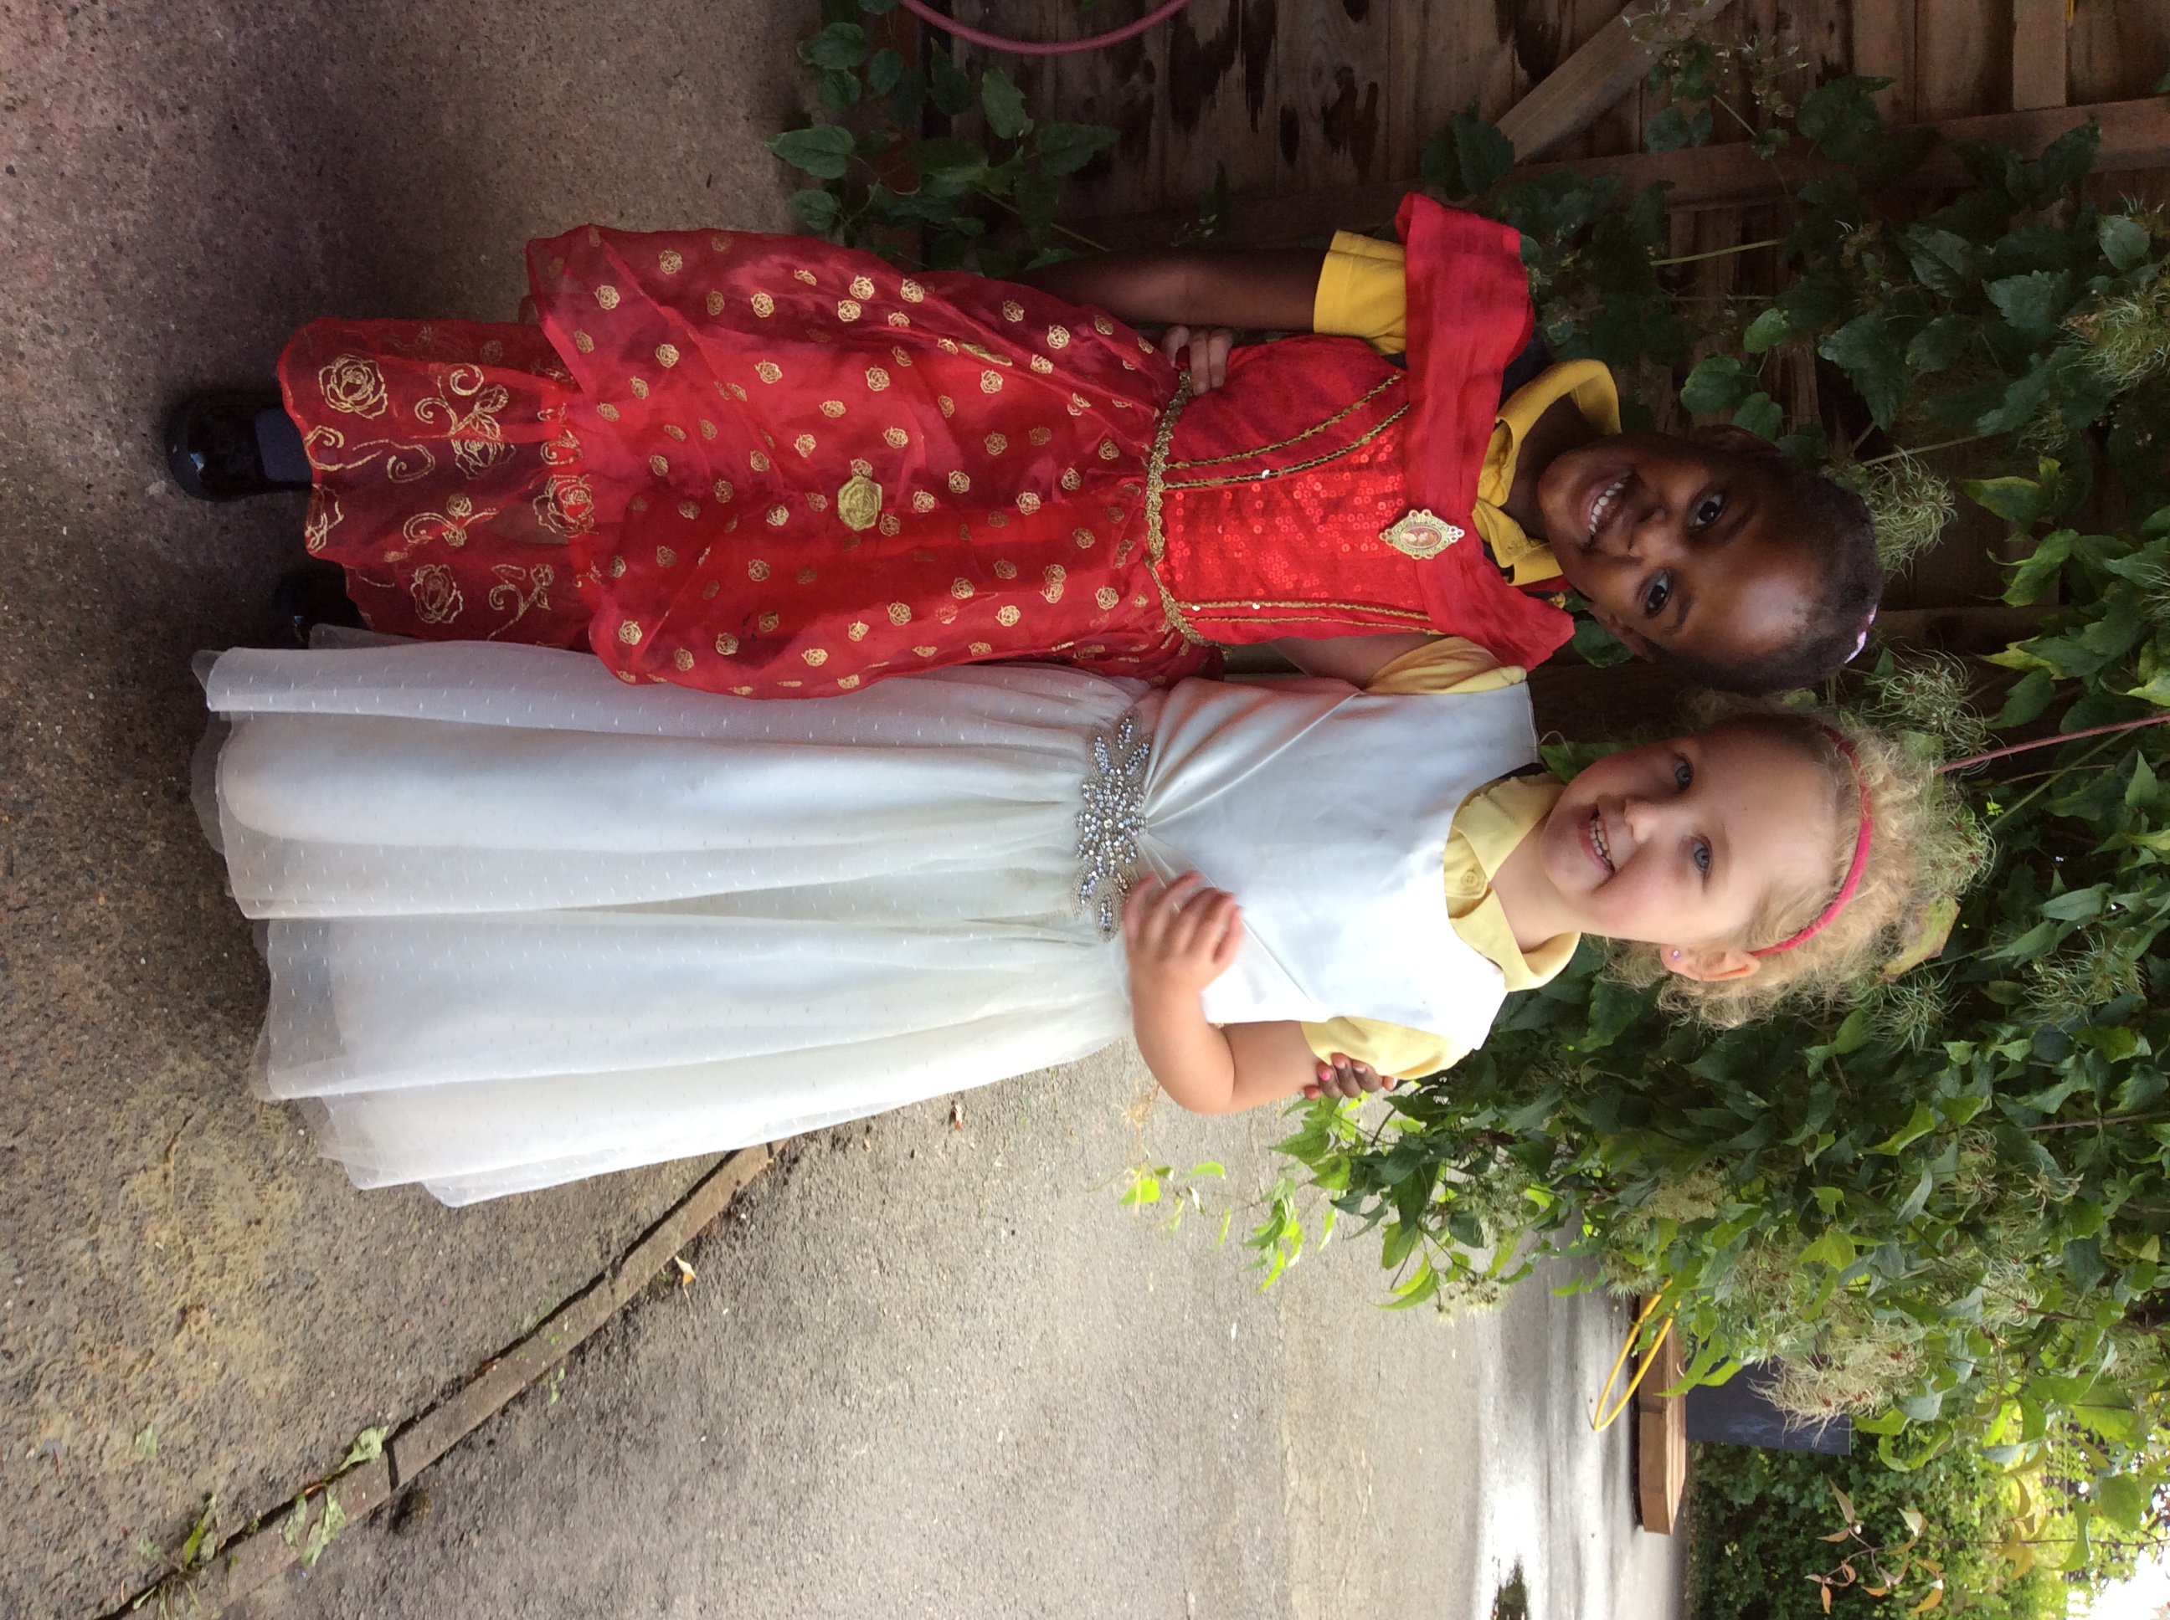
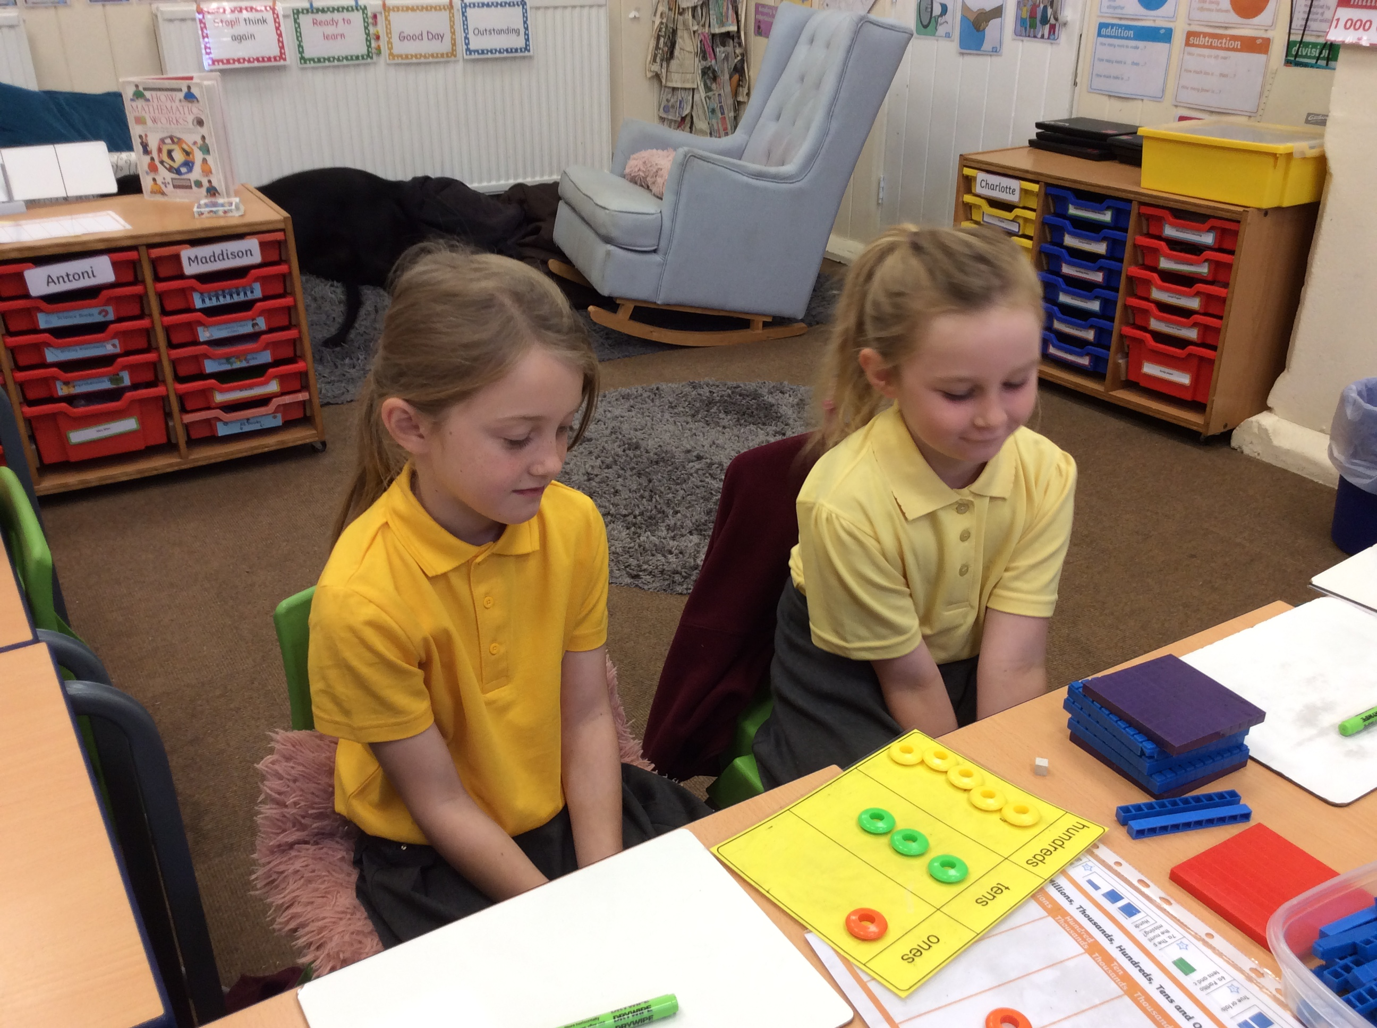
Maths in class 2

Dressing up at playtime Nursery reading area awaiting children

Monday 8th September | Nursery for 3-4 year olds opens  Muddy Monday – class 1 forest school  Afterschool clubs – Story Time – KS1
Tuesday 9th September | Class 1 PE – kit required  Class 2+3 PE – kit required  After school clubs – Football – KS1 and KS2  Art Club – KS1
Wednesday 10th | School photos
Thursday 11th | After school club – Hockey -KS2
Friday 12th | Forest school – class 2 and 3  Class 1 PE – kit required

This month we are celebrating ‘snack – tember’ we will be talking to the children about healthy snacks and keeping fit. There will be a snack making event on the 17th September which parents and carers will be invited to.

Stoke Bliss Annual Ploughing match – Saturday 20th September

Every year the pupils send entries into the various competitions run as part of this event. These, we do in school. This year there is opportunity for the children to do some extra bits at home that can then be brought into school for submission.
Reception – Decorate a hard-boiled egg
Class 1 – Decorate a stone
Class 2 – A seaside in a shoe box
Class 3 – An origami animal
All entries to be returned to school by the morning of Wednesday 17th September.

PE
This year we would like all children to bring their PE kit to school and change in school. PE kits can then be left in school.
This term class 2+3 have PE on a Tuesday and Class 1 have PE on Tuesday and Friday.

Forest School and Muddy Monday
Forest school and Muddy Monday will take place every other week. Children will need to come to school dressed for their session. Please bring wellies and waterproofs in a separate bag.

Dates for your diary (Letters to follow):

Wednesday 17th September – an afternoon of making healthy snack, parents welcome – 1:30pm-3:00pm.

All events will have individual letters as appropriate.

Photos (where possible) for all school events are on Facebook.
Parking – can we please ensure we do not park across residents drives.

Regards,
Samantha McAtear,
Head of School,
Bredenbury Primary School

