Newsletter Autumn 1:2
We will be thinking about what this means and what in our lives, we need for friendship.
Attendance: 98% - Target 96%
Value of the Month – Friendship
Dear Parents and Guardians,
We’ve had a wonderful first full week back at school! The classrooms and playgrounds are buzzing with energy as children settle into new routines, reconnect with friends, and dive into their learning.
Nursery Officially Open
This week also marks a very special milestone – the official opening of our Nursery! It has been such a joy to welcome our youngest learners into the school community. They’ve already been busy exploring, playing, and building new friendships. A huge thank you to our staff and families who have helped make this such a smooth and exciting start.
Class 1 have been exploring Handa’s Surprise, using it to inspire their reading, writing, and learning about fruits from around the world.
Class 2 are working really well on their states of matter topic. Tuesday, they had fun investigating melting of ice cubes at different temperatures.
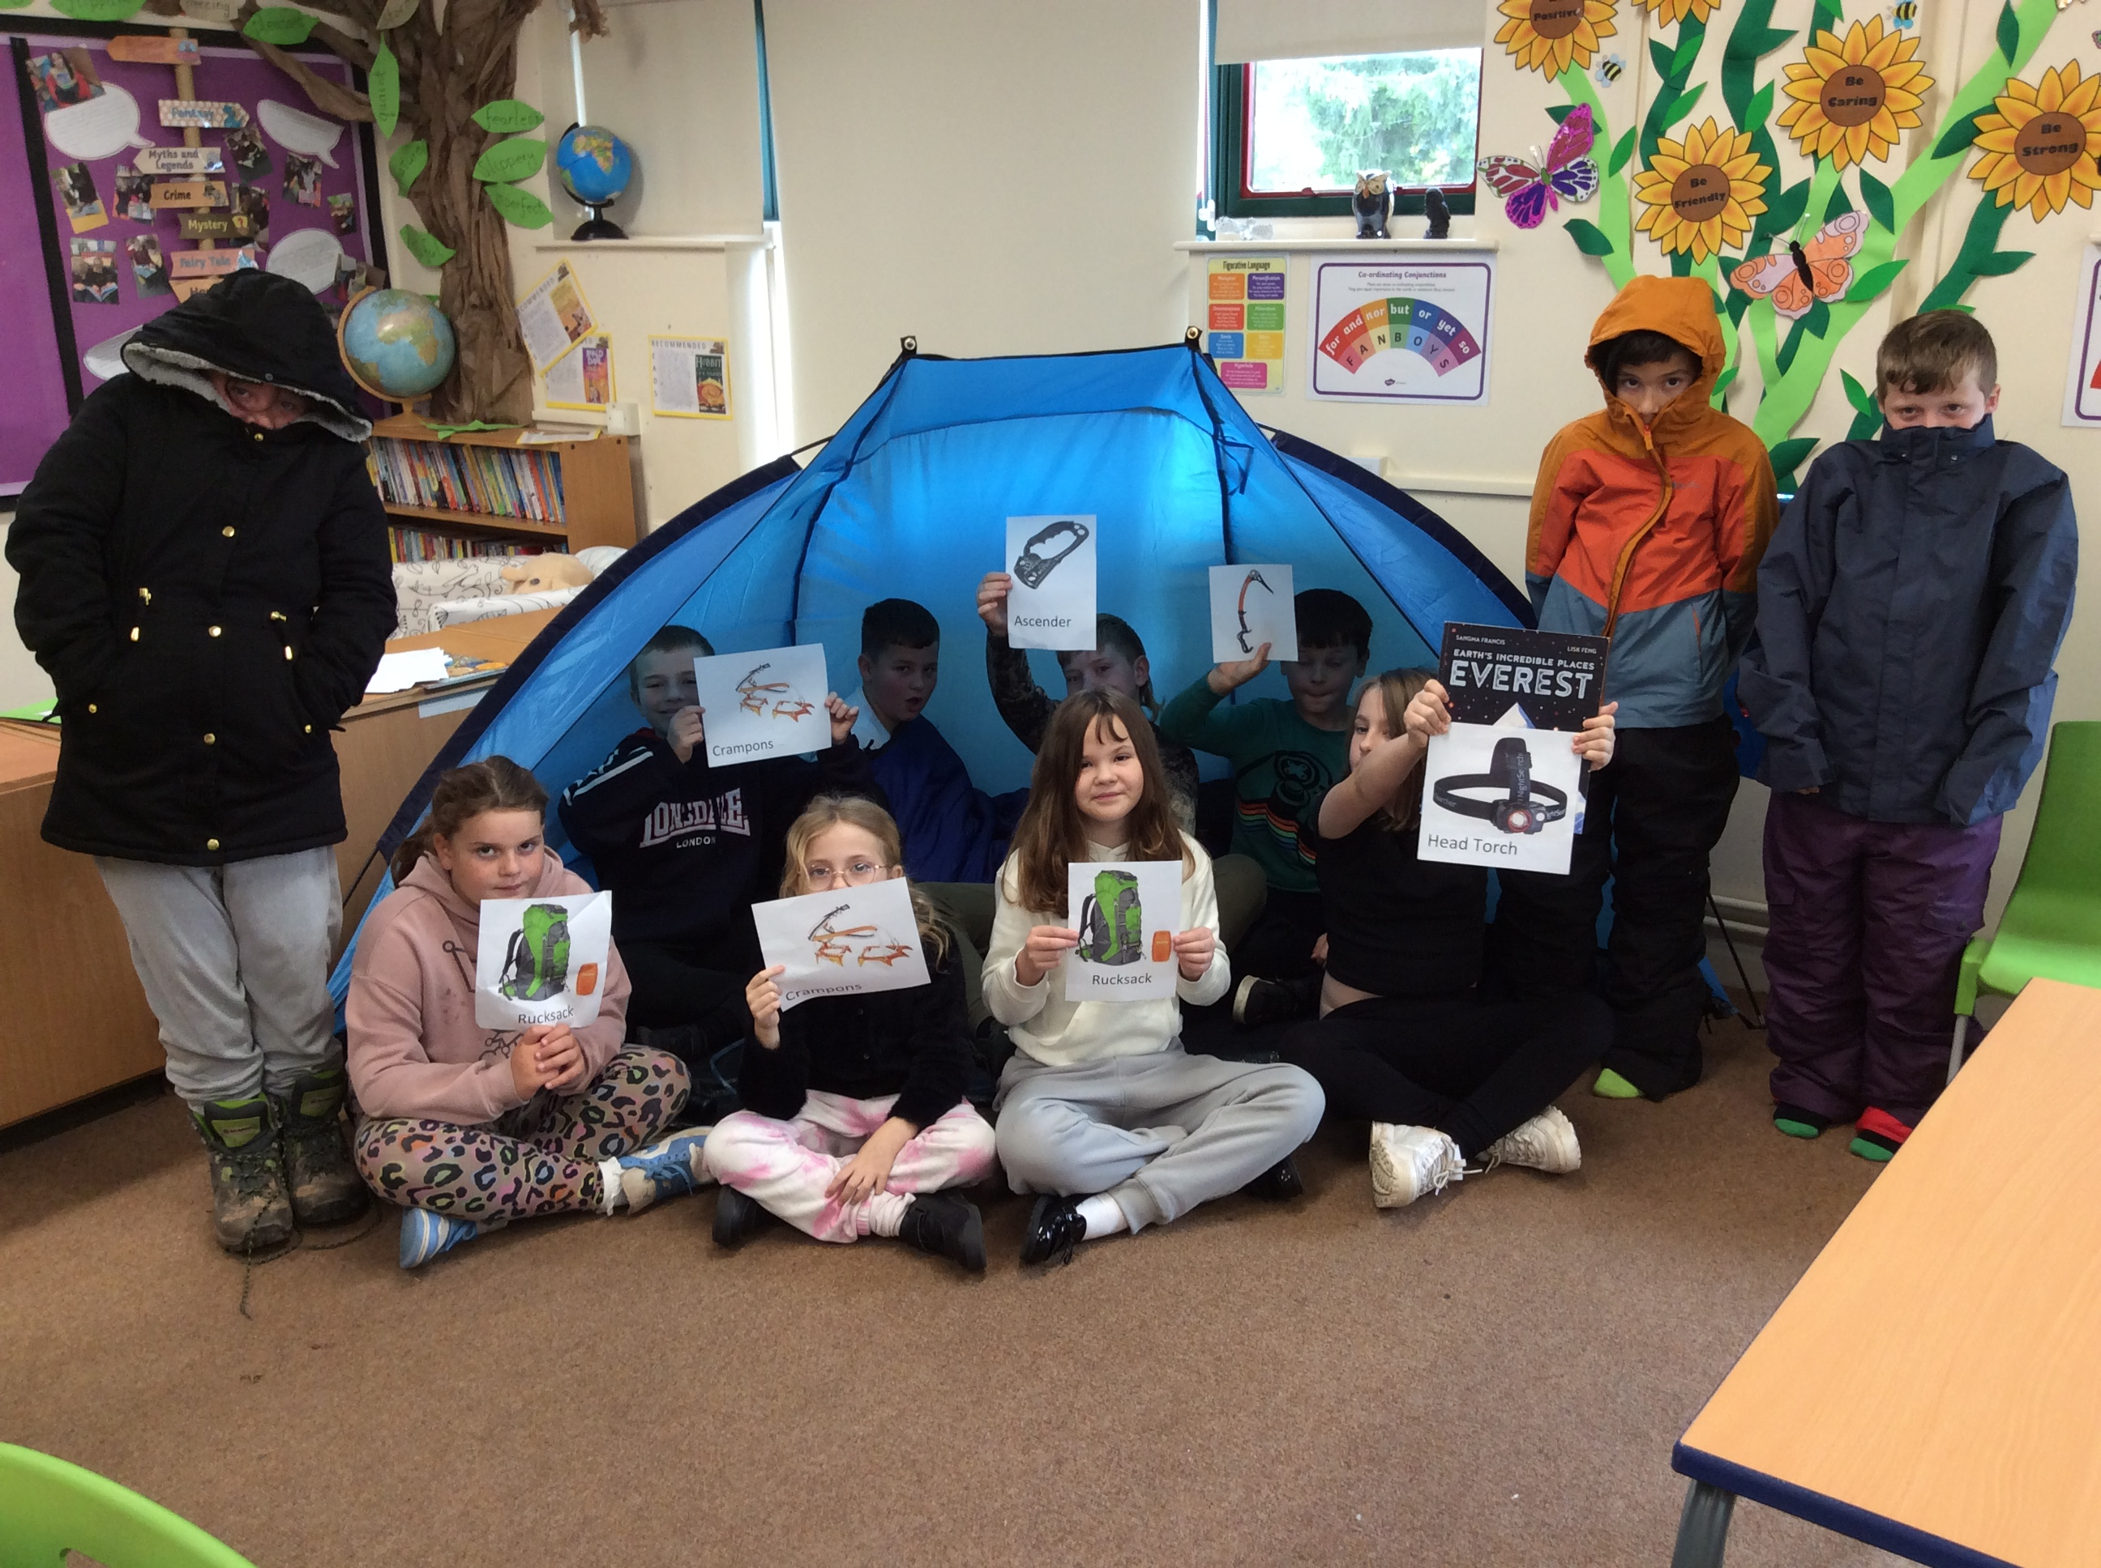
Class 3 have started a new topic Mount Everest. During their English lessons, they have been starting to write a non-chronological report on the mountain thinking about ways to describe it and entice people to visit it. Children have put themselves in the shoes of a climber thinking about what equipment they would need to climb such a mountain. In Geography, the class have been researching mountain ranges of the world and the highest peaks in each mountain range.
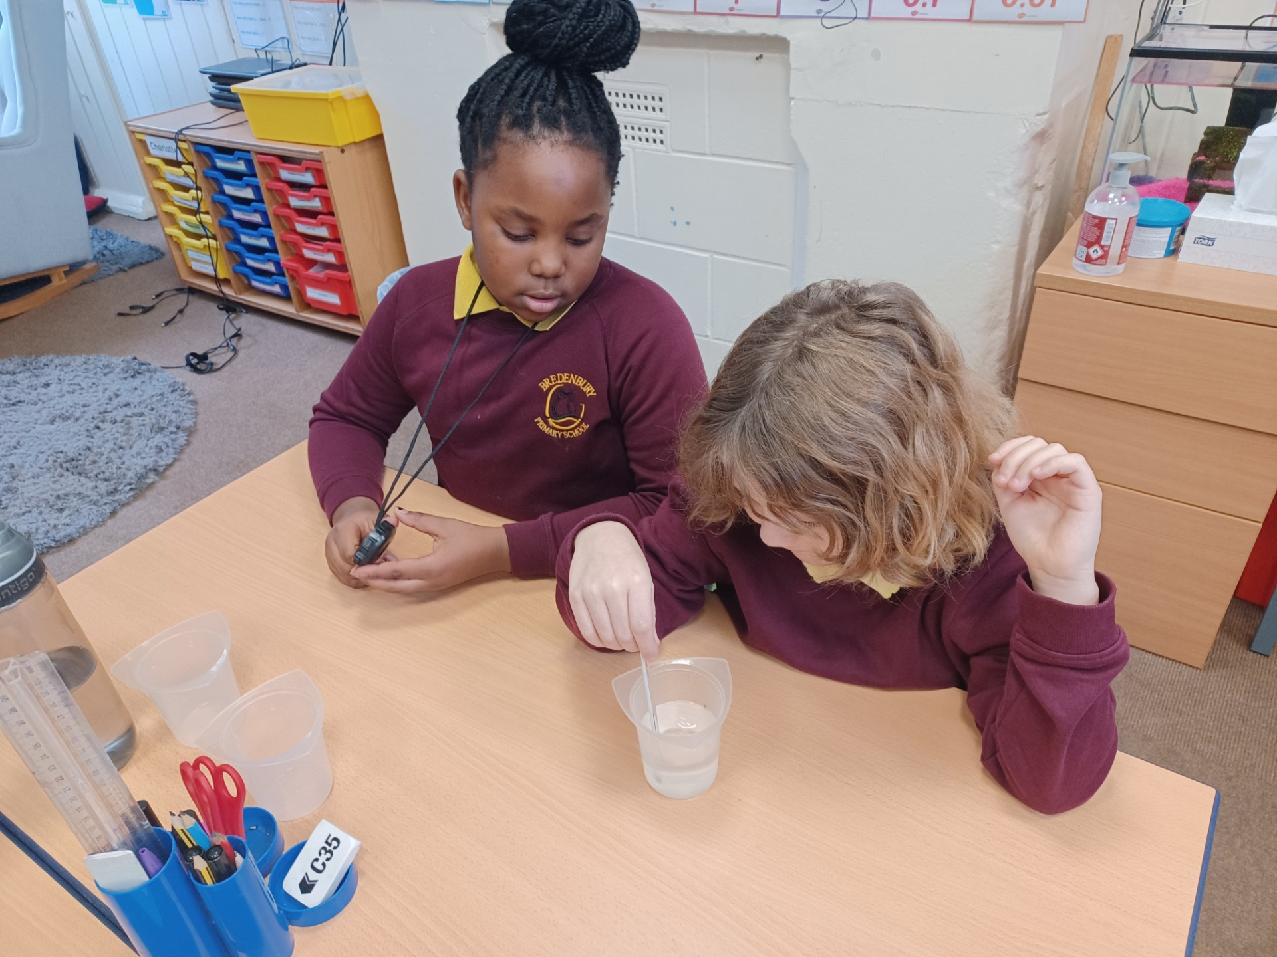
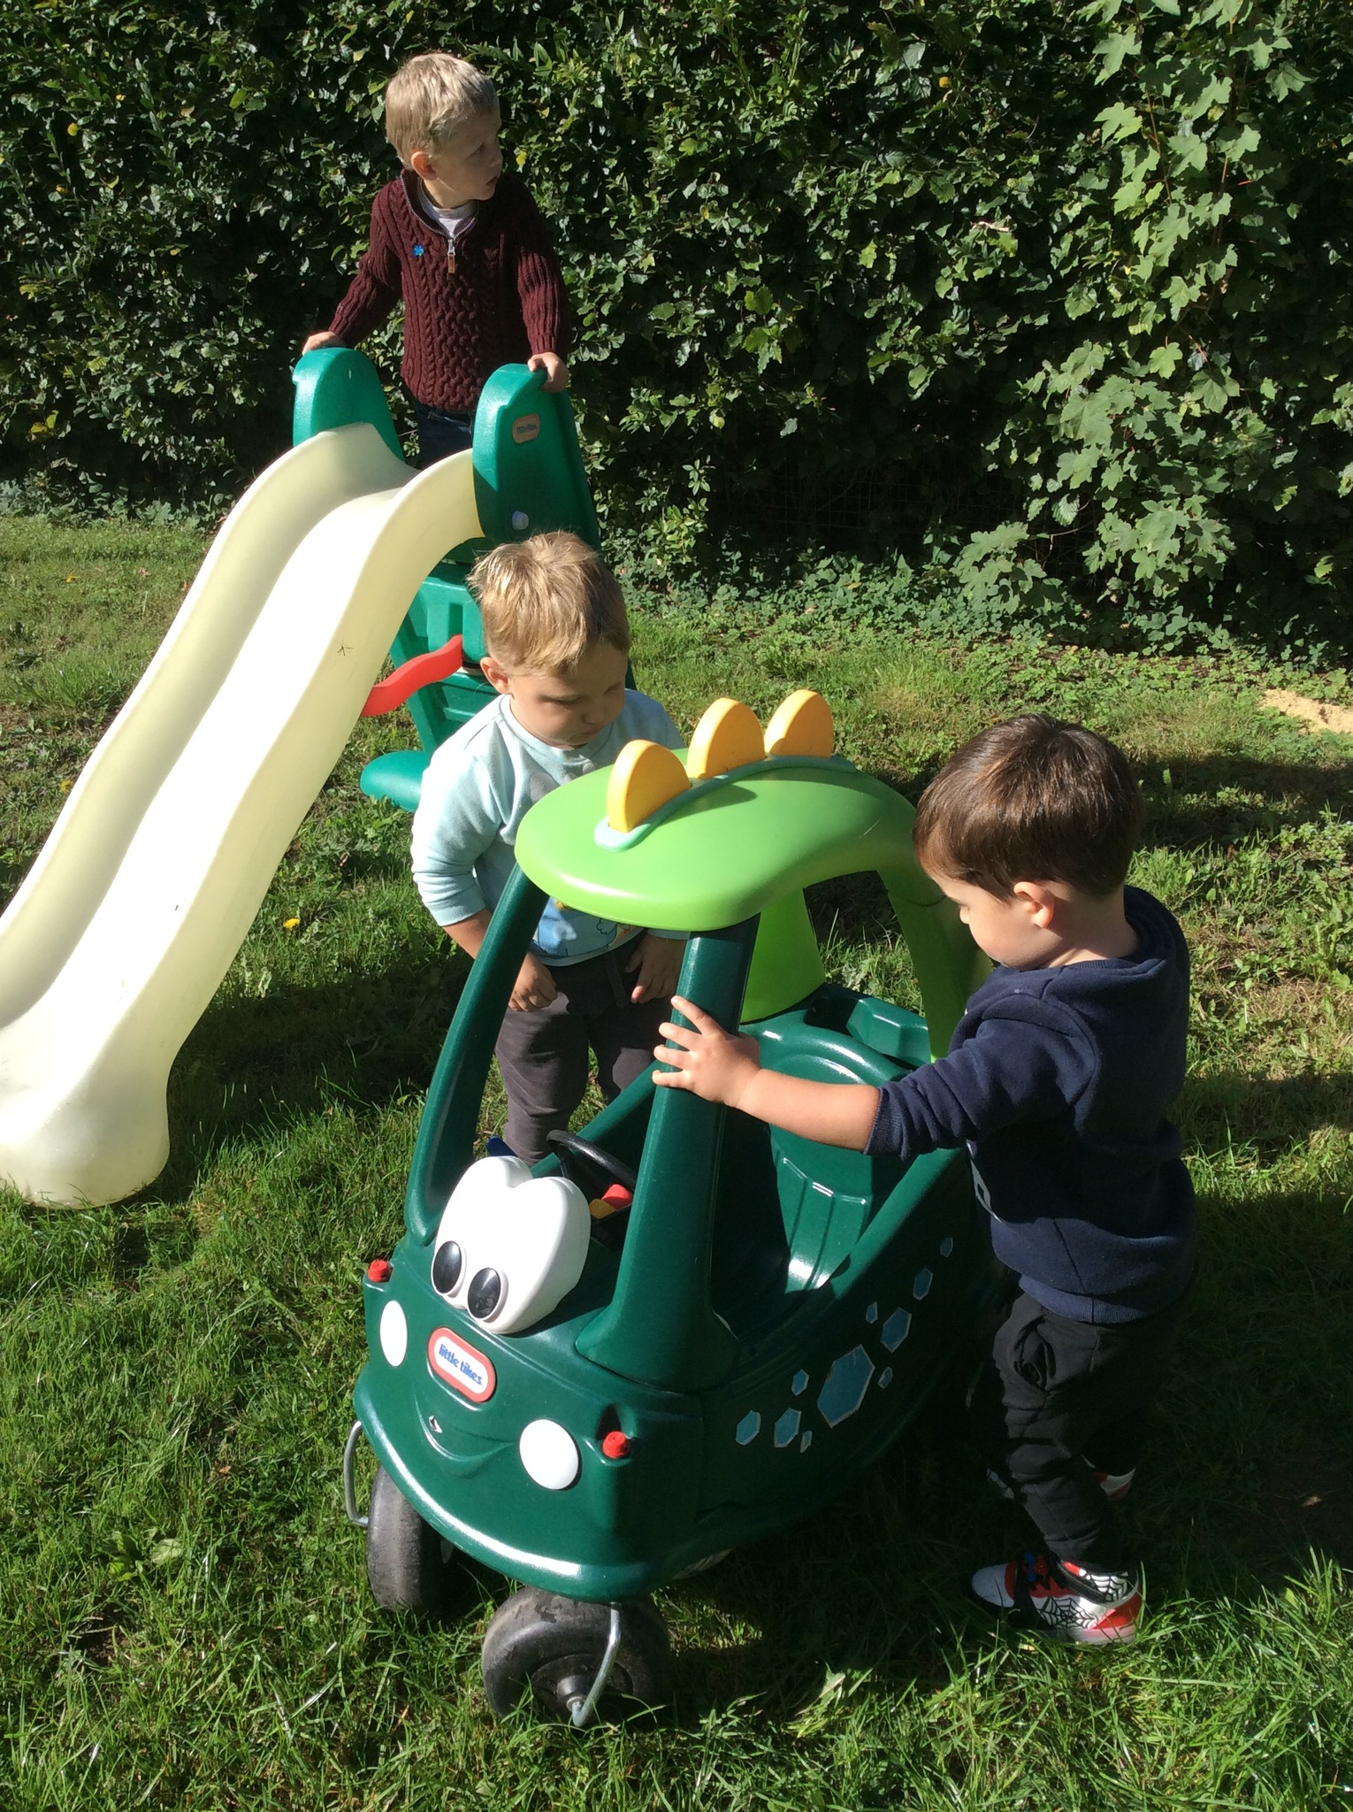
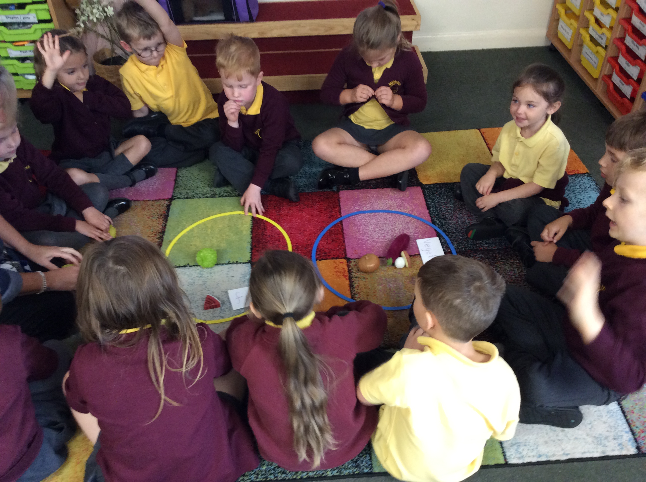

This month we are celebrating ‘snack – tember’ we will be talking to the children about healthy snacks and keeping fit. There will be a snack making event on the 17th September which parents and carers will be invited to.

Monday 15th September | Nursery for 2 year olds opens  Afterschool clubs – Story Time – KS1
Tuesday 16th September | Class 1 PE – kit required  Class 2+3 PE – kit required  After school clubs – Football – KS1 and KS2
Wednesday 17th
Thursday 18th | After school club – Hockey -KS2  Art Club – KS1
Friday 19th | Class 1 PE – kit required
Stoke Bliss Annual Ploughing match – Saturday 20th September
Every year the pupils send entries into the various competitions run as part of this event. These, we do in school. This year there is opportunity for the children to do some extra bits at home that can then be brought into school for submission.
Reception – Decorate a hard-boiled egg
Class 1 – Decorate a stone
Class 2 – A seaside in a shoe box
Class 3 – An origami animal
All entries to be returned to school by the morning of Wednesday 17th September.

PE
This year we would like all children to bring their PE kit to school and change in school. PE kits can then be left in school.
This term class 2+3 have PE on a Tuesday and Class 1 have PE on Tuesday and Friday.

Dates for your diary (Letters to follow):

Wednesday 17th September – an afternoon of making healthy snack, parents welcome – 1:30pm-3:00pm.

All events will have individual letters as appropriate.


Photos (where possible) for all school events are on Facebook.
Parking – can we please ensure we do not park across residents drives.
This is the new link to our school website. Please take a look, we value any feedback you can provide us with. There are lots of photos of your children on their class photo pages.
Regards,
Samantha McAtear,
Head of School,
Bredenbury Primary School

