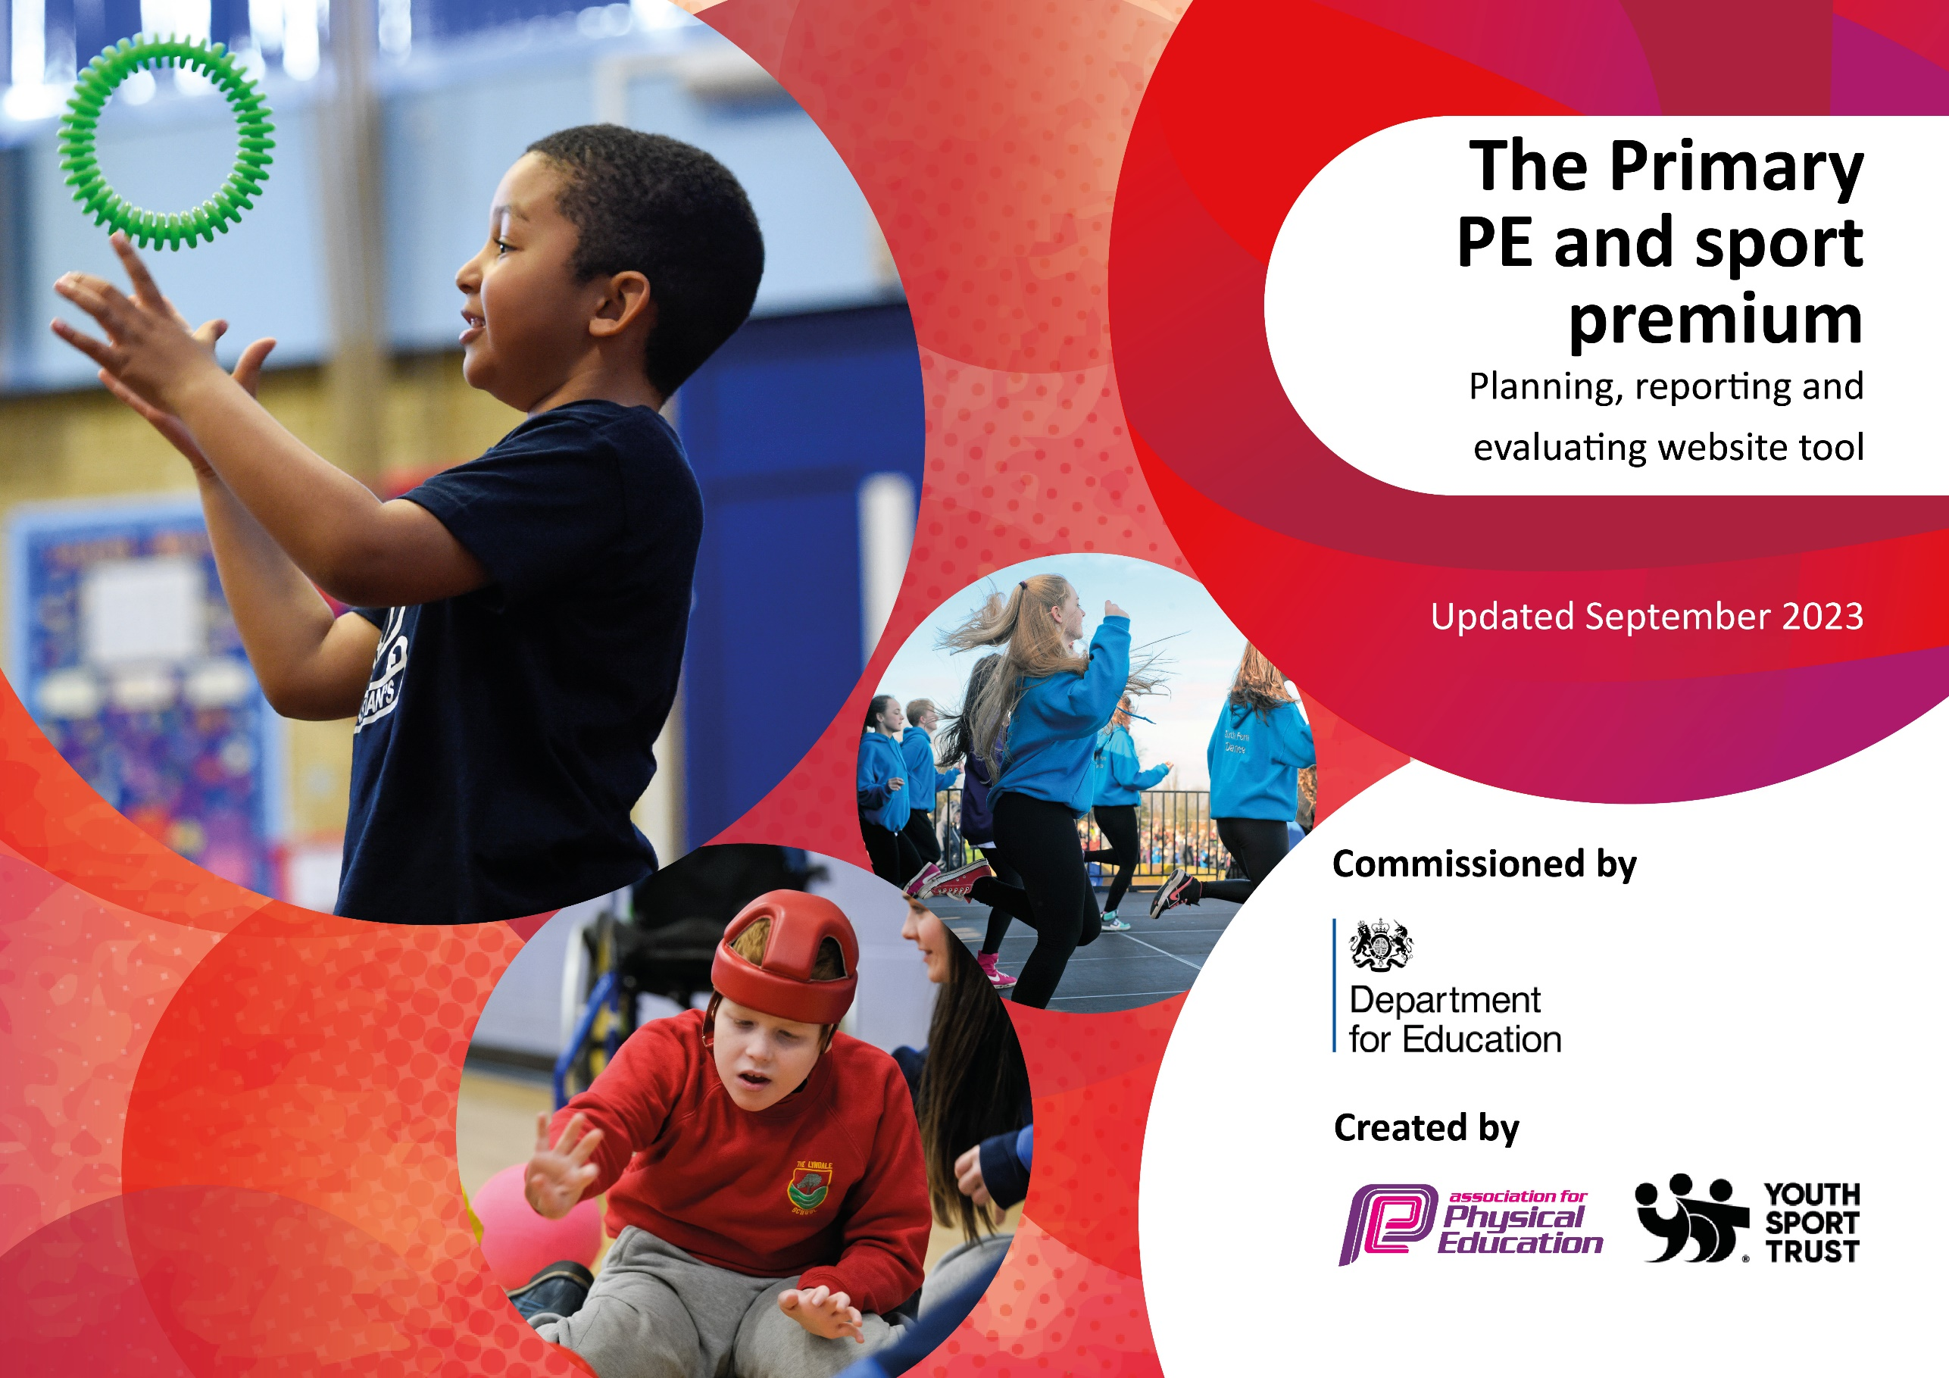

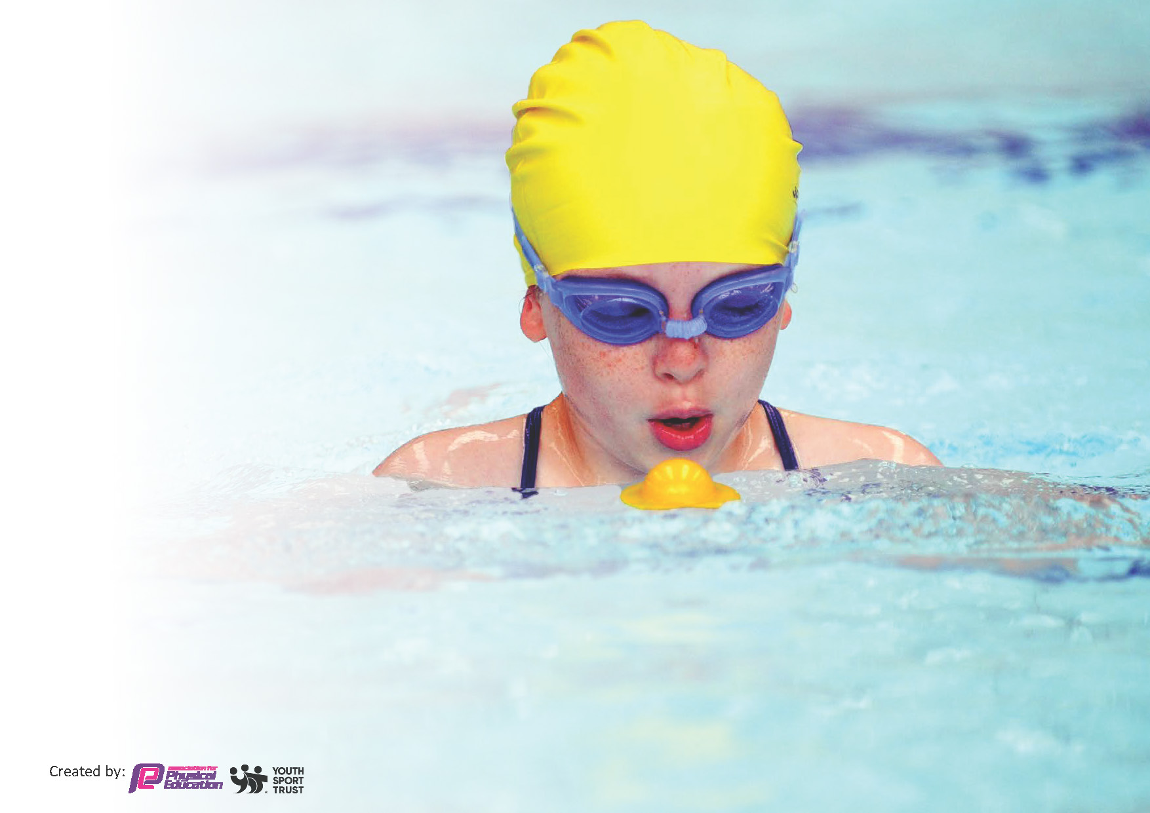
This template can be used for multiple purposes:
by:
- It enables schools to effectively plan their use of the Primary PE and sport premium
- It helps schools to meet the requirements (as set out in guidance) to publish information on their Primary PE and sport premium
- It will be an effective document to support Ofsted inspections enabling schools to evidence progress in Physical Education (PE) and evidence swimming attainment, which forms part of the PE National Curriculum. We would recommend schools consider
the Intent, Implementation and Impact of any spend, as examined within the Education Inspection Framework.

It is important that your grant is used effectively and based on school need.

Schools must use the funding to make additional and sustainable
improvements to the quality of the PE, School Sport and Physical Activity (PESSPA)
they offer. This means that you should use the Primary PE and sport premium to:

- Build capacity and capability within the school to ensure that improvements made now will benefit pupils joining the school in future years
- Develop or add to the PESSPA activities that your school already offers.

The Primary PE and sport premium should not be used to fund capital spend projects; the school’s core budget should fund these. Further detail on capital expenditure can be found in the updated Primary PE and sport premium guidance.

The Primary PE and sport premium guidance, outlines 5 key priorities that funding should be used towards. It is not

necessary that spending has to meet all the key priorities, you should select the priorities that you aim to use any funding towards.

Although completing this template is not a requirement for schools, schools are required to publish details of how they spend this funding. Schools must also outline what the impact this funding has had on pupils’ PE and sport participation and attainment and how any spending will be sustainable in the future. All funding must be spent by 31st July 2024.

The Department for Education has worked closely with the Association for Physical Education (afPE) and the Youth Sport Trust (YST) to develop this template and encourages schools to use it. This template is an effective way of meeting the reporting requirements of the Primary PE and sport premium.
Review of last year’s spend and key achievements (2022/2023)

We recommend you start by reflecting on the impact of current provision and reviewing your previous spend.

Activity/Action | Impact | Comments
Increment of various sporting tournaments throughout the year.  Sports coaching to Staff  Increase in the variety of sports activities | Wider range of sports activities and opportunities for pupils to participate enabling pupils to experience competitions and learn new skills.  Improving sustainability of quality provision.  Activities in and out of school provided for all year groups (R-6) so that pupils can engage in regular physical activity. Also, provides opportunity for pupils to find out if they are good at different sports. Encourages team working. | 22/23 Funding = £16,420  Overall, the PESSA provision here at St Peter’s Primary is excellent. We have a broad curriculum that pupils report as enjoying and feeling confident in, with high quality teaching and learning. We have a vibrant and varied co-curricular provision that is well attended, especially by SEND pupils. We enter the majority of competitions and our pupils have many opportunities to participate in school sports, either through afterschool club participation and/or competitions.

Key priorities and Planning
This planning template will allow schools to accurately plan their spending.

Action – what are you planning to do | Who does this action impact? |  | Key indicator to meet | Impacts and how sustainability will be achieved? | Cost linked to the action
Introduce a new assessment policy for physical education to monitor pupil progress and highlight specific strengths and weaknesses with the topics delivered. |  | Physical education co-ordinator and head teacher to research and discuss best options for assessment  Revise assessment policy | The completion of a new assessment and feedback procedure that supports the learning outcomes.  2. Engagement of all pupils in regular physical activity.  3. Profile of PE and sport is raised across the school. | Marking policy in the process of being updated. | £2,000
All staff to consistently use the assessment policy to inform learning of physical education. |  | Inform staff on the criteria for physical education assessment and conduct CPD for assistance if necessary. | All staff to use and keep up to date the assessment spreadsheets and to upload to the physical education folder on common staff  Key Indicator 1: Increased confidence, knowledge, and skills of all staff in teaching PE and sport.  3. Profile of PE and sport is raised across the school. | Implementation of new policy mostly in use but ongoing support and reminders needed. | £ 270
Encourage support for physical education from parents and carers and inform them about sporting events and clubs on offer to their children. | Parental engagement: notices, regular contact through seesaw and the school website.  Physical education newsletter updates  Give a wide variety of clubs for sporting opportunities to cater for all learners | Positive feedback from staff and parents.  3. Profile of PE and sport is raised across the school.  4. Broader experience of a range of sports and activities offered to all pupils.  Key indicator 5: Increased participation in competitive sport. | Ongoing communication with parents and carers about the variety of clubs and activities available to learners each term and the successes of these through communication outlets such as seesaw and newsletters. | £10,000
Ensure a support staff member is present in all year groups, for safety, staff ratios and to ensure that high expectations and challenge are met to allow learners to achieve their potential in physical education. | CPD meeting from county school games officers to co-ordinate and put procedures in place for next academic year (24-25).  Communicate with support staff to organise assistance in the meantime, if desperately required. | A support staff member present will ensure more efficient differentiation to the higher and lower ability learners, by assisting with behaviour issues and first aid eventualities.  Accurate assessment will ensure all teachers are able to challenge all children, particularly higher ability children, to achieve at higher levels.  3. Profile of PE and sport is raised across the school.  Key indicator 5: Increased participation in competitive sport. | CPD meeting in place with SGO. | £2,500
To further challenge learners and enhance skills with opportunities of inter and intra competitions. | Liaise with SGO’s to enable learners a range of opportunities for intra competitions.  Create connections with local schools to allow opportunity for inter competitions. | Communicate frequently with school games offices for up to date events happening in the county.  3. Profile of PE and sport is raised across the school.  4. Broader experience of a range of sports and activities offered to all pupils.  Key indicator 5: Increased participation in competitive sport. | In contact with Kieram and Beky on a regular basis to ensure learners receive every opportunity available, through physical education.  Email addresses of local schools sourced. | £1,500

Key achievements 2023-2024
This template will be completed at the end of the academic year and will showcase the key achievements schools have made with their Primary PE and sport premium spending.

Activity/Action | Impact | Comments
 |  | 23/24 PE Funding = £16,270

Swimming Data
Meeting National Curriculum requirements for swimming and water safety.
Priority should always be given to ensuring that pupils can perform safe self-rescue even if they do not fully meet the first two requirements of the National Curriculum programme of study

Question | Stats: | Further context  Relative to local challenges
What percentage of your current Year 6 cohort can swim competently, confidently and proficiently over a distance of at least 25 metres? | 67%
What percentage of your current Year 6 cohort can use a range of strokes effectively [for example, front crawl, backstroke, and breaststroke]? | 67%

What percentage of your current Year 6 cohort are able to perform safe self-rescue in different water-based situations? | 83%
If your schools swimming data is below national expectation, you can choose to use the Primary PE and sport premium to provide additional top-up sessions for those pupils that did not meet National Curriculum  requirements after the completion of core lessons. Have you done this? | No
Have you provided CPD to improve the knowledge and confidence of staff to be able to teach swimming and water safety? | Yes

Signed off by:

Head Teacher: | Mr Martin Farmer
Subject Leader or the individual responsible for the Primary PE and sport premium: | Miss Rebecca Jinks, PE Coordinator
Governor: | Peter Gallagher
Date:

