We will be thinking about what the children could do to show how important others are to them.
Newsletter Spring 1:4
Attendance: 96.7% - Target 96%
Value of the Month - Love

There has been lots of interest in the clubs after the letter went out this week ready for next half term. Thank you to all staff for running them. There will be an addition of Basketball on a Friday as most of the children would like to carry on and there are a few children that I am aware of that would like to join. This week the children had a strange visitor in the form of an otter that had been knocked down, there was numbers day yesterday and lots of clubs. My highlight of the week was seeing children in breakfast club randomly build sculptures using the rock my class have been looking at in Science.
Thank you James and George O for helping me sort out the computers.
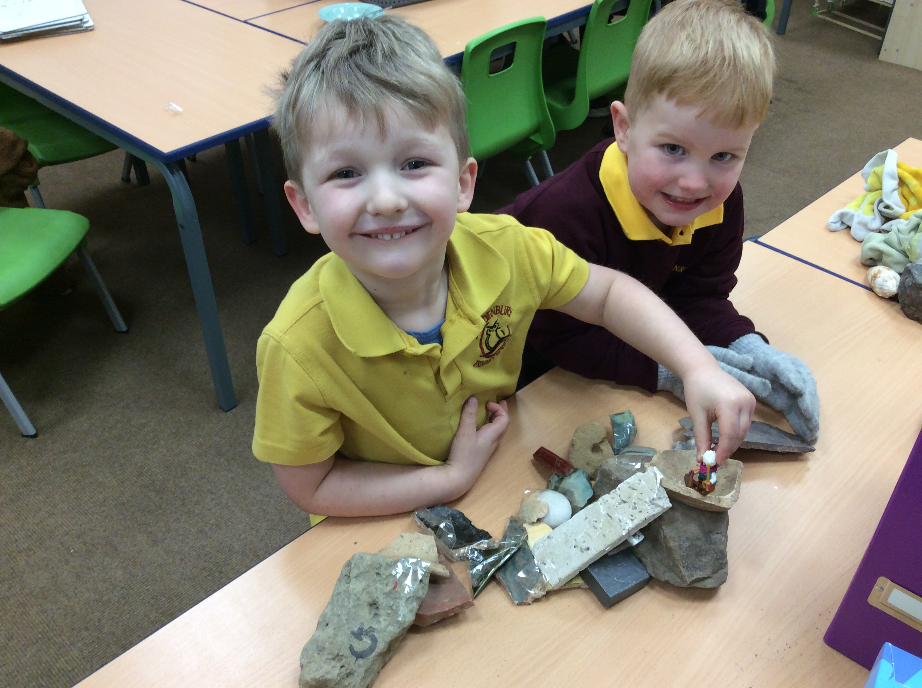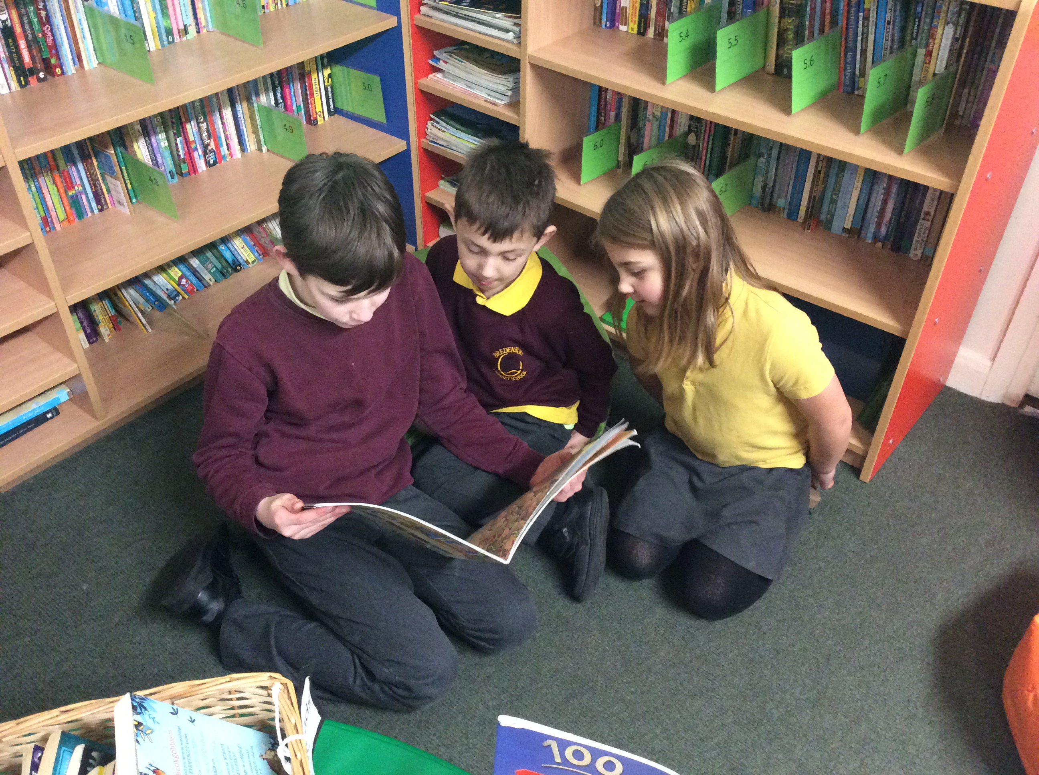
The children are all still really enjoying their shared reading. Class 2 next half-term!
Photos (where possible) for all school events are on face book.
Next week:
Monday 10th | Muddy Monday – class 1  After school club – Baking – KS2
Tuesday 11th | After school club – Football – KS1/KS2
Wednesday 12th
Thursday 13th | Rainbow disco – 3:30pm – 5pm. Children can come to school in their rainbow clothes. Refreshments provided by the PTA. I will send out a letter Monday so that you can confirm if your child is attending and provide an emergency contact number.
Friday 14th | Forest School – classes 2 and 3  Class 1 PE – Yoga – Kit not required Class 2 and 3 PE – Kit required  After school club - Minibeast crafts – KS1
Dates for your diary:
Monday 17th February is half-term.
PTA meeting Wednesday 5th March 3:30pm
Parents Evening 12th and 13th March
Pleasure ensure your child wears a warm coat and sweatshirt, hoodie or cardigan to school as it is particularly cold at the moment.

Regards, Samantha McAtear, Head of School, Bredenbury Primary School

