Spring Newsletter 1:4
We will be thinking about what this means and what in our lives, we need to be self aware
Attendance: 95.7% - Target 96%
Value of the Month – Self Awareness
Dear parents and carers,
As we head into the final week before half term, excitement is building for our upcoming Rainbow Colour Disco. Despite a wet and gloomy week, the children have remained enthusiastic and engaged in their learning, with one class even making the most of a rare sunny afternoon to take their work outside. It’s been a positive and productive week across the school.

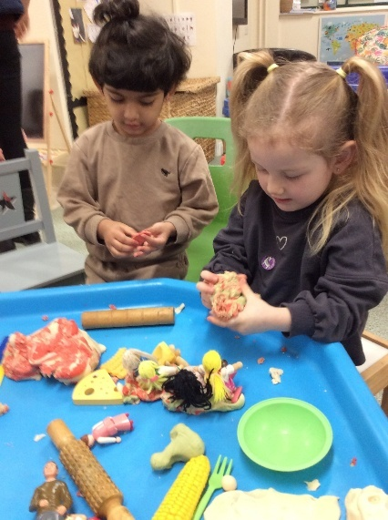

This week Nursery have been celebrating National Storytelling Week by exploring the classic story Little Red Riding Hood.

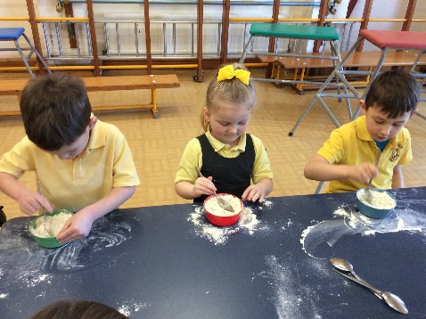
On Wednesday, Class 1 made their own playdough that the early years then used for ‘dough disco’
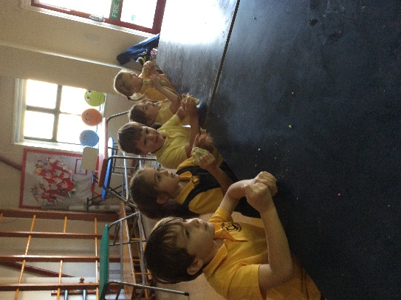

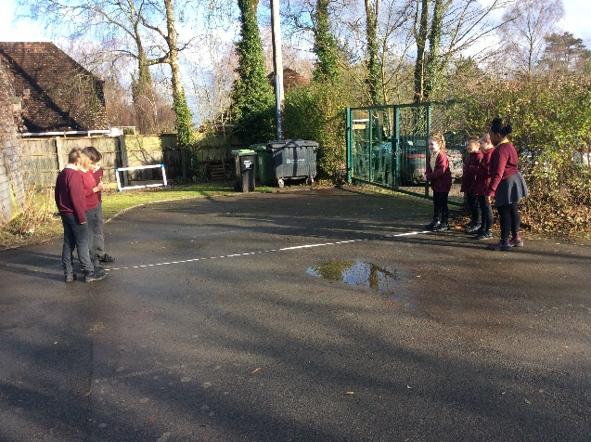

Class 2 have been investigating sound and how distance affects volume. They had fun in the sun investigating this with the school bell and a decibel monitor.

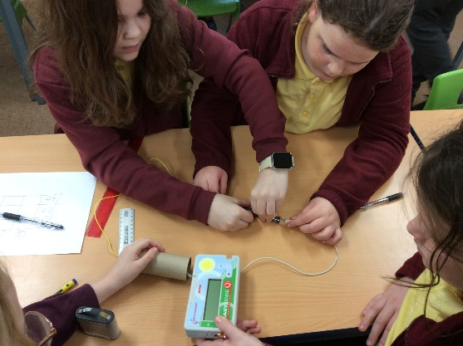


Our Stars of the week!
This week class 3 have been setting up an investigation into how the increase of voltage affects the components within a circuit. They have been using a data logger to record the brightness of a bulb in varying circuits.

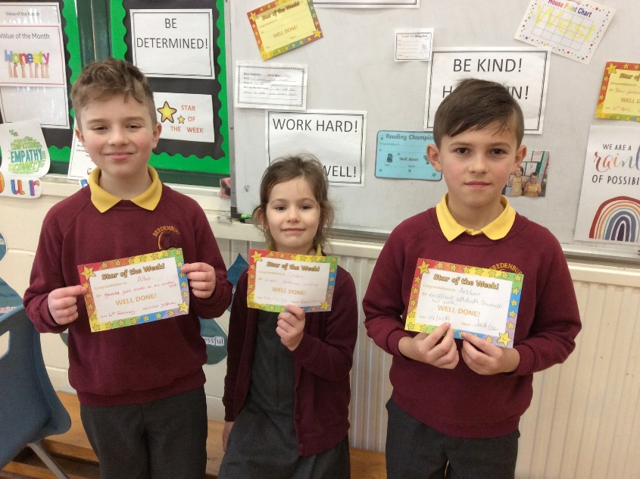
Chloe

Arthur
Alby

Class 2 and 3’s Forest School last week.
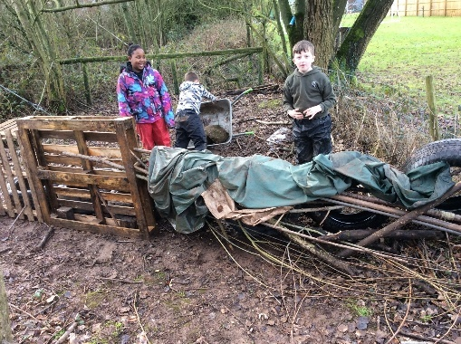
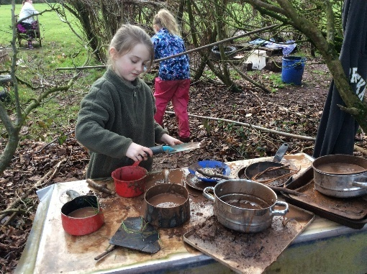

Our Reading Champions this week!

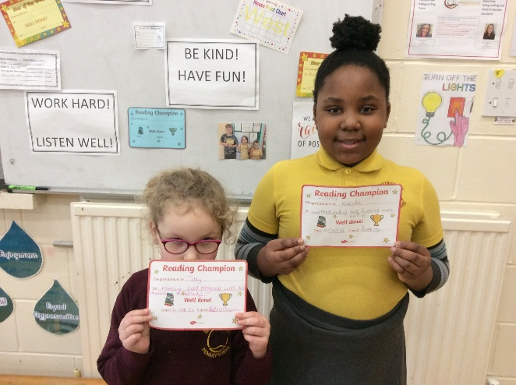

Tilly

Natalie

Pupil Achievements Outside of School
At Bredenbury, we love showing off and celebrating the wonderful things children achieve outside of school.
This week, our Class 2 pupil, Poppy, received her Rainbow Award for swimming 10 metres. Congratulations to Poppy on this fantastic achievement.

Have you got something your child would like to bring in and share with us? Please feel free — we love celebrating children’s achievements beyond the classroom!

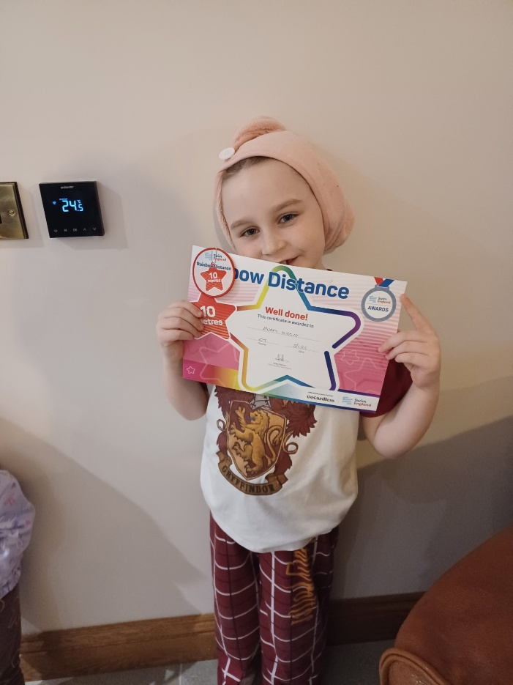

Monday 9th February
Tuesday 10th | Toast Tuesday – 50p  Class 1 - PE  Swimming at Leominster Pool – KS2 + Year 2  After school clubs – Wii Fit/Board Games – KS1  Sports Club - CANCELLED
Wednesday 11th
Thursday 12th | After school clubs – Cancelled  Rainbow Colour Disco
Friday 13th | Forest School – Class 2 and 3  Break up for half term

Dates for your diary (Letters to follow):

Monday 23rd February – Return to school
Monday 23rd February – Rags 2 Riches collection
Friday 27th February – Nursery Stay and Play

Wednesday 11th March and Thursday 12th March – Parents Evening
Monday 16th March – Wear What You Like
Wednesday 18th March – Red Ridge Residential Trip
Thursday 19th March – Class 1 visit to Wicton
Thursday 26th March – Easter Bonnet Parade
Friday 27th March – Nursery Stay and Play
Friday 27th March – Break up for Easter holidays

All events will have individual letters as appropriate.
Photos (where possible) for all school events are on Facebook.
Parking – can we please ensure we do not park across resident’s drives.
Regards,
Samantha McAtear,
Head of School,
Bredenbury Primary School




