Newsletter Summer 1:2
We will be thinking about what this means and what in our lives, we need to be determind about…
Attendance: 96.9% - Target 96%
Value of the Month - Determination
This week we honoured 80 years since VE Day by visiting the church on Thursday and taking part in a memorial service. All the children were fabulous, showed their respect, joined in for a 2 minute silence and some of Class 3 read a lovely poem.
Our football club did amazing in their football match against Stoke prior, winning with 4-1 to us! Well done all.
Next week is the start of year 6 SATs. Year 6 have been working and revising hard and we wish them the best of luck!
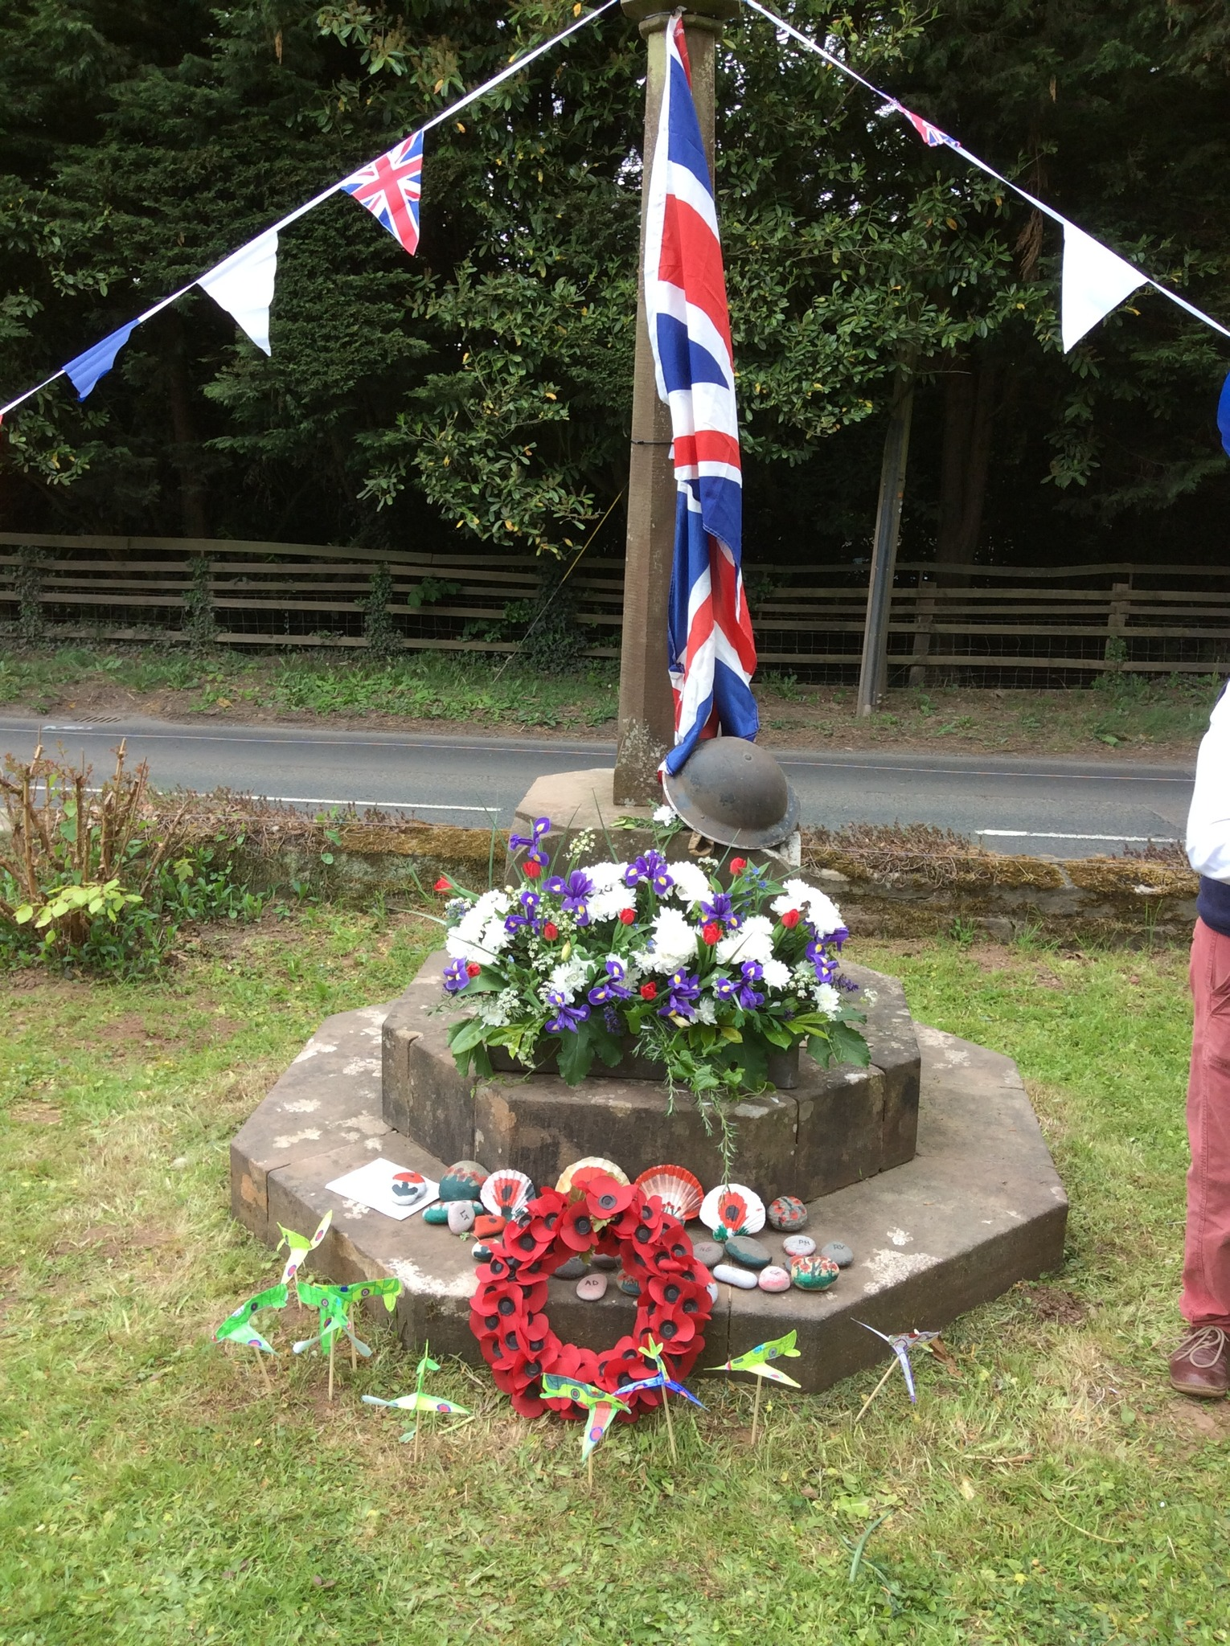

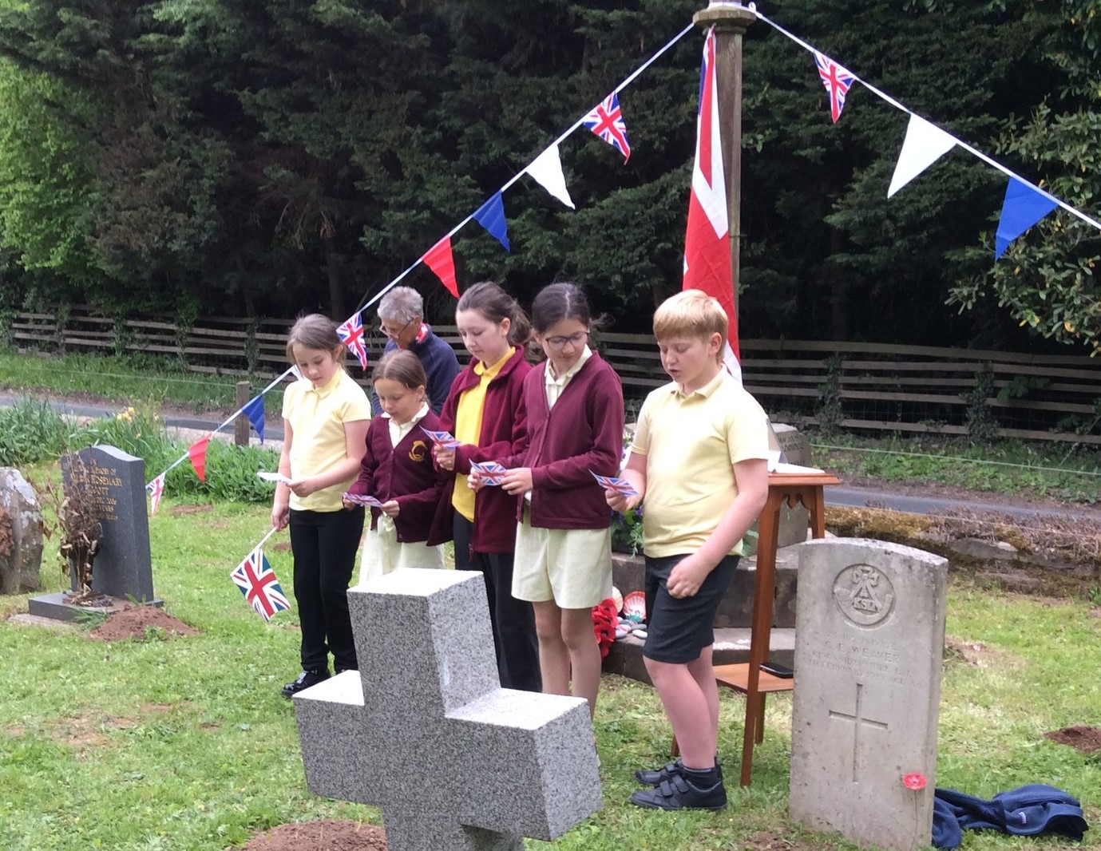

Monday 12th May | SATS Week  SATS breakfast – 8:15am  Muddy Monday – Class 1  After school Club - Rounders Club – KS2
Tuesday 13th | SATs breakfast – 8:15am  Class 1 PE – Kit required  Class 3 PE – Kit required  After school clubs – Football – KS2  Construction club – KS1
Wednesday 14th | SATs breakfast – 8:15am
Thursday 15th | SATS breakfast – 8:15am  SATs Finish  After school club - Boccia Club – KS1
Friday 16th | Forest School – Class 2 and 3  Class 1 PE – Kit required  After school club - Board Games and Puzzles – KS1

Dates for your diary (Letters to follow):

Wicton Farm Trip Thursday 22nd May – Class 3
Bikeability – Monday 9th June
Bromyard Scarecrow Festival Parade – June 13th 7:00pm
Year 5 Transition Days at QE High School – 19th-20th June
Year 6 Transition Days at QE High School – 2nd-4th July
Sports day – Friday 11th July in morning followed by picnic
Back up sports day – Tuesday 15th July
Celebration and leavers assembly – Thursday 17th July at 1:30pm.

Photos (where possible) for all school events are on Facebook.
Parking – can we please ensure we do not park across residents drives.
We have noticed children playing in the church car park at home time collection, obviously this is a dangerous place to play. Please ensure they don’t play in the car park.

Regards,
Samantha McAtear,
Head of School,
Bredenbury Primary School

