Newsletter Summer 2:2
We will be thinking about what this means and what in our lives, we need to be patient about.
Attendance: 97.8 % - Target 96%
Value of the Month – Patience

What a busy it has been! Year 6 completed their Bikeability on Monday and they all did brilliantly. Class 2 took a trip to Rowden Mill Station and had the opportunity to learn how the trains passed through the station and how farm animals were loaded onto the train.
As part of class 1’s history topic, the children explored the school and discovered the original school building and which part was an extension later on. As part of Science for class 1 this week, they have searched for ladybird larvae up in forest school, photographed and drawn what they found.
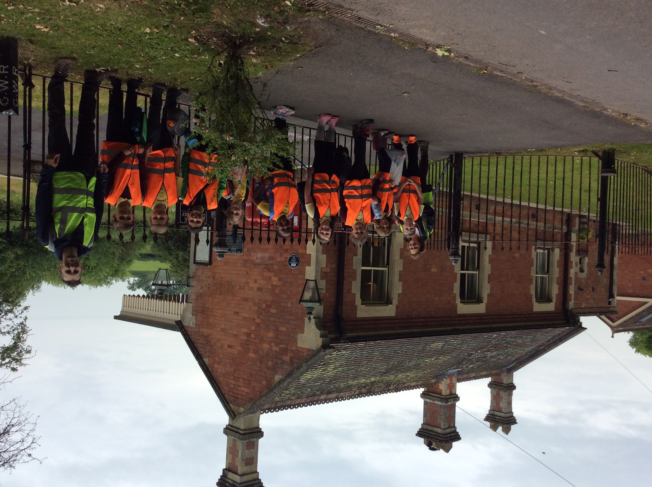
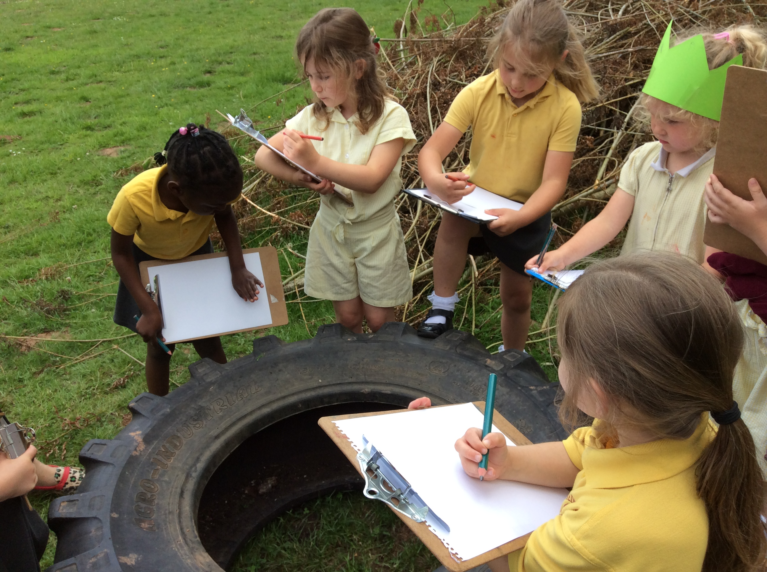
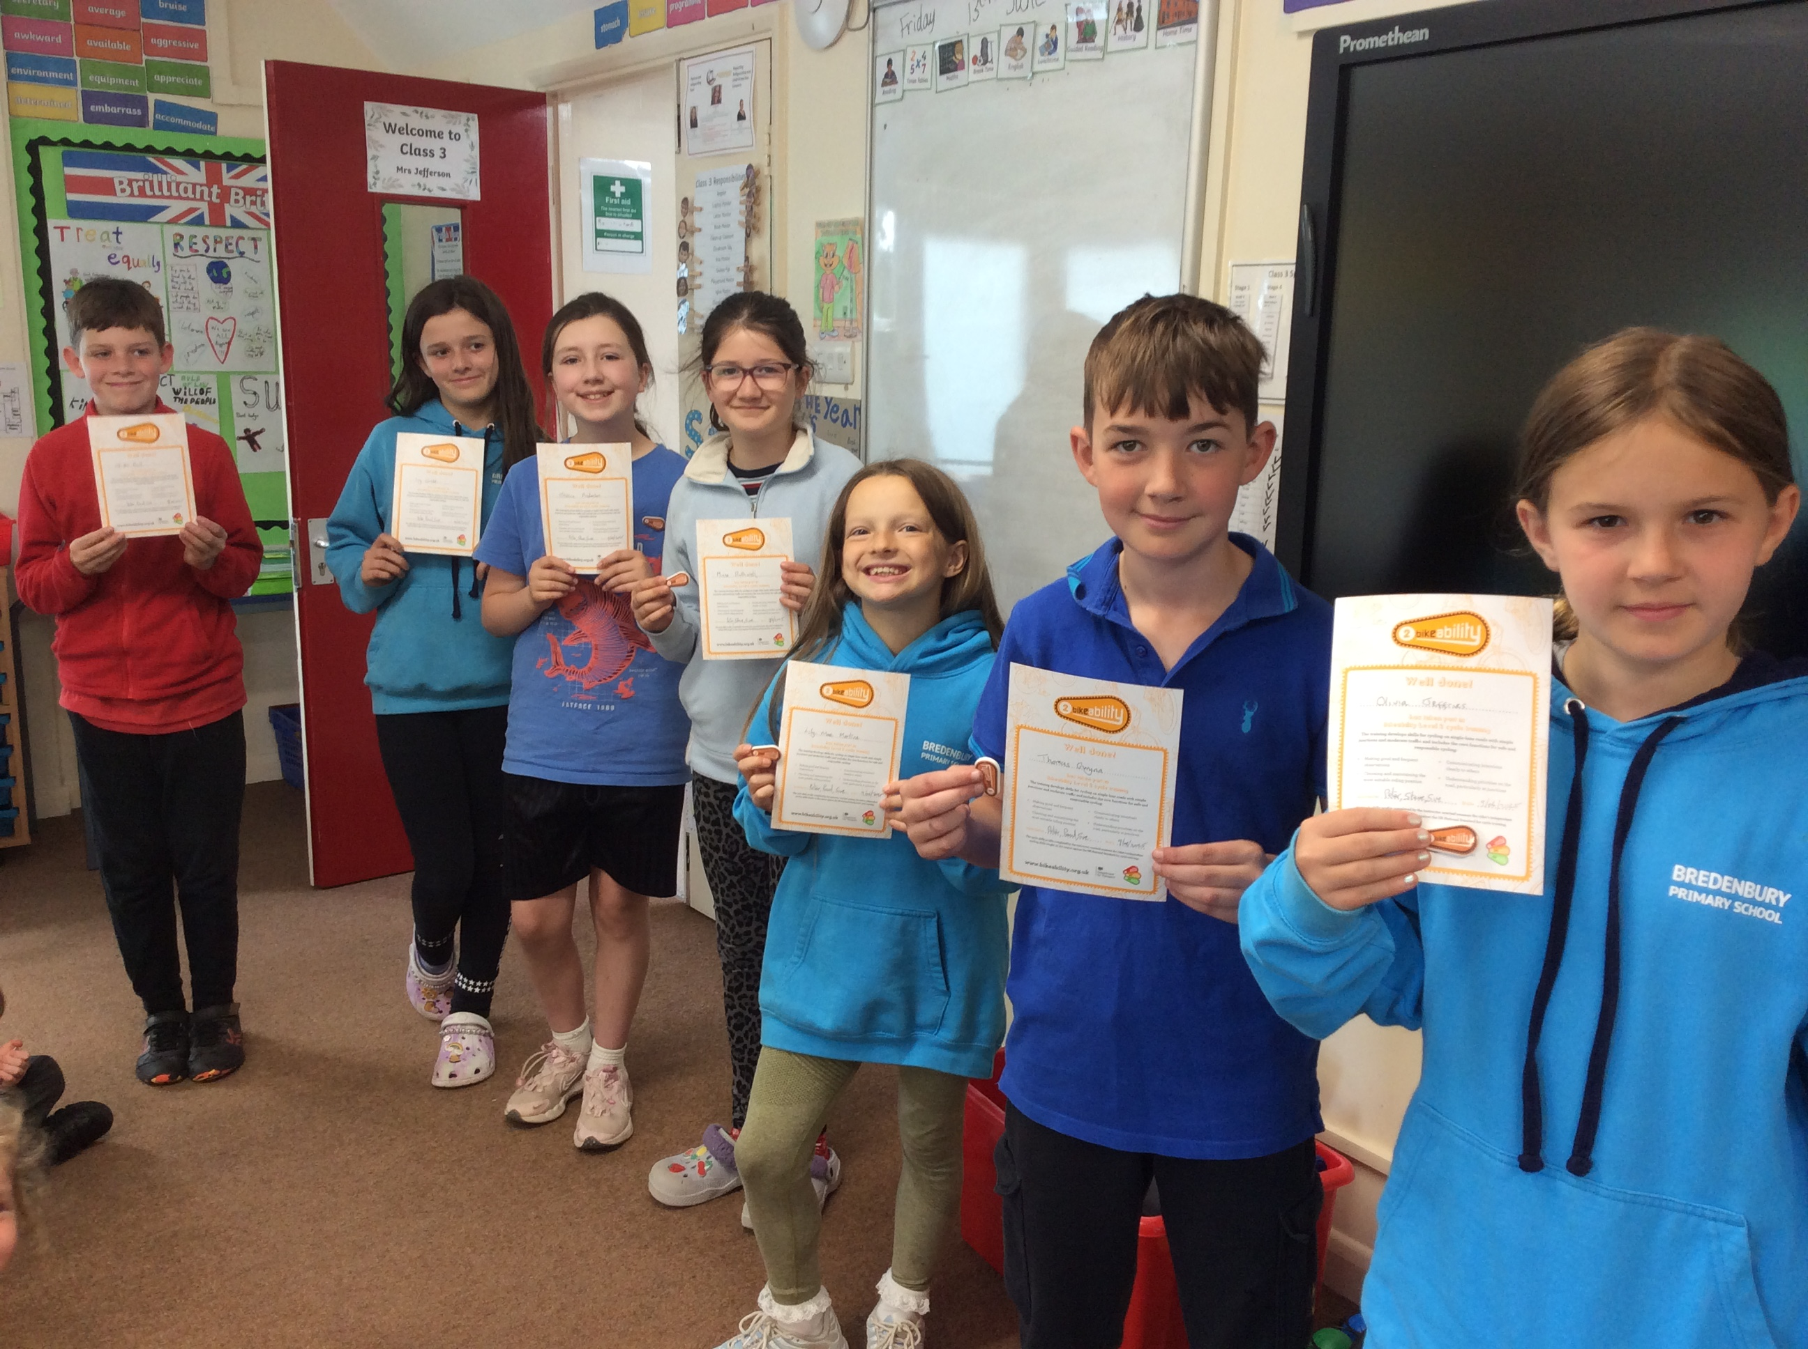
Monday 16th June | Year 5 taster day at QE  Class 2 PE – Kit required  After school Club - Rounders Club – KS2  Nature Rangers – KS1
Tuesday 17th | Class 1 PE – Kit required  Class 3 PE – Kit required  After school clubs – Football – KS2  Stay and Play – KS1
Wednesday 18th
Thursday 19th | After school club - Boccia Club – KS1
Friday 20th | Class 1 PE – Kit required

Dates for your diary (Letters to follow):

PTA meeting – Tuesday 17th 3:30pm
Campfire – Thursday 26th June
Nursery Outdoor Play in our forest area – Friday 27th June 9:00am-11:00am
Class 1 and 2 Summer School Games Festival – Wednesday 2nd July 9:30am-2:30pm
Class swap, children meet their new teachers – Thursday 3rd July
Year 6 Transition Days at QE High School – 2nd-4th July
Year 6 bowling – Monday 7th July
Year 6 Viking day – Wednesday 9th July
Reports home to parents – Wednesday 9th July
Sports day and school family fun afternoon – Friday 11th July in morning followed by picnic
Back up sports day – Tuesday 15th July
Celebration and leavers assembly – Thursday 17th July at 1:30pm.

All events will have individual letters as appropriate.

Photos (where possible) for all school events are on Facebook.
Class 1 gate will remain open for the foreseeable future from 8:30am – 8:45am

Parking – can we please ensure we do not park across residents drives.

Regards,
Samantha McAtear,
Head of School,
Bredenbury Primary School

