Newsletter Summer 2:3
We will be thinking about what this means and what in our lives, we need to be patient about.
Attendance: 96.9 % - Target 96%
Value of the Month – Patience

This week has truly felt like Summer has hit with the hottest week of this academic year.
We rounded off the end of last week with the scarecrow parade. Thank you to everyone who came and joined in, we may not have won but a great time was had by all.
We started off the week with the year 5s attending their taster day at QE where they had the chance to get a small glimpse of what to expect when their turn comes.
Class 1 have been looking at Vincent Van Gogh and his ‘Starry Night’ painting. They took on the challenge of painting it themselves and they all look amazing.
Class 2 have been planning their quiche making, looking at recipes and deciding their ingredients.
Class 3 have really been enjoying learning all about Vikings and have drawn their own versions of what a Viking looked like.

Monday 23rd June | Muddy Monday – class 1  Class 2 PE – Kit required  After school Club - Rounders Club – KS2  Nature Rangers – KS1
Tuesday 24th | Class 1 PE – Kit required  Class 3 PE – Kit required  After school clubs – Football – KS2  Stay and Play – KS1
Wednesday 25th
Thursday 26th | After school club - Boccia Club – CANCELLED  Summer campfire – 3:30pm-5:00pm
Friday 27th | Nursery Outdoor stay and play 9:00am-11:00am  Class 1 PE – Kit required
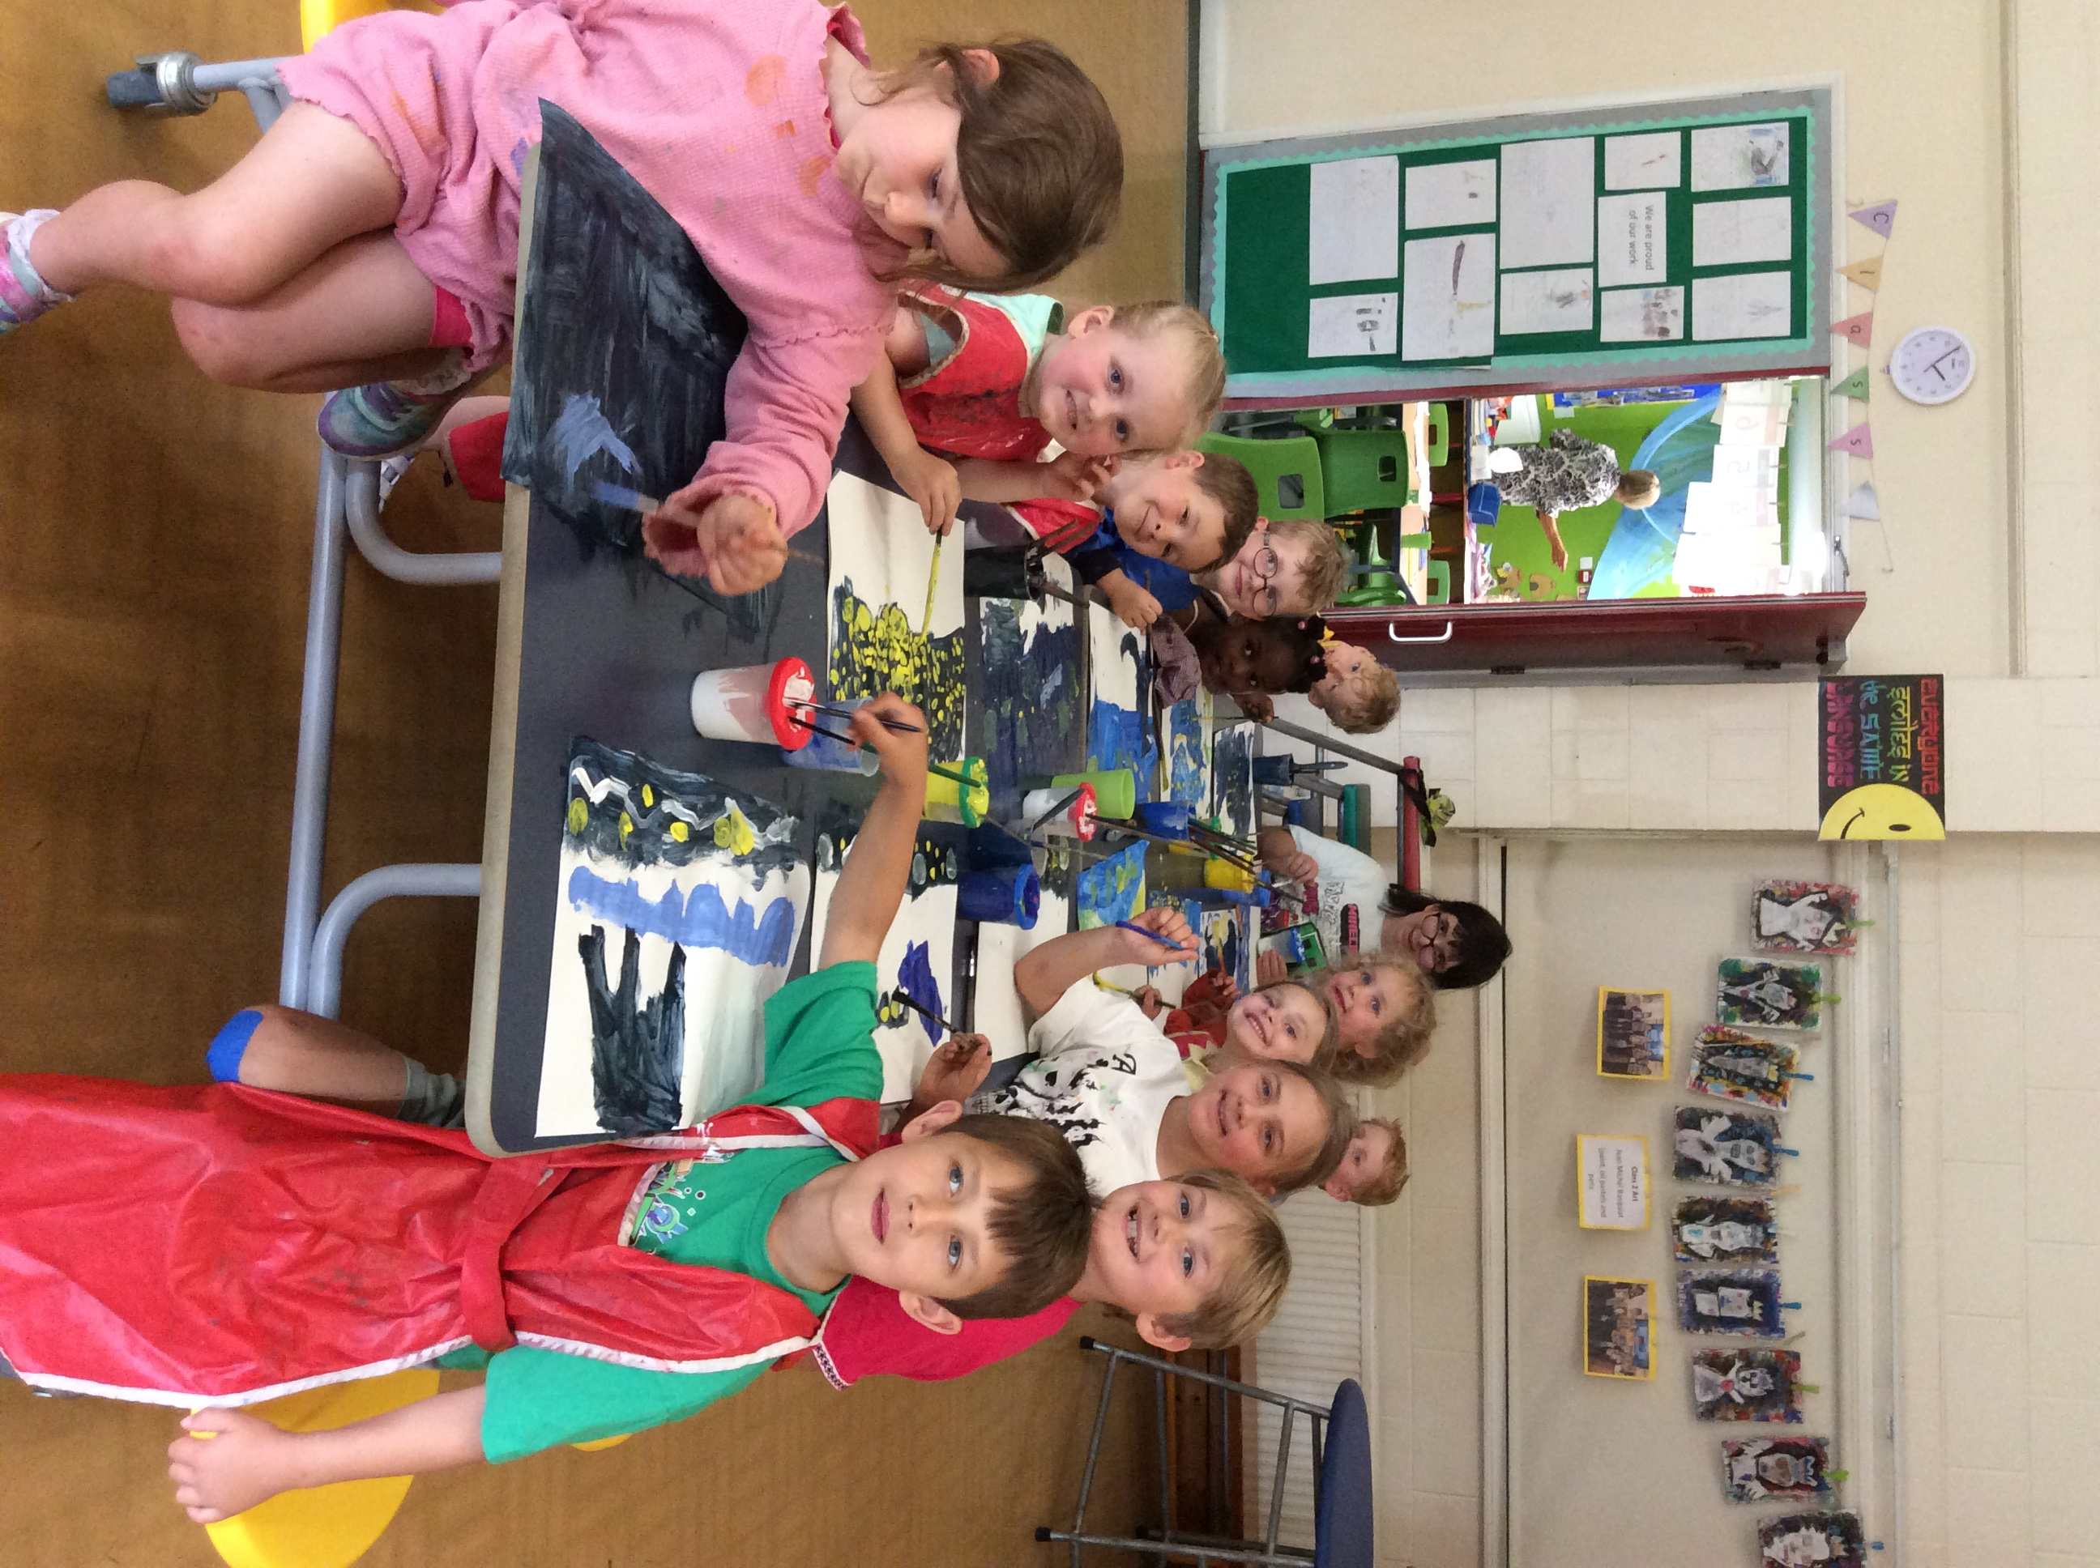

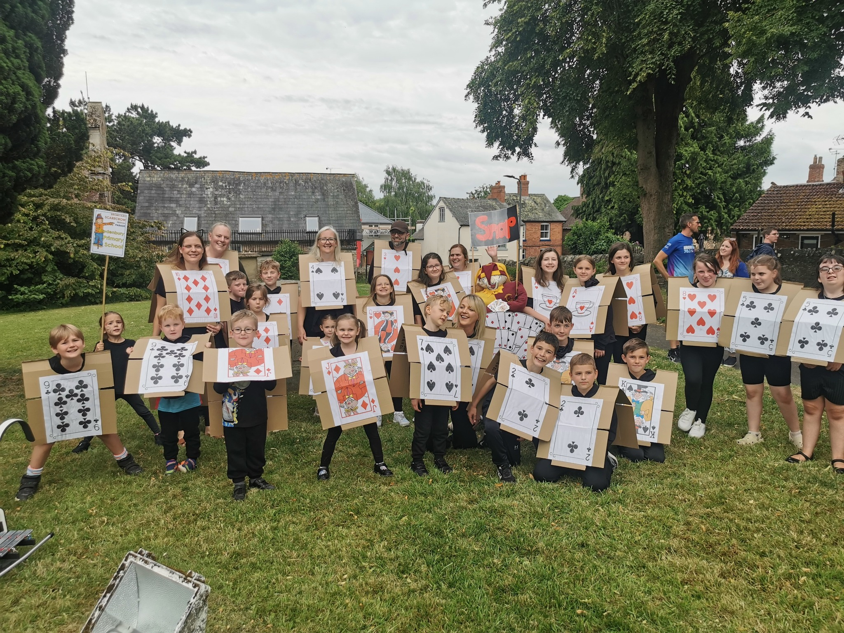
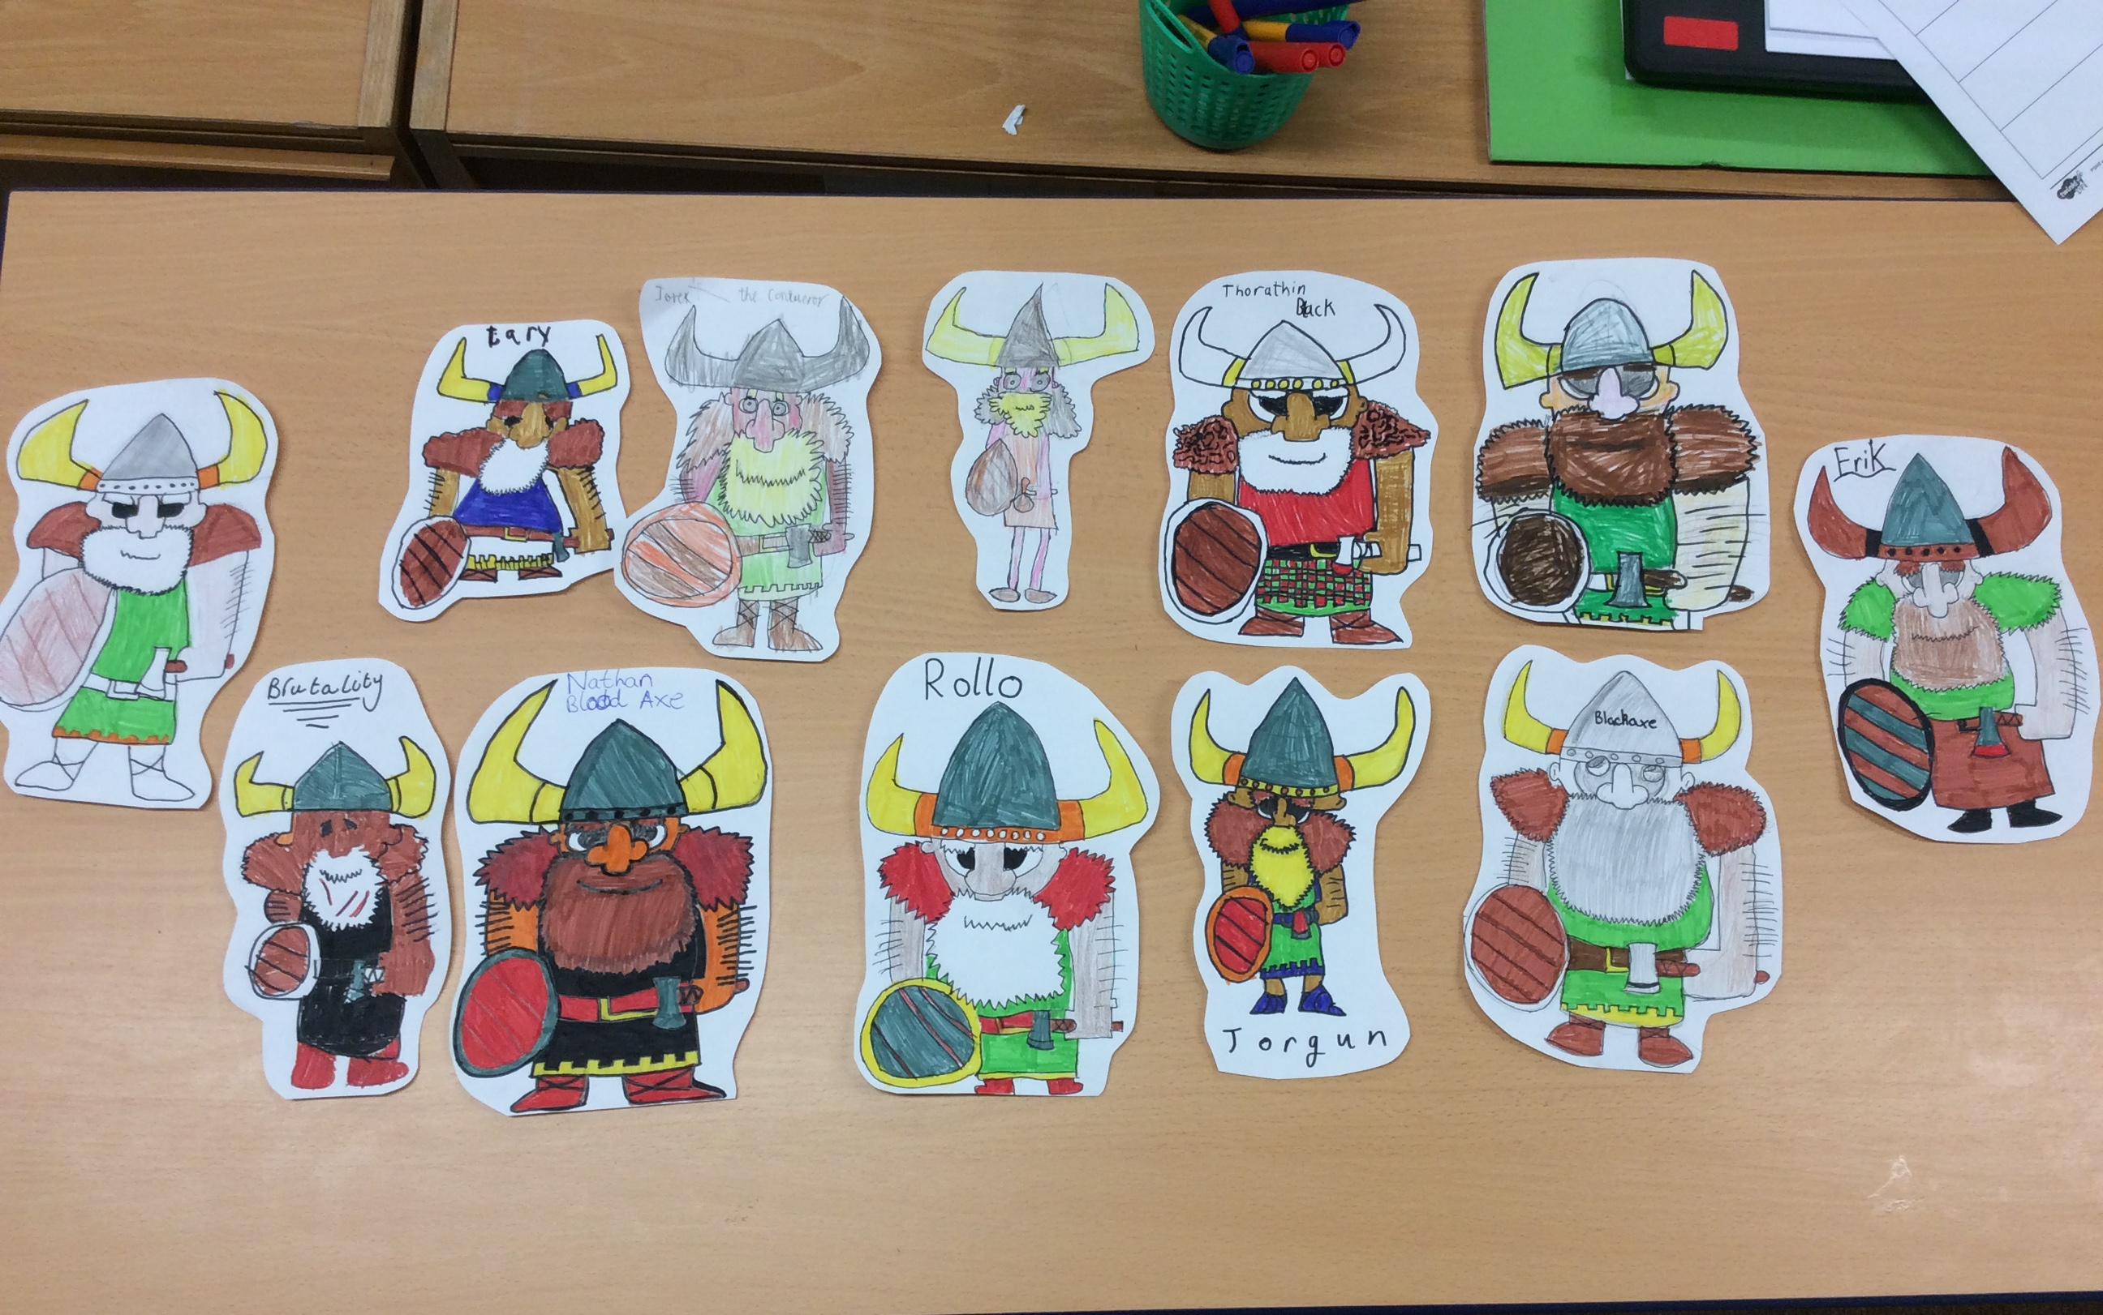

Dates for your diary (Letters to follow):

Class 1 and 2 Summer School Games Festival – Wednesday 2nd July 9:30am-2:30pm
Class swap, children meet their new teachers CHANGE OF DATE – Friday 4th July
Year 6 Transition Days at QE High School – 2nd-4th July
Year 6 bowling – Monday 7th July
Year 6 Viking day – Wednesday 9th July
Reports home to parents – Wednesday 9th July
Sports day and school family fun afternoon – Friday 11th July in morning followed by picnic
Back up sports day – Tuesday 15th July
Celebration and leavers assembly – Thursday 17th July at 1:30pm.

All events will have individual letters as appropriate.

Photos (where possible) for all school events are on Facebook.
Class 1 gate will remain open for the foreseeable future from 8:30am – 8:45am

Parking – can we please ensure we do not park across residents drives.

Regards,
Samantha McAtear,
Head of School,
Bredenbury Primary School

