A Level Transition Lessons from GCSE:

Surds

|  |
| --- |
| Contents |
| 02. Introduction to Surds & Multiplying  <https://www.youtube.com/watch?v=6B5VIjONJPM>  Slide 5, 128 can be split in 64 x 2  Slide 10 – second question on the left ($\sqrt{12}$). Answer should be 2 $\sqrt{3}$ Q7 last slide. Answer should be 60 root 10. |
| 03: Further Calculations with Surds  https://www.youtube.com/watch?v=O4X_H8UAw6w |
| 04. Brackets  https://www.youtube.com/watch?v=JzyAN7v1dyA |
| 05. Rationalising  https://www.youtube.com/watch?v=Njbo9_rZRxM |
| 06. Harder Rationalising  https://www.youtube.com/watch?v=1uFBuv1QjtQ |

02: Introduction to SURDS & Multiplying

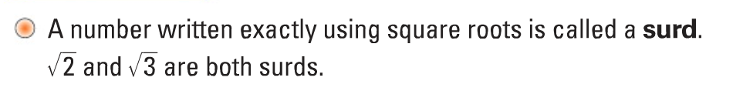

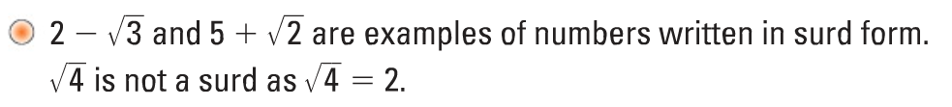

Square Numbers 1-15

|  |
| --- |
|  |

Get the skills…

Break down these numbers into the form $a^{2}×b$

|  |  |  |
| --- | --- | --- |
| 200 | 32 | 75 |

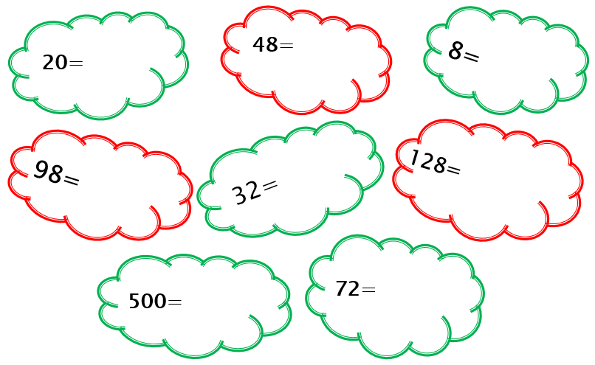

***A surd is simplified by having the lowest number possible under the square root.***



Simplifying Surds

Example: $\sqrt{32}$

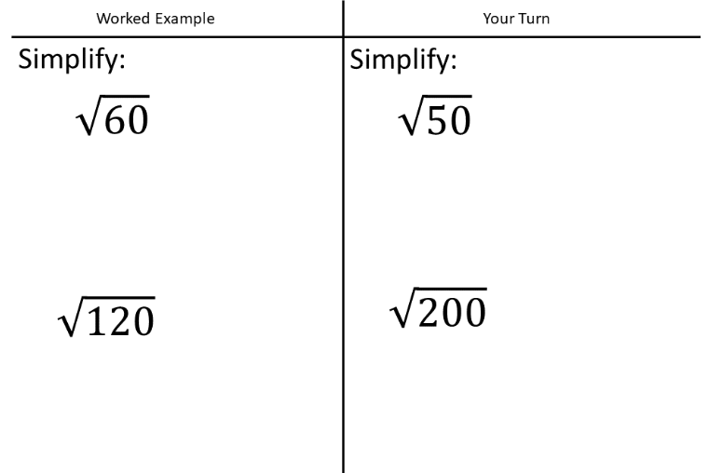

Sometimes it is easier to break it down in steps…

Example:

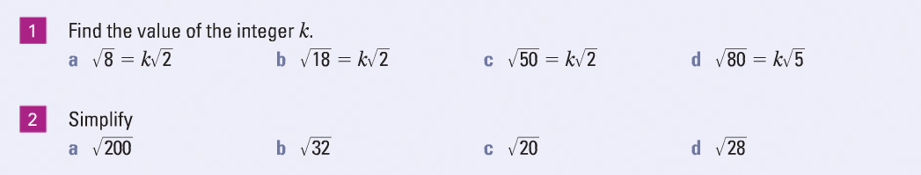

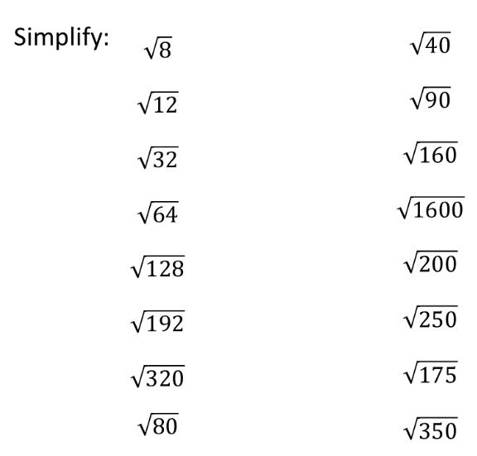







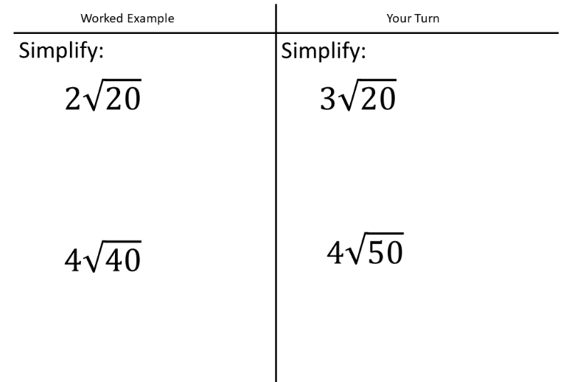

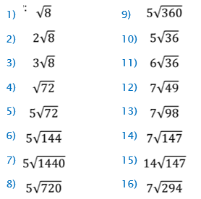

Find the value of integer $k$

a $\sqrt{48}=k\sqrt{3}$ b $\sqrt{90}=k\sqrt{10}$

c $\sqrt{150}=k\sqrt{6}$ d $\sqrt{80}=k\sqrt{5}$

e Solve the equation $x^{2}=32$

03: Further Calculations with Surds

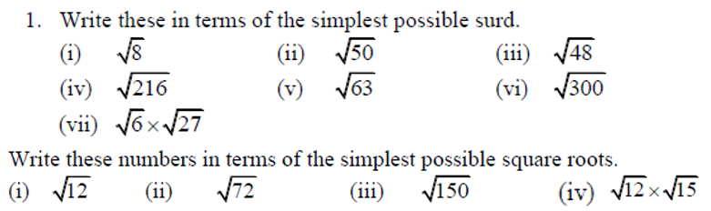



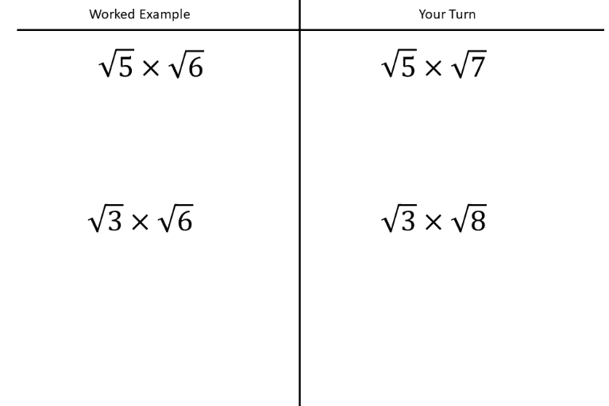

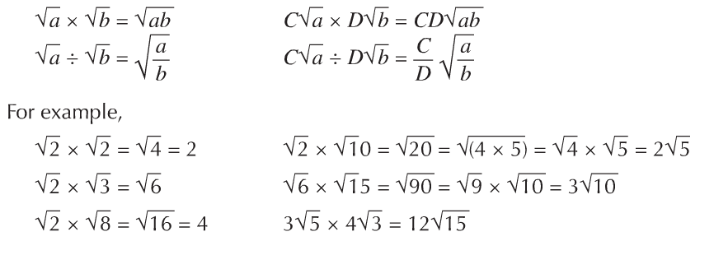



What do you notice?

1. $\sqrt{4}×\sqrt{4}$ 2) $\sqrt{6}×\sqrt{6}$ 3) $\sqrt{10}×\sqrt{10}$

Simplify:

|  |  |
| --- | --- |
|  |  |

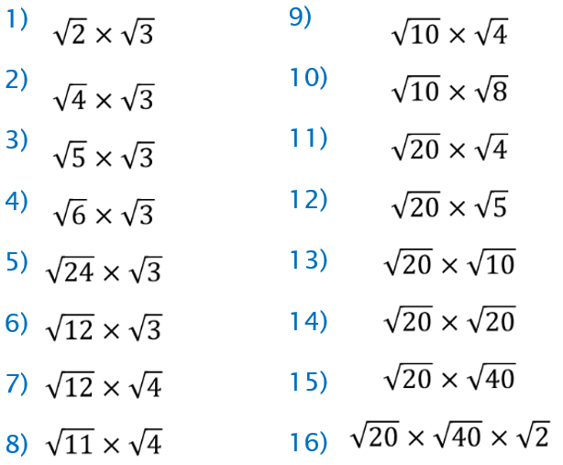

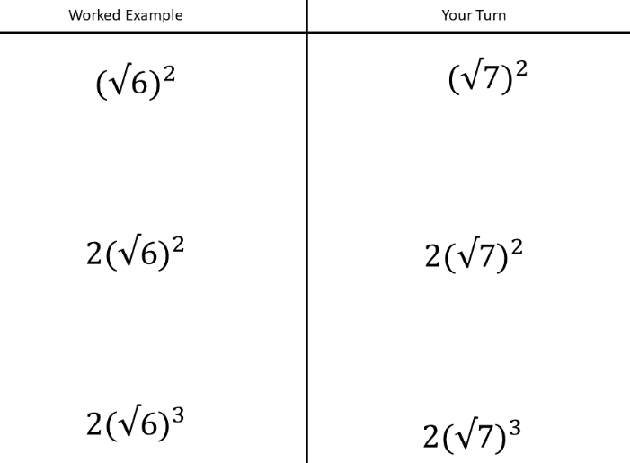

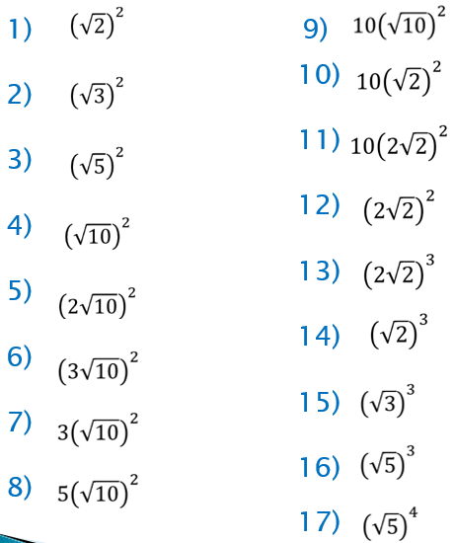



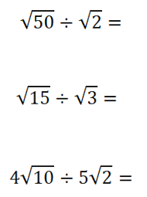

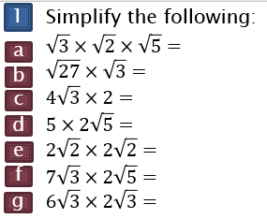

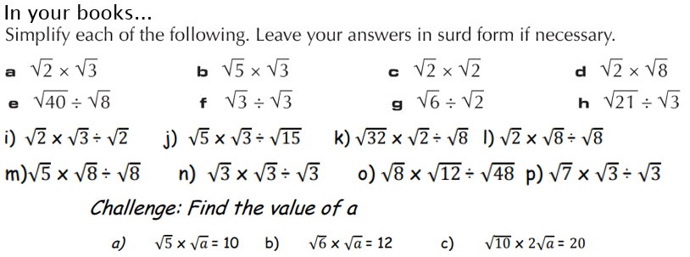

Adding & Subtracting

Treat them the same as algebraic terms…

Eg.

$$2a+3a=5a$$

$$4\sqrt{5}+3\sqrt{5}=7\sqrt{5}$$

|  |  |
| --- | --- |
| Find the integer $k$ $$3\sqrt{5}+\sqrt{125}=k\sqrt{5}$$ | Find the integer |
|  |  |

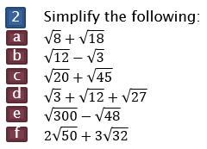

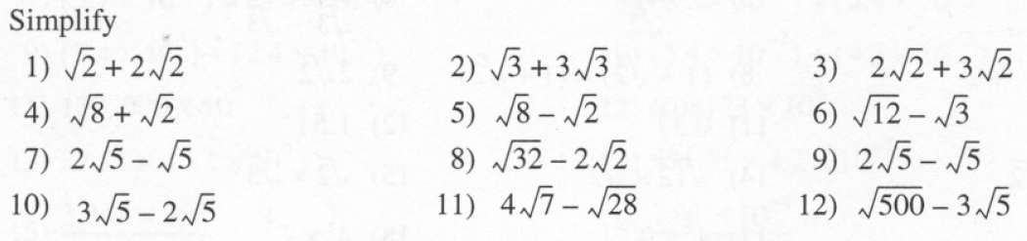

04: Brackets

|  |  |  |
| --- | --- | --- |
| Expand and simplify the following expression: $$\sqrt{3}(2+\sqrt{3})$$ | Example 2:  Expand and simplify the following expression: $$(2+\sqrt{5})(4+\sqrt{5})$$ | Expand and simplify the following expression: |
| Screen Clipping | Screen Clipping | Screen Clipping |

Harder Examples

|  |  |
| --- | --- |
| 1) ${\left(2+\sqrt{3}\right)}^{2}+{\left(4-\sqrt{5}\right)}^{2}$ | 2) |

|  |
| --- |
|  |

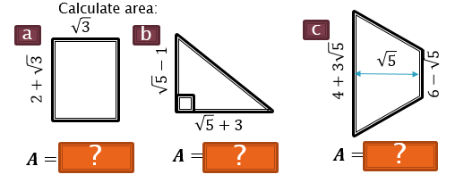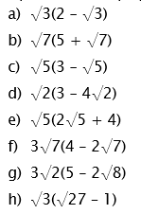Task 1: Task 2: Extension:

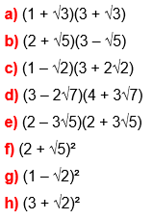Challenge: ${\left(1+\sqrt{3}\right)}^{2}-{\left(1-\sqrt{3}\right)}^{2}$

05: Rationalising

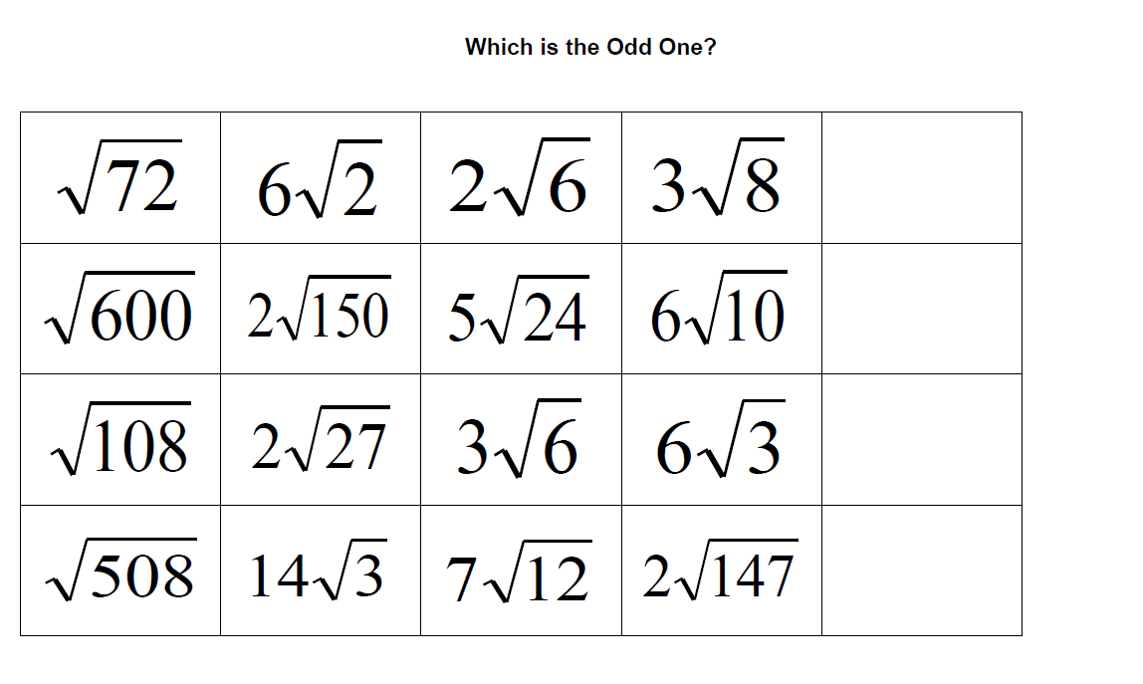Starter:  
1) Change to a fraction: $0.1\dot{2}\dot{3}$

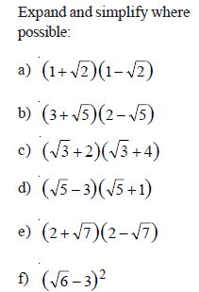2)

* A simplified surd should have no surds in the denominator of a fraction.
* Eg. The following surds are not in their simplest form $\frac{1}{\sqrt{2}}, \frac{1+\sqrt{3}}{\sqrt{5}}$, $\frac{3}{1+\sqrt{3}}$
* When we simplify a fraction which contains a surd in the denominator we call the process ‘Rationalising the Denominator’.

Examples:

|  |  |  |
| --- | --- | --- |
| 1) Rationalise $\frac{2}{\sqrt{3}}$ | 2) Simplify $\frac{3\sqrt{2}}{\sqrt{5}}$ | 3) Simplify $\frac{4}{2\sqrt{3}}$ |
| 4) Simplify $\frac{15-\sqrt{5}}{\sqrt{5}}$ Give your answer in the form $a+b\sqrt{5}$ | 5) $\frac{60}{\sqrt{20}}+3\sqrt{5}$ | 6) $\frac{45}{3\sqrt{5}}-\sqrt{5}$ |

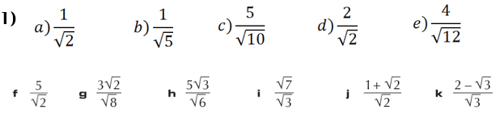

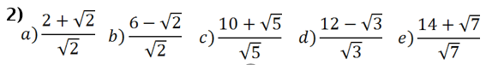

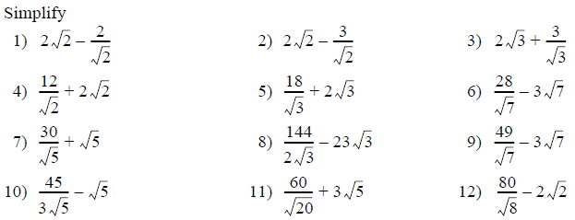**3)**

06: Harder Rationalising

|  |  |  |
| --- | --- | --- |
| $$\frac{1}{\sqrt{2}+1}$$ | $$\frac{1}{\sqrt{5}-2}$$ | $$\frac{2}{1-\sqrt{3}}$$ |
| $$\frac{2+\sqrt{2}}{1+\sqrt{3}}$$ | $$\frac{2\sqrt{5}-1}{3-\sqrt{5}}$$ | $$\frac{\sqrt{6}+\sqrt{3}}{\sqrt{6}-\sqrt{3}}$$ |

Killer Questions

|  |  |
| --- | --- |
|  |  |

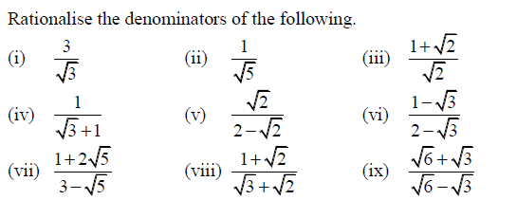1)

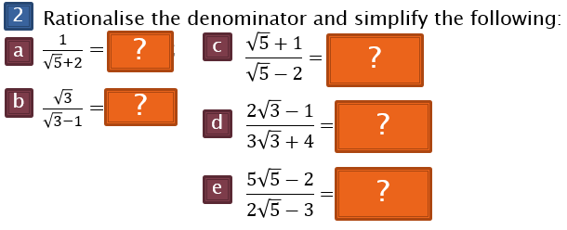

Extension

