A Level Transition Lessons from GCSE:

Basic Algebra

|  |
| --- |
| Contents |
| 05. Factorising Harder Quadratics  <https://m.youtube.com/watch?v=3XsZ7do3OOw> |
| 06. Factorising Quads Summary  <https://m.youtube.com/watch?v=83GifIRQha4> |
| 08. Simplifying Algebraic Fractions  <https://m.youtube.com/watch?v=E4BMvEM4NpY> |
| **Rearranging Formula** |
| 03. Powers & Roots  https://www.youtube.com/watch?v=R_vtXT19VVc |
| 04. Subject appears twice  https://www.youtube.com/watch?v=CRW3NNhFxXc |

05: Factorising Harder Quadratics

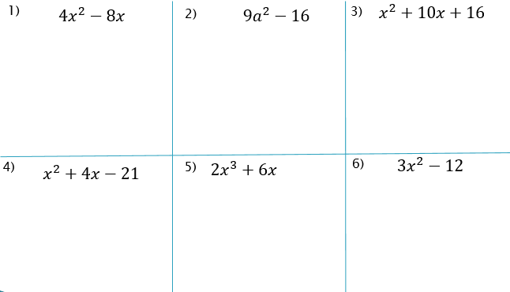Starter

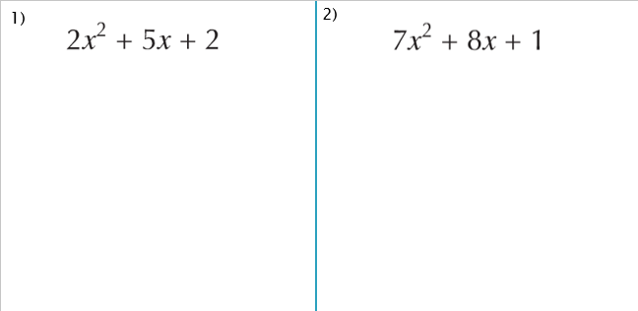Examples:

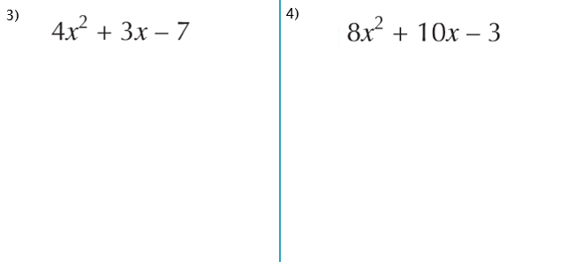

|  |  |  |
| --- | --- | --- |
|  |  |  |
|  |  |  |

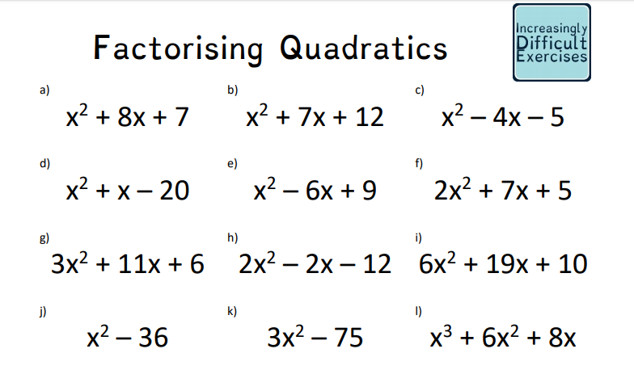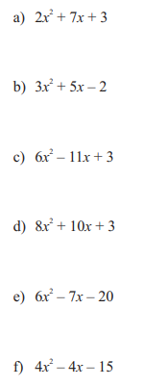

06: Factorising Quads Summary

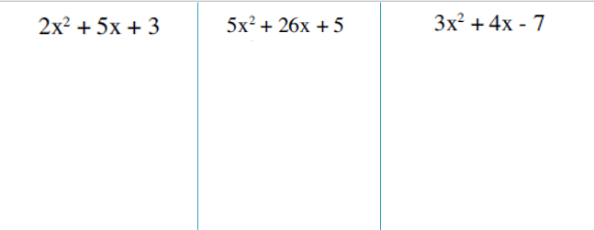

Decision time… Factorise the following

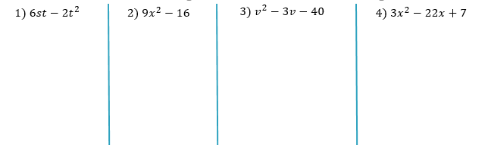

10 Quick Questions…



$x^{2}-6x$

$x^{2}-100$

$7x-x^{2}$

$4x^{2}-1$

$3x^{2}-21x$

$x^{2}-8x+16$

$6x^{2}+7x-3$

$5x-10x^{2}$

$10x^{2}+9x+2$

$x^{2}-x-20$

Special Cases:

1) 2) 3) 3) 4) 4)

Past Paper Question

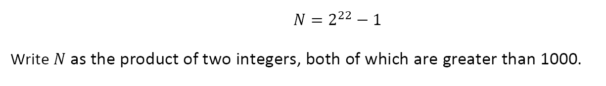

Using difference of 2 squares to find exact values…

Find the exact value of:

a) ${105}^{2}-{95}^{2}$ b) ${2003}^{2}-{1997}^{2}$

08: Simplifying Algebraic Fractions

Example:

$$\frac{3x+9}{x^{2}-9}$$

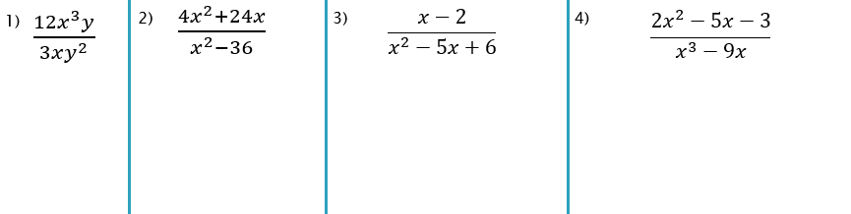

Exam Question



Exam Question 2

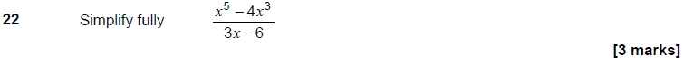

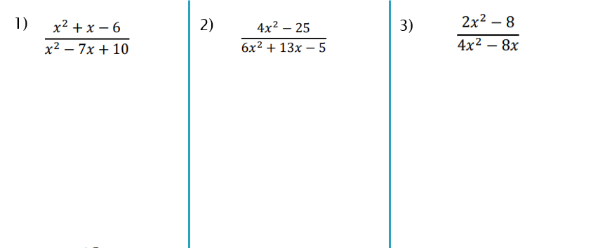

More Practice

