A Level Transition Lessons from GCSE:

Equations Transition Lessons

|  |
| --- |
| Contents |
| **Quadratics** |
| 01. Solving by factorising  https://www.youtube.com/watch?v=AjIemDMnIZ4 |
| 02. Solving by Factorising 2  https://www.youtube.com/watch?v=2GO4g1oGvso |
| 03.Completing the Square  https://www.youtube.com/watch?v=VnzJcRd6ass |
| 04. Solving by completing the square  https://www.youtube.com/watch?v=9fsvoNLQJjw |
| 05. Solving with the Quadratic Formula  https://www.youtube.com/watch?v=oJRXOSN_yGA |
| **Simultaneous Equations** |
| 02. Non Linear Simultaneous Equations  https://www.youtube.com/watch?v=prZPZF237ms |
| 03. Non Linear Simultaneous Equations  https://www.youtube.com/watch?v=__fHuhdXUig |

01: Solving By Factorising

Factorising Revision

|  |  |  |
| --- | --- | --- |
| $2x^{2}+4x$ | $6xy+9x^{2}$ | $12ab^{2}+4a^{2}b+20abc$ |
| $10x^{3}y+20x^{2}y^{2}$ | $x^{2}+10x+21$ | $x^{2}+14x+49$ |

Factorising Quadratics

|  |  |  |
| --- | --- | --- |
|  | Screen Clipping | Screen Clipping |
|  |  |  |

3 quick questions

$1) x^{2}+3x-10$ $2) 3x^{2}-9x$ $3) x^{2}-16$

There are 6 ways to solve a quadratic equation:

1. **Rearranging (making $x$ the subject)**
2. **Factorising**
3. By completing the square
4. Using the Quadratic Formula (need to memorise)
5. Looking at the graph of the quadratic
6. Iteration

|  |  |  |
| --- | --- | --- |
| $$x^{2}=25$$ | $$x^{2}-8=0$$ | $$0=x^{2}-121$$ |

Solving by factorising

Examples:

|  |  |
| --- | --- |
| 1) $\left(x-1\right)\left(x+2\right)=0$ | $$2) x(x-6)=0$$ |
| $$3) (6-x)(5+x)=0$$ | $$4) (2x+1)(x-3)=0$$ |

Quick Questions

|  |  |  |  |  |
| --- | --- | --- | --- | --- |
| $$x\left(x-3\right)=0$$ | $x(x+2)=0$ | $$(x+7)(x-9)=0$$ | $$(7x+2)(x-4)=0$$ | $$\left(9-2x\right)\left(10x-7\right)=0$$ |

1. Make sure equation is in the form $ax^{2}+bx+c=0 .$
2. Factorise the quadratic
3. Find the solutions

|  |  |  |
| --- | --- | --- |
| $$x^{2}-6x+8=0$$ | $$x^{2}+7x+6=0$$ | $$x^{2}+x-12=0$$ |

Further Examples

|  |  |  |
| --- | --- | --- |
|  |  |  |

|  |  |
| --- | --- |
|  |  |

Quick Questions: In your books.

|  |  |  |  |  |
| --- | --- | --- | --- | --- |
| x2 + 7x + 12 = 0 | x2 + x – 6 = 0 | x2 + 10x + 21 = 0 | x2 + 2x + 1 = 0 | x2 + 5x = 14 |
| x2 – 3x = 0 | x2 + 7x = 0 | 2x2 – 2x = 0 | x2 – 49 = 0 | 4x = x2 |

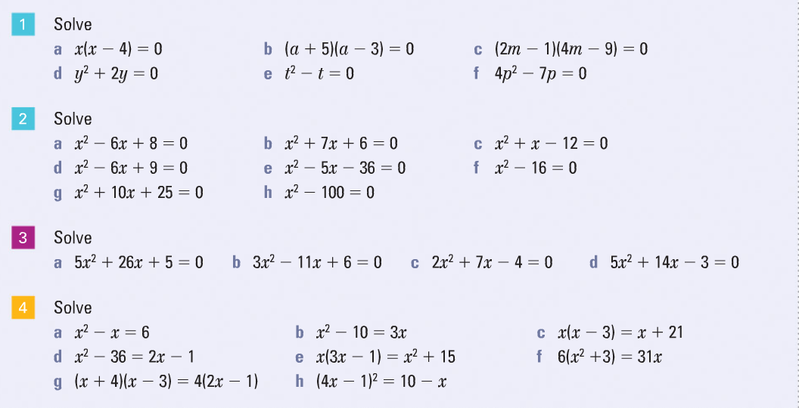

02: Solving By Factorising 2

Starter: Factorise the following…

|  |  |  |
| --- | --- | --- |
| Screen Clipping | Screen Clipping | Screen Clipping |

|  |  |  |
| --- | --- | --- |
| a) | b) | c) |

Further Example:

Solve

c.tiffa.tiffb.tiff



03: Completing the Square

|  |  |  |
| --- | --- | --- |
| 1) | 2) | 3) |
| 4) |  | 6) |

Screen Clipping

Quadratics in this form can be solved using an easier technique because $x$ only appears once.

|  |  |
| --- | --- |
| $${1) \left(x+3\right)}^{2}=$$ | $${2) \left(x+5\right)}^{2}+1=$$ |
| $${3) \left(x-3\right)}^{2}=$$ | $${4) \left(x-6\right)}^{2}-9=$$ |

Completing the square

|  |  |  |
| --- | --- | --- |
| a) $x^{2}+4x$ | b) $x^{2}-10x$ | c) $x^{2}+12x$ |

Further Examples

|  |  |
| --- | --- |
| $$x^{2}+4x+7$$ | $$x^{2}+8x+17$$ |

Typical Exam Question:

Write $x^{2}-6x-5$ in the form ${\left(x+p\right)}^{2}+q$, stating the values of $p \& q$

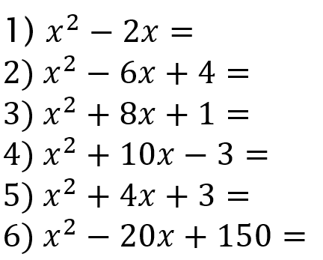Quick Questions: In your books…

When the coefficient of $x$ is odd…

|  |  |
| --- | --- |
| $$x^{2}+3x-7$$ | $$x^{2}-5x+1$$ |

Exercise: In your books

${1) x}^{2}+2x$ $2) x^{2}+12x$ $3) x^{2}-22x$ ${4) x}^{2}+6x+10$ ${5) x}^{2}+14x+10$ ${6) x}^{2}-2x+16$

${7) x}^{2}-40x+20$ $8) x^{2}+x$ $9) x^{2}+5x-1$ ${10) x}^{2}-9x+20$

When there is a coefficient of $x^{2}$

|  |  |  |
| --- | --- | --- |
| $$3x^{2}+12x-6$$ | $$5x^{2}+20x-19$$ | $$-2x^{2}-4x+2$$ |

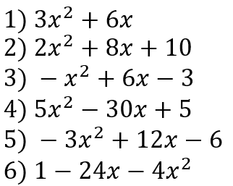

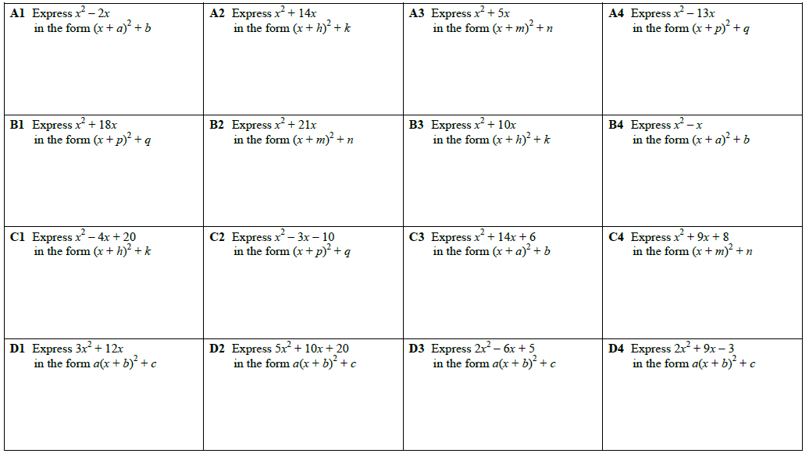

04: Solving in completed square form

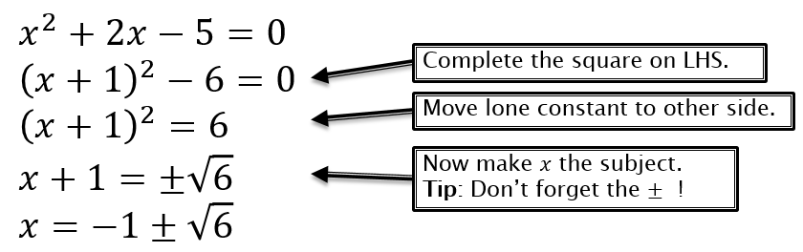

Possible GCSE Question:

a) Put the expression $x^{2}+6x+1$ in the form ${\left(x+a\right)}^{2}+b$.

b) Hence find the exact solutions to $x^{2}+6x+1=0$*.*

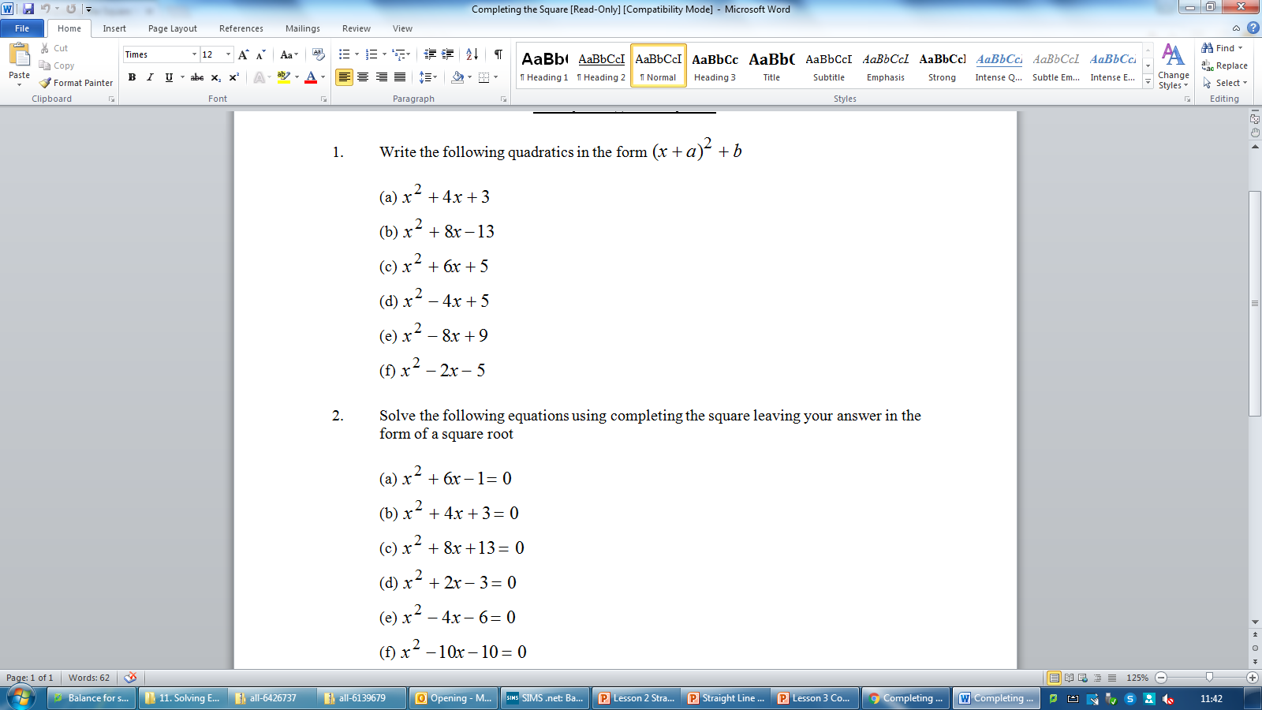Further Examples:

|  |  |
| --- | --- |
| $$1) x^{2}-8x+2=0$$ | $${2) 6x}^{2}+24x+6=0$$ |

Working Backwards

|  |  |  |
| --- | --- | --- |
| You are given that $x^{2}+ax-4≡{\left(x-4\right)}^{2}-b$ Work out $a \& b$ | You are given that $x^{2}+ax+6≡{\left(x-2\right)}^{2}-b$ Work out $a \& b$ | You are given that $x^{2}+ax-10≡{\left(x-5\right)}^{2}-b$ Work out $a \& b$ |

05: Quadratic Formula

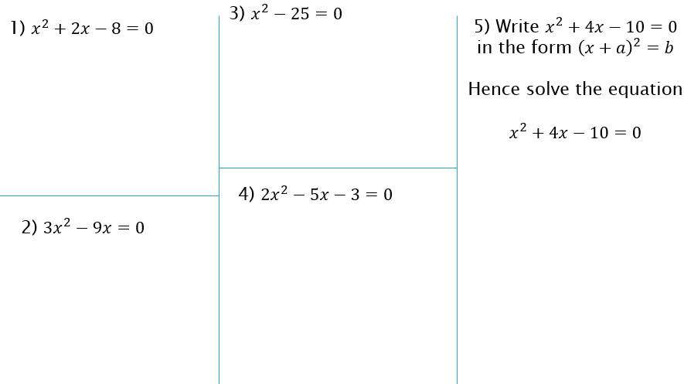

**Solving Quadratic Equations in the form $ax^{2}+bx+c=0$**

1. Start by making the quadratic is equal to zero.

2) If the quadratic doesn’t factorise then we either use completing the square or the **quadratic formula.**

1.tiff

1.tiff

1.tiff

These quadratics don’t factorise. Which would method would you use?

Completing the square or Formula?

|  |  |
| --- | --- |
| $x^{2}+6x-3$ =0 | ${3x}^{2}+5x-3$ =0 |

|  |  |  |
| --- | --- | --- |
| Solve $x^{2}-5x+3=0$ Give your answer to 2 decimal places | Solve ${5x}^{2}+x-3=0$ Give your answer to 2 decimal places | Solve ${3x}^{2}-12x-2=0$ Give your answer in exact form |

Working Backwards:

|  |
| --- |
| Screen Clipping |

Solve the equation $x^{2}+7x-18=0$ by:

|  |  |  |
| --- | --- | --- |
| 1) Factorising | 2) Completing the square | 3) Formula |

Exercise:

1)  3)

5) 7) )

The Discriminant

Some quadratic equations have no solutions…

Solve ${2x}^{2}+3x+10=0$

$$x=\frac{-b±\sqrt{b^{2}-4ac}}{2a}$$

$b^{2}-4ac$ is known as the discriminant and is very important as it tells you about the nature of the solutions of the equations.

|  |  |  |
| --- | --- | --- |
| 1) $2x^{2}+6x-3=0$ | 2) $x^{2}-10x+25=0$ | 3) $x^{2}+x+4=0$ |

