A Level Transition Lessons from GCSE:

Harder Algebra

|  |
| --- |
| Contents |
| 03. Quadratic Inequalities  https://www.youtube.com/watch?v=gI2SAhXq1m4 |
| 04. The Discriminant  https://www.youtube.com/watch?v=zikmr7tb6LM |
| **Transformation of Graphs** |
| 01. Stretches  https://www.youtube.com/watch?v=-WbCLbqARh0 |
| 02. Translations  https://www.youtube.com/watch?v=UKhUiMtH4Ss |
| 03. Equations of new graphs  https://www.youtube.com/watch?v=X3JEMvgRbSA |
| 04. Completed Square Form  https://www.youtube.com/watch?v=dC2uy8hPSqI |

03: Quadratic Inequalities

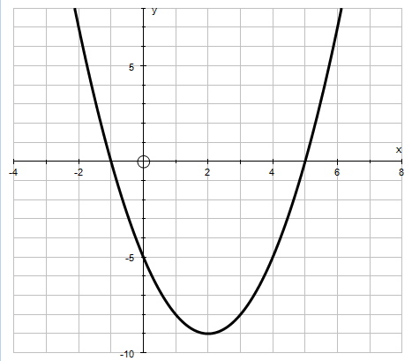Give me a value for $x$ where…

$$x^{2}-4x-5=0$$

$$x^{2}-4x-5>0$$

$$x^{2}-4x-5<0$$

Examples:

1) Solve



2) Find the set of values for $x$ which satisfy $x^{2}-6x+4<0$ 3. Solve

4) Find the set of values for $x$ which satisfy $2x^{2}+5x-1<0$ 5) Find the set of values for $x$ which satisfy $x^{2}-1<0$

Exam Questions:  
Screen Clipping

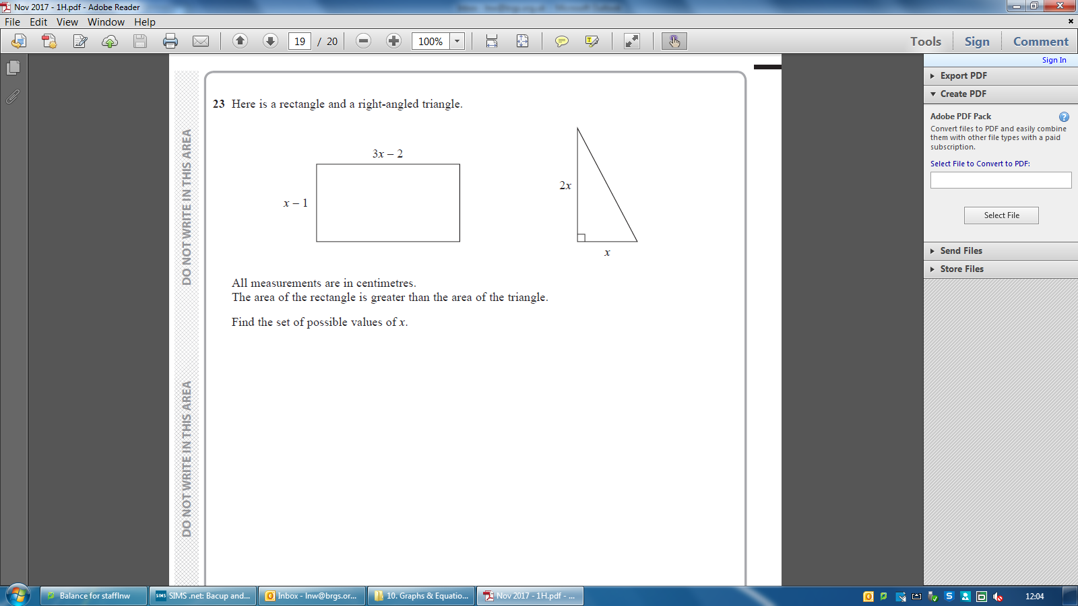

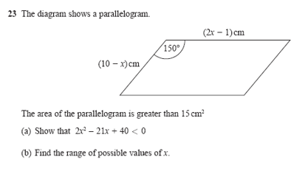

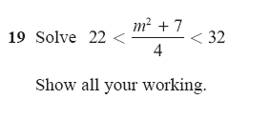

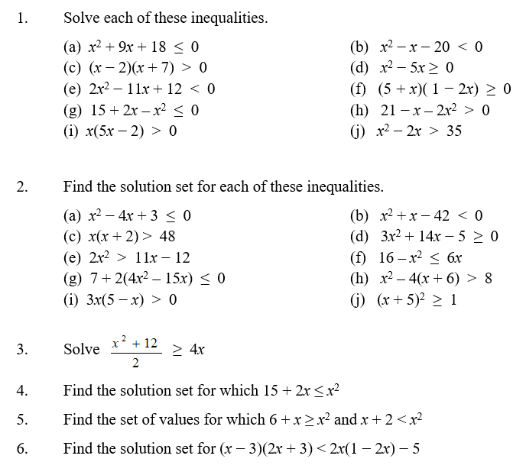

04: The Discriminant

Starter: Choose 1 method to Solve ${2x}^{2}+8x-7=0$

Quadratic Formula: $x=\frac{-b±\sqrt{b^{2}-4ac}}{2a}$

Solve the following using the quadratic formula, show the full working…

|  |  |  |
| --- | --- | --- |
| 1) $2x^{2}+3x-5=0$ | 2) $x^{2}-8x+16=0$ | 3) $x^{2}+4x+10=0$ |

$$x=\frac{-b±\sqrt{b^{2}-4ac}}{2a}$$

$b^{2}-4ac$ is known as the discriminant and is very important as it tells you about the nature of the solutions of the equations.

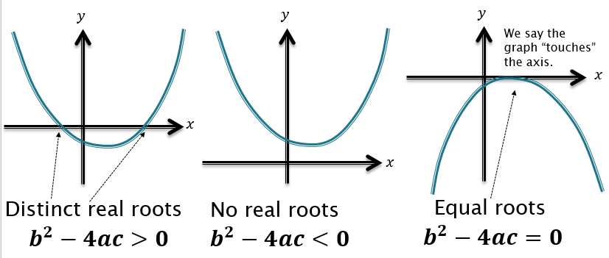

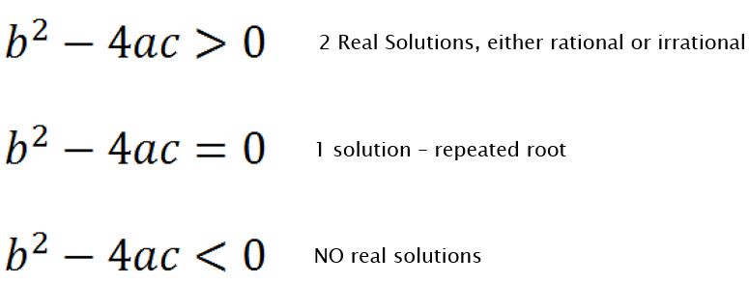

|  |  |  |
| --- | --- | --- |
| Equation | Discriminant $b^{2}-4ac$ | No. of roots |
| $$x^{2}+3x+4=0$$ |  |  |
| $$x^{2}-4x+1=0$$ |  |  |
| $$x^{2}-4x+4=0$$ |  |  |
| $$2x^{2}-6x-3=0$$ |  |  |
| $$-3x^{2}+x-4=0$$ |  |  |
| $$1-x^{2}=0$$ |  |  |

Examples:

|  |  |
| --- | --- |
| 1) Find the set of values of $k$ for which the equation $2x^{2}+kx+2=0$ has no real roots. | 2) Find the values of $k$ for which $f\left(x\right)=x^{2}+kx+9$ touches the $x$-axis |
| 3) Find the values of $k$ for which $f\left(x\right)=x^{2}+4x+k$ has two distinct real roots. | 4) Find the set of values of $k$ for which the graph of $y=x^{2}+2kx+5$ does not intersect the $x$-axis. |

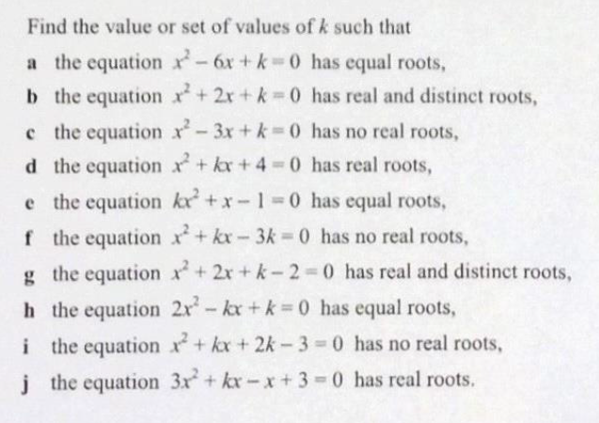

01: Transformations of Graphs

Recap of Trig Graphs.

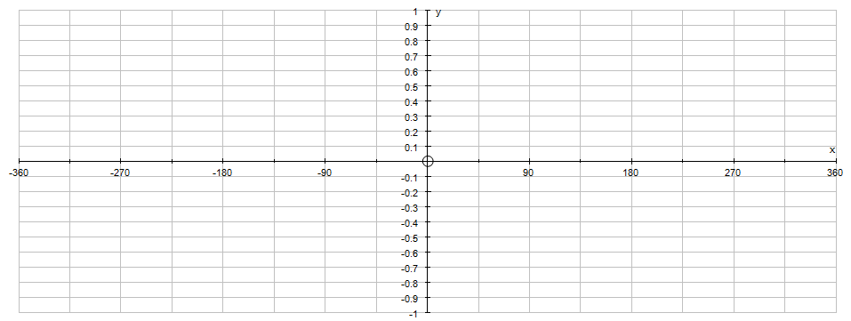Sketch $y=sin⁡(x)$

Think…

* ‘something happens every ${{90}^{o}}^{'}$… either 1, 0, -1
* Makes an ‘S’ over the origin
* Repeats every ${360}^{o}$ (period)
* Maximum 1, minimum -1 (amplitude)

Sketch $y=cos⁡(x)$

Think…

* ‘something happens every ${{90}^{o}}^{'}$… either 1, 0, -1
* Makes an ‘C’ over the origin
* Repeats every ${360}^{o}$ (period)
* Maximum 1, minimum -1 (amplitude)

Stretches

|  |  |
| --- | --- |
| Sketch $y=\sin{x}\& y=3\sin\left(x\right)$ | Sketch $y=\sin{x}\&$ $y=\sin\left(2x\right)$ |
| Sketch $y=\cos{x \& }y=2\cos\left(x\right)$ | Sketch $y=\cos{x \& }y=\cos\left(3x\right)$ |
| Sketch $y=\sin{x}\& y=4\sin\left(x\right)$ | Sketch $y=\sin{x}\& y=\sin\left(\frac{1}{2}x\right)$ |

Sketch $y=\sin{x}\& y=3\sin\left(2x\right)$

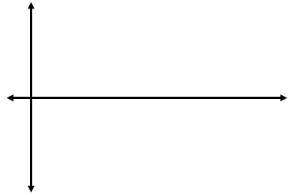

|  |  |  |
| --- | --- | --- |
| **Graph** | **Amplitude** | **Period** |
| y=sinx |  |  |
| y=2sinx |  |  |
| y=5sinx |  |  |
| y=sin(3x) |  |  |
| y=2sin(4x) |  |  |
| y=6sin(6x) |  |  |
| y=cosx |  |  |
| y=3cosx |  |  |
| y=cos4x |  |  |

Stretches

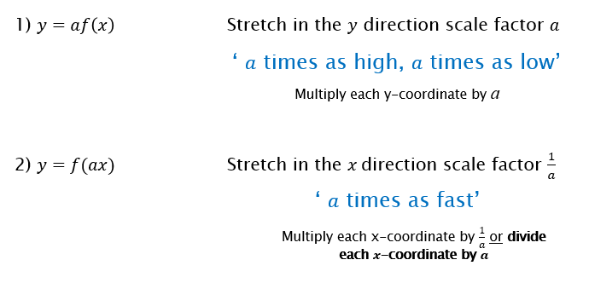

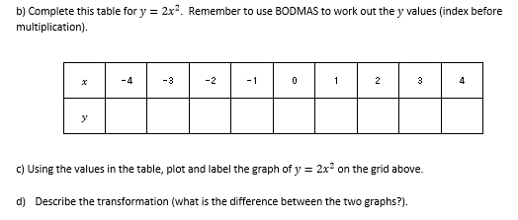Screen Clipping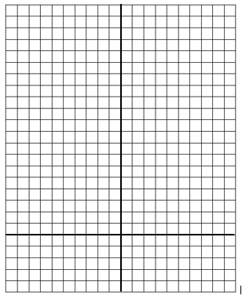

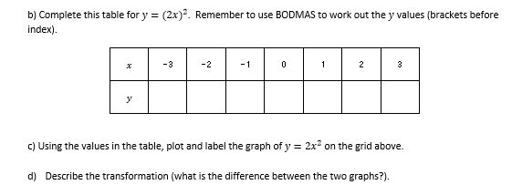Screen Clipping

|  |  |
| --- | --- |
| 1) Screen Clipping | 2)  Screen Clipping |

|  |  |
| --- | --- |
| 3)  Screen Clipping | 4)  Screen Clipping |

GCSE Questions

|  |  |  |
| --- | --- | --- |
| Here is the graph of $f\left(x\right),$ sketch )  Screen Clipping | Here is the graph of sketch )  Screen Clipping | Here is the graph of sketch )  Screen Clipping |

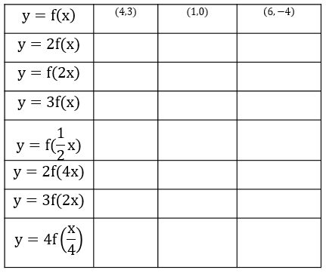

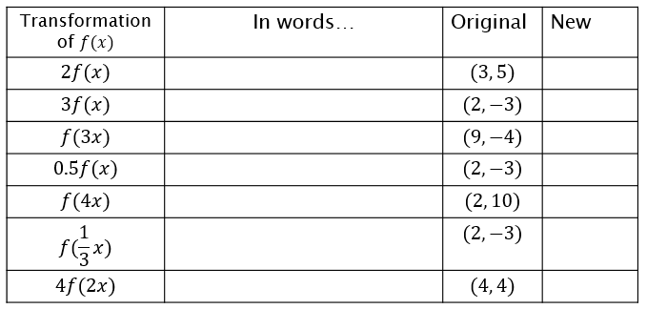

Screen Clipping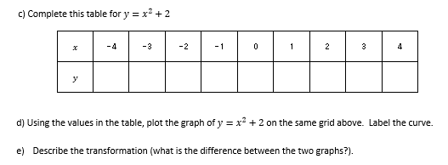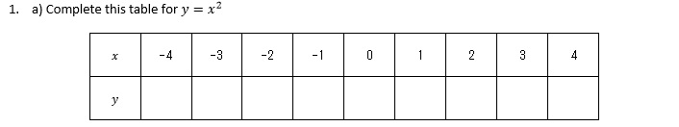02: Translations

|  |  |
| --- | --- |
| Sketch $y=\sin{x}\& y=\sin\left(x\right)+1$ | Sketch $y=\sin{x}\&$ $y=\sin\left(x+90\right)$ |
| Sketch $y=\cos{x \& }y=\cos\left(x\right)-2$ | Sketch |



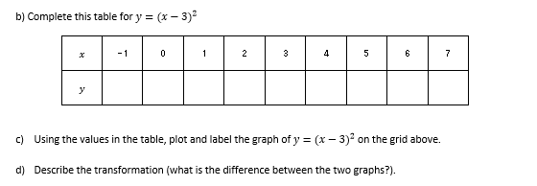Screen Clipping

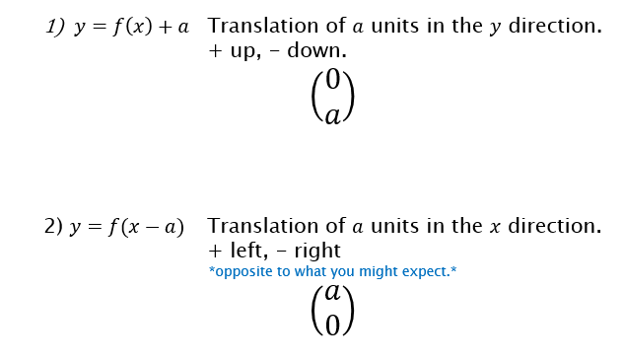

|  |  |
| --- | --- |
| 1) Screen Clipping | 2)  Screen Clipping |

|  |  |
| --- | --- |
| Screen Clipping1) | Screen Clipping2) |

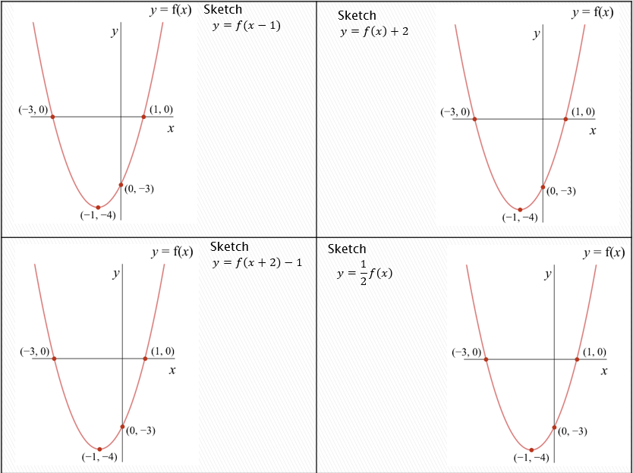

Reflections

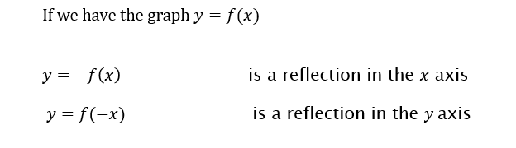

|  |  |
| --- | --- |
| 1) Screen Clipping | 2)  Screen Clipping |

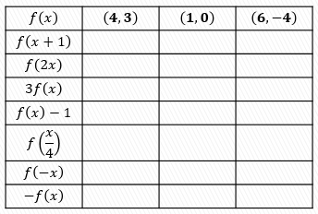

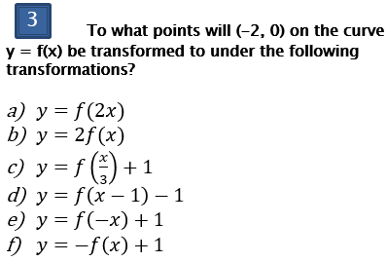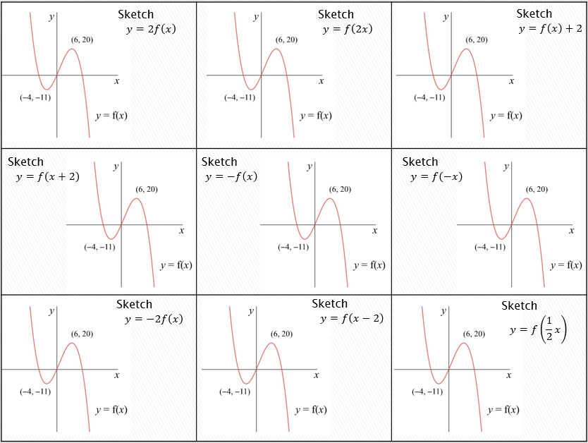

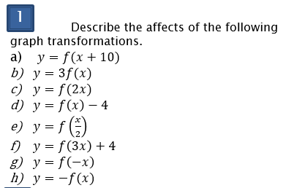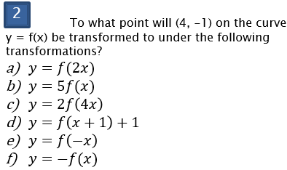

03: Sum Up & New Equations

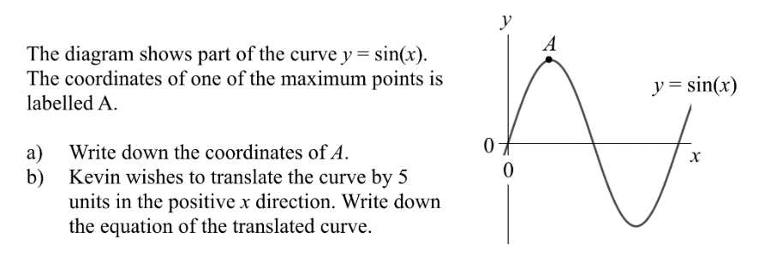

|  |  |  |
| --- | --- | --- |
| $$f\left(x\right)=x^{2}-4x$$ Here is the graph of $y=f\left(x\right)$ Sketch  a)  Screen Clippingb) Find the new equation | $$f\left(x\right)=x^{2}-4x$$ Here is the graphs of $y=f\left(x\right)$ Sketch  a)  Screen Clippingb) Find the new equation | $$f\left(x\right)=x^{2}-4x$$ Here is the graph of $y=f\left(x\right)$ Sketch  a)  Screen Clippingb) Find the new equation |

Further example:

The graph of $y=cosx$ is translated by vector $\left(\begin{matrix}45 \\ 2\end{matrix}\right)$

What is the equation of the new graph?

Describing Transformations of trig graphs (killer)

The graph shows the curve with equation $y=\sin\left(ax\right)+b$.

Determine the constants $a$ and $b$.

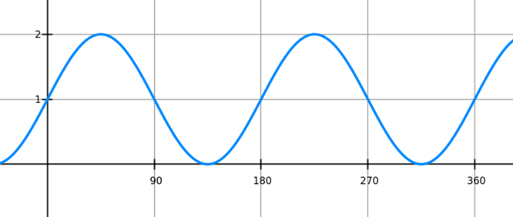

The graph shows the line with equation $y=a sin\left(bx\right)+c$.

Determine the constants $a, b$ and .

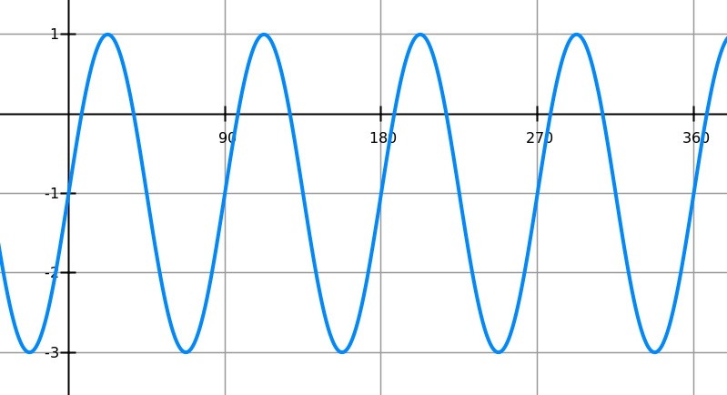

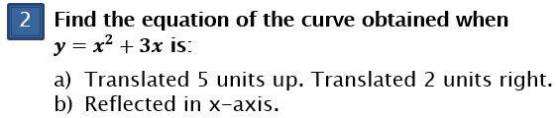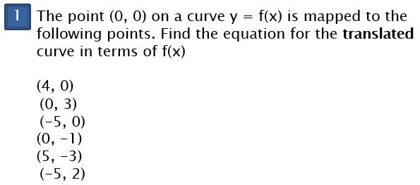

|  |  |
| --- | --- |
|  |  |
| 2. | 3. |

|  |  |
| --- | --- |
|  |  |
|  |  |
|  |  |
| 7. | 8. |

|  |
| --- |
| 9. |

04: Completed Square Form

Starter

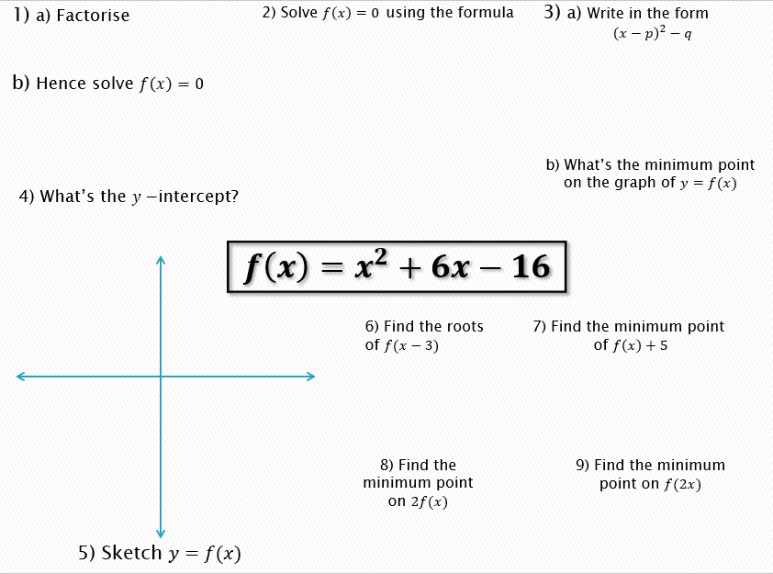

|  |  |  |  |
| --- | --- | --- | --- |
| $${1) x}^{2}+6x$$ | ${2) x}^{2}+4x+9$ | $${3) x}^{2}-3x-7$$ | 4) 2 $x^{2}+12x+1$ |

Translations of $y=x^{2}$

Example 1: Write $x^{2}+4x+9$ in the form of ${\left(x+a\right)}^{2}+b$.

Sketch the graph and state the minimum point and the line of symmetry.

Sketch the following graphs after writing in completed square form. Describe the translation of .

|  |  |  |  |
| --- | --- | --- | --- |
| 1) |  |  | 1. 4) |

Finding the equation of the curve

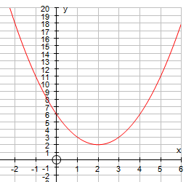

Killer GCSE ?

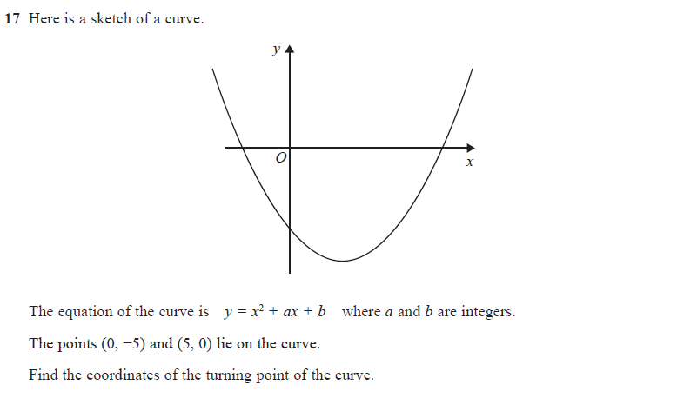

2.

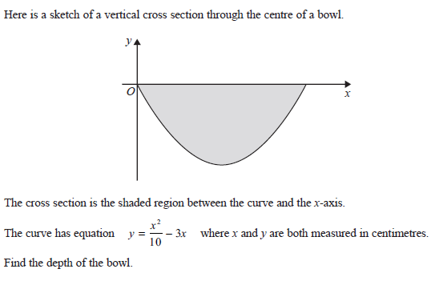

A Level Challenge ?

