English Literature: Moving from GCSE to A-Level…

|  |  |  |  |
| --- | --- | --- | --- |
| HOW DO I KNOW IF IT IS FOR ME? | | | |
| If you enjoyed reading and studying different literary texts (novels like *Lord of the Flies*, *Jekyll and Hyde, A Christmas Carol*; plays like *Macbeth, Romeo and Juliet, An Inspector Calls*; poems by a range of poets) at GCSE, then A-Level English Literature is for you. At A-Level, you will be studying more challenging and thought-provoking texts including novels, plays and poems, and probing the wider ideas and issues which are addressed in the texts, considering how the texts are a product of (and an influence on) the societies in which they are written and received. English Literature is about exploring, debating and analysing a broad range of social, political and historical issues through the medium of literature and delving into different societies and perspectives to enhance and deepen our own understanding and interpretations.  A-Level English Literature is the perfect companion to subjects such as drama & theatre, law, history, MFL and R.S., as well as A-Level English Language.  Delve into some of the links shown below to get more of an understanding of what you will explore in this particular subject at A-Level. | | | |
| **WATCH** | **READ AT HOME** | **LISTEN** | **FOLLOW** |
| The RSC currently have productions of *King Lear* and *I, Cinna* (a play inspired by *Julius Caesar*) available here: <https://www.rsc.org.uk/education/teacher-resources/online-performances>  Shakespeare’s Globe has also made available a version of Macbeth which teachers need to register for you share with their students. Check with your school if they have done so. The Globe player offers the opportunity to rent other productions too. <https://www.shakespearesglobe.com/watch/#full-length-productions>  Any of the TED talks on English Literature:  <https://www.ted.com/topics/literature> | ***Want to get ahead and read some of the texts we will study on the course?***  ***The texts are (in order of study):***   * ***A Streetcar Named Desire* by Tennessee Williams** * **Selected poems from *Poems of the Decade:*** <https://www.amazon.co.uk/Poems-Decade-Anthology-Forward-Poetry/dp/0571325408> * ***The Handmaid’s Tale* by Margaret Atwood** * ***Frankenstein* by Mary Shelley** * **Selected metaphysical poems** * ***Othello* by William Shakespeare**   ***Want to do some wider reading of literature that will complement the texts you will study? Why not try:***   * **Any play (particularly tragedies)by Shakespeare** * ***The Testaments* by Margaret Atwood (but only after you have read *The Handmaid’s Tale*!)** * **A range of poetry:** <https://www.poetryfoundation.org/> * **One (or more!) of the recommended holiday reads from Edexcel:** <https://qualifications.pearson.com/content/dam/pdf/A%20Level/English%20Language%20and%20Literature/2015/teaching-and-learning-materials/holiday_reading_inspiration.pdf> | **This is Spoke**  <https://play.acast.com/s/spoke>  **Selected Shorts**  <https://www.npr.org/podcasts/381443486/pri-selected-shorts?t=1589886059654>  **In Our Time**  <https://www.youtube.com/channel/UCp9ISh9oz5zFtd5_wJIu7gg/videos> | **(WARNING: Some adult content)**  @MargaretAtwood  @NYerFiction  @SparkNotes  @RobGMacfarlane |
| **SOMETHING TO PONDER…** | |
| *“You don’t have to burn books to destroy a culture. Just get people to stop reading them.” – Ray Bradbury*  How important is literature and reading to society?  How much is a text a product of the context and society in which it is written?  How much does the meaning(s) of a text come from the reader, rather than the writer? | |
| **WANT MORE?** | **READ ONLINE** | |
| **Visit the website for Edexcel A-Level Literature (our chosen specification) for more information about exams and content:**  <https://qualifications.pearson.com/en/qualifications/edexcel-a-levels/english-literature-2015.html> | * Articles from the British Library cover a range of different genres and authors: <https://www.bl.uk/> * To develop your contextual research and get used to reading critical essays around authors you are interested in or may be studying: <http://www.literaryhistory.com/> | |

Component 1: Drama

In this section you will study two plays: William Shakespeare’s *Othello* and Tennessee Williams’ *A Streetcar Named Desire*. You will analyse the meanings and ideas which arise from the texts, how these relate to the contextual factors influencing the plays and consider how far you agree (or disagree) with different interpretations and critical essays about *Othello*.

**Section A: William Shakespeare’s *Othello* (studied in Year 13)**

**Activity: Interpreting Shakespeare**

Watch one of the RSC productions of a Shakespearean play from those which are available online (some free to access e.g. *King Lear* <https://www.youtube.com/watch?v=zP_g-ODJ2SM>*)* Ideally, try to watch a performance of a play you have already read and/or studied.

Whilst you are watching (or after you have watched the performance), think about (and discuss with someone else if possible):

* The key themes and ideas which were most prominent in the play and what you feel Shakespeare was trying to communicate to his audience about those key themes/issues;
* How the staging, costume and performances contributed to your interpretation and understanding of the play (and the prominence of key ideas, characters and settings).
* (If you have previously read/studied the play) Are there any parts of the play which have been removed or altered? What is the effect of this? Why did the director make this decision and do you think it was a good decision? How does it alter/affect any of the ideas or meanings which arise from the play?
* (If you have previously read/studied the play) What would you do differently if you were the director? Why would you make these amendments?

**Section B: Tennessee Williams’ *A Streetcar Named Desire* (studied in Year 12)**

The first play you will study is *A Streetcar Named Desire* in the first term of Year 12. This play is rooted in the context of the Deep South of America in the 1950s, specifically New Orleans. If you have already read/watched the play (if not, there are spoilers in the video!) then it might be helpful to watch this short video which considers some of the contexts and interpretations of the play: <https://www.youtube.com/watch?v=VKigIgStwRs>.

Component 2: Prose

In this component you will study and compare two novels: Mary Shelley’s *Frankenstein* and Margaret Atwood’s *The Handmaid’s Tale.* The focus of the unit is ‘Science and Society’ and your study will focus around key themes and issues which arise from the two novels about issues such as (amongst others): humanity and what it is to be human; the interplay between an individual and the society they live in; gender; the impact of science and scientific thinking on humans and society.

**Activity: Analysing an Extract**

Read through these two short extracts from *A Handmaid’s Tale* and then make notes/annotations on the prompt questions below.

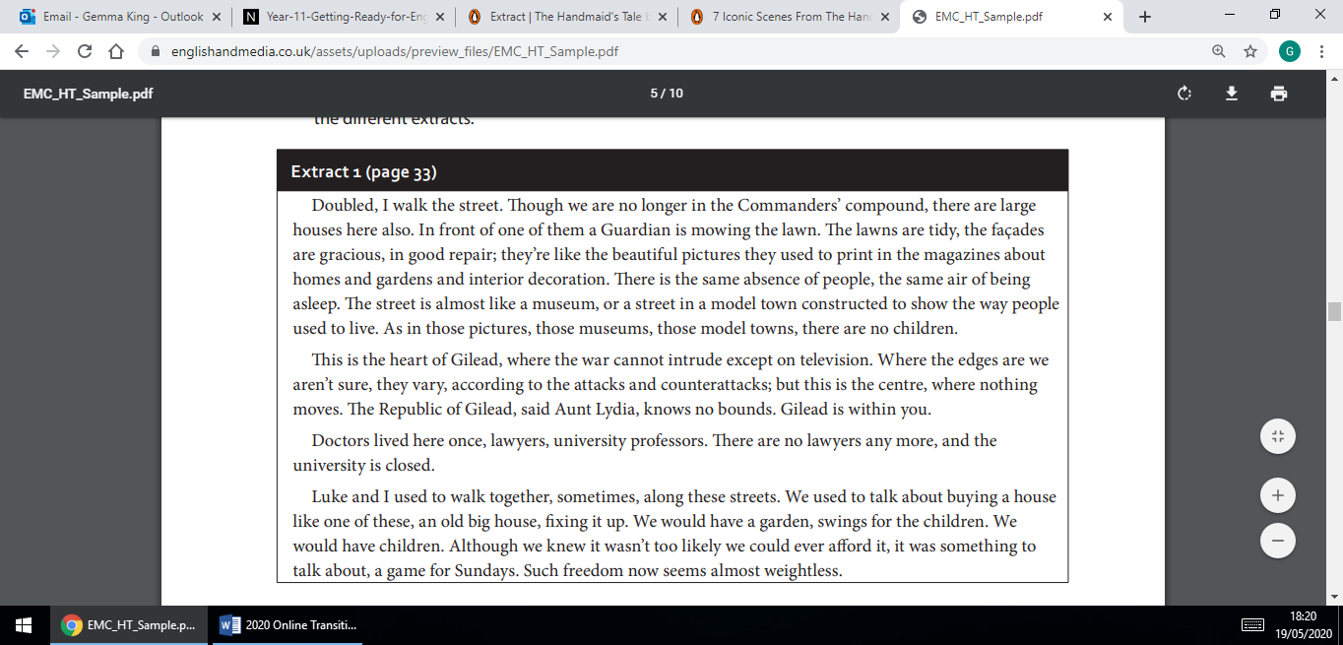

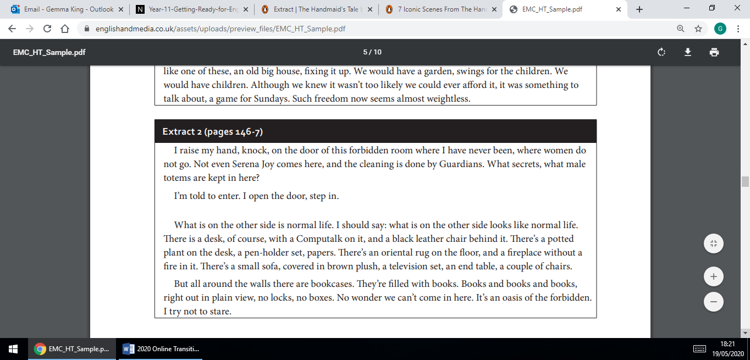

Thinking points:

* What can you tell from the extracts about the possible storyline or characters in this novel?
* What can you tell about the kind of book it is – the genre? Have you read any other books which are from a similar genre? What are the expectations and characteristics of this genre?
* What issues are being raised in these extracts? Any clues about underlying tensions and possible points of conflict?
* What’s interesting about the style in which these extracts are written?

Component 3: Poetry

In this component you will study, analyse, discuss and explore a range of modern and metaphysical poetry from a wide range of poets. The modern poems you will study are specific poems from the poetry anthology *Poems of the Decade* (<https://www.amazon.co.uk/Poems-Decade-Anthology-Forward-Poetry/dp/0571325408>). The metaphysical poetry includes specific poems from a range of poets, including Donne, Herbert and Marvell.

**Activity: Analysing and Interpreting a Poem**

Read through ‘The Gun’ by Vicki Feaver (one of the poems from the modern poetry anthology) and listen to Feaver’s reading of the poem online: <https://poetryarchive.org/poem/gun/>. Then read through the reading of the poem on the right hand side of the poem; this is one reader’s interpretation and understanding of the poem. Finally, consider and make notes on the bullet points at the bottom of the page.

**A reading of ‘The Gun’**

This poem has the power to shock on several levels.

It inverts most current liberal attitudes to the natural world, to hunting and to the intrinsic value of wildlife. It is brutally unemotional and makes no moral judgments.

It also juxtaposes two concepts normally thought of as opposites — a house and kitchen with its associations of home, warmth and security, and a gun with its association of violence and death. Adding sex to the mix results in an uncomfortable, disturbing poem about killing and the grim pleasure it engenders.

**Structure**

The poem comprises five irregular length stanzas with lines also of irregular length. There is no rhyme scheme, though occasional assonant rhyme, as in ‘dead’ and edge' in stanza two, and ‘string’ and ‘tins’ in stanza three. More noticeable is the consonant rhyme in the final stanza — ‘cooking’, ‘jointing’, ‘tasting’ etc.

Enjambment is cleverly used to create a choppy, uneasy rhythm, with line endings at unexpected points, giving emphasis to words at the beginning and end of lines. For example ‘You trample/fur and feathers.’ in stanza five.

**Language and Imagery**

The voice is that of the partner of the protagonist who is fired up by possessing and using the gun. It is not clear if this is the poet. She uses the first person singular pronoun ‘I’ and addresses her partner as ‘you’.

She uses straightforward, everyday language, though there is symbolic imagery, like the shadow cast by the gun on the kitchen table in stanza two. This applies until the last stanza where she refers to the ‘King of Death’, and moves into the world of mythology.

The tone is flat, understated and unemotional throughout, which makes the violence towards and killing of the animals all the more chilling. The poem is unsettling and inventive.

‘The Gun’

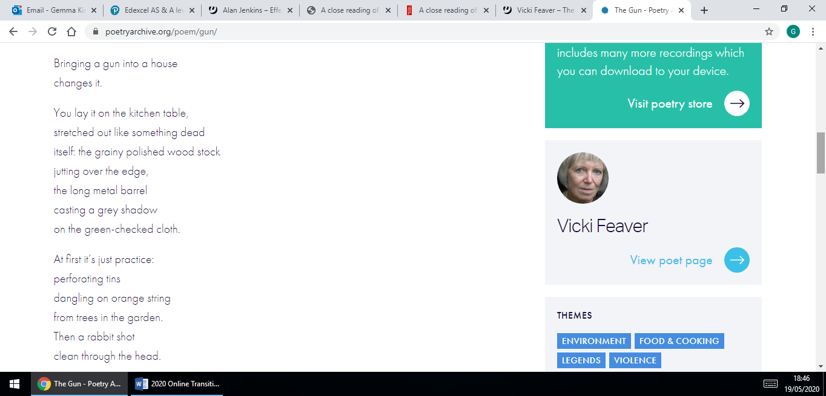

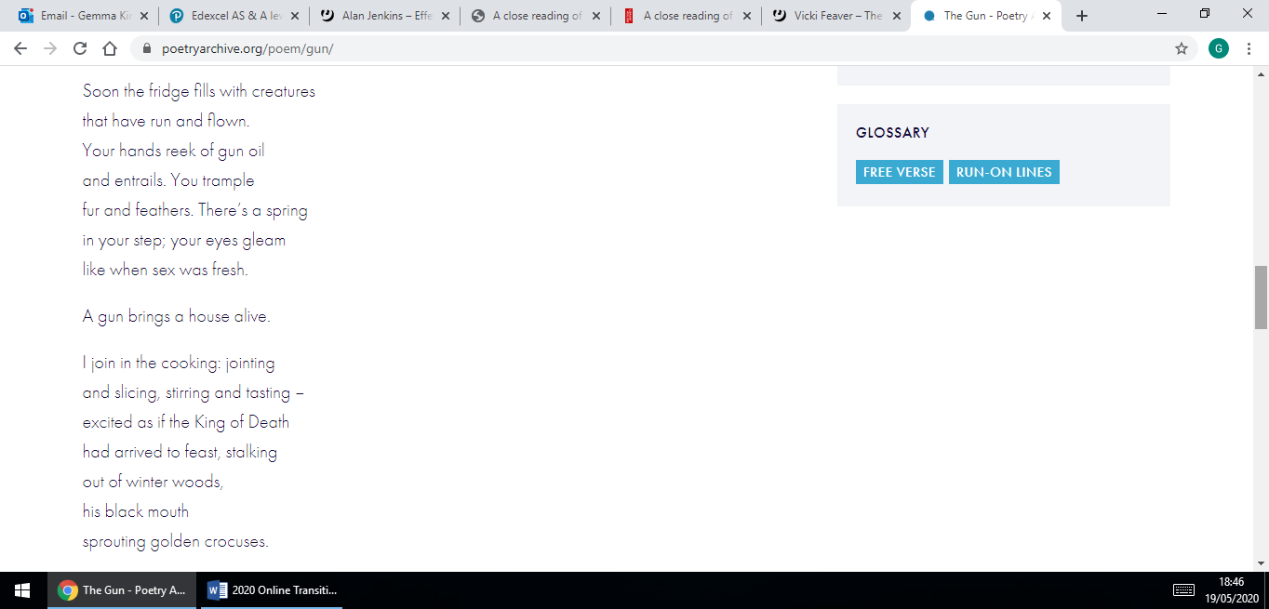

Consider:

* How far you agree with this reading of the poem;
* Whether there are any other interesting or significant elements of the poem and/or methods the poet is using which seem important to you;
* What you think the poet is showing about violence and killing;
* How the poem could be considered to be exploring ideas about masculinity and femininity; what ideas are put forward and which specific sections of the poem are important to the presentation of these ideas?

Component 4: Non Examined Assessment (Coursework)

At BRGS we see the coursework as an opportunity for you to explore an aspect of literature that you love. You will read, research and analyse two texts (you can choose from a selection of different texts which span a variety of genres, movements, authors and literary periods) before producing an extended comparative essay (2500-3500 words) comparing the two literary texts. Texts may be selected from poetry, prose and drama.

**Activity: Text in Context**

Firstly read the very brief overview of some of the contextual factors influencing F. Scott Fitzgerald’s novel, *The Great Gatsby:*

* *The Great Gatsby* was published in 1926.
* It is deeply rooted in American society of the time and explores the concept of The American Dream and how it is perceived (and attempted to be achieved) by different characters.
* The American Dream is a cultural, national dream that basically states that anyone in the USA can be successful, no matter what background they come from. The premise of ‘successful’ at the heart of The American Dream is: owning your own property & land; being good looking; being successful and popular; earning your own money; owning the latest consumer goods; having a family.
* As the 20th Century drew closer, the Dream became that of industry and capitalism (and, later, consumerism), with men such as John D Rockerfeller beginning life in humble conditions, but going on to control vast corporations and the fortunes that resulted. Successes such as these suggested that talent, intelligence and a willingness to work hard were all that was needed to achieve the dream.
* *The Great Gatsby* is focused on a society in the aftermath of the First World War and, crucially, before the Wall Street Crash of 1929.

Then read the extracts from **Chapters 1 and 3** (below) of *The Great Gatsby* which describe Gatsby’s house and party from the perspective of the narrator, Nick.

* How does Fitzgerald use language and setting to reflect Gatsby’s character and lifestyle?
* How do any of the details here relate to your understanding of The American Dream?
* Is Gatsby living The American Dream? Has he achieved The American Dream?

Finally, watch the extract where the narrator (Nick Carraway played by Tobey Maguire) meets Gatsby (played by Leonardo DiCaprio) from the 2013 film adaptation of the novel: <https://www.youtube.com/watch?v=2zHHkSu1br4>

* How does the film emphasise key aspects and key ideas about The American Dream?
* What links can you make between the film and the extracts from the text in terms of the key themes, ideas and atmosphere being conveyed?

