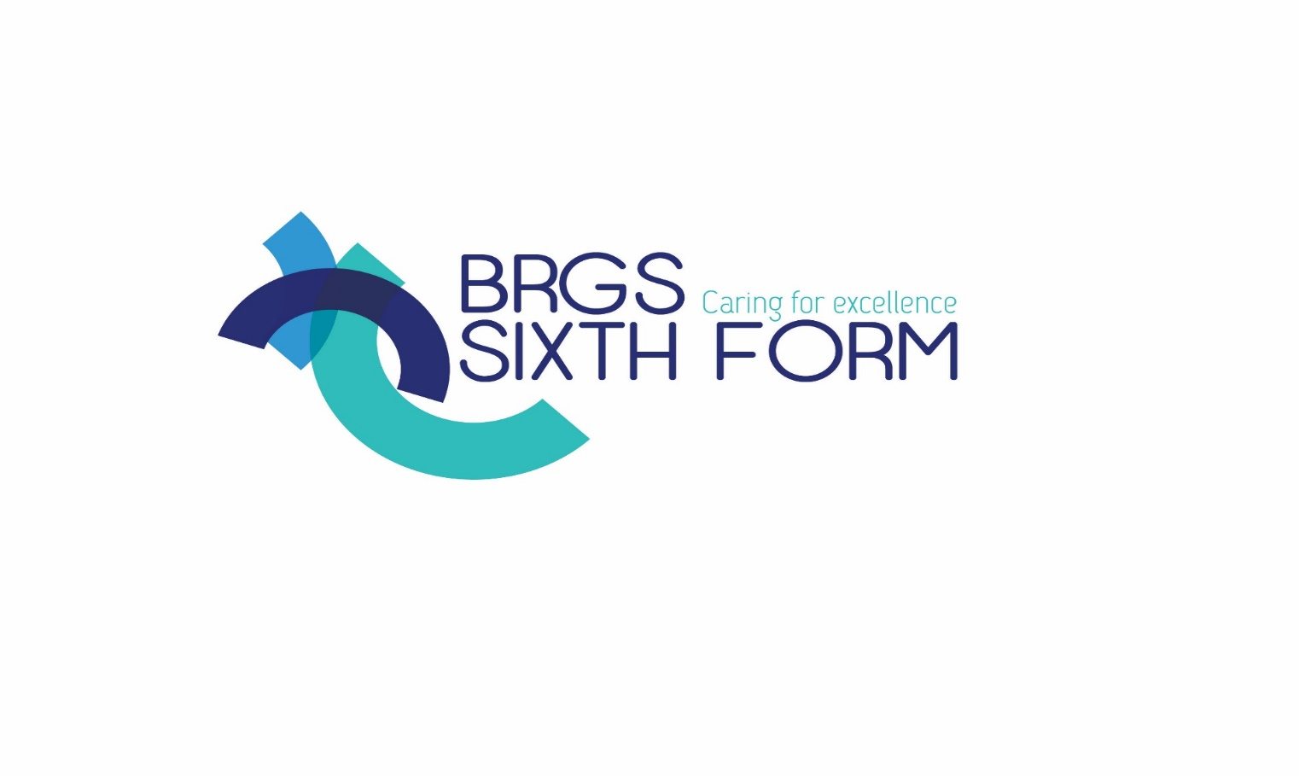

 A LEVEL RELIGIOUS STUDIES

Transition Booklet

Philosophy, Ethics and Religion at BRGS

Why you might just be interested …

Religious Studies helps makes sense of it

Right now, everyone has something to say about religion

An RS student – you’re special!

**What students say:**

*“ I think in RS it is always interesting to learn about different beliefs while still believing in my own”*

*“I like RS because we can ask questions and talk about what we think”*

*“We discuss issues that make me look inside myself and think very deeply about the world, behaviour, my personality, my beliefs”*

*“In philosophy and ethics I like it that there is not just one right answer. I like the debates. I like getting people to respond and I like to understand other peoples’ decisions”*

*“It really works well with my other subjects, such as history”*

If you enjoy the discussions and debates, the idea that there is not just one right answer and listening to other people’s views, then A level RS is right for you!

The course offers an excellent opportunity for students who have an enquiring mind to explore some of the great classical ideas in the world of philosophy and ethics and to discuss some of the ultimate questions facing humanity today.

You will also become acquainted with some of the greatest minds and figures in the world’s history: Plato and Aristotle, Jesus and St Paul, St Thomas Aquinas and Jeremy Bentham, Freud and Jung. Views of key atheists are also prominent, such as Richard Dawkins.

Although lively debate in lessons is encouraged, independent study also forms a crucial part of our learning. Below you will find some useful clips, readings, films and activities that will help you in your preparations for study here. There is also information at the end giving an overview of the course in more detail and information about assessment (the exam board we use is Eduqas).

PHILOSOPHY

The word `philosophy’ comes from two Greek words: `*philo–sophos’* meaning Love of Wisdom.

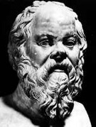This should remind you that philosophy was invented by the Greeks. Something we forget is this: the Greeks were free and independent people with their thoughts, just like we are. Actually we learnt it from them. So the important issue about philosophy, is that you have to be a free agent. People who live in dictatorships, or tyrannies, usually don’t philosophize because they are told how to live and think.

I give you an example. Back in ancient Greece, Socrates (pictured left) used to walk the streets and ask people, what is life all about? He could ask us today the same questions. In the end he always said: the unexamined life is not worth living. This means that life must be lived with a conscious awareness of what is ethical in your dealings with others.

Welcome to the world of philosophy!

Let’s start with a clip that will introduce you to this special way of thinking …

<https://www.youtube.com/watch?v=1A_CAkYt3GY>

**Socrates, Plato and Aristotle (The Great Greek Three)**

These men taught that things are not what they seem.

Plato taught that all of the things in this world were pale imitations of things in a perfect world, the world of the forms.

Aristotle, a pupil of Plato, disagreed and said that objects were made up of two qualities essentially. Their appearance and their reality.

What is a chair? How’s it different to a table?

How can we be sure of anything?

Unfortunately, when we look at the world, all we have to rely on are our perceptions

***The Allegory of the Cave***

Here's a little story from Plato's most famous book, **The Republic**.

Socrates is talking to a young follower of his named Glaucon, and is telling him this fable to illustrate what it's like to be a philosopher - a lover of wisdom:

Most people, including ourselves, live in a world of relative ignorance.

We are even comfortable with that ignorance, because it is all we know.  When we first start facing truth, the process may be frightening, and many people run back to their old lives.  But if you continue to seek truth, you will eventually be able to handle it better.  In fact, you want more!

It's true that many people around you now may think you are weird or even a danger to society, but you don't care.  Once you've tasted the truth, you won't ever want to go back to being ignorant!

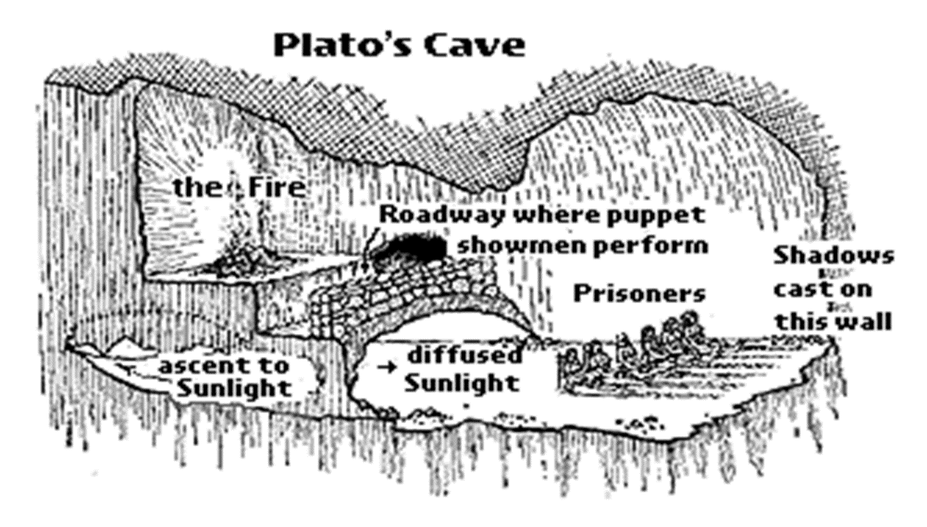**Task**: Look up what the diagram means

This theme is taken up in a modern context by `The Matrix’ – a movie that messes with your head!

**This world is a shadow of the real transcendent world of true, pure forms**

**The Matrix** **– can we be certain of anything?**

 Neo  Morpheus

**Task**: watch the key scene where Morpheus offers the choice of pills to Neo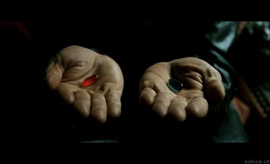

<https://www.youtube.com/watch?v=zQ1_IbFFbzA>

and the follow-up scene about the `desert of the real’:

<https://www.youtube.com/watch?v=EVM5-_fusjs&t=108s>

**So, what’s the point?**

* You will learn how to think analytically, critically and logically.
* Such skills are invaluable in a very wide range of careers from law to medicine (incidentally we cover quite a range of medical ethics)
* These skills do not just help out in the world of work. They’re important for life!

ETHICS

Ethics is the study of the nature of right and wrong. What distinguishes humans from other animals is our ability to make moral decisions. We deliberate before making choices; we feel guilt; we are motivated to take great risks for what we believe is right; we have a moral dimension.

Our course explores how human beings decide what is right or wrong, good or bad. It examines how different thinkers have tried to define what it means to be a good person. It also investigates some of the most prominent ethical issues of our time.

There are lots of different scenarios that help to tease out key ethical dilemmas. If you watch `The Good Place’, you may well be familiar with the way in which that RS-friendly series picks out a number of key ideas. For example, watch the following clip which centres on the classic `Trolley Problem’:

<https://www.youtube.com/watch?v=JWb_svTrcOg>

So, here’s a few for you to try yourself (with some ethics views following):

**What would you do?**

You witness a car crash. The wreckage is burning, but you may be able to save one of the two passengers. To your horror, you realise that one is your father and the other is a famous cancer specialist on the brink of a breakthrough. Who do you save?

**What would you do?**

Your ship goes down and you’re lost in the sea with two others, all of you in a life raft. You have no food. Without a supply of food, there’s no hope of rescue before you starve to death. Two would survive by eating the third: otherwise, all three will die. What do you do?

**NATURAL LAW ETHICS**

A THEORY PUT FORWARD BY ST THOMAS AQUINAS

When you make an ethical decision you must:

1. use your reason;
2. follow the first precept (rule) which is to preserve life;
3. as far as possible keep to what is natural, i.e. part of the natural scheme of things.

Does this help with the above dilemmas?

**What would you do?**

A railway drawbridge operator is closing the bridge for the express train that is about to arrive when he sees his son trapped in the machinery. To close the bridge will kill his son but save the train. To open the bridge will save his son, but the train will not be able to stop in time. What should he do?

**What would you do?**

Siamese twins are born, attached at the abdomen and sharing several major organs. If nothing is done, both will eventually die. If the twins are separated, one will die and one will live. What should be done?

**UTILITARIAN ETHICS**

A THEORY PUT FORWARD BY JEREMY BENTHAM

When you are making an ethical decision you must:

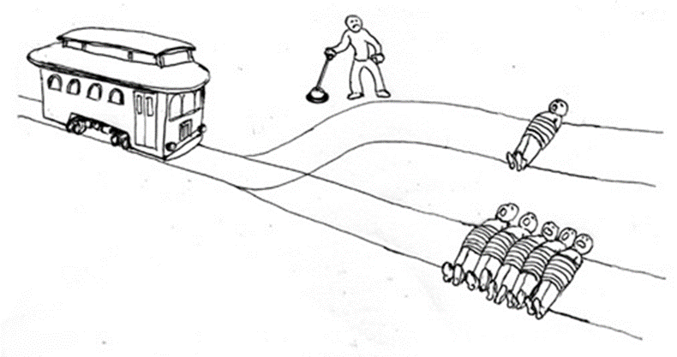a. decide what action would bring the greatest happiness to the greatest number of people;

b. or what action would bring the least amount of unhappiness to the most people.

c. not take personal relationships into account.

**So what?**

You might find some of these questions interesting and enjoy the intellectual challenge of them. Fancy that! A subject at school/college you actually enjoy!

If you do, you are likely to do very well when you sit your exams. Anecdotal research suggests a strong link between enjoyment and performance at A level.

A STUDY OF RELIGION -

CHRISTIANITY

RS probably wouldn’t be RS without some advanced study of a particular religion. We offer Christianity as the religious component of the course. The intent is to deepen students’ knowledge and understanding of Christians and Christianity, but also to give you opportunities to consider your own ways of thinking and living.

**A LEVEL RELIGIOUS STUDIES**

**The A level is split into three components:**

**Component 1: A Study of Religion**

**Written examination: 2 hours**  **33**⅓**% of qualification**

This component offers the choice of the study of **one** religion

Option A: Christianity

There will be four themes :

* religious figures and sacred texts
* religious concepts and religious life
* significant social and historical developments in religious thought
* religious practices and religious identity

**Component 2: Philosophy of Religion**

**Written examination: 2 hours**  **33**⅓**% of qualification**

There will be four themes within this component:

* arguments for the existence of God
* challenges to religious belief
* religious experience
* religious language.

**Component 3: Religion and Ethics**

**Written examination: 2 hours**  **33**⅓**% of qualification**

There will be four themes within this component:

* ethical thought
* deontological ethics
* teleological ethics
* freewill and determinism

See below if you would like to know in more detail what is taught within each theme:

[**Christianity 33%**](http://www.rsrevision.com/Alevel/boards/eduqas/christianity.html)

**Religious figures and sacred texts**

* Jesus – his birth
* Jesus – his resurrection
* The Bible as a source of wisdom and authority
* The early church (in Acts of the Apostles)
* Two views of Jesus

**Religious concepts**

* the nature of God
* the Trinity
* the Atonement

**Religious life**

* faith and works
* the community of believers
* key moral principles

**Social developments in religious thought**

* attitudes towards wealth
* migration and Christianity in the UK
* religion, equality and discrimination

**Historical developments in religious thought**

* challenges from secularisation
* challenges from science
* challenges from pluralism and diversity within a tradition

**Religious identity through:**

* diversity in baptism
* diversity in Eucharist
* diversity in festivals
* unification
* religious experience
* responses to poverty and injustice

[**Philosophy of religion 33%**](http://www.rsrevision.com/Alevel/boards/eduqas/philosophy.html)

**Arguments for the existence of God**

* inductive - cosmological
* inductive - teleological
* deductive - ontological

**The problem of evil and suffering**

* The problem of evil
* Augustinian type theodicy
* Irenaean type theodicy

**Religious belief as a product of the human mind**

* Sigmund Freud
* Carl Jung
* Atheism

**Religious experience**

* Visions, Conversion, Mysticism, Prayer
* Mystical experience - William James, Rudolf Otto
* Challenges to the objectivity and authenticity of religious experience
* The influence of religious experience on religious practice and faith
* Miracles
* A contrasting study of David Hume and Richard Swinburne

**Religious language**

* inherent problems
* cognitive, but meaningless
* non-cognitive and analogical
* non-cognitive and symbolic
* non-cognitive and mythical
* a language games

[**Ethics 33%**](http://www.rsrevision.com/Alevel/boards/eduqas/ethics.html)

**Ethical thought:**

* Divine command theory
* Virtue theory
* Ethical egoism
* Meta-ethics - [Naturalism](http://www.rsrevision.com/Alevel/boards/eduqas/a2ethics/naturalism.html), [Intuitionism](http://www.rsrevision.com/Alevel/boards/eduqas/a2ethics/intuitionism.html), [Emotivism](http://www.rsrevision.com/Alevel/boards/eduqas/a2ethics/emotivism.html)

**Deontological ethics:**

* Thomas Aquinas’ Natural Law
* The role of virtues and goods
* Natural Law, applied to:

1. abortion
2. voluntary euthanasia

* [John Finnis’ development of Natural Law](http://www.rsrevision.com/Alevel/boards/eduqas/a2ethics/finnis.html)
* [Bernard Hoose's Proportionalism](http://www.rsrevision.com/Alevel/boards/eduqas/a2ethics/hoose.html)
* Finnis’ Natural Law and Hoose’s Proportionalism applied to:

1. [immigration](http://www.rsrevision.com/Alevel/boards/eduqas/a2ethics/immigration.html)
2. [capital punishment](http://www.rsrevision.com/Alevel/boards/eduqas/a2ethics/death_penalty.html)

**Teleological ethics:**

* Joseph Fletcher’s Situation Ethics, applied to:

1. homosexual relationships
2. polyamorous relationships

* Jeremy Bentham’s Act Utilitarianism
* John Stuart Mill's development of Utilitarianism
* Utilitarianism applied to:

1. animal experimentation for medical research
2. the use of nuclear weapons as a deterrent

**Determinism & Free Will**

* [Religious concepts of predestination - St Augustine, Calvin](http://www.rsrevision.com/Alevel/boards/eduqas/a2ethics/predestination.html)
* [Concepts of determinism](http://www.rsrevision.com/Alevel/boards/eduqas/a2ethics/determinism.html)
* [The implications of predestination / determinism](http://www.rsrevision.com/Alevel/boards/eduqas/a2ethics/implications.html)
* [Religious concepts of free will - Pelagius, Armenius](http://www.rsrevision.com/Alevel/boards/eduqas/a2ethics/freewill.html)
* [Concepts of libertarianism](http://www.rsrevision.com/Alevel/boards/eduqas/a2ethics/libertarianism.html)
* [The implications of libertarianism and free will](http://www.rsrevision.com/Alevel/boards/eduqas/a2ethics/implications.html)

**Further reading**

If you would like to get ahead with some background reading, the following are recommended:

**Philosophy**

*Reason and Religious Belief* (Oxford University Press 2012) is edited by Michael Peterson and three others and works at a fairly elementary level with chapters on some of the areas we have mentioned. It’s a comprehensive guide.

**Ethics**

*Ethics in the Real World*, Peter Singer (Princeton University Press 2017). This book is sub-titled *82 Brief Essays on Things That Matter*. Peter Singer is often described as today’s most influential philosopher, and in this book he dissects current events in a few hundred words. He applies his controversial thinking to topics such as climate change, animals, abortion, euthanasia and ways of increasing happiness.

*Ethics: a Very Short Introduction*, Simon Blackburn (Oxford University Press 2003). This pocket-sized book is a good way to get into the subject very quickly.

**Christianity**

*Christianity: A Very Short Introduction*, Linda Woodhead (Oxford University Press 2014). An overview which explores the cultural and institutional dimensions of Christianity over two millennia.

Finally, in case you were wondering, our RS students over the years have had consistent, excellent achievement.

Our 2019 (last proper exam series) figures were:

100% Pass rate

43% A* - A

86% A* - B

We hope to be able to welcome you soon to Religious Studies at BRGS!