

**Advanced Level Art**

**At BRGS**

[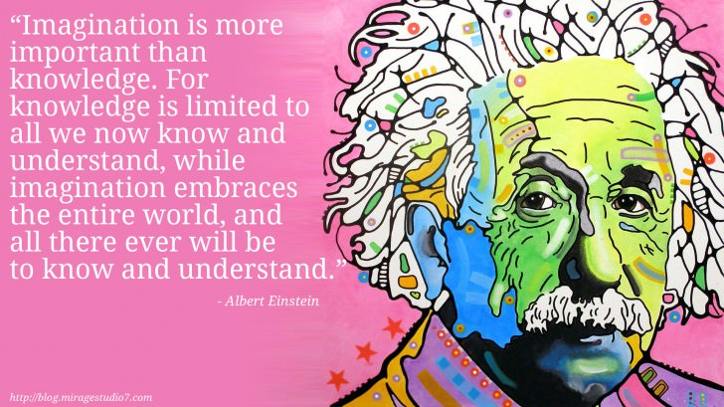](https://www.google.co.uk/url?sa=i&url=https%3A%2F%2Fblog.miragestudio7.com%2Finspiring-quotes-from-creative-thinkers-leaders-and-artists%2F5314%2F&psig=AOvVaw33idEG7gHzuRsne_sWgfIc&ust=1591103412514000&source=images&cd=vfe&ved=0CAIQjRxqFwoTCPCIgKDY4OkCFQAAAAAdAAAAABAW)

Art at BRGS is a subject that allows you expand your creative concepts, as well as hone practical (hand/eye coordination) fine art skills plus it builds on critical thinking and new computer skills such as utilising Adobe Photoshop. This combination enables students to step into a whole gamut of careers that includes everything from the new creative media industries (many are based at the ever expanding Media City in Salford) to architecture, product design, gaming, animation, fashion, illustration, web design, art historian and curators, landscape and interior design and so on.

All industries are now asking for creative thinkers to join their spheres.

[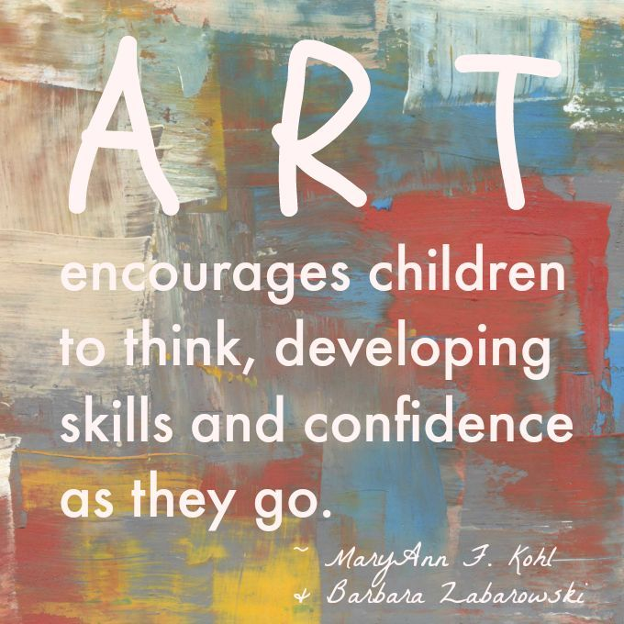](https://www.google.co.uk/url?sa=i&url=https%3A%2F%2Fwww.pinterest.com%2Fpin%2F259590365999568540%2F&psig=AOvVaw33idEG7gHzuRsne_sWgfIc&ust=1591103412514000&source=images&cd=vfe&ved=0CAIQjRxqFwoTCPCIgKDY4OkCFQAAAAAdAAAAABAe)

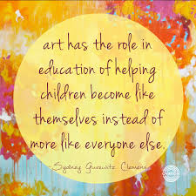

**A Level Art**

With the expansion and continued growth of media platforms, film, television, animation and gaming, art and design continue to be a vital part of the burgeoning creative industries. Even if you do not wish to step into an art based career, most industries and employers now appreciate a qualification that has extended your critical and creative thinking and developed your original thought.

Here at BRGS, you will do research and contextual studies around art history, producing mini writing assignments as required by the EDUQAS exam board. You will also refine your core art skills of drawing and painting from observing life around you, but in addition, be able to experience and develop computerised skills via Adobe Photoshop. Combine original thought with the dovetailing of the traditional and modern and our students achieve a unique set of transferable skills that can be applied to most careers.

Our programme of study starts with a mini foundation course where students get chance to develop these skills:-

* Drawing and painting in various media, including acrylic painting
* Critical analysis of art history and art works
* Presentation of sketchbooks and artwork
* Observational photography
* Adobe Photoshop skills
* Printmaking
* Lettering
* Concept and idea building
* Self-evaluation plus self and peer critiquing
* Independent learning skills
* Developing work with personal meaning, from a starting brief
* Sustained development and improvement of ideas
* Creating complex ideas in visual form

***ART A’LEVEL IS RIGHT FOR YOU IF:-***

***You know you want to work in an art or creative capacity in the future***

***or if…***

***You are creative and artistic but are unsure yet what you want to do in the future***

|  |
| --- |
| **ART A’LEVEL RESULTS AT BRGS**   * **Our art results are consistently very strong.** * **We have regularly been praised by the exam boards for extremely high levels of work in the department.** * **Students always pass A’level art** * **It is unusual for there to be lower than a D and Ds are not the norm either.** * **Students come to us from other schools and find they increase their skill sets considerable ie. coming in at a B/C GCSE standard and leaving with an A at A’level is a regular occurrence. One male student has just done exactly this.** * **Our students always gain their first choice of a creative degree** |

COURSE STRUCTURE

1. Mini Foundation Sept – Feb Yr 1. Trialling and developing skills and experience until students are confident about which processes, methods and materials to advance with. This also includes an art trip, art enrichment experiences and we have regularly had artists working in the field come and work with our students such as animators, printmakers and gamers.
2. Art portfolio Feb – Feb Yr 1 and 2. An extensive project of the student’s choice that covers four exam board stages of observation, critical students, development and outcome. We have come to know the students experience, expertise and ambitions well by this stage and will do everything within our breadth of knowledge to assist, guide and enable success. For example, if a student in interested in architecture, we can offer artists and architects to study, we understand what university courses are looking for, we will guide students to hone their technical drawing skills and produce a portolio and project outcome that demonstrates extensive focus on architecture. *We offer personalised UCAS references for creative courses and help with portfolio for interview.*
3. Exam art project – Feb – May Yr 2. An exam board lead choice of questions that incorporates 3 months preparatory work (1 month per stages of observation, critical studies and development). This will culminate in a 10 hour controlled assessment producing a piece of work that was meticulously outlined, and concept developed, during the three months previously.

**STAFF AND TEACHING**

* Sixth form teaching is shared between two highly experienced teachers: Head of Art, Mrs Bamford and art teacher, Miss Flint. This enables different specialism experience to be gained by pupils who are lead equally by the two teachers, via separate lessons of 9 per fortnight.

**EQUIPMENT**

* Basic art equipment is essential, however we have provision where we sell portfolios of equipment and art sketchbooks at no profit to ourselves.
* In an ideal world, you would have a decent phone camera and Adobe Photoshop accessible at home, however, every classroom has 15 computers in with Adobe Photoshop on plus we school cameras that can be utilised also.

**INDEPENDENT LEARNING AND SUPPORT**

We expect you to spend about3/4 hours per week outside lessons working. This includes set homework, but if you aren’t set any following a lesson, it’s best to use this time for ongoing development of your sketchbook and artwork.

We offer specific lunchtime support sessions to help you with anything you need. Some students come along just to complete their homework in a focused and supportive environment, others attend with specific questions, and some are advised to come along for some extra help with a particular aspect of their learning.

**TRANSITION ACTIVITIES**

As drawing underpins art in many different ways, we would recommend that you do online tutorials found on youtube regarding drawing with pencils, biros, ink pens etc and you become confident with drawing tools.

If you have not tried acrylic painting before, we would also recommend that you buy a basic set of acrylics and have a little practice, again look at online tutorial and start by blending paint and mixing colours. A good exercise is to pick an artist’s piece that is not too complicated (a Matisse still life or a Picasso portrait for example) and try to emulate the brush strokes and colours as closely as you can, critiquing yourself on how to improve as your progress.

If you are doing a creative course, CONTACT THE UNIVERSITY/COURSE LEADER and ask if there is a summer project for you to do, or ask what a theme will be and you can start working on that.There are summer schools in many things now, such as architecture. A google of: architecture, summer school, UK, for example, will bring up a list of UK summer schools. Or be specific. Same for animation, fashion etc. If you have a new computer package to learn for the course, then start training yourself on these through online tutorials such as CAD, Adobe Illustrator or Blender.

**THINKING AHEAD – (these are just examples to be broadened to other forms of art and design disciplines).**

* **You may know you wish to be an animator for example and want to student all things Studio Ghibli. But if you are unsure, start looking at art work (via the Tate galleries online or in real life – ie. Go to Liverpool) and understanding what type of art you like, are interested in, or you want to study further. Is there an artist that inspires you?**
* **Also think what your personal theme might be and start collecting names and images in a little scrap book of artists linked to that theme. For example: You may like fashion – so you can study and collect imagery of fashion designers you like. But you may also like origami and you could collect origami imagery too because in the future you may want to combine origami and fashion to produce something exciting and original. If you do a google search on origami and fashion, you may find interesting things pop up already!**