Contents Page(s)

Keeping things organised 1-4

Recommended purchases 5

Log-ins and passwords 5

Grammar checklist 6-7

Writing an effective essay 8

Essay phrases/language 9-10

German websites

for listening/reading practice 11



A Level German

Keeping things organised

It will be vital to organise your German file effectively in the coming two years. You will stay on top of the course and it will make revising all the easier if you know exactly where everything is when you need it.

1. **Organise your file in sections according to themes and sub-topics:**

**Section A**

**Year 12**

**Theme: Aspects of German-speaking society**

**Familie im Wandel** (the changing family)

* Beziehungen innerhalb der Familie (Relationships within the family)
* Partnerschaft und Ehe (Partnership and marriage)
* Verschiedene Familienformen (Various forms of family life)

**Die digitale Welt**

* Das Internet
* Soziale Netzwerke
* Die Digitalisierung der Gesellschaft (Digital society)

**Jugendkultur: Mode, Musik und Fernsehen**

* Mode und Image
* Die Bedeutung der Musik für Jugendliche
* Die Rolle des Fernsehens

**Theme: Artistic culture in the German-speaking world**

**Feste und Traditionen**

* Feste und Traditionen – ihre Wurzeln und Ursprünge (The roots and origins of festivals)
* Feste und Traditionen – ihre soziale und wirtschaftliche Bedeutung (The social and economic significance of festivals and traditions)
* Vielfältige Traditionen in verschiedenen Regionen (Diverse regional festivals and traditions)

**Kunst und Architektur**

* Künstler und Architekten
* Kunst und Architektur im Alltag (How art and architecture shape daily life)
* Kunst und Architektur – Vergangenheit, Gegenwart und Zukunft (Past, present and future)

**Das Berliner Kulturleben damals und heute**

* Berlin – geprägt durch seine Geschichte (Berlin and its history)
* Theater Musik und Museen in Berlin
* Die Vielfalt innerhalb der Bevölkerung Berlins (Life in a muliti-cultural Berlin)

**Section B**

**Year 13**

**Theme: Multiculturalism in German speaking society**

**Einwanderung (Immigration)**

* Die Gründe für Migration (People’s reasons for migrating)
* Vor- und Nachteile der Einwanderung ( Advantages and disadvantages of immigration)
* Migrationspolitik (Migration policy)

**Integration**

* Maβnahmen zur Integration (How integration is promoted)
* Hindernisse für die Integration (Obstacles which stand in the way of effective integration)
* Die Erfahrungen verschiedener Migrantengruppen (Experiences of various migrant groups)

**Rassismus**

* Die Opfer des Rassismus (The victims of racism)
* Die Ursprünge des Rassismus (The origins of racism)
* Der Kampf gegen Rassismus (The fight against racism)

**Theme: Aspects of political life in the German-speaking world**

**Deutschland und die Europäische Union**

* Die Rolle Deutschlands in Europa
* Vor- und Nachteile der EU für Deutschland
* Die Auswirkung der EU-Erweiterung auf Deutschland (Effects of the expansion of the EU for Germany)

**Die Politik und die Jugend**

* Politisches Engagement Jugendlicher (Political commitment amongst young people)
* Schwerpunkte der Jugendpolitik (Priorities for youth politics)
* Werte und Ideale (Values and ideals – pressure groups)

**Die Wiedervereinigung und ihre Folgen** (German Reunification and its consequences)

* Friedliche Revolution in der DDR
* Die Wiedervereinigung – Wunsch und Wirklichkeit (Desired and actual outcomes)
* Alte und neue Bundesländer – Kultur und Identität (Cultural identity of old and new federal states)

**Section C**

Literature and film – include your separate handbook/notes

**Section D**

Independent Research Project – notes/handouts

**Section E**

Grammar – sheets given out will be used in conjunction with our Collins Grammar Book.

**Section F**

Vocabulary – we will use our Quizlet account to set vocab tests/revision BUT you will also receive a separate book to note new words/phrases which occur naturally during lessons or when you are doing your independent work. Quizlet printouts can be stored here. Please also note – some students prefer to construct their own vocab sets systematically on Quizlet, Memrise or in their own databases.

In addition:

* Make sure you file handouts away in the appropriate section of your file and make sure you ask for copies of work should you be absent at any time.
* Bring your folder and text book to lessons
* Look after the books you are given. Our main texts are

Oxford University Press AQA A level German

Collins easy learning German Grammar and Practice.

* We recommend you buy a decent German dictionary – Collins is highly recommended.
* Other book you may like to invest in (have a look on Amazon or Ebay… they are often cheap as chips!):

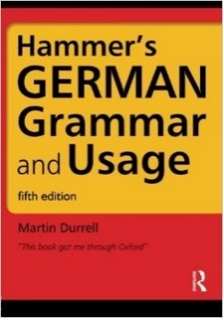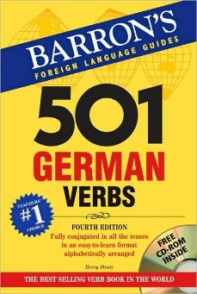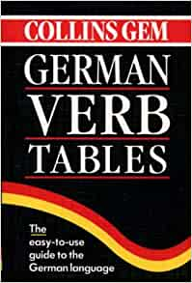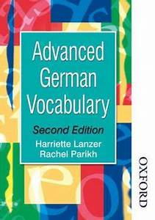

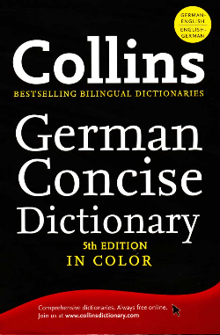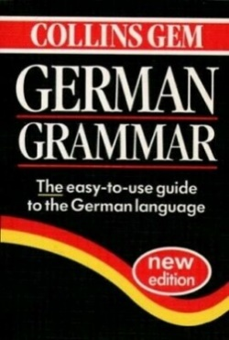

* We highly recommend spending some of your free periods/private study time to develop your German skills independently – there are plenty of online topical, exam based resources in Kerboodle and there is a list of websites later in this handbook which will enable you to practise listening and reading. Please do not just limit your study to completing homework – we need to go above and beyond this!

|  |  |
| --- | --- |
| My Kerboodle log-in |  |
| My Kerboodle password |  |
| My Google Classroom log-in |  |
| My Google Classroom password |  |

1. **Grammar checklist – the main stuff!**

You will have covered a good deal of this through GCSE. I suggest you tick off what you are familiar with and take it from there. Please refer to your grammar book for explanations and examples – if unsure, just ask! Remember – we will be covering stuff in lessons!

|  |  |
| --- | --- |
|  | ✓ |
| 1. Understand the German case system – nominative, accusative, dative, genitive – what are they? |  |
| 1. Nouns – gender, singular forms, plurals – eg. der Gast – die Gäste |  |
| 1. Weak nouns (masculine “n” nouns) eg. Ich kenne den Student**en** |  |
| 1. Adjectives used as nouns – Der Kleine (the little one), die Guten (the good ones) |  |
| 1. Definite articles (der/die/das/die etc) and Indefinite articles (including kein)   (ein/eine/ein etc) |  |
| 1. Adjective endings across the cases eg. Ich esse den rot**en** Apfel etc |  |
| 1. Comparatives and superlative adjective forms – eg. der gröβere Hund, der gröβte Hund etc |  |
| 1. Demonstrative adjectives across the cases – dieser, jeder etc |  |
| 1. Possessive adjectives across the cases – mein(e), dein(e), sein(e) etc |  |
| 1. Interrogative adjectives across the cases – welcher/welches/welches etc |  |
| 1. Question words – wann, warum, wie, wie viel(e) etc |  |
| 1. Qualifiers – sehr, besonders, kaum, recht, extrem, total etc |  |
| 1. Particles - doch, eben, ja, mal, schon, bloβ, eigentlich, vielleicht |  |
| 1. Personal pronouns across the cases ich/mich/mir, du/dich/dir etc |  |
| 1. Order of pronouns/nouns in a sentence – ‘the accusative before the dative unless the accusative is a noun’ eg.Sie kauft mir den Apfel/Sie kauft ihn mir. |  |
| 1. Reflexive pronouns – ich wasche mich/Ich wasche mir die Hände |  |
| 1. Relative pronouns – Die Leute, die in Hamburg wohnen, sind stolz auf den Hafen. |  |
| 1. Possessive pronouns – Ist das dein Auto? Nein, es ist **meins** etc |  |
| 1. Verbs in the present tense – weak (regular) and strong (irregular) |  |
| 1. Verbs in the perfect tense – those taking ‘haben’/’sein’ as auxiliaries |  |
| 1. Verbs in the imperfect tense – weak, strong, mixed |  |
| 1. Verbs in the future tense (Ich werde …. + verb) and the futuristic present tense (Ich esse nächsten Samstag im Restaurant.) |  |
| 1. Conditional – Ich **würde** am Samstag spielen aber/I would play on Saturday but … .... (Imperfect subjunctive of ‚werden‘) |  |
| 1. Pluperfect tense – Er hatte zu Mittag gegessen – He had ..... eaten, Sie war nach Hamburg gefahren – She had driven to Hamburg |  |
| 1. The passive voice – das Buch wird oft gelesen/The book is often read |  |
| 1. Imperative – command forms. (Geh! Geht! Gehen Sie!) |  |
| 1. Subjunctive a. In conditional clauses b. After ‘als ob’ c. In reported speech |  |
| 1. Prepositions a. taking dative b. taking accusative c. taking either dat/acc |  |
| 1. Verbs which have acc/dat prepostions – warten auf + acc etc |  |

**Grammar checklist (cont/d)**

|  |  |
| --- | --- |
|  | ✓ |
| 1. Sentence structure – where do the verbs go? 2. Standard sequence – Subject + verb + rest of sentence 3. Inversion (switcheroo!) 4. Subordinate clauses (Including relative clauses) (Verb-to-enders) |  |
| 1. Conjunctions 2. Coordinating conjunctions – und, aber, den etc 3. Adverbial conjunctions – jedoch, auch, deshalb etc 4. Subordinating conjunctions – wenn, weil, da, obwohl, nachdem etc |  |
| 1. Using lassen + infinitive eg. fallen lassen |  |

1. **Writing an effective essay**

**Essay structure**

**Introduction**

Briefly tell your reader what you are going to say and make sure you directly unpack the title. For example – Was erfährt der Leser über Hannas Prozess? Welche Funktion hat der Prozess innerhalb des Romans, Ihrer Meinung nach?

In Bezug auf den Prozess, lernt man nicht nur über die Greueltaten, die passiert waren und was die Angeklagten gemacht hatten, sondern auch über andere Themen. Der Prozess klärt uns über die folgenden Themen auf; die Vergangenheitsbewältigung, das Schuldgefühl, der Analphabetismus und das Verhältnis zwischen Michael und seinem Vater als Michael versuchte mit dem Prozess zurechtzukommen.

**Central section**

* around 4-6 paragraphs either in a ‘list’ or (as in this case) a ‘for/against’ pattern
* each paragraph needs to ‘flow’ from your main **point** into a couple of supporting **examples** and finish with a **personalised, analytical comment** – we call it **PEEP**ing your paragraph.

**Conclusion**

This is where you “close the circle” by referring back to the issue/question within the title and giving your final, clinching comment.

**Then**

Check your essay for quality, clarity and accuracy

1. **To help with your writing**

For your introduction

|  |  |
| --- | --- |
| Es ist wohl bekannt, dass | It is well known that |
| Zuerst | Firstly |
| Hier beprechen wir, ob | Here we are discussing |
| Hier müssen wir in Betracht ziehen, ob | Here we must take into account whether |
| Hier müss die Frage gestellt werden, ob | Here we must ask the question whether |

Lending your writing a personalised feel

|  |  |
| --- | --- |
| Meiner Meinung nach (+verb) | in my opinion |
| Was mich betrifft (+ verb) | As far as I’m concerned |
| Bemerkenswert ist, (dass/ob etc) | It is noteworthy ... |
| Interessanterweise (+ verb) | Interestingly ... |
| Meines Erachtens (+ verb) | In my opinion |
| Ich würde sagen, dass | I would say that |
| Ich finde, dass | I find that |
| Wir gehen davon aus, dass | We assume that |
| Es steht fest, dass | One thing for sure is that |

Emphasising stuff

|  |  |
| --- | --- |
| Man könnte mit Recht sagen, dass | You could justifiably say that |
| auf jeden Fall | definitely |
| ohne Zweifel | without doubt |
| zweifellos | without doubt |
| allerdings | indeed |
| mit Sicherheit | certainly |
| sicherlich | certainly |
| Es liegt klar auf der Hand, dass | It is obvious that |
| Wichtig zu merken ist, dass | It is important to notice that |
| Bemerkenswert ist, dass | It is worthy of note that |
| gewiss | certainly |
| hauptsächlich | mainly |
| teilweise | partly |
| zum Teil | partly, in part |
| eine gutes Beispiel wäre | A good example would be |
| das Auffallende ist, dass | The striking thing is that |

Explaining relationships/saying how and why

|  |  |
| --- | --- |
| folglich | consequently |
| als Folge | as a consequence |
| deshalb | that is why, hence |
| aus diesem Grund | for this reason |
| oder mit anderen Worten | or in other words |
| oder anders gesehen | or seen in a different way |
| deswegen | that is why, hence |

Giving an opposing opinion

|  |  |
| --- | --- |
| auf der anderen Seite | on the other hand |
| andererseits | on the other hand |
| anders gesehen | seen in a different way |
| in Wirklichkeit | in reality |
| trotzdem | in spite of that |
| immerhin | nevertheless |
| im Gegenteil | on the contrary |

Concluding remarks

|  |  |
| --- | --- |
| zum Schluss | in conclusion |
| schlieβlich | finally |
| abschlieβend | in closing |

1. **German websites – ideal for listening/reading practice!**

Take note: in order to sharpen your listening skills, you will regularly need to access listening/video clips which:

* are quite short or you listen to a little bit of a longer clip.
* you listen to a number of times
* you then summarise with a list of 8-10 key words in German

German news

<https://www.nachrichtenleicht.de/>

<https://www.spiegel.de/>

<https://www.dw.com/de/deutsch-lernen/s-2055>

<https://www.zdf.de/kinder/logo>

<https://www.tagesschau.de/>

<https://de.nachrichten.yahoo.com/>

Radio

ndr.de/ndr2/

<https://www.deutschlandfunk.de/>

<https://www.br.de/nachrichten/>

<https://www.sport1.de/>

Miscellaneous – ‘at an easier pace!’

<https://slowgerman.com/>

<https://www.newsinslowgerman.com/>