**ORGANISING YOUR FILE** 2

**GRAMMAR** 4

**REALLY USEFUL WRITING TIPS** 7

**ESSAY TERMINOLOGY** 8

**★** INTRODUCTORY REMARKS 8

**★ PERSONAL COMMENTS** 8

**★ IMPERSONAL EXPRESSIONS** 8

**★ CAUSE AND EFFECT RELATIONSHIPS** 9

**★ CONTRADICTING** 9

**★** CONCLUSION 9

**WRITTEN WORK CHECK GRID** 9

**TYPICAL SPANISH IDIOMS** 11

**REALLY USEFUL SPANISH WEBSITES and how to use them best!** 12

**TO WORK ON YOUR LISTENING** 12

**TO WORK ON YOUR READING** 13



**A Level Spanish**

**ORGANISING YOUR FILE**

A well-organised file is the key to success at A Level. If you have all your notes organised by topic, you will have no problems when it comes to revising for exams, and preparing essays.

If you keep to these guidelines, you should have no difficulty with keeping up with the course, staying prepared throughout the year, keeping up with what is expected of you.

I suggest setting out your folder as follows, keeping all subtopics grouped within their main topic.

* Course information
* Aspects of Hispanic society
* Artistic culture in the Hispanic world
* Multiculturalism in Hispanic society
* Aspects of political life in the Hispanic world
* Literature and film (in separate booklets)
  + Research and presentation (in separate booklet)
  + Grammar (in separate exercise book)
  + Vocabulary (in separate exercise book)
* When you are given handouts, please ensure that they are filed in the appropriate section of your folder. If you miss a lesson for any reason, it is your responsibility to get a copy of anything handed out, and to complete any missed work
* You must bring your folder to every class.
* It is your responsibility take good care of the text books you are given. They must be returned to school at the end of the course in the *same state* that they were given to you. The text book is:
  + OUP AQA A Level Spanish
  + Collins easy learning Spanish Grammar and Practice

You should bring your textbook to every lesson, as it will be used in class, and homework will be set from it.

It is also recommended that you buy a decent Spanish dictionary, please see one of your teachers if you'd like a recommendation!

Here are some other books that you might find useful / interesting:

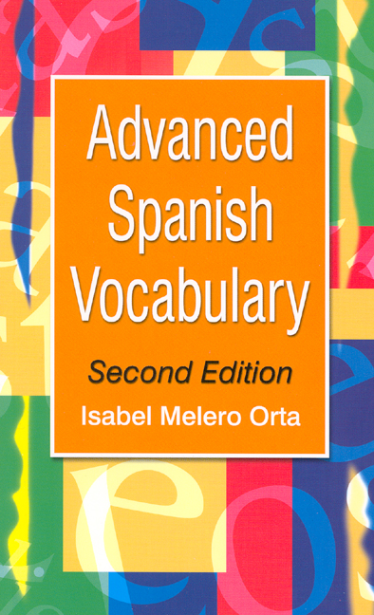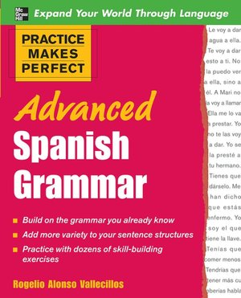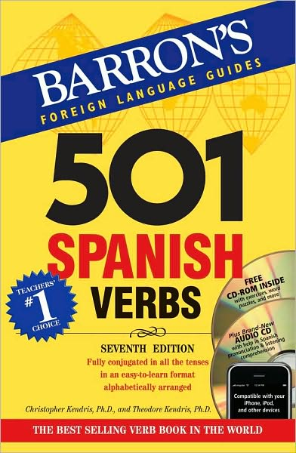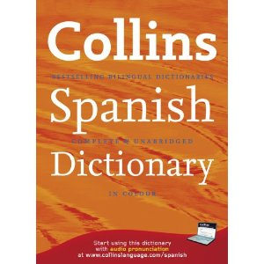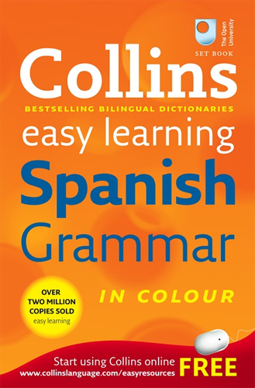

* Use your free periods at school and private study time at home to develop your independent study skills (not just to complete homework!). For every hour that you have in lesson, you should complete an hour or private study. Use online resources such as Kerboodle for explicit exam practice, or for more general information read Spanish newspapers or blogs. There is a list of websites that you could use to practise reading and listening skills at the back of this handbook.
  + My Kerboodle Log-in: _______________________
  + My Kerboodle Password: _______________________
  + My Google Classroom Log-in: _______________________
  + My Google Classroom Password: _______________________

**GRAMMAR**

* **Nouns**: gender, Singular and plural forms, Plural of male/female pairs (e.g. los Reyes), Affective suffixes (R)
* **Articles:** Agreement
* **Adjectives:** Agreement, Position, Apocopation (eg gran, buen, mal, primer), Comparative and superlative (eg más fuerte; mejor, peor, mayor, menor), Use of adjectives as nouns (eg una triste, la roja, las norteamericanas), Demonstrative (eg este, ese, aquel), Indefinite (eg alguno, cualquiera, otro), Possessive (weak and strong forms) (eg mi / mío), Interrogative and exclamatory (eg ¿cuánto? / ¡cuánto!, etc, including use of ¿qué? / ¡qué!), Relative (cuyo)
* **Numerals:** Cardinal (eg uno, dos), Ordinal 1–10 (eg primero, segundo), Agreement (eg cuatrocientas chicas), Expression of time and date
* **Adverbs:** Formation of adverbs in -mente, Comparative and superlative (eg más despacio), Use of adjectives as adverbs (eg rápido, claro), Adjectives as equivalents of English adverbs (eg Salió contenta), Interrogative (eg ¿cómo?, ¿cuándo?, ¿dónde?)
* **Quantifiers/intensifiers:** (eg muy, bastante, poco, mucho)
* **Pronouns:** Subject, Object: direct and indirect; use of se for le(s); ‘redundant’ use of indirect object (eg Dale un beso a tu papá), Reflexive, Unstressed/stressed forms (eg me/mí), Position and order, Relative (que, quien, el que, el cual), Demonstrative (este, ese, aquel; esto, eso, aquello), Indefinite (eg algo, alguien), Possessive (eg el mío, la mía). Expression of possession by the use of the indirect object pronoun (Le rompió el brazo) must also be included, Interrogative
* **Verbs:** Regular conjugations of -ar, -er and -ir verbs, including radical-changing (eg recordar/recuerdo, pedir/pido) and orthographic-changing (eg abrazar/ abracé) verbs in all tenses and moods, finite and non-finite forms, Regular and irregular verbs, in all tenses and moods, finite and non-finite forms, Agreement of verb and subject, Use of hay que in all tenses,   
    
  Use of tenses: present, preterite, imperfect, future, conditional, perfect, future perfect, conditional perfect, pluperfect.  
    
  Use of the infinitive, the gerund and the past participle, Verbal paraphrases and their uses. These include but are not limited to the following:  
  ir a + gerund, estar + gerund, acabar de + infinitive, estar para + infinitive, llevar + gerund, ir + gerund   
  venir + gerund  
    
  Use of the subjunctive: Commands, Conditional sentences, After conjunctions of time, After para que, sin que, In relative clauses , After other subordinating conjunctions , With verbs and verbal expressions of wishing, commanding, influencing, emotional reaction, doubt, denial, possibility, probability   
    
  Sequence of tense in indirect speech and other subordinate clauses, Voice, Use of the reflexive as a passive (eg El puente se construyó para unir a las comunidades), Use of the reflexive to express an impersonal subject (eg ¿Cómo se llega a la estación?), Use of ser + past participle, Use of estar + past participle, ‘Nuance’ reflexive verbs (eg caerse, pararse), Modes of address (tú, usted; vos (R)), Constructions with verbs, Verbs followed directly by an infinitive (eg querer, poder), Verbs followed by a preposition plus an infinitive or noun phrase (eg insistir en, negarse a), Verbs followed by a gerund (eg seguir), Verbs of perception (eg Vi asfaltar la calle), Uses of ser and estar
* **Prepositions:** All prepositions, both simple (eg bajo) and complex (eg encima de), ‘Personal’ a, Discrimination of por and para
* **Conjunctions:** Coordinating conjunctions (eg y, o, pero), Subordinating conjunctions. These include but are not limited to the following: cause (porque), purpose (para que), proviso (con tal que), supposition (a no ser que), time (cuando), concession (aunque).  
    
  Use of que to introduce a clause (eg ¡Cuidado, que se va a quemar la tortilla!)
* **Negation**
* **Questions**
* **Commands**
* **Word order:** Subject following verb (Ha llegado el profesor; Me gustan las patatas), Focalisation (Tú ¿qué opinas?; A Cristiano lo odian)
* **Other constructions:** Time expressions with hace/hacía and desde hace/hacía, Cleft sentences (Fue en Madrid donde nos conocimos), Comparative constructions. These include but are not limited to the following:  
  tan... como..., etc  
  más... que..., etc.  
  Tiene más dinero de lo que creía  
  Indirect speech
* **Discourse markers:** (eg Es que..., Por ejemplo, Ahora bien...)
* **Fillers:** (eg pues, bueno)
* **ESSAY WRITING TIPS**

Your essay should consist of 3 main sections:

1. **The introduction**

Say what you are going to discuss in your essay – stick to the essay title! Make sure EVERYTHING you say is relevant to what you are being told to write about. Answer the question asked, not the question you fancy answering!

1. **The main body of the essay**

For each argument, remember, one idea per paragraph and for each paragraph:

1. What is my point?
2. Where is my evidence? This has to be taken from the film / play, but it does not have to be a quote. It can be a paraphrasing of the lines, a description of the scene etc.
3. How does this answer the question? What explanation have I got for putting this point in here? What is my personal reaction to this, and how does it support the view I expressed in the original point?

Remember the basic paragraph structure: **P E E**

**POINT EXAMPLE EXPLANATION**

**Keep your reader with you, make your paragraphs concise and to the point. Don't waffle, keep it interesting!**

1. **The conclusion**

Sum up the main points you have made throughout the essay – DON’T introduce new ideas. Give your opinion if possible. Finish, if you can, with something which could be important to your topic in the future.

**Finally**

1. Do a **systematic error check** using the checklist below.

1. Does your language read above GCSE level? Can you bring more interest and complexity to your language? Show off all the new stuff you have learnt at A level!

**REALLY USEFUL WRITING TIPS**

* Avoid phrases like *pienso que…/creo que….* If you want to make clear you are expressing a personal opinion use: ***en mi opinión, desde mi punto de vista*** or***a mi modo de ver***; or a more sophisticated expression like: ***estimo que****…* or***considero que****…*or even***tengo que admitir que****…or* ***quisiera añadir que****…*
* Avoid phrases like *mucha gente piensa que*. If you want to express a commonly held view, say:***como se sabe, teniendo en cuenta(consideración) que, como es bien conocido por todos, considerando que***
* Do not overuse the word *problema*. Try ***el tema (en cuestión)*** (issue) or ***el tópico*** (topic) or ***la polémica***(debate) or ***el asunto*** (matter)
* Use good sentence starters: ***se puede notar que****,* ***no se puede negar que****…,* ***es obvio que****…,* ***lo primero que hace falta decir es que, no cabe duda de que****….*
* Use linking phrases to start new paragraphs: ***siendo eso así*** *…,* ***dicho eso****…,* ***no se debe olvidar que*** *…,* ***lo que demuestra que****…*
* Try to include subjunctives
* Use rhetorical devices:

Rule of three – ***la televisión es informativa, omnipresente , pero adictiva***

Contrast – ***por un lado…,******por otro lado****…/****por una parte…por otra parte…***

Interjections – **¡*Qué horror! ¡Qué desastre!***

Rhetorical questions – ***¿Quién puede dudar eso?***

Proverbs or sayings –***poner algo patas arriba****,* ***la mejor defensa es un ataque, más vale prevenir que luego lamentar, más vale tarde que nunca…***

Emotional appeal – ***imagina si estuvieras desempleada, ponte en el lugar de…***

Imagery –

* Don’t use *decir* – try ***afirmar/declarar/pretender/comprobar***
* Don’t use *ser/estar* – try ***representar/constituir/encontrarse***
* Don’t use *tener* – try ***disponer de/poseer/ofrecer/ejercer***
* Don’t use *causar* – try ***provocar/acarrear/producer/llevar a***
* Do not overuse the phrase *hay*. **Try  *existe/se encuentra***
* Don’t use *mucho/a(s)* – try ***un buen número de/una cantidad importante de***
* Avoid weak and vague adjectives like *bueno/malo/fuerte/interesante/importante.* Try ***favorable/dañino/persuasivo/fascinante/indispensable/prejudicial/beneficioso***

**ESSAY TERMINOLOGY**



### ★ INTRODUCTORY REMARKS

|  |  |
| --- | --- |
| Primeramente  En primer lugar  En segundo lugar  Voy a hablar de/Me gustaría hablar /analizar/  Vamos a estudiar…  El tema que he elegido es…  La pregunta que me gustaría abordar es  Lo que encuentro más interesante es….  Me gustaría examinar el tema de…  Es necesario que nos preguntemos….  Vamos a considerar dos aspectos del problema....  Para clarificar el problema vamos a observar….  Debemos considerar las ventajas y desventajas….  De todos es sabido…. | *First of all*  *First(ly)*  *Secondly*  *I am going/ we are going to talk about/*  *We are going to examine/ study*  *The theme I chose to study is…*  *The question I want to ask/ address is…*  *What I find most interesting is…*  *I would like to look into the topic of…*  *It is necessary to ask ourselves whether…*  *We have to consider two aspects of the problem*  *In order to clarify the problem, we are going to observe...*  *We have to weigh the pros and cons*  *It is well known…* |

**★ PERSONAL COMMENTS**

|  |  |
| --- | --- |
| En mi opinión  En lo que a mí me concierne  Por mi parte  En mi caso  Desde mi punto de vista  Pienso que  Creo que  Encuentro que  Me parece que  Estoy segura que  Estoy convencido/a que  Yo diría que  Me inclino a creer que | *In my opinion*  *As far as I am concerned*  *For my part*  *As for me*  *From my point of view*  *I think that*  *I believe that*  *I find (that)*  *It seems to me that*  *I am sure that*  *I am convinced that*  *I would say that*  *I am inclined to believe that* |

**★ IMPERSONAL EXPRESSIONS**

|  |  |
| --- | --- |
| Es necesario precisar que  Es importante tener en cuenta que  Es evidente que  Es incuestionable que  Es posible distinguir  Se debe resaltar que  Sería más correcto decir que  Nos hace pensar que  Parece claro/evidente que  Basta decir que  Hoy en día hay una tendencia a decir que | *It is necessary to specify that…*  *It is important to take into account*  *It is obvious that…*  *It is unquestionable that…*  *It is possible to distinguish*  *One must point out that…*  *It would be more accurate to say that…*  *There is ground for thinking that…*  *It seems clear that…*  *Suffice (it) to say that…*  *Today there is a tendency to say that…* |

**★ CAUSE AND EFFECT RELATIONSHIPS**

|  |  |
| --- | --- |
| Por consiguiente  Así que  Por lo tanto  Por esta razón  Es decir  Además  Entonces  Esta es la razón por la que  Se deduce que  Se piensa que  Se puede entender que  Podemos interpretar que  Este estudio revela que  Este ejemplo prueba que  Este párrafo nos muestra que  No hace falta decir que | *Consequently*  *Therefore*  *Thus*  *For this reason*  *That is to say / namely*  *Besides*  *Then*  *That’s why*  *It can be deduced that…*  *It can be thought that…*  *It can be understood that…*  *We can interpret this as…*  *This study reveals that…*  *This example proves that…*  *This passage shows that…*  *It goes without saying that…* |

**★ CONTRADICTING**

|  |  |
| --- | --- |
| Pero  Sin embargo  Por el contrario  En realidad  Por un lado / por una parte  Por otro lado / por otra parte  Más que  Aunque  Incluso si  A pesar del hecho de que / a pesar de  En realidad  De hecho | *But*  *However*  *On the contrary*  *Actually*  *On one hand*  *On the other hand*  *Rather*  *Although*  *Even if/ even though*  *Despite the fact that*  *To tell the truth*  *In fact* |

|  |  |
| --- | --- |
| En conclusión  Para resumir / para concluir  Finalmente / para terminar /  En pocas palabras / en una palabra  Brevemente  Habiendo considerado todos los aspectos  En conjunto  Como hemos explicado  Como hemos dicho  Como hemos resaltado / subrayado antes  Esto muestra que  Esto demuestra que  Podemos concluir que  Hemos llegado a la conclusión de que | *In conclusion*  *To sum up*  *Finally*  *In a few words / In a word*  *In short*  *All things considered*  *All in all*  *As was explained*  *As was stated*  *As was pointed out earlier*  *This shows that*  *This demonstrates that*  *We can conclude that*  *We have reached the following conclusion that* |

### ★ CONCLUSION

**WRITTEN WORK CHECK GRID**

|  |  |  |  |  |  |  |
| --- | --- | --- | --- | --- | --- | --- |
| **FECHA:** |  |  |  |  |  |  |
| 1. **Planned an outline** (essays: intro, main body of 2-4 points, opinions, conclusions, solutions) |  |  |  |  |  |  |
| 1. **Tenses** (pret/ imp/ plup/ perf/ past cont/ pres cont/ pres/ fut perf/ cond perf/ fut/ fut cont/ cond..) |  |  |  |  |  |  |
| 1. **Person of verb** (yo/ tú..) |  |  |  |  |  |  |
| 1. la mayoría/ la gente/ la ciudad= **singular** |  |  |  |  |  |  |
| 1. **Personal A** (But not when it is doing action: el hombre hacía... Vi **a**l hombre |  |  |  |  |  |  |
| 1. **Prepositions after verbs** (a/ con/ de/ sobre...) |  |  |  |  |  |  |
| 1. **Adjectival agreements** (la chica guapa |  |  |  |  |  |  |
| 1. **Correct gender for nouns** (el hombre/ la participación/ el problema/ el sistema) |  |  |  |  |  |  |
| 1. **Por/ para** (para + inf, por + time..) |  |  |  |  |  |  |
| 1. **Passive** (ser + past participle agreeing: fue matado por…- he was killed by...) |  |  |  |  |  |  |
| 1. **Avoidance of passive** (se bebe el vino- Wine is drunk*) |  |  |  |  |  |  |
| 1. **Accents** ( la declaración/ las declaraciones) |  |  |  |  |  |  |
| 1. **Spellings** (use dictionary to help you) |  |  |  |  |  |  |
| 1. **Appropriate register of language used** (high/ technical/ complicated for essays) |  |  |  |  |  |  |
| 1. **Essay expressions** (se debe mencionar que/ es imprescindible que se mencione…) |  |  |  |  |  |  |
| 1. **Subjunctives** (checked endings: regular/ irregular) |  |  |  |  |  |  |
| 1. **Subjunctives** (used correctly with phrase in correct tense) |  |  |  |  |  |  |
| 1. **Checked work thoroughly before handing in?** |  |  |  |  |  |  |
| 1. **How long did I take to do it?** |  |  |  |  |  |  |

Complete with the date and note down what topic your essay was on, and run through the checklist each time you do one:

**TYPICAL SPANISH IDIOMS**

**Modismos típicos españoles**

<http://www.geocities.com/athens/thebes/6177/idioms.htm>

**Al hierro caliente batir de repente** *Beat the hot iron at once.* **Strike while the iron is hot**

**Antes que te cases mira lo que haces** *Before you marry look what you do* **Look before you leap**

**Beben agua en el mismo jarrito** *They drink water from the same little jug* **They are as thick as thieves**

**Cada perico a su estaca, cada changa a su mecate** *Each parrot on its perch, each monkey on its rope.* **To each his own**

**Caras vemos, corazones no sabemos** *Faces we see, hearts we don't know* **Can’t judge a book by its cover**

**Darle un beso a la botella.** *To give the bottle a kiss* **To have a swig**

**De la subida más alta es la caída más lastimosa.** *Of the highest rise, the shortest fall.* **The bigger they are the harder they fall**

**En menos que canta un gallo***. In less time than the rooster crows* **In a shake of a lamb’s tail**

**Estar como perro en barrio ajeno.** *To be like a dog in a neighbor's yard* **To feel like a fish out of water**

**Más loco que una cabra** *Crazier than a goat* **mad as a hatter**

**Más vale pájaro en mano que ciento volando.** *A bird in the hand is worth more than a hundred flying* **A bird in the hand is worth two in the bush**

**Meter la cuchara** *To put the spoon in* **put your oar in**

**Mientras que en mi casa estoy, rey soy** *While in my house, I am king.* **A man’s home is his castle**

**Ser más listo que un coyote** *To be more ready (alert) than a coyote* **sharp as a tack**

**Tener más lana que un Borrego** *To have more wool than a lamb* **To have money to burn**

**Vivito y coleando** *Alive and wagging tail* **alive and kicking**

**Al que madruga, Dios lo ayuda** *God helps he who gets up early* **The early bird catches the worm**

**No hay nada tan atrevido como la ignorancia** *There is no-one so daring as ignorance* **Fools rush in where angels fear to tread**

**El campo fértil no descansado, tórnase estéril** *The unrested field becomes sterile* **All work and no play makes Jack a dull boy**

**Al canto del petiguere** *At the cock’s crow/At Day break*

**REALLY USEFUL SPANISH WEBSITES and how to use them best!**

**TO WORK ON YOUR LISTENING**



You should select a short audio or video clip from the Internet. Play the clip at least three times and write a brief summary in Spanish (it needn’t be any longer than 50 words) with a vocabulary list of at least 10 words. These could be key words or they could be words that are new to you and had to be looked up.

It is easier to start with short news bulletins. Video clips are ideal as they are easier to understand. Start with shorter clips and then when you feel ready, you could choose a radio programme from the radio station websites listed below.

**Spanish News**

[www.euronews.net](http://www.euronews.net) Select language ‘español’ and then choose from a wide variety of News videos.

[www.20minutos.es/](http://www.20minutos.es/)

[es.news.yahoo.com/](http://es.news.yahoo.com/) Follow the link to **Video Noticias** for three-minute news clips [es.noticias.yahoo.com/](http://es.noticias.yahoo.com/)

**Spanish TV channel websites:**

[www.antena3tv.com](http://www.antena3tv.com)

Choose from the menu for the topic area you are interested in and then browse for video clips:

[www.antena3videos.com/](http://www.antena3videos.com/)

**For news, browse for videos at:**

[www.informativos.telecinco.es/](http://www.informativos.telecinco.es/)

[www.elmundo.es](http://www.elmundo.es)

[www.elpais.es](http://www.elpais.es)

[www.canalsur.es](http://www.canalsur.es) Click on the link to TV “en directo” (live) and you will be able to watch the channel on streaming video.

[www.informativos.telecinco.es/reproductor_video.htm](http://www.informativos.telecinco.es/reproductor_video.htm)

**For celebrity gossip....**

[es.celebrities.yahoo.com/](http://es.celebrities.yahoo.com/) Click on “Perfiles de Famosos”

**Spanish Radio on-line**

[www.rtve.es/rne/envivo.htm](http://www.rtve.es/rne/envivo.htm) Select a radio station from the list.

[www.topradio.es/](http://www.topradio.es/) Easy listening music radio station for Spanish and English / American pop music.

[www.lyngsat.com/freeradio/Spain.html](http://www.lyngsat.com/freeradio/Spain.html) Selection of the most important radio channels

**TO WORK ON YOUR READING**



Select an article which interests you then read it carefully and select at least 10 new pieces of vocabulary to look up. The choice of topic area is limitless. It is a good idea to vary the topic area and to choose articles related to the course topics so that you encounter a variety of vocabulary. Remember to note down all new vocab in your vocab books

[www.bbc.co.uk/languages/spanish/news](http://www.bbc.co.uk/languages/spanish/news) The best place to start is the BBC’s languages web-pages. Choose the “**reportajes**” link to find articles from the former “**Semanario** **Internet**” with a variety of reading exercises. The articles are archived into topic areas that relate to the AS and A level syllabus. Some of them include audio clips so you can base your listening task on the same topic.

[www.elmundo.es](http://www.elmundo.es) Spanish daily newspaper. The website gives you access to all of the day’s news articles.

[www.elpais.es](http://www.elpais.es) Spanish daily newspaper. The website gives you access to the day’s news articles although you may require a subscription to view the majority of the articles in full.

[es.news.yahoo.com/](http://es.news.yahoo.com/)

[www.abc.es/](http://www.abc.es/) On-line Spanish daily news.

[www.terra.es](http://www.terra.es) On-line Spanish daily news.

[www.donbalon.es/front/](http://www.donbalon.es/front/) Spanish football website with related articles.

[www.hola.com](http://www.hola.com) Spanish celebrity gossip magazine. Subscription required to view some of the articles.

[www.terra.es](http://www.terra.es/) ( archive news)

[www.marca.es](http://www.marca.es/) (sport)

[www.estrelladigital.es](http://www.estrelladigital.es/)