**A-level Physics**

**Transition booklet**



**You’re studying A-level Physics, congratulations!**

Studying physics after your GCSEs really develops your practical and mathematical skill and your understanding of the universe!. If you enjoy experimenting in the lab, you’ll love it. If you like solving problems where you are either right or wrong you’ll love it. If you love know how things work and why they do what they do – you’ll really love it.

At first, you may find the jump in demand from GCSE a little daunting – there is no doubt that it is harder – you won’t be the only one, but if you work hard you’ll soon adapt.

**Why study A-level Physics?**

Physicists explore the fundamental nature of almost everything we know of. They study everything from the fundamental particles that build matter, to the galaxies that make up the universe itself. Join them to enter a world deep beneath the surface of normal human experience. Even if you don’t decide to work in physics, studying it still develops useful and transferable skills for other careers. You’ll develop research, problem solving and analytical skills, alongside teamwork and communication. Universities and business regard all of these very highly.

**Possible degree options**

According to bestcourse4me.com the top seven degree courses most commonly taken by students who have A-level Physics are:

* mathematics
* physics
* mechanical engineering
* computer science
* civil engineering
* economics
* business.

However, there really are far, far more courses that you can apply for. Physics is a well-respected subject and universities are always pleased to see that a student has studied it. It requires a range of skills and intellect to do well, and a good grade indicates to universities and employers that you are someone they should take note of.

**What do I have do to pass the course?**

The assessment for the A-level consists of three exams which you will be preparing for over the two years.

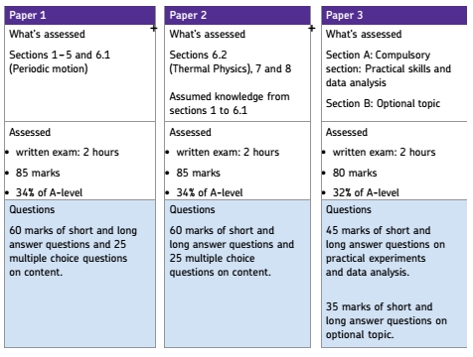

Honestly, it is important to work hard from the start of the course – you can’t just revise towards the end like you *might* have done for your GCSE assessments this year?! The students aiming for the highest grades keep on top of their work and use the topic tests as the time to revise in detail.

You will also need to complete 12 required practicals; these are completed in lesson time with some writing up in between lessons. Achieving a good performance in these leads to a separate Practical Endorsement which is either a pass or fail.

**Resources to help**

When you start the course at BRGS we will give you a textbook and a revision guide, so there is no need to buy these. A detailed bank of notes will be given out as the lessons progress, but there are also other useful sources of information and help:

1. The **AQA website** ([www.aqa.org.uk](http://www.aqa.org.uk)) is a great place to start. The Physics webpages contain lots of useful information including:

* The specification – this explains exactly what you need to learn for your exams.
* Practice exam papers
* Lists of command words and subject specific vocabulary – so you understand the words to use in exams
* Practical handbooks explain the practical work you need to know
* Past papers – exam papers from previous years.
* Maths skills support.

1. **Institute of Physics (IOP)**

The IOP do everything from research like that taking place at CERN to lobbying MPs. You’ll find lots of handy resources on their website at [www.iop.org/tailored/students/](http://www.iop.org/tailored/students/)

1. **The student room**

Join the A-level Physics forums and share thoughts and ideas with other students if you’re stuck with your homework.. Visit [www.thestudentroom.co.uk](http://www.thestudentroom.co.uk)

**Useful information and activities**

**Greek letters**

Greek letters are used often in science. They can be used as symbols for numbers (such as π = 3.14…), as prefixes for units to make them smaller (eg μm = 0.000 000 001 m) or as symbols for particular quantities (such as λ which is used for wavelength). The Greek alphabet is shown below.

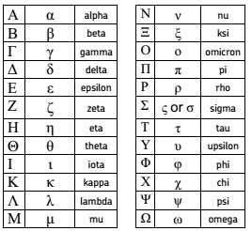

**SI units**

Every measurement must have a size (eg 2.7) and a unit (eg metres or ºC). Sometimes, there are different units available for the same type of measurement. For example ounces, pounds, kilograms and tonnes are all used as units for mass. To reduce confusion, and to help with conversion between different units, there is a standard system of units called the SI units which are used for most scientific purposes. These units have all been defined by experiment so that the size of, say, a metre in the UK is the same as a metre in China.

The seven SI base units are:

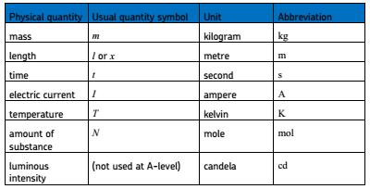

All other units can be derived from the SI base units. For example, area is measured in square metres (written as m2) and speed is measured in metres per second (written as ms–1). Some derived units have their own unit names and abbreviations, often when the combination of SI units becomes complicated. Some common derived units are:

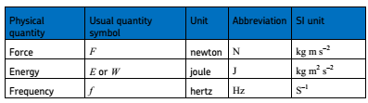

It is not always appropriate to use a full unit. For example, measuring the width of a hair or the distance from Manchester to London in metres would cause the numbers to be difficult to work with. Prefixes are used to multiply each of the units. You will be familiar with centi (meaning 1/100), kilo (1000) and milli (1/1000) from centimetres, kilometres and millimetres. There is a wide range of prefixes. The majority of quantities in scientific contexts will be quoted using the prefixes that are multiples of 1000. For example, a distance of 33 000 m would be quoted as 33 km. The most common prefixes you will encounter are:

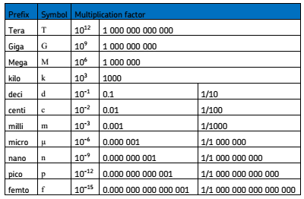

Activity 1:

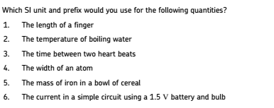

Sometimes, there are units that are used that are not combinations of SI units and prefixes. These are often multiples of units that are helpful to use. For example, a light year is a distance of 9.46 × 1012 km.

Activity 2:

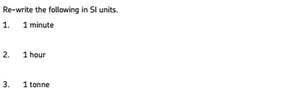

Activity 3:

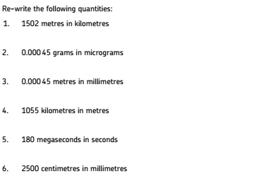

**The delta symbol Δ**

The delta symbol is used to mean “change in”. For example, at GCSE, you would have learned the formula:

$speed=\frac{distance}{time}$ which can be written as $s=\frac{d}{t}$

What you often measure is the change in the distance of the car from a particular point, and the change in time from the beginning of your measurement to the end of it.

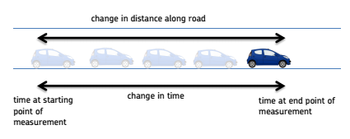

Because of the fact that the distance and the speed are changing, you use the delta symbol to emphasise this. The A-level version of the above formula becomes:

$velocity=\frac{displacement}{time}$ which can be written as $v=\frac{∆s}{∆t}$

Note: the delta symbol is a property of the quantity it is with, so you treat “Δs” as one thing when rearranging, and you cannot cancel the delta symbols in the equation above.

**Practical vocabulary**

There are many words used in practical work. You will have come across most of these words in your GCSE studies. It is important that you are using the right definition for each word. The activity below tests your understanding of terms used in practical work.

Activity 4:

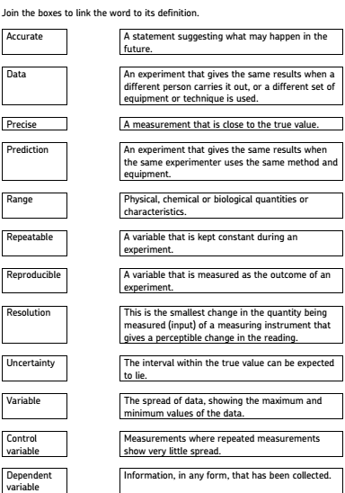

**Maths in Physics**

Physics uses the language of mathematics to make sense of the world. It is important that you are able to use maths. At BRGS you do not have to take A-level Maths to complete the course, although students who do find it helpful. We will teach you the bits of A-level maths that you need in the early stages of the course.

All students, whether takig A-level maths or not, need to be mathematicaly confident. For example, 40% of the question in the exams will be calculations, and more will require some mathematical and logical thinking.

The following exercises will help you to practise some of the maths you have covered during your GCSE studies to help with your A-level course – if you need to. Have a look through to see the sorts of things you are expected to be able to do when you start the course.

Activity 5 - Standard form:

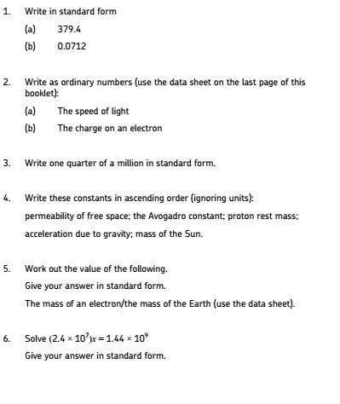

Activity 6 – Decimal places, significant figures and rounding:

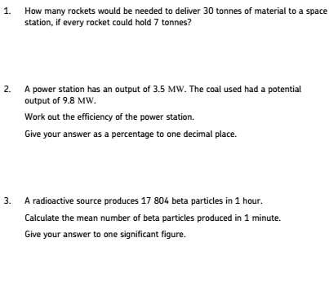

Activity 7 – Fractions, ratios and percentages:

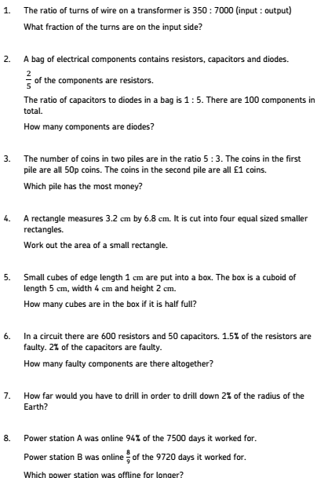

Activity 8 – Using sine, cosine and tangent:

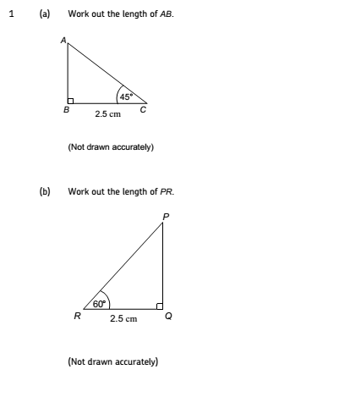

Activity 9 – Using Pythagoras’ theorem:

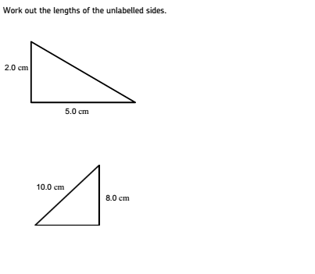

Activity 10 – Using means / averages:

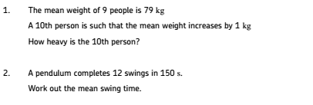

Activity 11 – Rearranging formulas:

This is perhaps the most important skill, and it is one that we will practise throughout the course. Many students do not master this until a few weeks into the course, so don’t worry if you can’t do all of the examples below.

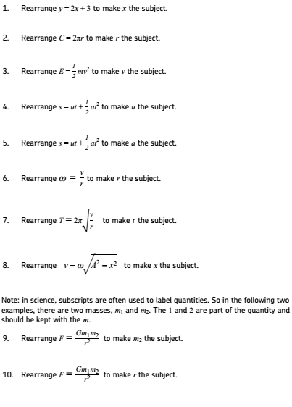

That is probably enough for now! If you have any questions about A-level Physics at BRGS – or would like any answers or help with the sample activities - please do contact the Head of Science and Physics, Mr Wilkinson at [amw@brgs.org.uk](mailto:amw@brgs.org.uk) . He is a lovely man and he won’t mind (he wrote this ☺ ).



Many thanks to the AQA for creating the activities within this document.