



**A-LEVEL BIOLOGY**

**Transition Booklet**

**2021**

**INTRODUCTION**

We are delighted that you are considering A-level Biology here at BRGS Sixth Form. Biology is a fascinating subject that will challenge your thinking and develop your skills in a range of valuable areas, including teamwork, communication, practical work, independent learning, analysis, evaluation, mathematics and research.

You might have opted to study Biology because it is directly relevant to a university course and / or career you’re already aspiring to, or because it was a strength for you at GCSE, but ultimately we hope that you’ve chosen it because you **enjoy** it and are **interested** in the range of topic areas that Biology covers (from biochemistry to biodiversity, cells to speciation, exchange to ecosystems, photosynthesis to factors affecting populations, and respiration to recombinant gene technologies) as you learn about bacteria, viruses, plants, animals and their environments! The more you enjoy what you’re learning, the more likely to are to succeed!

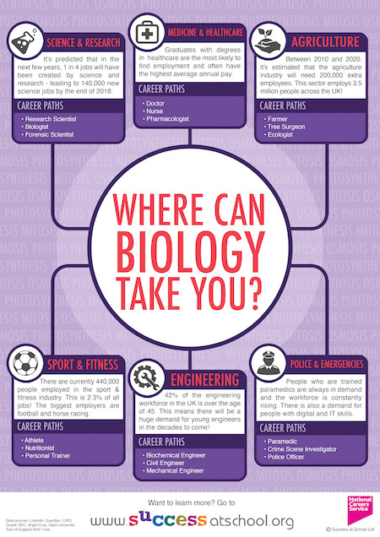

**PROGRAMME OF STUDY**

You will follow the AQA specification. Below is an overview of the subject content, but you can find more detail on each section at:

<https://filestore.aqa.org.uk/resources/biology/specifications/AQA-7401-7402-SP-2015.PDF>

1. Biological molecules
2. Cells
3. Organisms exchange substances with their environment
4. Genetic information, variation and relationships between organisms
5. Energy transfers in and between organisms
6. Organisms respond to changes in their internal and external environments
7. Genetics, populations, evolution and ecosystems
8. The control of gene expression

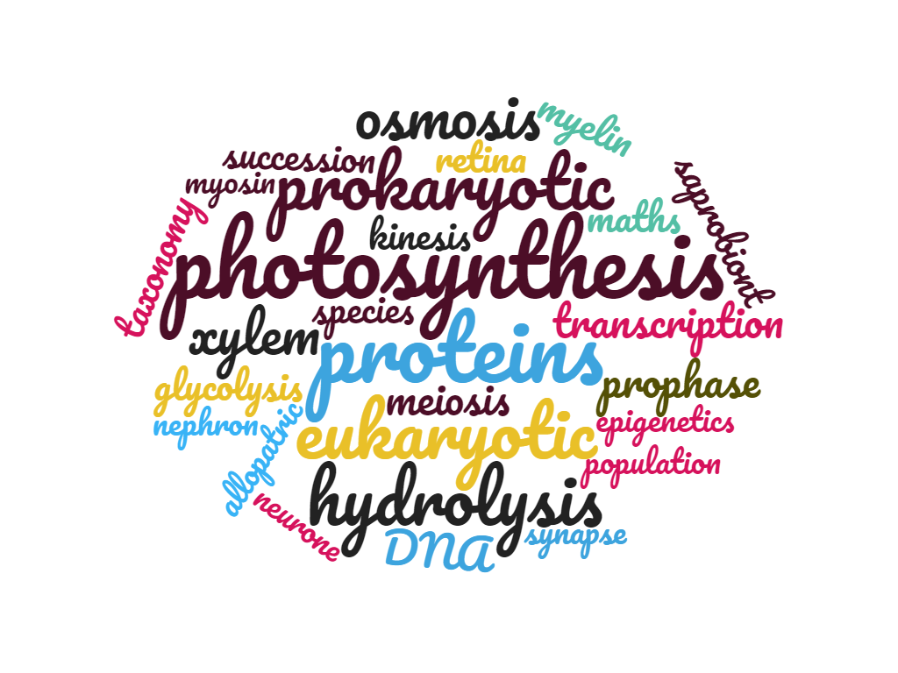

**ASSESSMENT**

In August 2022, you will receive your A-level results! For Biology, you will have two results: one will be an **A-level grade (A, B, C, D, E or U)** based on your performance in three examinations at the end of the course (end of Year 13), one will reflect your competency in a range of practical skills and investigations (**practical endorsement: pass / fail**).

* There is no coursework / controlled assessment
* The assessment is purely examination-based
* These examinations will assess your mathematical skills (10% of the total marks) and practical skills, as well as your knowledge and understanding of the specification content, and ability to apply this to unfamiliar contexts.
* You will also be assessed on your practical skills by your teachers, who will recommend whether or not you should pass the **practical endorsement** element of the course

Below is the content of the three A-level exam papers:

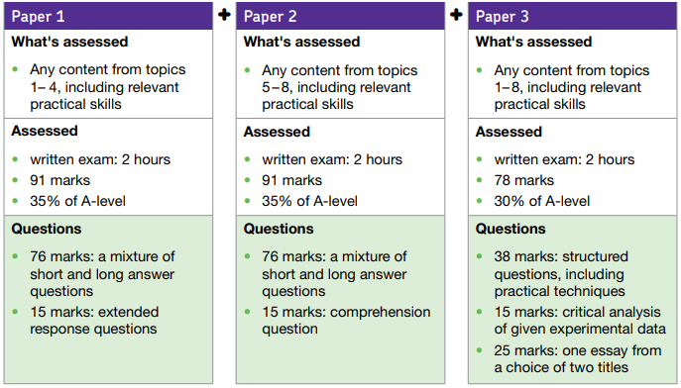

**STAFF AND TEACHING**

Mrs. C. Black (Head of Biology)

Mr. P. Flynn

Dr. J. Jackson (Post-16 Enrichment Coordinator)

Mr. D. Morriss (Director of Sixth Form)

Mrs. K. Porteous (Head of Year, lower school)

Mrs. K. Spencer

* Each class has 9 one-hour lessons per fortnight
* Two teachers share each class
* Each teacher teaches two sections of the subject content in Year 12 and two in Year 13
* Classes work on practical and mathematical skills with both teachers

**EQUIPMENT**

We recommend that you have the following equipment to help you to produce and organise your learning materials in A-level Biology and to support the ongoing review and revision you’ll need to engage in to prepare for the final examinations. Some of the equipment is also mentioned in the BRGS Sixth Form handbook:

* Academic diary
* Ring binder / lever arch folder
* Subject dividers
* Pens (different colours, including purple)
* Pencils
* Ruler (ideally 30 cm)
* Highlighter pens (range of colours)
* Scientific calculator
* A4 lined refill pad
* Blank index / flash cards
* Whiteboard and whiteboard pen
* Notebook / exercise book (plain / lined and plain pages)

You will be loaned a text book from the Biology department to support your learning, especially outside of lessons.

It is sensible to wait to buy a revision guide, if you want to buy one at all, as you will have the opportunity to discuss options available with your teachers, who will likely be able to show you samples of some of them.

**INDEPENDENT LEARNING AND SUPPORT**

Biology is not an easy A-level – you will need to work hard, both in and outside lessons.

We expect you to spend about 4.5 hours per week outside lessons working – yes, that’s just for Biology!! This includes set homework, but if you aren’t set any following a lesson, it’s best to use this time for ongoing revision / review of prior learning or for extra past paper question practice.

We offer specific lunchtime support sessions to help you with anything you need. Some students come along just to complete their homework in a focussed and supportive environment, others attend with specific questions, and some are advised to come along for some extra help with a particular aspect of their learning.

**TRANSITION ACTIVITIES**

What follows are some activities designed to give you opportunities to refresh your knowledge of key concepts from GCSE and ensure you have no gaps if the coverage of GCSE courses was incomplete. They will also allow you to practise some mathematical and Working Scientifically skills before you start in Year 12. All we ask is that you do your best with them using what you have available to you at home. There will be the opportunity to discuss the activities when you join us!

**Overview**

The transition activities are based around some of the knowledge and skills essential to A-level Biology. As you begin Year 12, you will study important biological molecules – such as DNA, proteins, lipids and carbohydrates – and cells, including transport across membranes. As well as developing biological knowledge and the necessary literacy skills to communicate this, you will also need to demonstrate that you can use practical and mathematical skills and have the ability to apply your understanding to unfamiliar contexts. Such knowledge, understanding and skills will all be assessed through short answer questions, comprehension questions and extended response questions in the three exam papers you will sit at the end of Year 13.

In addition, to reach the highest grades in A-level Biology, we recommend that you engage in wider reading around the subject – driven by a genuine interest in Biology – to develop your understanding beyond the limits of the specification, which you can demonstrate within the essay you write in exam Paper 3. There are some optional recommended reading materials at the end of this document.

**Task 1: Photosynthesis and respiration**

Two of the most important reactions that take place in living things are photosynthesis and respiration, and it’s really important that you understand both for A-level Biology. Both reactions involve the transfer of energy.

Complete the table to consolidate your GCSE knowledge and understanding of photosynthesis and respiration.

Supporting links:

<https://www.bbc.co.uk/bitesize/topics/zgws7p3>

<https://www.youtube.com/watch?v=rAJGnS_ktk4>

<https://www.youtube.com/watch?v=ZKAaDbTP6Dc>

|  |  |  |
| --- | --- | --- |
|  | Photosynthesis | Respiration |
| Which organisms carry out this process? |  |  |
| Where in the organisms (in which cells) does the process take place? |  |  |
| Energy store at the beginning of the process | Sun |  |
| Energy store at the end of the process |  | In cells e.g. as starch |
| Reactants needed for the process |  |  |
| Products of the process |  |  |
| Word equation for the overall process |  |  |
| Balanced symbol equation for the overall process |  |  |

Which of the answers for aerobic respiration would be different from those for anaerobic respiration? Add these answers to your table in a different colour.

**Task 2: Transport across membranes**

In order for organisms’ cells to obtain the reactants they need for photosynthesis and respiration and in order for the products to be stored in or removed from the organisms’ cells, there needs to be a range of transport processes that occur across boundaries such as cell membranes.

In the box for each transport process, give a definition or a brief description of what occurs and then match the examples and the key points to the correct process – some key points may match more than one transport process.

Supporting links:

<https://www.bbc.co.uk/bitesize/guides/zc7k2nb/revision/1>

<https://www.youtube.com/watch?v=C5pMigXBAgk>

<https://www.youtube.com/watch?v=qqe2NhQt8bY>

<https://www.youtube.com/watch?v=BXTi5tbnOr0>

|  |  |  |
| --- | --- | --- |
| **Key Points** | **Transport Process** | **Examples** |
| Involves water only | **Diffusion** | Moving ions into root hair cells |
| Requires energy | Potato cylinders get heavier (gain mass) when put into pure water |
| Is passive | Absorbing nutrients from food into the body |
| Movement of particles | Carbon dioxide entering leaves through open stomata |
| Needs a semi-permeable membrane | **Osmosis** | Water moving from the leaves into the atmosphere through open stomata |
| Oxygen moving from the blood in a capillary into the cells of a tissue |
| Movement from an area of high concentration to an area of low concentration | Gas exchange in the lungs |
| Water being reabsorbed into the blood capillaries in the kidney tubules |
| Movement from an area of low concentration to an area of high concentration | **Active transport** | Glucose being absorbed from the small intestine following digestion of starch |
| The effect of salt on slugs |
| Occurs in nature | Water moving into root hair cells |
| Involves transport of solutes | Potato cylinders get lighter (lose mass) when put in very salty water |

**Task 3: The heart and the blood**

* Describe the path taken by a red blood cell from the left ventricle and back to the right atrium via a muscle cell in the leg.
* Ensure that you clearly name the parts of the heart and the blood vessels that the red blood cell travels through.
* Make sure you describe what happens when the red blood cell reaches the lung and when it reaches the muscle cell in the leg.

Use these supporting links to help if you need to:

https://www.bbc.co.uk/bitesize/guides/zqnsrwx/revision/1

https://www.youtube.com/watch?v=bpYaKM2hVFY

<https://www.lornelabs.com/news-events/blog/the-journey-of-a-red-blood-cell>

|  |
| --- |
| Journey of a red blood cell: |

**Task 4: Practical investigation 1 – The effect of exercise on pulse rate**

This task will give you the opportunity to practise applying your practical and mathematical skills which are really important in Biology – they will be assessed in the written exams as well as recognised through the practical endorsement component of the A-level course.

**Hypothesis**

* First of all, make a prediction – what do you think will happen to your heart rate, and therefore your pulse rate, as you exercise? What do you think will happen to your heart rate once you’ve stopped exercising?
* Now turn this into a hypothesis – give an explanation for your prediction – why do you think your heart rate will change in this way?
* Write your hypothesis in the box below:

|  |
| --- |
|  |

You will need:

* A stopwatch or timer (such as the one on your phone or smart watch)

**Preliminary work**

This is to help you practise taking your pulse rate and think about why you will take your pulse for 20 seconds in the investigation.

1. Sit down for 5 minutes.
2. While you are sitting down, find the pulse in your wrist by putting the tip of your first finger on the inside of your wrist as shown in the photograph below.

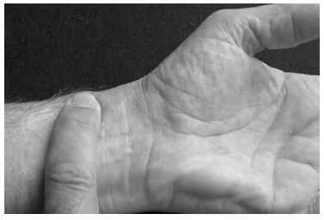

1. Take your pulse for 10 seconds and record the number of beats counted in the table below.

|  |  |  |  |  |  |  |  |
| --- | --- | --- | --- | --- | --- | --- | --- |
| Time interval over which pulse was taken /s | Number of beats | | | | | Mean number of beats per trial | Mean pulse rate /beats per minute |
| Trial 1 | Trial 2 | Trial 3 | Trial 4 | Trial 5 |
| 10 |  |  |  |  |  |  |  |
| 20 |  |  |  |  |  |  |  |
| 30 |  |  |  |  |  |  |  |
| 60 |  |  |  |  |  |  |  |

1. Repeat step 3 four times so you have a total of five readings (five trials) and record the additional results in the table above.
2. Repeat steps 3 and 4, taking your pulse for 20 seconds, 30 seconds and then 60 seconds. Record the results in the table above.
3. Complete the table by calculating:
   * The mean number of beats per trial
   * The mean pulse rate

Next, answer the questions on the next page, based on your preliminary work.

1. You were told to sit down for 5 minutes before you took your pulse (step 1). This was so that you took your resting pulse. How could you find out if 5 minutes was long enough to give your resting pulse? [2 marks]

………………………………………………………………………………………………………………………………………..

………………………………………………………………………………………………………………………………………..

………………………………………………………………………………………………………………………………………..

………………………………………………………………………………………………………………………………………..

1. In the investigation that follows, you will measure pulse rate after a period of exercise. You are advised to measure your pulse for 20 seconds.
   1. Measuring pulse for much shorter than 20 seconds will give unreliable results. Suggest why. [2 marks]

………………………………………………………………………………………………………………………………………..

………………………………………………………………………………………………………………………………………..

………………………………………………………………………………………………………………………………………..

………………………………………………………………………………………………………………………………………..

* 1. Measuring pulse for much longer than 20 seconds will give unreliable results. Suggest why. [2 marks]

………………………………………………………………………………………………………………………………………..

………………………………………………………………………………………………………………………………………..

………………………………………………………………………………………………………………………………………..………………………………………………………………………………………………………………………………………..

**Investigation – Method**

Read these instructions carefully before you start the investigation, and use them to design a table for your results **before** you start collecting data.

1. Sit down and rest for 10 minutes. You can use this time to draw the table in which you will record your results (see next page).
2. Take your pulse for 20 seconds at 1 minute intervals for 5 minutes. This sequence of events is shown in the diagram below.

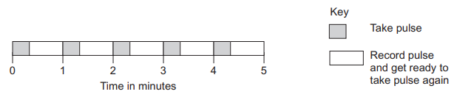

1. Exercise by holding the edge of a table and repeatedly squatting down then standing up again. You must decide for yourself how long to continue exercising for, but it should not be for longer than 5 minutes.
2. Immediately after you have stopped exercising, take your pulse for 20 seconds at 30 second intervals for 5 minutes. This sequence of events is shown in the diagram below.

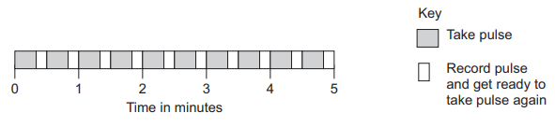

1. Ask your volunteers to complete steps 1 to 4 and report back their pulse rates.

You must decide for yourself:

* How to standardise the exercise so that you or another person may repeat the exercise in exactly the same way to improve the repeatability or reproducibility of the investigation.

Define the terms:

Repeatability ………………………………………………………………………………………………………………………………

……………………………………………………………………………………………………………………………………………………

Reproducibility……………………………………………………………………………………………………………………………

……………………………………………………………………………………………………………………………………………………

You will use the next page to draw a table in which to put your results.

The guidelines that follow may help you with this.

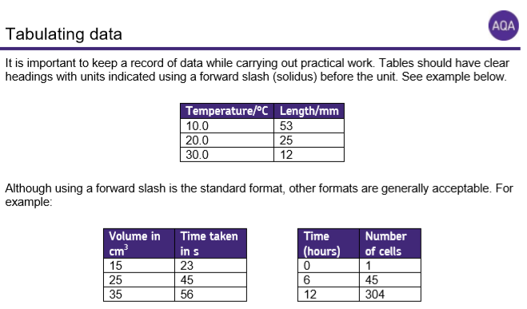



**Variables**

Use the table below to identify the independent and dependent variables as well as any controlled variables in the investigation you have just completed – controlled variables are variables that are kept the same so that they do not impact your dependent variable (results). This will help you to structure your table correctly as outlined in the above guidelines.

|  |  |
| --- | --- |
| Independent variable | (measured in seconds) |
| Dependent variable | (measured in beats per minute) |
| Controlled variable(s) |  |

**Results**

Use the blank space below to draw your results table. Then use your table to record your data as you carry out the method on the previous page.

**Presenting data**

Draw a graph of your results from the investigation

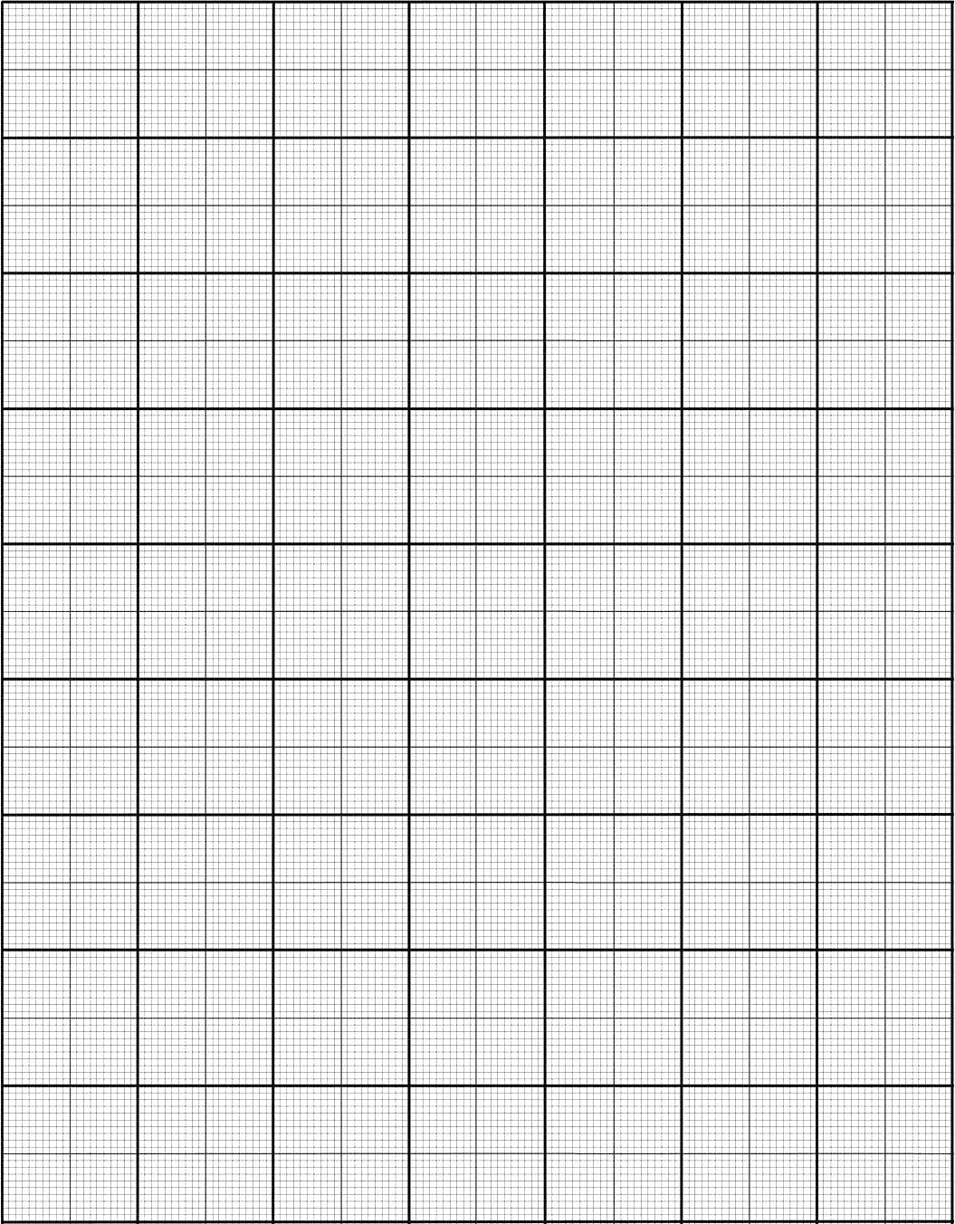

**Conclusion**

* How was your heart rate different at rest and immediately after exercise?
* Why did this change occur?
* Did your heart rate reach the resting rate after you stopped exercising?
* How long did it take for your heart rate to return to resting rate (the recovery time)?
* Why does it take time for your heart rate to return to its resting rate after stopping exercising?

Use your ideas from the previous task on the journey of a red blood cell to help you.

|  |
| --- |
|  |

**Task 5: Applying mathematical skills in a biological context**

This task is based on the investigation you completed into the effect of exercise on pulse rate, which is affected by the heart rate.

Heart rate can be used to calculate cardiac output - provided that you have a value for the individual’s stroke volume - using the equation:

**cardiac output = heart rate x stroke volume**

1. Define the terms ‘cardiac output’ and ‘stroke volume’ (you may need to use the Internet or other research to help you). [2 marks]

………………………………………………………………………………………………………………………………………..

………………………………………………………………………………………………………………………………………..

………………………………………………………………………………………………………………………………………..

………………………………………………………………………………………………………………………………………..

1. Cardiac output is measured in cm3min-1 (cm3/min). Heart rate is measured in beats per minute. Suggest what units stroke volume is measured in. [1 mark] …………………………………..
2. Rearrange the above equation so that stroke volume is the subject of the equation. Use your rearranged equation to calculate the athlete’s stroke volume after training, using the data below. Show your working. [3 marks]

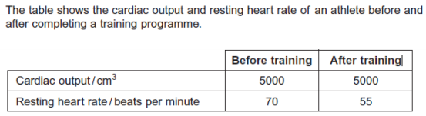

1. Using the data above, calculate the percentage decrease in the athlete’s resting heart rate after training. Show your working. [3 marks]

**Task 6: Structure and function of DNA**

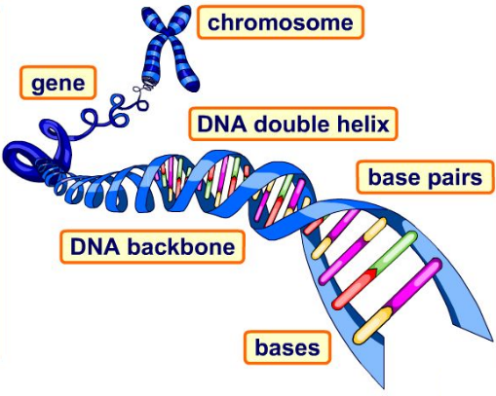If you did not study this in detail at GCSE, for example if you completed AQA Combined Science: Trilogy, you would benefit from using the links below to complete this task (you can also use them to refresh your knowledge if you did study this in detail at GCSE!)

<https://www.bbc.co.uk/bitesize/guides/z9pkmsg/revision/5>

<https://www.bbc.co.uk/bitesize/guides/z9pkmsg/revision/8>

<https://www.youtube.com/watch?v=o4LHU79fB3s>

Answer the questions in the spaces below:

1. How many chromosomes does a human body cell contain? [1 mark] ………………………….….
2. Describe the structure of DNA. [2 marks]

…………………….………………………….………………………….………………………….………………………….…………

…………………….………………………….………………………….………………………….………………………….…………

1. Where in the cell is DNA stored? [1 mark] ….………………………….……………………………………..….
2. What does a gene code for? [1 mark] ……………………………….…………………………………………….
3. What is a gene made up of? [1 mark] ….…..……………………….…………………………………………….
4. Draw lines to match the DNA base on the left to its complementary base on the right to identify the complementary base pairs. [2 marks]

|  |  |
| --- | --- |
| A | C |
| G | T |

1. Define the following terms. [4 marks]

Mutation…….………………………….………………………….………………………….………………………….…………

Allele………….………………………….………………………….………………………….………………………….…………

Dominant…….………………………….………………………….………………………….………………………….…………

Recessive…….………………………….………………………….………………………….………………………….…………

Phenotype….………………………….………………………….………………………….………………………….…………

Genotype…….………………………….………………………….………………………….………………………….…………

1. What effect could a mutation have on the amino acid sequence of a protein? [1 mark]

…………………….………………………….………………………….………………………….………………………….…………

1. In which part of a cell are proteins synthesised? [1 mark] ……………………………………………..

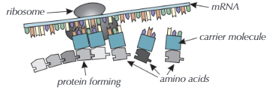The images below may help you with question 10. You may have referred to mRNA as a “messenger molecule” at GCSE.

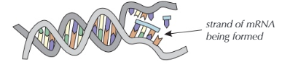

1. Briefly outline how a protein is synthesised, starting with DNA in the nucleus [4 marks]

…………………….………………………….………………………….………………………….………………………….…………

…………………….………………………….………………………….………………………….………………………….…………

…………………….………………………….………………………….………………………….………………………….…………

…………………….………………………….………………………….………………………….………………………….…………

…………………….………………………….………………………….………………………….………………………….…………

…………………….………………………….………………………….………………………….………………………….…………

…………………….………………………….………………………….………………………….………………………….…………

…………………….………………………….………………………….………………………….………………………….…………

…………………….………………………….………………………….………………………….………………………….…………

**Task 7: SI units**

* SI units are the standard international units used for measurements such as length (metre), time (second) and mass (gram).
* All other units can be derived from the SI base units e.g. area (square metre), volume (cubic metre), speed (metres per second).
* We can multiply or divide very small or very big numbers (e.g. by 1000) and then use prefixes to represent quantities that would otherwise be difficult to deal with in calculations, for example, kilo (1 kg = 1000 g), milli (1000 mm = 1 m).
* The majority of quantities used in Biology will be quoted using prefixes that are multiples of 1000. See the table below as a brief introduction:

|  |  |  |  |
| --- | --- | --- | --- |
| Prefix | Symbol | Multiplication factor | |
| Nano | n | 10-9 | 0.000 000 001 |
| Micro | µ | 10-6 | 0.000 001 |
| Milli | m | 10-3 | 0.001 |
| Kilo | k | 103 | 1000 |
| Mega | M | 106 | 1 000 000 |

Complete the following practice questions, showing your working.

1. A burger contains 4 500 000 J of energy. Write this in:
   1. kilojoules [1 mark] ……………………………………………………………… kJ
   2. megajoules [1 mark] ……………………………………………………………. MJ
2. HIV is a virus with a diameter of between 9.0×10−8 m and 1.20×10−7 m.

Write this range in nanometres.

……………………………………………………………. nm

Now suggest the most appropriate SI unit (with a prefix if necessary) for the following quantities:

1. The length of a leaf from an oak tree
2. The width of a cheek cell
3. The mass of a guinea pig
4. The distance travelled by bird each year during migration
5. The length of time between beats of the heart
6. The mass of a newborn baby
7. The volume of the trunk of a Christmas tree

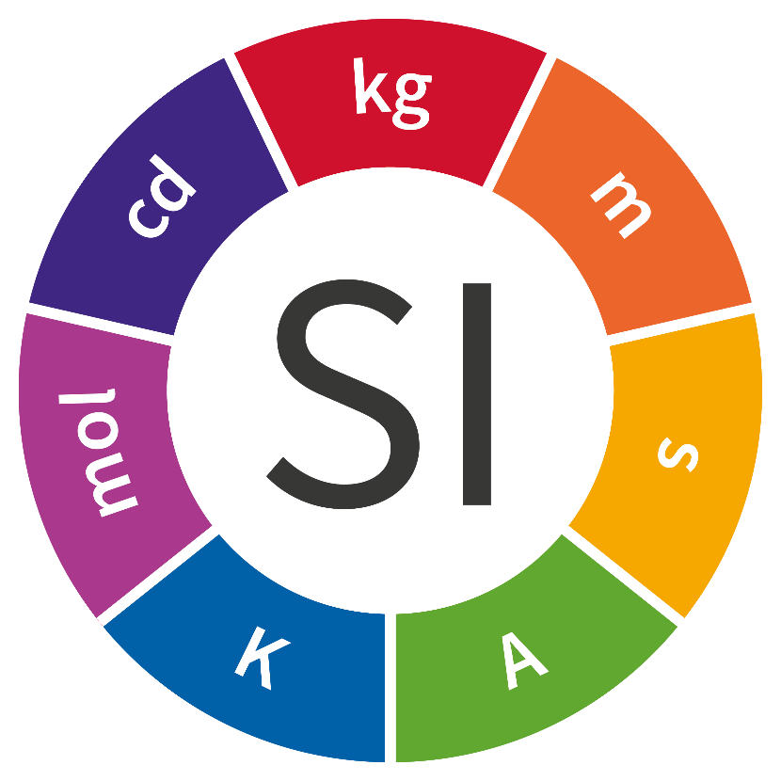

|  |
| --- |
| Extension (optional):  Using the image above, can you state the 7 SI units and what quantities they are used to measure? |

**Independent learning**

**- for those who have not studied AQA GCSE Biology (Single Science)**

You would find it useful to at least look over the topic areas that you may not have studied if you have not completed AQA GCSE Biology (Single Science). These topic areas are named below, together with links you can use to learn about these topic areas before you join us.

**You don’t need to follow every single link.** Perhaps start with the BBC Bitesize links then use the YouTube links to the Free Sciences Lessons videos if you think you need to go over the content again or in a different format.

All of the content for AQA GCSE Biology (Single Science) can be found on this [BBC Bitesize](https://www.bbc.co.uk/bitesize/examspecs/zpgcbk7) page if you want to see it all in one place, or if you’ve studied a different exam board from AQA and want to see exactly what the AQA Biology course covers. Alternatively, you could use [Seneca Learning](https://app.senecalearning.com/classroom/course/6b76a6e0-cf79-11e7-83a9-29a486db2c9f) in the same way.

Ultimately, please don’t worry if you haven’t studied AQA Science / Biology. We will ensure that you develop the knowledge and understanding that you need for A-level Biology, these links just help to ensure that everyone has the opportunity to be starting at the same point in Year 12.

**Culturing microorganisms**

https://www.bbc.co.uk/bitesize/guides/z8fkmsg/revision/5

https://www.youtube.com/watch?v=BkbLI2mAMP8

**Monoclonal antibodies**

https://www.bbc.co.uk/bitesize/guides/zt8t3k7/revision/1

https://www.youtube.com/watch?v=cGNvdB3qNw4

https://www.youtube.com/watch?v=Bgde7orTxD8

**Plant disease**

https://www.bbc.co.uk/bitesize/guides/z3tgw6f/revision/1

https://www.youtube.com/watch?v=VHnS8HUtu44

https://www.youtube.com/watch?v=02Mx7s8gIig

**The brain**

https://www.bbc.co.uk/bitesize/guides/zprxy4j/revision/5

https://www.youtube.com/watch?v=Fuv76dJKBkE

**The eye**

https://www.bbc.co.uk/bitesize/guides/zprxy4j/revision/7

https://www.youtube.com/watch?v=G_clJP1VGtk

**Control of body temperature**

https://www.bbc.co.uk/bitesize/guides/zxgmfcw/revision/1

https://www.youtube.com/watch?v=WoMPARSQPZw

**Maintaining water and nitrogen balance in the body (the kidney)**

https://www.bbc.co.uk/bitesize/guides/zxgmfcw/revision/4

https://www.youtube.com/watch?v=kmRh_yRbAR4

https://www.youtube.com/watch?v=DbLVB_EDnRs

**Plant hormones**

https://www.bbc.co.uk/bitesize/guides/zc6cqhv/revision/1

https://www.youtube.com/watch?v=_Bf5WKEMB5o

**Advantages and disadvantages of sexual and asexual reproduction**

https://www.bbc.co.uk/bitesize/guides/z9pkmsg/revision/3

https://www.youtube.com/watch?v=4n7Cd7SLEQE

**DNA structure**

https://www.bbc.co.uk/bitesize/guides/z36mmp3/revision/1

https://www.youtube.com/watch?v=o4LHU79fB3s

**Cloning**

https://www.bbc.co.uk/bitesize/guides/zsg6v9q/revision/8

https://www.youtube.com/watch?v=QekStThHD2M

https://www.youtube.com/watch?v=hNq-y2Kg5CE

**Theory of evolution**

https://www.bbc.co.uk/bitesize/guides/zcqbdxs/revision/2

https://www.youtube.com/watch?v=2waYa0ZwoXg

**Speciation**

https://www.bbc.co.uk/bitesize/guides/zcqbdxs/revision/6

https://www.youtube.com/watch?v=sqBZRQirPM4

**The understanding of genetics**

https://www.bbc.co.uk/bitesize/guides/zg8f4qt/revision/9

https://www.youtube.com/watch?v=n3cXcDEveRc

**Decomposition**

https://www.bbc.co.uk/bitesize/guides/zy7gw6f/revision/1

https://www.youtube.com/watch?v=6utMftGxuaI

**Impact of environmental change**

https://www.bbc.co.uk/bitesize/guides/zt8f4qt/revision/9

https://www.youtube.com/watch?v=fZxw0QiaSN4

**Trophic levels in an ecosystem**

https://www.bbc.co.uk/bitesize/guides/zs7gw6f/revision/1

https://www.youtube.com/watch?v=AFC5LQ3KnvU

**Food production**

https://www.bbc.co.uk/bitesize/guides/ztwvk2p/revision/1

https://www.youtube.com/watch?v=_ACn3e4qnaM

https://www.youtube.com/watch?v=nrbJl3R4YJU

https://www.youtube.com/watch?v=u59Eg1uNr5g

<https://www.youtube.com/watch?v=6C6lPfQbtek>

**Student tips**

Current Year 12 Biology students at BRGS sixth form were asked what advice they would give to their “12-month-younger self” i.e. to pass on some tips to you to think about, and act on, over the summer before you start with us.

Keep all GCSE revision notes and flash cards and, before Year 12 starts, go over the flash cards instead of restarting each topic from its foundations when you get to it.

Buy a whiteboard! They’re so useful to do revision with!

Review the GCSE content before you start the A-level course in September.  There are lots of topics in the course that are based on your knowledge from GCSE so it’s essential that you are confident with the basics.

I looked over some A-level Biology to see if it was what I wanted to study every day for the next two years. I really recommend doing this as it allowed me to get a feel for the subject even before I started it.

It would be good to start the course knowing clearly your interests, you should ask yourself why exactly you’ve chosen Biology and investigate those interests - start on your further reading maybe?

Try and stay organised. I found having one folder with a set of dividers, in which to keep the current topic in each of my subjects, works well. It helps to keep things safe. Most teachers have a hole punch so handouts can be filed - just ask! Once a topic is finished I then transfer my notes into separate folders for each subject and store them at home.



Go over previous topics regularly to keep knowledge in your head.

Ask questions! Chances are, someone else wanted to ask that too! Don't be shy.

Use past paper questions to really work out what you need to know. I now add to my notes in the booklets once we have done a set of questions to make sure I have the correct definitions or common phrases used on the mark schemes. I wish I had started doing this right at the start of the course.

Don't rush past paper questions; they are one of the best ways of testing what you know.

Use your textbook at home - either to pre read a topic or to consolidate work afterwards. Teachers might not use them in lessons but it is really useful to get into the habit of reading up at home. There are useful questions too with the answers in the back.

Go to the lunchtime support sessions - they really help.

Get into good study habits straight away as once you get into a poor pattern it is hard to break - I speak from experience! I've had a lot of catching up to do......

Teachers are really friendly and happy to help. It is scary asking to see them one-to-one at first, but they expect it and don't think any worse of you. I really wished I had started asking for help earlier than I did!

Try and make revision aids as you complete each topic so you are learning your work as you go along. I've found flashcards are the best way to learn all the factual information, and have a large stack on my desk at home!

Make good use of your private study time in school, rather than use it all to socialise, otherwise you'll be working long hours in the evenings and at weekends.

**Wider engagement**

Below are ideas of books, websites, TV programmes etc. that you could use to widen your knowledge and interest in Biology, including in response to one of the tips above! **All optional!**

**Things to read**

|  |  |  |  |
| --- | --- | --- | --- |
| Biological Sciences Review Extras Magazine Archives | [Sample articles](https://www.hoddereducation.co.uk/media/Documents/Magazines/Biological_Sciences_Review_sample-1.pdf) from the *Biological Sciences Review*, a journal magazine written by students and researchers at the University of Manchester with an audience of A-level Biology students in mind! |  | Free digital archive of publications including [The Biologist](https://exacteditions.com/login%22) magazine – select the ‘library card’ option in the top right-hand corner and enter BRGS’s library card number 559247. |
|  | Advice on [how to read health news](https://www.nhs.uk/news/Pages/Howtoreadarticlesabouthealthandhealthcare.aspx) articles. | Junk DNA: A Journey Through the Dark Matter of the Genome | Our DNA is much more complex than you probably appreciate; [this book](https://www.amazon.co.uk/Junk-DNA-Journey-Through-Matter/dp/1848319150/ref=sr_1_1?dchild=1&keywords=nessa+carey+junk&qid=1589369116&s=books&sr=1-1) will really deepen your understanding of the work you’ll do on DNA and inheritance. |
|  | Apply the advice in the above link to articles you can find on the [BBC Health](https://www.bbc.co.uk/news/health) news pages. | Home | Have a look at these [featured resources](https://www.stem.org.uk/big-picture/featured-resources) including posters and articles. |
| Head Start to A-level Biology (CGP A-Level Biology): Amazon.co.uk ... | [This book](https://www.amazon.co.uk/Head-Start-level-Biology-Level/dp/1782942793) introduces A-level concepts and includes questions to test your understanding. Do remember though – we will teach you everything you need to know! |  | Explore the [online collection](https://wellcomecollection.org/) of stories, digital books, artwork and photos from the “free museum and library for the incurably curious”! |
|  | [A whistle-stop tour](https://www.amazon.co.uk/Short-History-Nearly-Everything-Bryson/dp/1784161853/ref=sr_1_1?dchild=1&keywords=a+short+history+of+nearly+everything+bill+bryson&qid=1589369087&s=books&sr=1-1) through the history of science! |  | An influential [book](https://www.amazon.co.uk/Selfish-Gene-Anniversary-Landmark-Science/dp/0198788606/ref=sr_1_1?dchild=1&keywords=the+selfish+gene+richard&qid=1589371859&sr=8-1) that views evolution from a gene’s perspective! |

**Things to watch**

|  |  |  |  |
| --- | --- | --- | --- |
| Pain, Pus & Poison: The Search for Modern Medicines - DVD PLANET STORE | The excellent BBC series *Pain, Pus and Poison* can be accessed through [iPlayer](https://www.bbc.co.uk/iplayer/episodes/p01f51s5/pain-pus-and-poison-the-search-for-modern-medicines). All about the history of medicine and where different drugs have come from! | PART 2 - LIFE STORY: The Race for the Double Helix [2/2] Staring ... | An old-school Life Story documentary about the discovery of DNA (The Race for the Double Helix)! [Part 1](https://www.dailymotion.com/video/xitlyu) and [part 2](https://www.dailymotion.com/video/xitmu3) are available online. |
|  | Go to [TED](https://www.ted.com/) and type ‘Biology’ into the search engine to find interesting lectures on current topics such as [Growing New Organs](https://www.ted.com/talks/anthony_atala_growing_new_organs?language=en), [Why Bees Are Disappearing](https://www.ted.com/talks/marla_spivak_why_bees_are_disappearing?language=en) and [A New Superweapon in the Fight Against Cancer](https://www.ted.com/talks/paula_hammond_a_new_superweapon_in_the_fight_against_cancer?language=en). | YouTube Banner Size & YouTube Channel Art Size Guide | May 2020 | [YouTube](https://www.youtube.com/) has some great animations that you could use to go over biological processes. [Free Science Lessons](https://www.youtube.com/channel/UCqbOeHaAUXw9Il7sBVG3_bw) and [Khan Academy](https://www.youtube.com/user/khanacademy) are excellent channels. |
|  | Find [BBC Science and Nature programmes](https://www.bbc.co.uk/programmes/genres/factual/scienceandnature/scienceandtechnology) by typing ‘Biology’ into the search bar. Watch anything that takes your interest. |  |  |

**Things to learn**

|  |  |  |  |
| --- | --- | --- | --- |
| E-learning: MOOC Essentials of youth policy - France | MOOC stands for Massive Open Online Courses. Why not see if any free ones take your fancy at [Future Learn](https://www.futurelearn.com/search?q=biology) (type ‘Biology’ into the search bar or try [Valuing Nature: Should We Put a Price On Ecosystems](https://www.futurelearn.com/courses/valuing-nature-should-we-put-a-price-on-ecosystems), [Discover Dentistry](https://www.futurelearn.com/courses/discover-dentistry), [Biochemistry: The Molecules of Life](https://www.futurelearn.com/courses/biochemistry), [How Does the Body Use DNA as a Blueprint](https://www.futurelearn.com/courses/the-body-and-dna)? or [Exploring Our Ocean](https://www.futurelearn.com/courses/exploring-our-ocean). | The Naked Scientists - Wikipedia | [The Naked Scientists](https://www.thenakedscientists.com/) website has lots of resources for you to explore! |