

**A-LEVEL CHEMISTRY**

**Transition Booklet**

1. Introduction

Chemistry explains how the material world works on a macro and micro level. It focusses on developing models to explain the structure of atoms, what drives chemical reactions, methods of analysis and carbon based chemistry. It is a fascinating subject and a well-regarded A-level to study.

A-level Chemistry is conceptually demanding and academically rigorous. It requires substantial and sustained hard work and revision of old topics. One of the things you can do to ensure a good start to Chemistry A-level is work through this booklet, which contains specific GCSE level topics that are required knowledge for A-level.

There is a lot of other revision and preparation you could do, but this booklet selects some essential knowledge and tasks that you should revise and complete before September. Some of it may seem basic, but you can’t build a house without foundations!

Contents

1. Introduction, online resources and book recommendations for wider reading
2. Use of the periodic table
3. Recall and construction of formulae
4. Constructing symbol equations
5. Calculations
6. A-level periodic table
7. Blank flashcard columns
8. Solutions for tasks

Useful links

AQA A-level chemistry specification:

<https://www.aqa.org.uk/subjects/science/as-and-a-level/chemistry-7404-7405/specification-at-a-glance>

Resources that we recommend throughout the course:

[https://www.chemguide.co.uk](https://www.chemguide.co.uk/)

[https://chemrevise.org](https://chemrevise.org/)

[http://www.a-levelchemistry.co.uk](http://www.a-levelchemistry.co.uk/)

[http://www.docbrown.info](http://www.docbrown.info/)

[https://www.physicsandmathstutor.com](https://www.physicsandmathstutor.com/)

Book recommendations

Calculations in A-level chemistry by Jim Clark – slightly out of date but still very good and very accessible for many topics involving calculations.

<https://www.amazon.co.uk/Calculations-Level-Chemistry-Jim-Clark/dp/0582411270>

Periodic tales: the curious lives of the elements.

<https://www.amazon.co.uk/Periodic-Tales-Curious-Lives-Elements/dp/0141041455>

Stuff matters.

<https://www.amazon.co.uk/Stuff-Matters-Marvellous-Materials-Man-made/dp/0241955181>

The disappearing spoon.

<https://www.amazon.co.uk/Disappearing-Spoon-other-tales-Periodic/dp/0552777501>

You will be issued a textbook as part of the course. We do not specifically recommend any other textbooks or revision guides given the amount of online content for free.

1. Use of the periodic table

You will always have a periodic table during assessments. You need to be able to quickly deduce:

* Whether an element is a metal or a non-metal
* What type of bonding is present in a compound
* What charge an ion will have based on its group number

There is a full size AQA A-level periodic table at the end of this booklet.

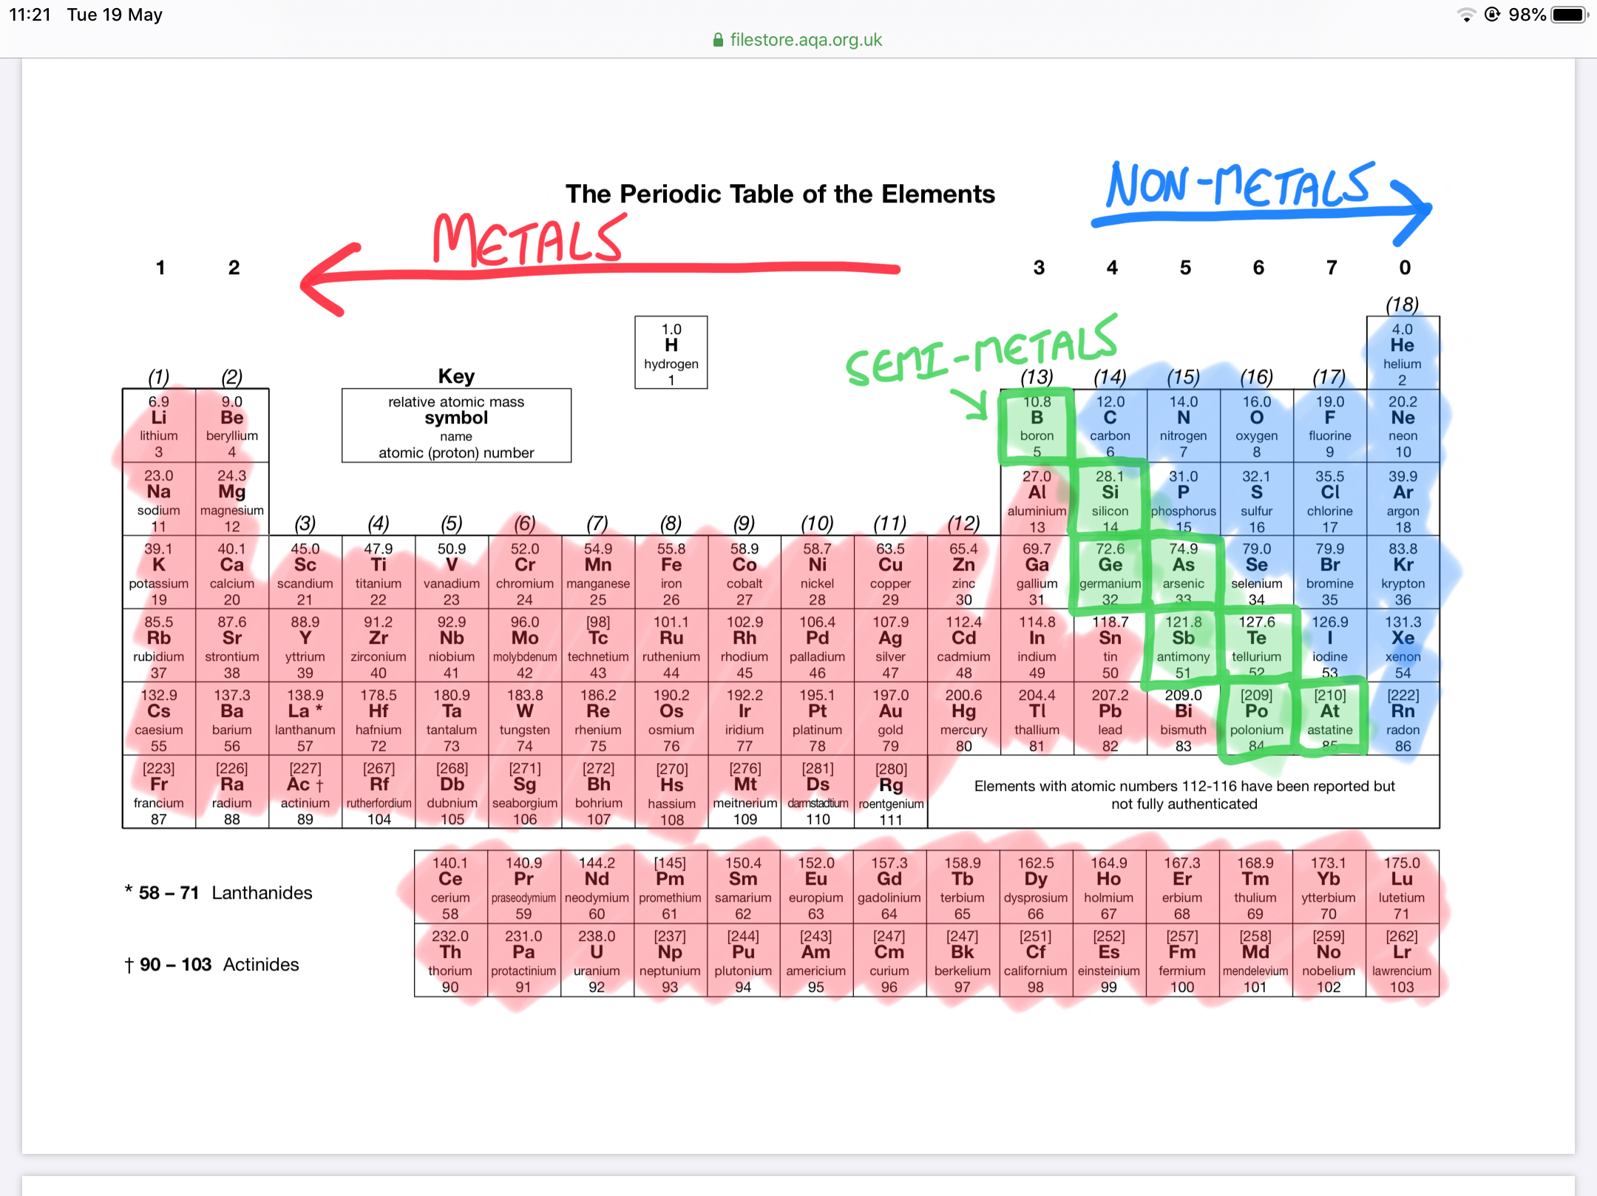

The majority of elements are metals. Metals form positive ions. Non-metals form negative ions.

The types of elements in a compound can be used to deduce its type of bonding.

|  |  |
| --- | --- |
| **Combination of elements** | **Type of bonding** |
| Metal only | Metallic |
| Metal and non-metal | Ionic |
| Non-metal and non-metal | Covalent |

Task 1:

Use the information provided to deduce types of bonding for the following compounds. The first three have been completed for you.

|  |  |  |
| --- | --- | --- |
| **Substance** | **Type of elements within substance** | **Most likely bonding type** |
| H2O | Non-metal and Non-metal | Covalent |
| Lithium fluoride | Metal and non-metal | Ionic |
| Fe | Metal | Metallic |
| K2O |  |  |
| CH4 |  |  |
| Magnesium Oxide |  |  |
| Carbon Dioxide |  |  |
| SO2 |  |  |
| Calcium chloride |  |  |
| CoCO3 |  |  |
| H2S |  |  |
| Fe2O3 |  |  |

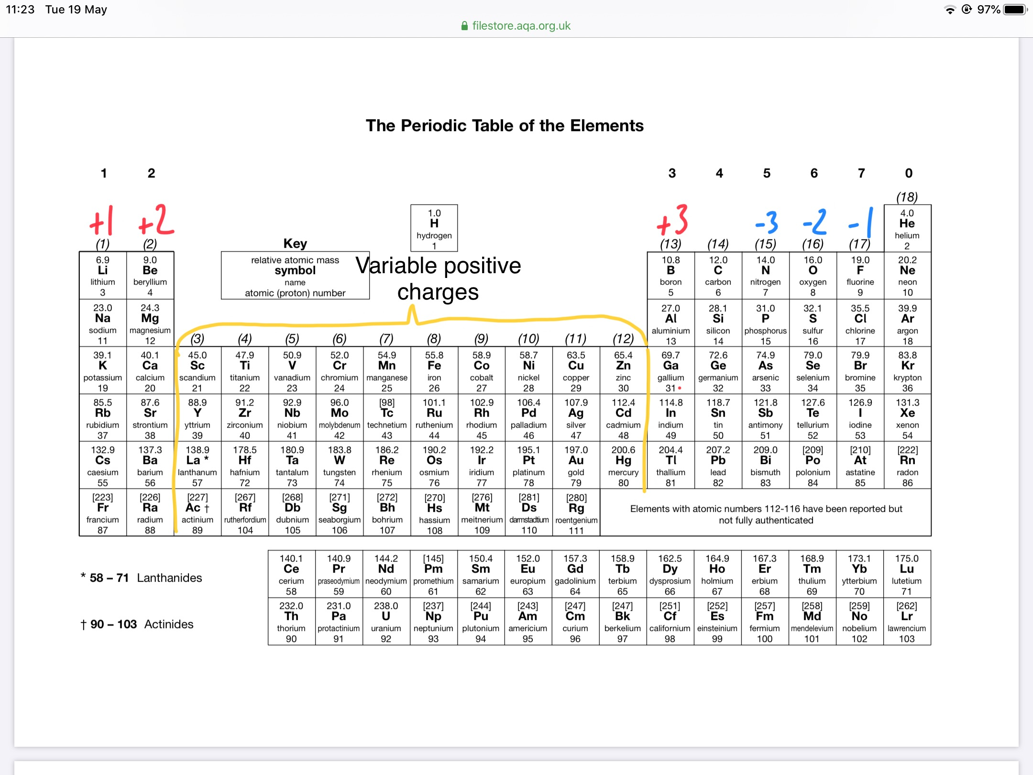

Main group elements (1-7) have very predictable charges when they form ions, as shown on the table. The reasoning for this is explained at GCSE.

Transition elements do not have easily predictable charges. You will learn much more about transition element chemistry during A-level Chemistry. For now, remember the following roman numerals which are used to show positive charges for transition elements.

1. = +1
2. = +2
3. = +3
4. = +4

Task 2:

Use the information provided so far to give symbols for the following ions:

|  |  |  |  |
| --- | --- | --- | --- |
| **Ion** | **Symbol** | **Ion** | **Symbol** |
| Lithium ion | Li+ | Copper (I) ion |  |
| Iron (II) ion | Fe2+ | Cobalt (III) ion |  |
| Fluoride ion |  | Tin (IV) ion |  |
| Sulfide ion |  | Bromide ion |  |
| Oxide ion |  | Potassium ion |  |

1. Recall and construction of formulae

There are some formulae you simply need to know. This is **non-negotiable**. Molecular substances with covalent bonding fall mainly into this category.

Here are some substances you should know the formulae for:

|  |  |  |  |
| --- | --- | --- | --- |
| Carbon Dioxide | CO2 | Carbon Monoxide | CO |
| Nitrogen monoxide | NO | Nitrogen dioxide | NO2 |
| Sulfur dioxide | SO2 | Sulfur trioxide | SO3 |
| Ammonia | NH3 | Methane | CH4 |
| Hydrogen sulfide | H2S | Hydrogen peroxide | H2O2 |
| Hydrochloric acid | HCl | Sulfuric Acid | H2SO4 |
| Nitric Acid | HNO3 | Phosphoric Acid | H3PO4 |
| Oxygen | O2 | Fluorine, Chlorine, Bromine, Iodine | F2, Cl2, Br2, I2 |
| Nitrogen | N2 | Hydrogen | H2 |

You also need to know the formulae of some more complicated or unusual ions. You will not find these on the periodic table!

|  |  |  |  |
| --- | --- | --- | --- |
| Hydrogen ion | H+ | Sulfate ion | SO42- |
| Hydride ion | H- | Nitrate ion | NO3- |
| Carbonate ion | CO32- | Phosphate ion | PO43- |
| Hydroxide ion | OH- | Ammonium ion | NH4+ |

Retrieval practice – formulae

Remembering all these things requires structured practice. One of the simplest ways to do this is to create short knowledge quizzes like flashcards. Use the table below to revise the suggested formulae. There is a blank version of this table at the end of the booklet. You can fold it over and repeat writing out the formulae, then check if you got it right.

|  |  |
| --- | --- |
| Hydrogen ion |  |
| Water |  |
| Carbon monoxide |  |
| Ammonia |  |
| Sulfate ion |  |
| Ammonium ion |  |
| Carbonate ion |  |
| Methane |  |
| Sulfuric acid |  |
| Nitric acid |  |
| Nitrate ion |  |
| Nitrogen monoxide |  |
| Carbon dioxide |  |
| Nitrogen dioxide |  |
| Sulfur dioxide |  |
| Hydrogen sulfide |  |
| Chlorine |  |
| Oxygen |  |
| Hydride ion |  |
| Hydroxide ion |  |
| Hydrogen |  |

Constructing formulae:

For ionic substances, you should be able to construct their formulae without much thought. Students at GCSE sometimes find this challenging, but again at A-level it is a **non-negotiable** skill. You need to use information from Task 1 to do this.

Task 3:

Construct formulae for the following compounds. If you are struggling, check some GCSE resources to refresh your memory.

|  |  |  |  |  |  |
| --- | --- | --- | --- | --- | --- |
| 1 | Sodium chloride |  | 11 | Aluminium sulfate |  |
| 2 | Sodium hydroxide |  | 12 | Copper (II) sulfate |  |
| 3 | Sodium carbonate |  | 13 | Copper (I) oxide |  |
| 4 | Sodium sulfate |  | 14 | Silver (I) bromide |  |
| 5 | Magnesium chloride |  | 15 | Iron (II) oxide |  |
| 6 | Magnesium nitrate |  | 16 | Iron (III) oxide |  |
| 7 | Magnesium hydroxide |  | 17 | Calcium sulfide |  |
| 8 | Aluminium chloride |  | 18 | Ammonium sulfate |  |
| 9 | Ammonium chloride |  | 19 | Zinc (II) iodide |  |
| 10 | Zinc (II) nitrate |  | 20 | Calcium carbonate |  |

1. Writing symbol equations

Many A-level questions require you write a symbol equation without specifically telling you. This is often the case in calculations, where you need a balanced symbol equation to proceed and you might not even be told to write it!

You are never told to write word equations at A-level, but you should know some general word equations in order to be able to construct symbol equations. Here are some examples to learn:

|  |
| --- |
| Metal + oxygen 🡪 metal oxide  e.g. magnesium + oxygen 🡪 magnesium oxide |
| Metal + sulfur 🡪 metal sulphide  e.g. calcium + sulfur 🡪 calcium sulfide |
| Metal + water 🡪 metal hydroxide + hydrogen  e.g. sodium + water 🡪 sodium hydroxide + hydrogen  *(this only applies to reactive metals e.g. group 1 and group 2)* |
| Metal + acid 🡪 salt + hydrogen  e.g. magnesium + hydrochloric acid 🡪 magnesium chloride + hydrogen |
| Metal oxide + acid 🡪 salt + water  e.g. sodium oxide + nitric acid 🡪 sodium nitrate + water |
| Metal hydroxide + acid 🡪 salt + water  e.g. calcium hydroxide + sulfuric acid 🡪 calcium sulfate + water |
| Metal carbonate + acid 🡪 salt + water + carbon dioxide  e.g. potassium carbonate + hydrochloric acid 🡪 potassium chloride + water + carbon dioxide |
| Hydrocarbon + oxygen 🡪 carbon dioxide + water  e.g. ethane + oxygen 🡪 carbon dioxide + water  *(this is complete combustion, incomplete combustion is different)* |

Task 4:

Write word equations for the following reactions. To repeat you will **never** be asked to do this at A-level but it is good practice to embed the information on the previous page. Symbol equations come next.

1. Aluminium reacting with sulfur
2. Copper burning in oxygen
3. Ethane (C2H6) burning completely in oxygen
4. Ethanol (C2H5OH) burning completely in oxygen
5. Lithium reacting with water
6. Magnesium reacting in nitric acid
7. Potassium oxidising in the air
8. The reaction of calcium hydroxide with hydrochloric acid
9. The reaction of sodium oxide with sulphuric acid
10. Zinc carbonate reacting with hydrochloric acid

Task 5:

Writing balanced symbol equations is something you are expected to do at A-level regularly. If you need help with this, check some GCSE resources about how to do the balancing. For this task, you should write the formulae of the reactants and products first – before trying to balance. This may well require you to use information from previous tasks, because a lot of the compounds are ionic!

Write balanced symbol equations for the following processes:

1. Zinc metal reacts with copper (II) sulfate solution to produce solid copper metal and zinc sulfate solution
2. Solid calcium hydroxide reacting with hydrochloric acid solution.
3. Copper reacts with oxygen to make copper (II) oxide
4. Magnesium reacts with nitric acid
5. Lithium carbonate reacts with sulfuric acid
6. Octane, C8H18 reacts with oxygen in a complete combustion reaction
7. Iron reacts with hydrochloric acid to form iron (III) chloride and hydrogen
8. Sodium reacting with water
9. Aluminium reacting with sulfur
10. When lead(II) nitrate is heated in a dry tube lead (II) oxide, nitrogen dioxide gas and oxygen are produced.
11. Hydrogen peroxide decomposes to form water and oxygen
12. Calculations

Calculations make up a huge part of A-level chemistry. The AQA specify that they comprise at **minimum** 20% of the questions in exams. It tends to be higher than that; it is an easy way for an exam author to make a question hard.

The mathematical content in A-level chemistry is of higher GCSE standard, meaning it is relatively simple. However, students often find it very difficult because of the complex language of chemistry. All of the things covered so far, in particular formulae and equations are relevant to how calculations are carried out.

GCSE maths skills that you should refresh before starting the course are:

* Expressing and using numbers in standard form
* Stating numbers to specific numbers of significant figures and decimal places
* Rearranging equations (not everything fits in a triangle!)
* Simple algebra
* Unit conversion

Relative formula mass and molecular mass

The relative atomic masses given on the periodic table are added up to give a relative formula mass (RFM) or relative molecular mass (Mr). Technically these two things are different but they are often used interchangeably by chemists.

e.g. The RFM/Mr of water, H2O is 1 + 1 + 16 = 18.

Task 6:

Calculate the relative formula/molecular mass of the following. You will **need to construct the formula first,** using skills from earlier in the booklet!

|  |  |  |  |  |  |
| --- | --- | --- | --- | --- | --- |
| 1 | Barium chloride |  | 11 | Sodium hydride |  |
| 2 | Ammonium nitrate |  | 12 | Zinc (II) hydroxide |  |
| 3 | Calcium sulfate |  | 13 | Potassium oxide |  |
| 4 | Barium nitrate |  | 14 | Zinc |  |
| 5 | Silver (I) oxide |  | 15 | Carbon dioxide |  |
| 6 | Aluminium sulfate |  | 16 | Hydrogen |  |
| 7 | Fluorine |  | 17 | Sulfur trioxide |  |
| 8 | Sulfur dioxide |  | 18 | Beryllium hydroxide |  |
| 9 | Iron (II) sulfate |  | 19 | Vanadium (V) oxide |  |
| 10 | Sodium carbonate |  | 20 | Copper (I) oxide |  |

Calculating numbers of moles

The mole is the chemist’s unit. You will study it in more depth at A-level, but for this booklet we will focus on simple mole calculations. You need to know and be able to rearrange the formula:

$$Moles=\frac{mass}{Relative formula mass}$$

This is often shown as the triangle:

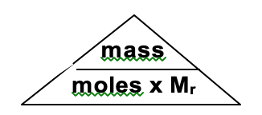

Task 7:

Calculate the number of moles of each of the following substances:

|  |  |  |  |  |  |
| --- | --- | --- | --- | --- | --- |
| 1 | 9.0 g of H2O |  | 11 | 19.3 g of NaCl |  |
| 2 | 88.0 g of CO2 |  | 12 | 21.25 g of NaNO3 |  |
| 3 | 1.70 g of NH3 |  | 13 | 2.25 g of Na2CO3 |  |
| 4 | 230 g of C2H5OH |  | 14 | 0.800 g of NaOH |  |
| 5 | 560g of C2H4 |  | 15 | 17.75 g of Na2SO4 |  |
| 6 | 0.640 g of SO2 |  | 16 | 3.16 g of KMnO4 |  |
| 7 | 80.0 g of SO3 |  | 17 | 32.33 g of K2CrO4 |  |
| 8 | 18.0 g of HBr |  | 18 | 100 g of KHCO3 |  |
| 9 | 0.0960 g of H2SO4 |  | 19 | 7.63 g of potassium iodide |  |
| 10 | 3.15 g of HNO3 |  | 20 | 3.90 g of caesium nitrate |  |

Task 8:

Calculate the mass of the following:

|  |  |  |  |  |  |
| --- | --- | --- | --- | --- | --- |
| 1 | 2 moles of H2O |  | 11 | 0.45 moles of NaCl |  |
| 2 | 3 moles of CO2 |  | 12 | 0.70 moles of NaNO3 |  |
| 3 | 8 moles of NH3 |  | 13 | 0.11 moles of Na2CO3 |  |
| 4 | 0.50 moles of C2H5OH |  | 14 | 2.0 moles of NaOH |  |
| 5 | 1.2 moles of C2H4 |  | 15 | 0.90 moles of Na2SO4 |  |
| 6 | 0.64 moles of SO2 |  | 16 | 0.050 moles of KMnO4 |  |
| 7 | 3 moles of SO3 |  | 17 | 0.18 moles of K2CrO4 |  |
| 8 | 1 mole of HBr |  | 18 | 0.90 moles of KHCO3 |  |
| 9 | 0.012 moles of H2SO4 |  | 19 | 1.5 moles of potassium iodide |  |
| 10 | 0.15 moles of HNO3 |  | 20 | 0.12 moles of caesium nitrate |  |

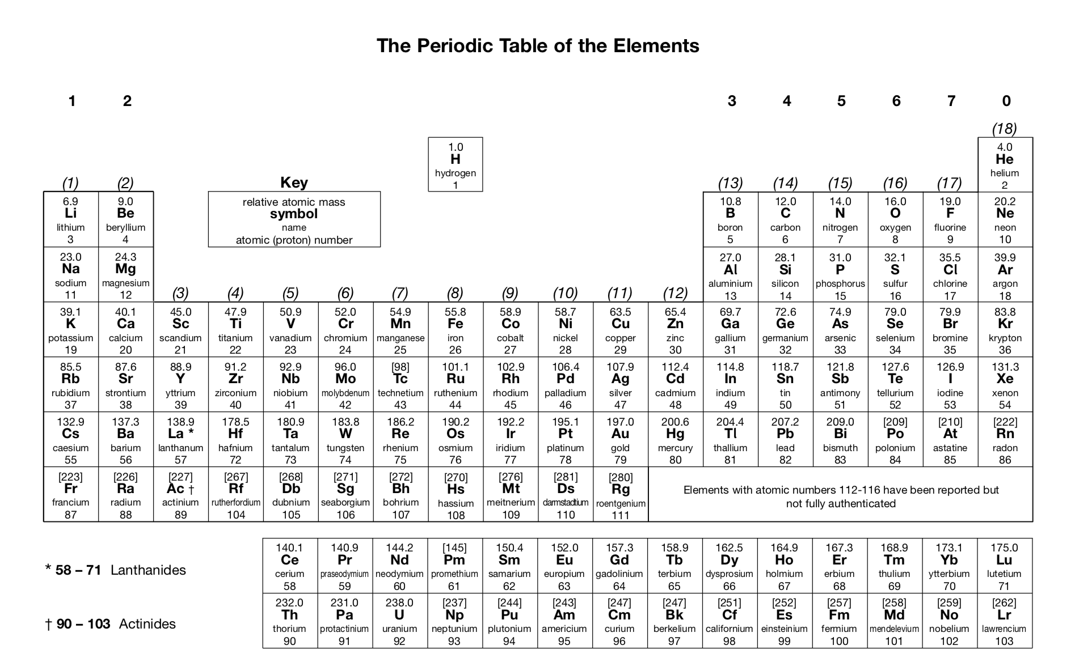

|  |  |
| --- | --- |
| Give the products of a reaction between a metal and acid | A salt and hydrogen gas |
|  |  |
|  |  |
|  |  |
|  |  |
|  |  |
|  |  |
|  |  |
|  |  |
|  |  |
|  |  |
|  |  |
|  |  |
|  |  |
|  |  |
|  |  |
|  |  |
|  |  |
|  |  |
|  |  |
|  |  |

7. Retrieval practice: blank table

Use the blank tables to create your own knowledge quizzes. There is an example in the first box.

|  |  |
| --- | --- |
| Give the products of a reaction between a metal and acid | A salt and hydrogen gas |
|  |  |
|  |  |
|  |  |
|  |  |
|  |  |
|  |  |
|  |  |
|  |  |
|  |  |
|  |  |
|  |  |
|  |  |
|  |  |
|  |  |
|  |  |
|  |  |
|  |  |
|  |  |
|  |  |
|  |  |
|  |  |
|  |  |
|  |  |
|  |  |
|  |  |
|  |  |
|  |  |
|  |  |
|  |  |
|  |  |
|  |  |
|  |  |
|  |  |
|  |  |
|  |  |
|  |  |
|  |  |
|  |  |
|  |  |
|  |  |
|  |  |
|  |  |
|  |  |

1. Solutions:

Task 1:

|  |  |  |
| --- | --- | --- |
| **Substance** | **Type of elements within substance** | **Most likely bonding type** |
| H2O | Non-metal and Non-metal | Covalent |
| Lithium fluoride | Metal and non-metal | Ionic |
| Fe | Metal | Metallic |
| K2O | Metal and non-metal | Ionic |
| CH4 | Non-metal and Non-metal | Covalent |
| Magnesium Oxide | Metal and non-metal | Ionic |
| Carbon Dioxide | Non-metal and Non-metal | Covalent |
| SO2 | Non-metal and Non-metal | Covalent |
| Calcium chloride | Metal and non-metal | Ionic |
| CoCO3 | Metal and non-metal | Ionic |
| H2S | Non-metal and Non-metal | Covalent |
| Fe2O3 | Metal and non-metal | Ionic |

Task 2:

|  |  |  |  |
| --- | --- | --- | --- |
| **Ion** | **Symbol** | **Ion** | **Symbol** |
| Lithium ion | Li+ | Copper (I) ion | Cu+ |
| Iron (II) ion | Fe2+ | Cobalt (III) ion | Co3+ |
| Fluoride ion | F- | Tin (IV) ion | Sn4+ |
| Sulfide ion | S2- | Bromide ion | Br- |
| Oxide ion | O2- | Potassium ion | K+ |

Task 3:

|  |  |  |  |  |  |
| --- | --- | --- | --- | --- | --- |
| 1 | Sodium chloride | NaCl | 11 | Aluminium sulfate | Al2(SO4)3 |
| 2 | Sodium hydroxide | NaOH | 12 | Copper (II) sulfate | CuSO4 |
| 3 | Sodium carbonate | Na­­2CO3 | 13 | Copper (I) oxide | Cu2O |
| 4 | Sodium sulfate | Na2SO4 | 14 | Silver (I) bromide | AgBr |
| 5 | Magnesium chloride | MgCl2 | 15 | Iron (II) oxide | FeO |
| 6 | Magnesium nitrate | Mg(NO3)2 | 16 | Iron (III) oxide | Fe2O3 |
| 7 | Magnesium hydroxide | Mg(OH)2 | 17 | Calcium sulfide | CaS |
| 8 | Aluminium chloride | AlCl3 | 18 | Ammonium sulfate | (NH4)2SO4 |
| 9 | Ammonium chloride | NH4Cl | 19 | Zinc (II) iodide | ZnI2 |
| 10 | Zinc (II) nitrate | Zn(NO3)2 | 20 | Calcium carbonate | CaCO3 |

Task 4:

1. Aluminium + sulfur 🡪 Aluminium sulfide
2. Copper + oxygen 🡪 Copper oxide
3. Ethane + oxygen 🡪 carbon dioxide + water
4. Ethanol + oxygen 🡪 carbon dioxide + water
5. Lithium + water 🡪 Lithium hydroxide + hydrogen
6. Magnesium + nitric acid 🡪 magnesium nitrate + hydrogen
7. Potassium + oxygen 🡪 Potassium oxide
8. Calcium hydroxide + hydrochloric acid 🡪 calcium chloride + water
9. Sodium oxide + sulfuric acid 🡪 sodium sulfate + water
10. Zinc carbonate + hydrochloric acid 🡪 zinc chloride + carbon dioxide + water

Task 5:

1. Zn + CuSO4 🡪 ZnSO4 + Cu
2. Ca(OH)2 + 2HCl 🡪 CaCl2 + 2H2O
3. 2Cu + O2 🡪 2CuO
4. Mg + 2HNO3 🡪 Mg(NO3)2 + H2
5. Li2CO3 + H2SO4 🡪 Li2SO4 + CO2 + H2O
6. C8H18 + 12.5O2 🡪 8CO2 + 9H2O OR 2C8H18 + 25O2 🡪 16CO2 + 18H2O
7. 2Fe + 6HCl 🡪 2FeCl3 + 3H2
8. 2Na + 2H2O 🡪 2NaOH + H2
9. 2Al + 3S 🡪 Al2S3
10. 2Pb(NO3)2 🡪 2PbO + 4NO2 + O2
11. 2H2O2 🡪 2H2O + O2

Task 6:

|  |  |  |  |  |  |
| --- | --- | --- | --- | --- | --- |
| 1 | Barium chloride | BaCl2  = 208.3 | 11 | Sodium hydride | NaH = 24 |
| 2 | Ammonium nitrate | NH4NO3 = 80 | 12 | Zinc (II) hydroxide | Zn(OH)2 = 99.4 |
| 3 | Calcium sulfate | CaSO4 = 136.2 | 13 | Potassium oxide | ­K2O = 94.2 |
| 4 | Barium nitrate | Ba(NO3)2 = 261.3 | 14 | Zinc | Zn = 65.4 |
| 5 | Silver (I) oxide | Ag2O = 231.8 | 15 | Carbon dioxide | CO2 = 44 |
| 6 | Aluminium sulfate | Al2(SO4)3 = 342.3 | 16 | Hydrogen | H2 = 2 |
| 7 | Fluorine | F2 = 38 | 17 | Sulfur trioxide | SO3 =80.1 |
| 8 | Sulfur dioxide | SO2 = 64.1 | 18 | Beryllium hydroxide | Be(OH)2 = 43 |
| 9 | Iron (II) sulfate | FeSO4 = 151.9 | 19 | Vanadium (V) oxide | V2O5 = 181.8 |
| 10 | Sodium carbonate | Na2CO3 = 106 | 20 | Copper (I) oxide | CuO = 79.5 |

Task 7:

|  |  |  |  |  |  |
| --- | --- | --- | --- | --- | --- |
| 1 | 9.0 g of H2O | 0.5 mol | 11 | 19.3 g of NaCl | 0.33 mol |
| 2 | 88.0 g of CO2 | 2.0 mol | 12 | 21.25 g of NaNO3 | 0.25 mol |
| 3 | 1.70 g of NH3 | 0.1 mol | 13 | 2.25 g of Na2CO3 | 0.021 mol |
| 4 | 230 g of C2H5OH | 5.0 mol | 14 | 0.800 g of NaOH | 0.02 mol |
| 5 | 560g of C2H4 | 20 mol | 15 | 17.75 g of Na2SO4 | 0.125 mol |
| 6 | 0.641 g of SO2 | 0.01 mol | 16 | 3.16 g of KMnO4 | 0.02 mol |
| 7 | 80.1 g of SO3 | 1 mol | 17 | 32.33 g of K2CrO4 | 0.167 mol |
| 8 | 18.0 g of HBr | 0.22 mol | 18 | 100.1 g of KHCO3 | 1.0 mol |
| 9 | 0.0960 g of H2SO4 | 0.001 mol | 19 | 7.63 g of potassium iodide | 0.046 mol |
| 10 | 3.15 g of HNO3 | 0.05 mol | 20 | 3.90 g of caesium nitrate | 0.02 mol |

Task 8:

|  |  |  |  |  |  |
| --- | --- | --- | --- | --- | --- |
| 1 | 2 moles of H2O | 36.0 g | 11 | 0.45 moles of NaCl | 26.3 g |
| 2 | 3 moles of CO2 | 132 g | 12 | 0.70 moles of NaNO3 | 59.5 g |
| 3 | 8 moles of NH3 | 136 g | 13 | 0.11 moles of Na2CO3 | 11.7 g |
| 4 | 0.50 moles of C2H5OH | 23.0 g | 14 | 2.0 moles of NaOH | 80.0 g |
| 5 | 1.2 moles of C2H4 | 33.6 g | 15 | 0.90 moles of Na2SO4 | 127.8 g |
| 6 | 0.64 moles of SO2 | 41.0 g | 16 | 0.050 moles of KMnO4 | 7.9 g |
| 7 | 3 moles of SO3 | 240.3 g | 17 | 0.18 moles of K2CrO4 | 34.92 g |
| 8 | 1 mole of HBr | 80.9 g | 18 | 0.90 moles of KHCO3 | 90.09 g |
| 9 | 0.012 moles of H2SO4 | 1.18 g | 19 | 1.5 moles of potassium iodide | 249 g |
| 10 | 0.15 moles of HNO3 | 9.45 g | 20 | 0.12 moles of caesium nitrate | 194.9 g |