A LEVEL

PHYSICAL EDUCATION

AQA



**Why study PE?**

As a talented sportsperson your skill, ability, motivation and brain power will be rewarded with a recognised academic qualification. A level PE covers an incredibly diverse and interesting range of topics.

In addition, much of the knowledge and understanding gained on the course can be applied to you as a sportsperson and used to improve your personal performance. By the end of the course you will be well rounded in the world of sport with knowledge in science, psychology and sociology.

**Exam Board:**

AQA: [www.aqa.org.uk](http://www.aqa.org.uk/)

**Course Outline:**

1. Applied anatomy and physiology

2. Skill acquisition

3. Sport and society

4. Exercise physiology

5. Biomechanical movement

6. Sport psychology

7. Sport and society and the role of technology in physical activity and sport.

8. Non-Examined Assessment. One practical sport and coursework.

**How you are assessed:**

2 x 2 hour examinations will account for 70% of the assessment and will include a variety of question types: multiple-choice, short answer, levels of response answers up to 15 marks.

Students will need to supply detailed DVD evidence of their competitive performance in one sport from the syllabus. (15%)

Coursework: written/verbal analysis of performance. (15%)

**Studying this subject could lead to a career in:**

Physiotherapist, radiographer, podiatrist, doctor, PE teacher, outdoor education instructor, primary school teacher, armed forces, police force, journalist, sports business management, sport science, equipment design, nutrition, sports massage, fitness instructor, psychiatrist.

**Subject requirements:**

GCSE PE qualification desirable.

Students need to be performing at a competitive level in one of the sports listed on the syllabus. **DVD footage of performance in one sport will be needed as evidence to gain marks in this section of assessment. (15%) This will be needed in February of the second year of the course.**

Sports covered are as follows.

ACROBATIC GYMNASTICS, AMATEUR BOXING, ASSSOCIATION FOOTBALL, ATHLETICS, BADMINTON, BASKETBALL, CAMOGIE, CANOEING, CRICKET, CYCLING (Road, track. BMX – racing), DANCE, DIVING, EQUESTRIAN, FIGURE SKATING, FUTSAL, GAELIC FOOTBALL, GOLF, GYMNASTICS, HANDBALL, HOCKEY, ICE HOCKY, INLINE ROLLER HOCKEY, HURLING, KAYAKING, LACROSSE, NETBALL, ROCK CLIMBING, ROWING, RUGBY LEAGUE, RUGBY UNION, SAILING, SCULLING, SKIING, SNOWBOARDING, SQUASH, SWIMMING, TABLE TENNIS, TENNIS, TRAMPOLINING, TRIATHLON (sprint only), VOLLEYBALL, WATER POLO, WINDSURFING.

**Useful web links:**

Online resource where you will have access to the entire course through online lessons, small tests and end of topic quizzes.

<https://theeverlearner.com/>

Link to AQA syllabus.

<https://www.aqa.org.uk/subjects/physical-education/as-and-a-level/physical-education-7582>

2020 TRANSITION INFORMATION

THEORTICAL CONTENT

**REINFORCING GCSE KNOWLEDGE AND CONTENT.**

Students in 2020 will not have sat the GCSE exam papers and may not have completed the course. It would be a good idea to attempt some GCSE papers from the past to reinforce and check knowledge of content.

With this in mind, if you click on the following link you will find the Specification page of the AQA GCSE course. Click on the Teaching resources assess link and you will find 4 past papers to attempt with mark schemes. (2 x Paper 1, and 2 x Paper 2).

<https://www.aqa.org.uk/subjects/physical-education/gcse/physical-education-8582>

**SAMPLE CONTENT FROM THE A LEVEL COURSE** (Preview day activities).

Full specification can be found above in the useful web links. Here are some Introductory activities to sections of the course. Have a go at some of these and discovering the answers.

**From the Bio-mechanics section.**

**CENTRE OF MASS.**

Centre of mass is the point of concentration of mass or, more simply, the point of balance, of a body.

1. Work with a partner. They will try and push you over in each of these positions.

Put them in order of the most stable to least stable.

STABLE UNSTABLE

1. On your hand and knees.
2. Standing on 2 feet shoulder width apart
3. Standing on one foot
4. Standing with your feet together
5. Stand with your back up against the wall and try and touch your toes. What happens and why?

[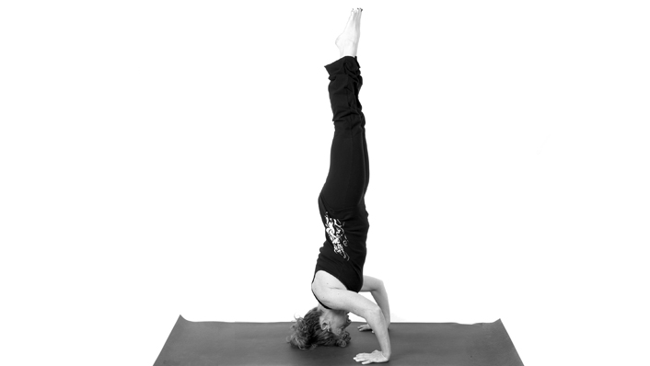](http://www.google.co.uk/url?sa=i&rct=j&q=&esrc=s&source=images&cd=&cad=rja&uact=8&ved=0ahUKEwjZ7-mJmIbUAhVFXRoKHZ8rBVkQjRwIBw&url=http://yahwehyoga.com/pose-descriptions/cool-down/head-stand/&psig=AFQjCNHmxsTKCjE8X9CRdRw8NYPKGg0nOw&ust=1495634816925340)

1. Perform a handstand and a headstand. Which is the most stable and why?

[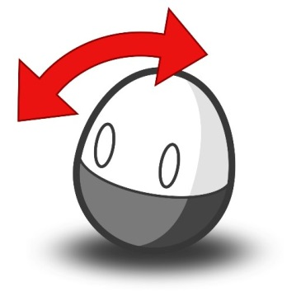](https://www.google.co.uk/url?sa=i&rct=j&q=&esrc=s&source=images&cd=&cad=rja&uact=8&ved=0ahUKEwiQsbCwmIbUAhXMsxQKHUAlCrcQjRwIBw&url=https://twitter.com/weeble&psig=AFQjCNEVhLdMP0NttZCDpE-Wm7UooOFxDg&ust=1495634887377508)

1. Why don t weebles fall over?
2. Why is it difficult to walk on stilts?
3. Pretend to do a full sprint start. Why do you feel more unstable as you go through the starting process?

[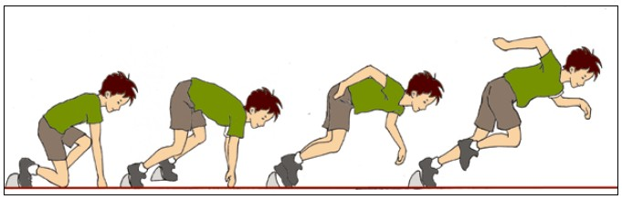](https://www.google.co.uk/url?sa=i&rct=j&q=&esrc=s&source=images&cd=&cad=rja&uact=8&ved=0ahUKEwj6rMzJmIbUAhWBmBQKHbZvDT0QjRwIBw&url=https://commons.wikimedia.org/wiki/File:SPRINT_START.jpg&psig=AFQjCNELpSZE558ZwCL8lZvCCouTPA-XCg&ust=1495634956342810)

1. List the mechanical principles that make an object more stable.

**From the Skill acquisition / Psychology section.**

**Personality**

Here is a list of 10 "Personality Traits"

Aggressive, confident, leadership, optimistic, outgoing, peaceful, thoughtful, talkative, calm, impulsive

A) Rank them from 1 to 10 in order of importance for a team sports player (e.g. basketball, football, hockey, netball or rugby)

B) Do the same exercise for an individual performer (e.g. golfer, long jumper, archer, 800 m runner, triathlete)

C) What about for a 1 v 1 sport (e.g. tennis, boxing)

Does the type of sport make any difference to the rank order of personality traits? Why/why not?

PRACTICAL CONTENT

**DVD footage of performance in one sport will be needed as evidence to gain marks in this section of assessment. (15%) This will be needed in February of the second year of the course.**

With the current situation meaning that virtually all sport is suspended this may well have to be adapted but there is no information on this at the moment.

FURTHER VIEWING AND READING

In the current climate you have time to use the resources available to increase your sporting knowledge which will be useful at A level. Hopefully some of these will interest you.

**NETFLIX**

The Last Dance Story of the Chicago Bulls/Michael Jordan

Counter Punch Boxing Documentary

The Game Changers Diet and Nutrition

The Short Game Youth golfers

Last Chance U American Football

Stop at Nothing Lance Armstrong Story

Sir Alex Ferguson Secret of Success

Icarus Sport and Doping

The English Game Birth of professional football

**PRIME VIDEO**

All or Nothing Manchester City

All or Nothing All Blacks

Steven Gerrard Make us Dream

Andy Murray Resurfacing

Fittest on Earth CrossFit

Redemption Climbing

Champs Boxing World Champions

This is Football The Impact on Society

**YOUTUBE**

The Answer Allen Iversen – Basketball

When Naz hit NYC Prince Naseem – Boxing

Road to Redemption Tyson Fury – Boxing

Who is Zlatan? Ibrahhimovic – Football

Chasing Perfections Cheerleading

The Black Mamba Mentality Kobe Bryant – Football

Journey to the Kop Jurgen Klopp

The Body Coach Home Workouts

My Sub 2 hr Marathon Eluid Kipchoge

The Masters 2019 Tiger Roars again – Golf

FIFA World Cup Rewind Football

Shame in the Game Racism – Football

All By Myself George Best – Football

Driven Billy Monger – Motor Sports

Inside the Game Inside Female MMA

Scotland’s Rugby Classics Rugby Union

**BOOKS**

Behind the Mask Tyson Fury

Open Andre Agassi

Unbeatable Jessica Ennis

You can be Serious Adrian Nicklin

No Limits Michael Phelps

The Greatest Muhammad Ali

Messi Lionel Messi

Courage to Soar Simone Biles

The Secret Race Tyler Hamilton – Doping in Cycling

Bounce Matthew Syed

Serve to Win Novak Djokovic

Fast Exercise Dr Michael Mosley

Seven Deadly Sins David Walsh – Lance Armstrong and Doping

Tour De France The Science of the Tour - James Witts

Cycling Science Max Glaskin