***Psychology***

Why study Psychology?

Believe it or not, we are all, to some extent, psychologists. Everyone knows something about human behaviour! We often try to figure out why people do what they do and ask questions such as:





What is Psychology?

The difference between our own views on human behaviour and that of psychologists is that psychology is based on scientific evidence. Psychologists are interested in what makes people tick and how this understanding can help solve major problems in society. To do this they gather scientific evidence, by observing, measuring and testing, then arriving at conclusions that are rooted in sound scientific methodology. For this reason, psychology is defined as ‘the scientific study of the mind and behaviour’.

Applied or practising psychologists use the knowledge gained from this research in a wide range of settings, helping people with all sorts of problems, working with them to bring about change for the better. For example, bio psychologists have used knowledge of the role of faulty chemicals in the brain in disorders such as schizophrenia and depression to develop drug treatments.

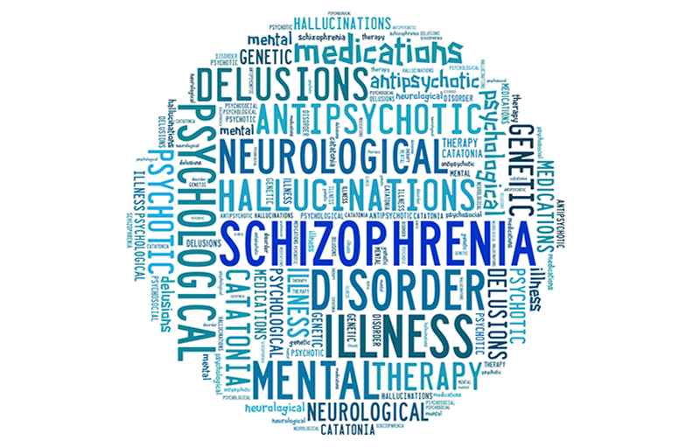

Where does Psychology A-Level lead?

Students who have completed the A Level in Psychology have taken a variety of courses at university. These include BSC courses in Psychology, Cognitive Science and Behavioural Science. However, many have applied successfully for a whole host of courses including Law, Medicine, Social Work, Nursing, Teaching, Arts and Humanities. This demonstrates how, as an A level, Psychology combines well with science subjects, social sciences and arts and humanities subjects. It can also be a great stepping stone to any apprenticeship course or job role that involves working with or an understanding of people.

Possible career options

Studying psychology at university can give you a whole host of exciting career options including: forensics, psychiatry, law, marketing, business development, accountancy, human resources, occupational therapy, clinical psychology, nursing, and teaching. The list is endless!

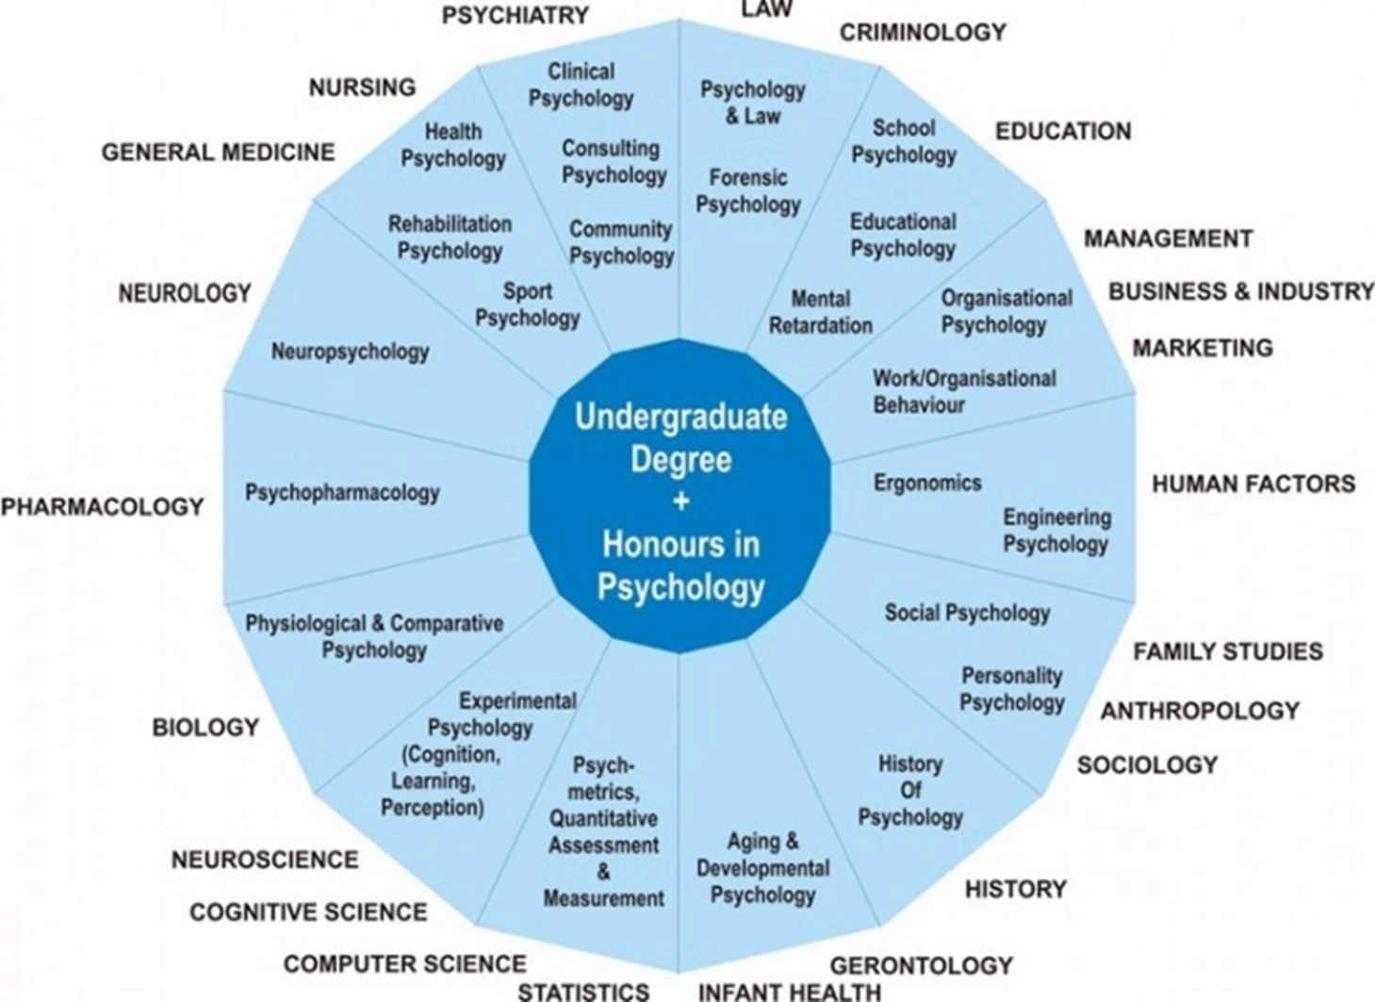

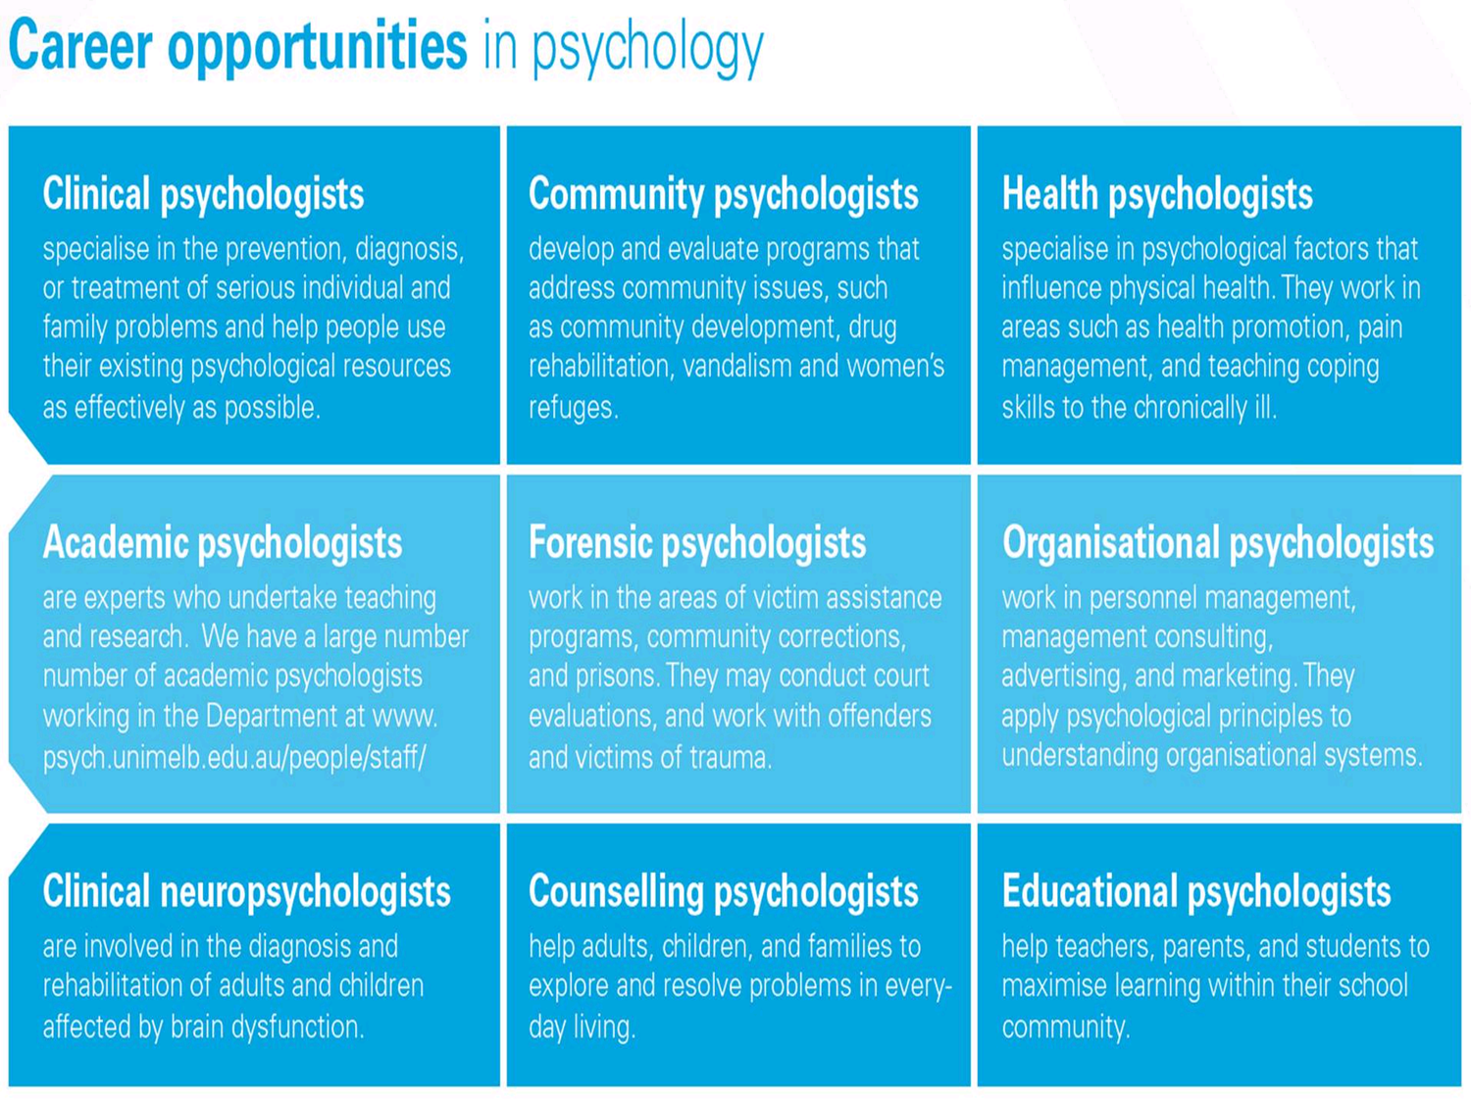

The Psychology Course at BRGS

We study the AQA specification. The topics we cover are listed below. If you are interested in looking at the course content in more detail, follow this link:



<https://www.aqa.org.uk/subjects/psychology/as-and-a-level>

**Paper 1**

**Introductory topics in psychology**:

Social Influence

Memory

Attachment

Psychopathology

**Paper 2**

**Psychology in Context:**

Approaches

Biopsychology

Research Methods

**Paper 3**

**Issues and Options in Psychology:**

Issues and Debates

Gender

Schizophrenia

Forensic Psychology

How are you assessed?

To gain an A-Level in Psychology, all 3 papers (1, 2 and 3) will be sat at the end of the second year in, each contributing 33.3% towards the final qualification.

Paper 1 – Introductory topics

Exam – 2 hours

96 marks

33.3 % of the total A-Level

Paper 2 – Psychology in context

Exam – 2 hours

96 marks

33.3 % of the total A-level

Paper 3 – Issues and Options in Psychology

Exam – 2 hours

96 marks

33.3 % of the total A-Level

Transition – what skills and knowledge will I need?

There is no prior knowledge that you need to study Psychology at A-Level and we teach you everything you need to know during the course. Whilst some schools offer Psychology at GCSE, you do not need to have studied it to take the A-level course. However, what you will need is enthusiasm, an enquiring mind and a willingness to study hard!

Equipment

We advise you have the following equipment to help you stay organised during your time with us and to enable you to engage in the process of on-going learning and revision.

* Lever arch folder
* Subject dividers
* A4 lined refill pad
* Blank index / flash cards
* Pens (different colours, including purple)
* Pencils
* Ruler (ideally 30 cm)
* Highlighter pens (range of colours)
* Scientific calculator

You do not need to buy any text books or revision resources as we will provide you with booklets and exam question booklets for each topic. If you do decide to buy any resources, then please make sure they are recommended for the AQA psychology course.

Independent Learning

We expect you to work hard, both in and outside of lessons.

We expect you to spend about 4.5 hours per week outside lessons working. This includes independent learning set by your teachers and ongoing review of previous learning. Your timetable is different at A-level compared to GCSE as it provides you with study periods during the day to work on your studies.

We offer specific lunchtime support sessions to help you with your studies, whether you want help with the content, advice on how to complete tasks, or to find out more about the topics taught.

Want to discover more before the course begins?

The following are suggestions for wider reading and viewing if you wish to gain a taster of the topic of psychology. These are completely optional and are simply designed to give you an insight into some of the topic areas.

Psychology sites to browse

|  |  |
| --- | --- |
|  | There are many documentaries on YouTube for you to watch. Simply type in any of the topics in the course content to find out more. |
| <https://psychcentral.com/> | Freely available psychology and mental health resources with news and expert information. This site will provide you with a good overview of some of the mental health disorders we study in the psychopathology topic. |
| <https://www.simplypsychology.org/> | Find psychology articles, student resources and learn about the theories and perspectives that have shaped the discipline. |
| Things to watch | This is a great psychology monthly journal that you need to pay to subscribe to. However, if you click on the link below, you can access some free resources and articles.  <https://www.hoddereducation.co.uk/magazines/magazines-extras/psychology-review-extras> |
|  | **A Beautiful Mind and Shutter Island**  Two great films that portray the issue of mental health in psychology. I won’t say any more as I don’t want to spoil them for you! |
|  | **The Mum who got Tourette’s - Channel4.com**  Watch this documentary about a woman who developed Tourette’s in her 40’s to help you gain an insight into this condition. |
|  | **The Mind explained - Netflix series**  Discover how your brain works with this fascinating series. |
|  | **What makes a murderer - Channel4.com**  Watch this documentary to find out why people murder! A great introduction to the Forensic Psychology topic. |