 **BRGS LAW**

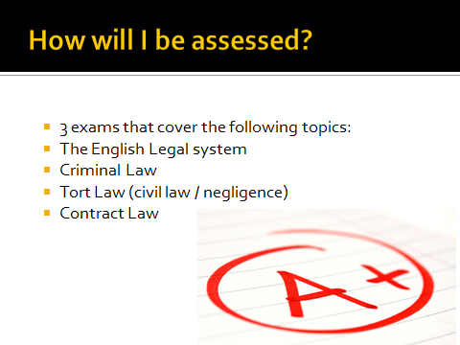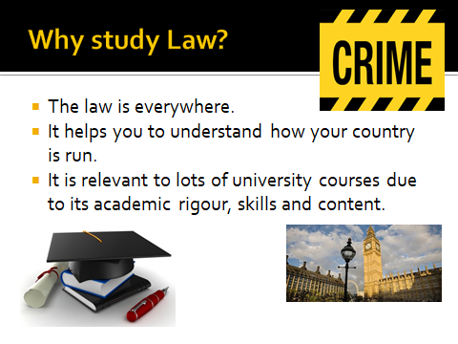

Exam Board

AQA



**Body parts stolen!**

**Man caught masturbating in public toilets!**

**Murder Manslaughter**

**Assault Making laws Battery**

**Topics and cases you will study**

**Prostitutes approaching men in the street!**

**Son murders mum to inherit her money!**

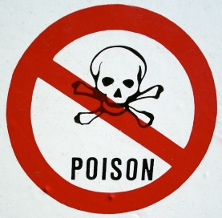**ABH GBH Theft Robbery Contracts Negligence Juries Prison sentences Judges**

**Man convicted of stealing his own car!**

**Man tries murdering mum with poison!**

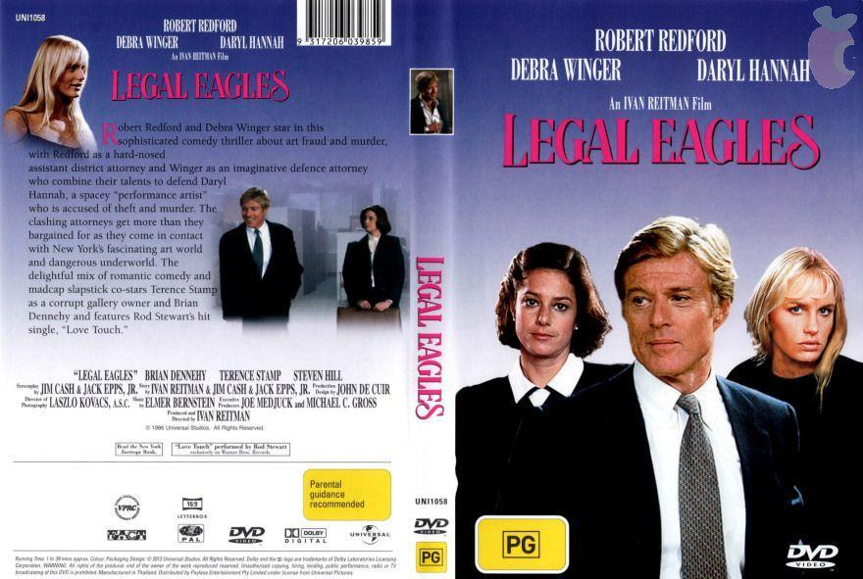

**SUGGESTED FILMS**

**SUGGESTED LINKS**

**English Legal System** <https://www.youtube.com/watch?time_continue=28&v=M4CIveEDtmk&feature=emb_logo>

**Crime** <https://www.youtube.com/watch?v=Q15bAd8s08I>

**Tort** <https://www.youtube.com/watch?v=_ds1fruLg3c>

**Contract** <https://www.youtube.com/watch?v=HrZDpDvxqJo>

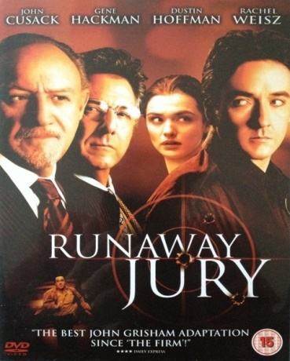

**STUDENT TESTIMONIALS**

**‘I am so glad I decided to do Law, I really enjoy it’**

**‘Law is really interesting’**

**‘Some of the cases we study are so shocking,**

**we have some great class discussions about them’**

**‘I can’t recommend it enough’**

If you would like any further information about A ‘Level Law please do not hesitate to contact us:

Mrs Taylor (Head of Law) [emt@brgs.org.uk](mailto:emt@brgs.org.uk)