Information about some of the products produced by Coca Cola and the strategies they have used to grow is given below.
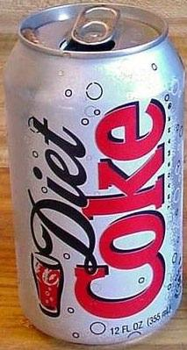
- Diet Coke

Since being introduced in 1982 as a result of a growing trend towards dieting and healthier living, Diet Coke has been a highly successful product for the Coca Cola company, selling millions of units per year. Throughout this time, Coca Cola has constantly adapted aspects of the marketing mix for Diet Coke in order to continually match customer trends and fashions.

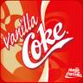
- Coca Cola Vanilla

Having had a successful launch in America, Coca Cola decided to launch it’s new Vanilla flavoured version in Great Britain. Prior to doing so, Coca Cola carried out taste tests and developed the graphical ‘look’ of the Diet Coke brand. When they did this, they took great care to incorporate aspects of the Coca Cola brand, but still differentiating it so consumers would see it as an alternative to Coke.

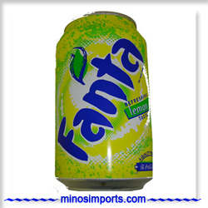
- Fanta Icy Lemon

The development of a new flavour sparkling drink by Coca Cola was as a direct result of listening to consumers who called the company’s Careline telephone service. The business conducted taste tests prior to the 2001 launch.

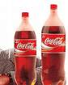
- Coca Cola Share Size 1.5l Bottle

Desk research showed Coca Cola that a growing number of households contained 1-2 people, which led them to believe that a smaller version of the 2 litre family sized bottle would sell well to these groups. In launching this product (simply sell existing brands such as Coca Cola, Diet Coke etc), Coke did need to alter the product itself, merely different aspects of the marketing mix.

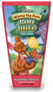
- Winnie the Pooh Roo Juice

Research informed Coca Cola of the opportunity to target parents of children aged 2-5 years with a juice drink that was packaged in a fun and colourful manner. They chose the characters from Winnie the Pooh for their universal appeal to children and made the product appeal to both children and their parents.

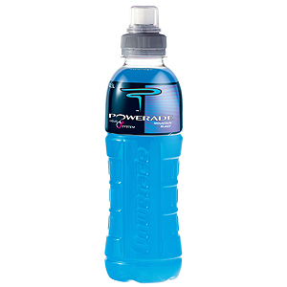
- Powerade

Coca Cola developed the energy drink ‘Powerade’ in response to growth in the sports drink market. Much research was carried out into potential competitors within this segment prior to the drinks development and launch.

Questions

- Decide which of these strategies is the most risky
- Which one of these strategies you think probably brought in the most profitability for Coca Cola?
- Which one do you think is the most unlikely to succeed over a long period of time?

