Can you think of some adjectives to describe the girl?
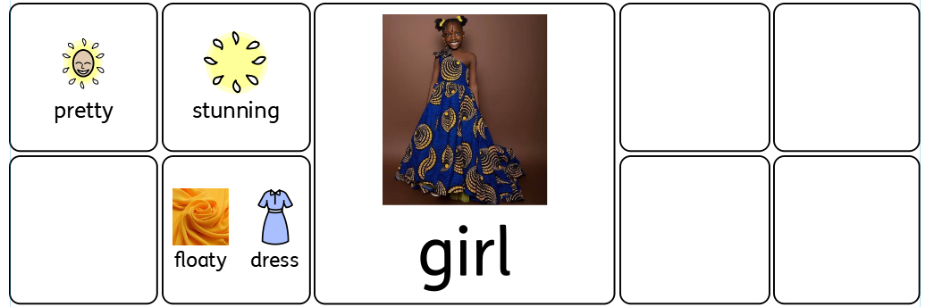

Put 2 adjectives into a sentence:
The girl wears a ______________________________ , _________________________________ dress.
Now write your own sentence:
_________________________________________________________________________________

_____________________________________________________________________________________________________________________________________

