English
In English, this half term, we will begin by reading and exploring Charlie and the Chocolate Factory. We will be writing a setting description, letter writing, playscript, report and biography.

Reading
Our class text this half term is ‘Charlie and the Chocolate Factory’ by Roald Dahl
We will explore the text together and develop our comprehension and inference skills.
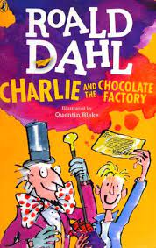
Maths- Area
This unit introduces the concept of area to children, giving them a tangible way to measure and compare a shape’s size. Children will be made aware of the need for standard units of measurement and will progress to measuring area by counting the number of centimetre squares that fit within a shape.

Multiplication and Division
Children explore multiplication and division, looking first at multiplying and dividing by 3, 6, 9, 7, 11 and 12, and then at multiplying and dividing by 0 and 1, the understanding of which is key to children’s mastery of this unit. This unit encourages children to use visual representations to tackle multiplication and division questions.

PSHE/MFL
In PSHE we will be looking at the puzzle piece – celebrating differences. We will look at understanding influences, bullying and problem solving.
In Spanish we will be revising what we have learnt in Year 3, including numbers and days and months. Then continuing to learn language relating to school.

Year 4
Autumn 2 2023
Newsletter
Important Notes:

Homework – Homework will be set on a Friday and should be returned by Tuesday of the following week.
Reading – Please ensure that your children are reading every night at home and their reading diary is signed to reflect this. Levelled reading books will be changed weekly. Children can change their library books ( reading for pleasure ) when they have finished reading.

Useful Websites –
www.oxfordowl.co.uk – a range of online books such as Winnie the Witch.
www.topmarks.co.uk – online maths games
www.bbc.co.uk/bitesize/primary - videos and activities based on topics covered in KS1.
www.copingskillsforkids.com/coping-with-coronavirus - Lots of resources and ideas to help children with anxiety, anger or stress.
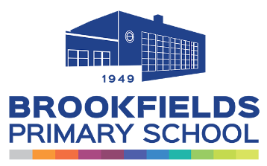

Science and Geography
In Science, we are looking at the topic States of Matter. In this topic we will be learning about particles, solids, liquids, and gas. We will also be looking at what happens to the particles in water when it is heated or cooled. Lastly, we will learn about the water cycle.

Rivers are the subject this half term. We will look at the longest rivers and learn about the types of erosions.

Music
We will be learning Ukuleles on Wednesdays (more information on this to follow).
DT
This half term we will be looking at circuits and making torches.
PE
In PE, we will be doing gymnastics and netball.
Our PE lessons will take place on a Wednesdays and Thursdays this half term.

Children will need to bring their P.E kit for those days.

Computing
In computing, we will be learning about Online Safety and Spreadsheets.

