English

In English this half term we will begin by exploring the fairy tale called ‘The Clock tower’ we will focus on writing setting and character descriptions using expanded noun phrases. The clip of The Clock Tower is available to watch on YouTube.

After this we will study a story from another culture which is called ‘Zahra.’ We will focus on description writing and retelling the narrative. After this we will move onto our novel which is called ‘Amazing Grace.’ We will focus on retelling different parts of the story and writing our own stories. We will end the unit by writing letters and postcards. The novel ‘Amazing Grace’ is available to read online

Reading /Phonics
Our class novel this half term is ‘The Hodgeheg.’ We will also be looking at Phase 5 in phonics. Please also begin to work on comprehension skills with your children.
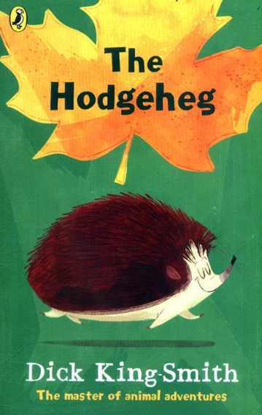

Maths

In Maths this half term we will start off by looking at numbers to 100. This includes understanding the value of a digit in a 2-digit number (tens and ones), partitioning numbers into tens and ones, comparing numbers using more than and less than. We will be counting in 2s, 5s and 10s. Please use the links below to help you with this:

The counting by twos song
https://www.youtube.com/watch?v=GvTcpfSnOMQ

Counting by 5s
https://www.youtube.com/watch?v=cJ4jV14Oz5I

Count together by 10s Jack Hartmann
https://www.youtube.com/watch?v=W8CEOlAOGas

PSHE

This half term in PSHE we will be looking at rules, routines and kindness. We will then move onto looking at me and my world.
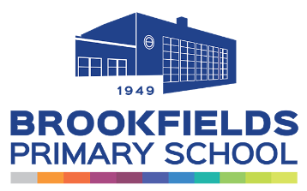
Year 2
Autumn 1 2023
Newsletter
Important Notes:

Homework – Homework will be set on a Friday and should be returned by Tuesday of the following week.
Reading – Please ensure that your children are reading every night at home and their reading diary is signed to reflect this. Levelled reading books will be changed weekly. Class library books will be changed on Monday. Children can also change their library books when they have finished reading.
Useful Websites –
www.oxfordowl.co.uk – a range of online books such as Winnie the Witch.
www.topmarks.co.uk – online maths games
www.bbc.co.uk/bitesize/primary - videos and activities based on topics covered in KS1.
www.copingskillsforkids.com/coping-with-coronavirus - Lots of resources and ideas to help children with anxiety, anger or stress.

Science and History

This half term during our Science lessons we will be looking at Materials. We will be investigating to see which materials can be bent, twisted and pulled and still return to their original shape. We will be carrying out scientific experiments which will help us decide which surface is suitable for a car to travel on. We will also be asking lots of scientific questions and finding ways to answer them.
In History we will be learning about Stuart Britain ‘The Great Fire of London.’ We will look at how the fire started, where it started and we will learn about ‘Samuel Pepys’ who is an important historical figure and played a huge role in The Great Fire of London. We will learn to sequence events on a timeline as well as compare the difference between London 1666 and London 2022. Please use the links below to help you with these topics. We will have a visit from the Fire Fighters.
How Did The Great Fire of London Start? | The Great Fire: London Burns | Channel 5 #History - YouTube
Materials And Their Properties - YouTube
Music
This half term our songs we are going to learn are called ‘Music is in my soul’ and ‘Hey Friends!’ We will be exploring different genres of music.
Art
In Art we will be looking at exploring the formal elements of art: pattern, texture and tone.
PE
Our PE lessons will take place on a Tuesday and Friday this half term. Children will need to have their PE kits in school on these days.

