Communication & Language and Literacy:
This term in Literacy we are exploring The Very Hungry Caterpillar and Colin and Lee, Carrot and Pea to support our listening, literacy and communication skills. We will still continue with our pre-phonics curriculum building on those skills in which was built upon last term. For example, rhymes, sounds, music, listening and joint attention. We will continue to make marks as we develop our fine motor skills through the use of resources such as sand, play dough, flour with the help of tools like paint brushes, glue sticks and so forth. In Communication and Language, we will follow our Talk 4 writing scheme in which is embedded throughout the whole school to understand the characters and story sequence in depth. All activities will be done through a 1 to 1 basis and small group work activities.
Class: Ladybirds Term: Spring Term 2026 EYFS / Y1

Mathematics:
Numbers
Count and handle objects one at a time – exploring value.
Explore number rhymes and patterns
Build towers and structures using construction
Sort groups such as colour and animal sorting
Join in actions and counting objects linked to number rhymes – introduction of Addition and subtraction concepts / comparing quantities.
Mathematics:
Number patterns
• Explore repeating patterns with toys, natural materials, or sensory resources.
• Recognise simple shapes and colours through puzzles, construction, and play.
• Use positional language (“on, in, under, next to”) to follow simple instructions.
• Explore daily routines using temporal concepts (“now”/“next”) in practical contexts.
• Engage with cause-and-effect toys and simple computer programs to reinforce early numeracy.

Physical Development
Moving and handling
To build on control of our bodies using Gross Motor skills.
Kicking, throwing, catching, balancing.
Develop balance and co-ordination through climbing in/ on / under indoors and outdoors.
Develop fine motor skills and hand eye co-ordination i.e. through the use of construction, threading, dough manipulation and dough printing.
Makes connections between our movement and the marks they make.

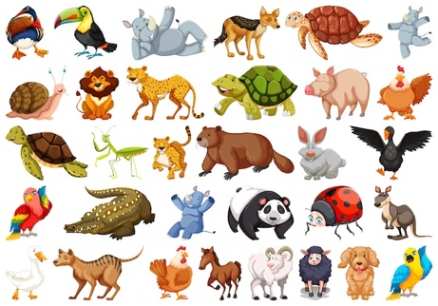
Personal, social and emotional development
Health & Self-Care:
- Explore healthy foods through snack preparation, tasting, and discussion of textures and smells.
- Develop independence in dressing, undressing, and hygiene routines.
- Practice self-regulation during sharing, turn-taking, and parallel or coactive play.
Managing Self & Building Relationships:
- Recognise self and others; develop empathy and tolerance.
- Engage alongside peers in structured and unstructured activities.
- Understand the importance of routines and self-exploration in daily classroom life.

Animals and their Habitats

Expressive Arts and Design & Understanding the World.
Using senses, we will be imaginative through exploring different materials to create a product and solidify our learning of objects such as the texture of different animals.
Explore musical instruments to imitate animal sounds and explore different sound walks and guess the animal sound. To further use songs and rhymes to encourage this learning development.
Use small worlds such as animals, shapes, play dough cutters to support imagination and role play through continuous provision.
As we explore People, culture and community we will identify the animals, explore what they do, where do they live and what they eat.
The themes of animals will support the learning of the natural world as we look at where the animals live such as jungle animals in hot weather / under the sea animals. We will look at the different textures and temperatures of these habitat climates.
We will plant our own food for the animals to eat as part of our past and present to develop an understanding and respect for living things within our nature to develop an understanding of sustainability.

