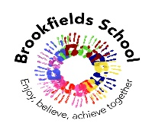
Thinking & Problem Solving:
Butterflies class will continue to explore and experience number and shape as part of our thinking and problem solving, progressing onto conservation of number, matching, comparisons and classification as part of our thinking and problem solving. The children will be working towards their individually IEP set targets. Through our topic of ‘The Seasode’ we will have many opportunities to explore shape, patterns, matching and sorting and measure. this will be in maths focused sessions as well as throughout the continuous provision and outdoors

Communication & Language:
We will explore a range of stories and non-fictional books this term linked to our topic of ‘The seaside’: Don’t worry little crab and Busy Boats, all supported by story sacks,story boards and objects of reference. Following Talk 4 Write, the children will be encouraged to develop their vocabulary, communication and imagination. We continue to develop our pre phonics skills and continue to work on our set 1 and set 2 ‘read write inc’ sounds. We are incorporating language groups into our Literacy sessions and throughout the day. Through attention autism/bucket therapy session we will continue to develop our attention skills.

Class: Butterflies Term: Summer Term Explorers Pathway

Learning through My Play:
All of our sessions will be followed by time within continuous provision for the children to explore a range of toys and activities in keeping with the focus of the lesson. Depending on where the children feel most comfortable they will have the opportunity to play solitary, opposite to their peers or engaging with the other children—this is an area that the children will subtly be encouraged to develop at their own pace. Linking to other areas within our curriculum, it will be at this time that the children have to problem solve to resolve difficulties with their peers.

Children learn in all different ways yet make most progress when they are happily and thoroughly engaged within an activity, most likely when it is their own choice to do so. All staff will encourage children to experience a range of toys and activities both indoors and out. The children have the opportunity to use a total communication system, expanded with communication boards around the room to request specific objects or activities that they may want.

This term a range of different seaside themed trays will enter our small world area to support our topic development. This will also be incorporated outdoors through water play, bikes and weather permitting.

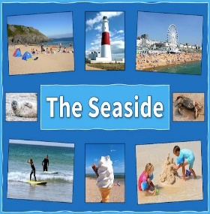
Myself & My Body:
We are continuing to develop our independence skills throughout the day where we will focus on PSHE & RSE skill with a focus on staying safe, healthy and people who help us as well as continuing to develop toileting, dressing, feeding and self help skills.
We will be going swimming weekly / on a rota basis where we will focus on how we can use our bodies in the pool. Our topic in PE this term is physical and health fitness where we will focus on coordination through sending and receiving and agility through reaction and response. We will do this through many different games and activities.

Thematic Learning: The Seaside

My World & My Community:
Our topic this term is The Seaside. This will include journeys and holidays as well. We will explore vehicles, focusing on naming and matching before exploring different ways to travel; air, water and land. This topic will include lots of practical experiments and exploratory activities to expand our historical, scientific and geographical knowledge such as ; balloon flying, car racing floating / sinking, the Seaside / promenade over time and junk modelling to name a few.

Religious Education & Celebration Days:
(SMSCD/ RSE)
Our topic in RE this term is “What makes us go wow?”. We will explore this theme through stories, song and practical exploration around the creation and looking after our planet and communities.

My Creativity
This will be incorporated in all of our sessions through craft activities, inclusion of technology and the use of song.
In art we will focus on the theme of going on a journey, to do this can junk model and decorate a range of different vehicles linked to our topic. Along with following water patterns and textures linked to the beach. Similarly in computing we will look at the journey we can go on using technology such as beebots, a mouse on a computer and creating a digital image. Our DT skills will allow us to plan, create and evaluate a variety of puppets for a seaside puppet show as well as preparing some tasty summer treats we might have at the beach. Music will take both a cross curricular approach as well as sessions to expand the children's rhythm, pitch and movement to music.

