|  |
| --- |
| Class: Hawks Term: Summer Term- 2025 (April – July) Explorers & Adventurers |

**Communication & Language / English – Language & Communication**

The Explorers this term will use songs and story rhymes to engage themselves. They will develop their understanding and work on their early reading skills, including attention building activities. They will explore stories through a Talk for Writing approach, ‘Where the wild things are’ and ‘Burger Boy’.

The Adventurers will continue to develop their reading and writing skills. They will develop their knowledge of sentence structure through a colourful semantics approach, aiding their writing to use descriptive language.

Read, Write Inc is the scheme of work we will follow to learn our letter sounds and names, word build and support us in learning those ‘tricky words’.

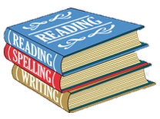

**Thinking & Problem Solving/Maths – Thinking, Problem Solving & Finance**

During Summer Term, our Adventurers will continue to widen their Mathematical skills to learn about Fractions, Statistics, Time and Position.

Our Explorers will continue to learn about early calculation, number and place value- transferring these skills across a range of concepts. They will develop their knowledge of early time concepts, including daily routines, day and night. They will explore the language of position i.e. forwards, backwards, in and out.

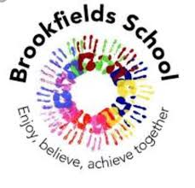

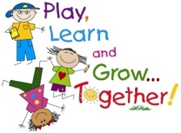

Myself & My Body / Personal Social & Emotional Development

This term we will be continuing to look at emotions. This will involve a continued theme of emotional awareness and regulation as we change and develop. In PSHE, we will learn about bullying and racism, understanding how discrimination makes people feel.

My Creativity / Creative Development

In DT, we will explore healthy recipes during food technology, understanding where foods come from. We will explore the artwork of famous artists, who make food inspired art.

Musical instruments will be explored - we will explore echoes and sounds in our environment whist learning beyond the classroom. We will further our knowledge and will create our own musical pieces and practice performance in front of our peers.

My World & My Community/Understanding My World & My Community

In History, we will explore the history of The Tudors, as well as developing our Geographical knowledge of Eastern Europe. We will learn about foods from this region, linked to our topic ‘Staying Healthy’.

In PE, we will practice problem solving games and support our teamwork & building strategies. This term we will participate in Everton in the Community, Karate and Swimming as part of our PE curriculum.

Learning through play:

This term as part of our ‘Staying Healthy’ topic, we will explore child-led play through roleplay, playing shops and restaurants. We will explore where food comes from through trips and visits.

Opportunities to learn through play will occur in other subjects: choose time, extension activities, PE sessions, learning beyond the classroom (soft play, outside play, tyre park, lightroom).