Public Health | Department
Cheshire West and Chester Council
The Portal, Wellington Road,
Ellesmere Port CH65 0BA
 | Tel:
Tel: 0300 1238 123

Your reference:  Our reference: MMR/1/23 | Our ref:
Email: enquiries@cheshirewestandchester.gov.uk | Your ref:
Web: www.cheshirewestandchester.gov.uk
 | Please ask for:
Date: 22 May 2023 | Email:

Dear Parents and Carers,

MMR and Measles

The UK Health Security Agency (UKHSA) has reported an increase in measles across the country and is encouraging people to check that they and their children have had two doses of the MMR vaccine.

The free MMR vaccine is a safe and effective way of protecting against measles, as well as mumps and rubella.

It’s important for parents to take up the offer of MMR vaccination for their children when offered at 1 year of age and as a pre-school booster at three years, four months of age. If children and young adults have missed these vaccinations in the past, it’s important to take up the vaccine now from GPs, particularly in light of the recent cases.

Check your child’s Red Book to see if they’ve received MMR vaccinations as scheduled or check with your GP surgery if you’re unsure. Most healthy adults will have developed some immunity to measles but can still receive two doses of the vaccine from their GP too.

Anyone with symptoms is also being advised to stay at home and phone their GP or NHS 111 for advice.
Measles symptoms to be aware of include:
- high fever
- sore, red, watery eyes
- coughing
- aching and feeling generally unwell
- a blotchy red brown rash, which usually appears after the initial symptoms.

For more information about measles, see the nhs.uk website here.
To find out more about childhood vaccinations, please visit the NHS website: https://www.nhs.uk/conditions/vaccinations/nhs-vaccinations-and-when-to-have-them/
What do I need to know about the MMR vaccine? - UK Health Security Agency (blog.gov.uk)

Thank you once again for your continued co-operation.

Yours sincerely
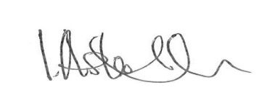
Ian Ashworth
Director of Public Health

