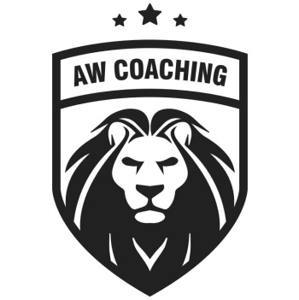

Dear Parents/Carers

AW Coaching are pleased to be delivering Football Sports Clubs open to all boys & girls at Brookside Primary School, running from week commencing Friday 6th September – Friday 25th October 2024

Children should wear their own sports kits or PE Clothing, including football boots or trainers for outside football.

**Friday Boys & Girls Football Open to all ages. Cost is £40.00 for 8 Sessions**

All children should be collected from the Reception, at 4pm

**TO BOOK YOUR CHILD’S PLACE FOLLOW LINK BELOW:**

[**http://aw-coaching.class4kids.co.uk/**](http://aw-coaching.class4kids.co.uk/)

**Once on the site, look for the classes stated BROOKSIDE PRIMARY SCHOOL – JUNE TO JULY 2024, click BOOK on the option you want and register and book.**