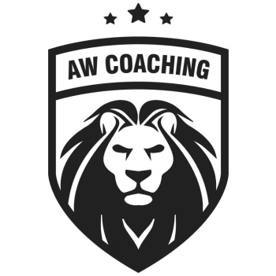
Dear Parents,
AW Coaching are pleased to be delivering Football & Dodgeball Sports Clubs open to all boys & girls at Brookside Primary School, running from week commencing 27th February – 31st March 2023.
Children should wear their own sports kits or PE Clothing, including football trainers or trainers for outside football and trainers for dodgeball.
Monday Football Reception – Year 2. The cost is £20.00 for the 5 sessions.
Wednesday Dodgeball Reception – Year 6. The cost is £20.00 for the 5 sessions.
Friday Football Year 3 – Year 6. The cost is £20.00 for the 5 sessions.

All children should be collected from the Playground, at 4pm

TO BOOK YOUR CHILD’S PLACE YOU HAVE 2 OPTIONS:
OPTION 1 – Follow the link below
http://aw-coaching.class4kids.co.uk/
Once on the site, look for the classes stated BROOKSIDE PRIMARY SCHOOL – FEBRUARY 2023, click BOOK on the option you want and register and book.
OPTION 2 – Pay Cash
Fill in the slip below & return to school office in an envelope clearly labelled for AW COACHING with the money enclosed.

If have any problems with booking, please contact Chris Aldcroft directly on 07504 816986 or email to aw_coaching1@hotmail.com
Child’s Name:________________________________________________ Class:______________
Emergency Contact Numbers: ___________________________________
Any Medical conditions that the coach should be aware of: YES/NO
If YES Please give further details:________________________________________________
Consent for your child to be photographed for AW Coaching promotional material: YES/NO
Name of the person collecting:____________________________________________
I give permission for son/daughter to walk home alone(Year 6 ONLY): YES/NO
The information collected will be used only for the purpose of emergency contact during the afterschool sports club. The information will be destroyed in line with our Data Protection Policy. Information will not be shared with 3rd parties, unless we are required under Safeguarding procedures.

