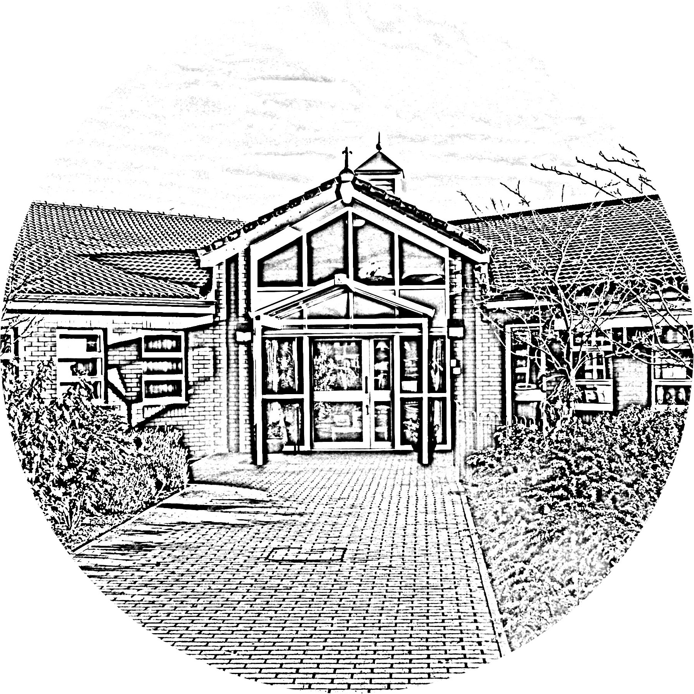

**BROOKSIDE PRIMARY SCHOOL**

Rostherne Avenue, Great Sutton, Cheshire, CH66 2EE

0151 558 1123 www.brookside.cheshire.sch.uk Headteacher – Mr D Orme BA (Hons) NPQH Deputy Head – Ms J Smith B Ed (Hons) NPQSL

*“Happy and Successful in Everything we Do!”*

Dear Parents/Guardians,

At the start of the school year, we would like to highlight some of the key points regarding the administration of medication;

* Medicines **MUST** be in the original container as dispensed by a pharmacist with the prescription label, including the child’s name and the prescriber’s instructions for administration.
* Medicines that need to be taken three times a day could be taken in the morning, after school and at bedtime so do not need to be administered in school.
* Medication such as paracetamol, ibuprofen or aspirin cannot be administered by staff unless prescribed.
* We are unable to administer medicines that have not been prescribed by a doctor, dentist, nurse prescriber or pharmacist prescriber. Parents/carers are welcome to come into school to administer these medicines to their child.
* All medicines should be delivered to a member of staff by the parent/carer. Under no circumstances should medicines be left in a child’s possession.

**Parent/carer Responsibilities;**

* Should give sufficient information about their child’s medical needs if treatment or special care is required.
* Must deliver all medicines to a member of staff.
* Must complete and sign the parental agreement form.
* Must keep staff informed of changes to prescribed medicines.
* Keep medicines in date – particularly emergency medication such as epi-pens.

Please find a copy of our ***Administering Medication Policy on our website.***

Yours sincerely,

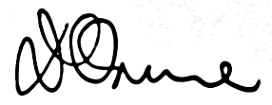

Mr D Orme

Headteacher