Brookside Primary School
Ellesmere Port, Cheshire

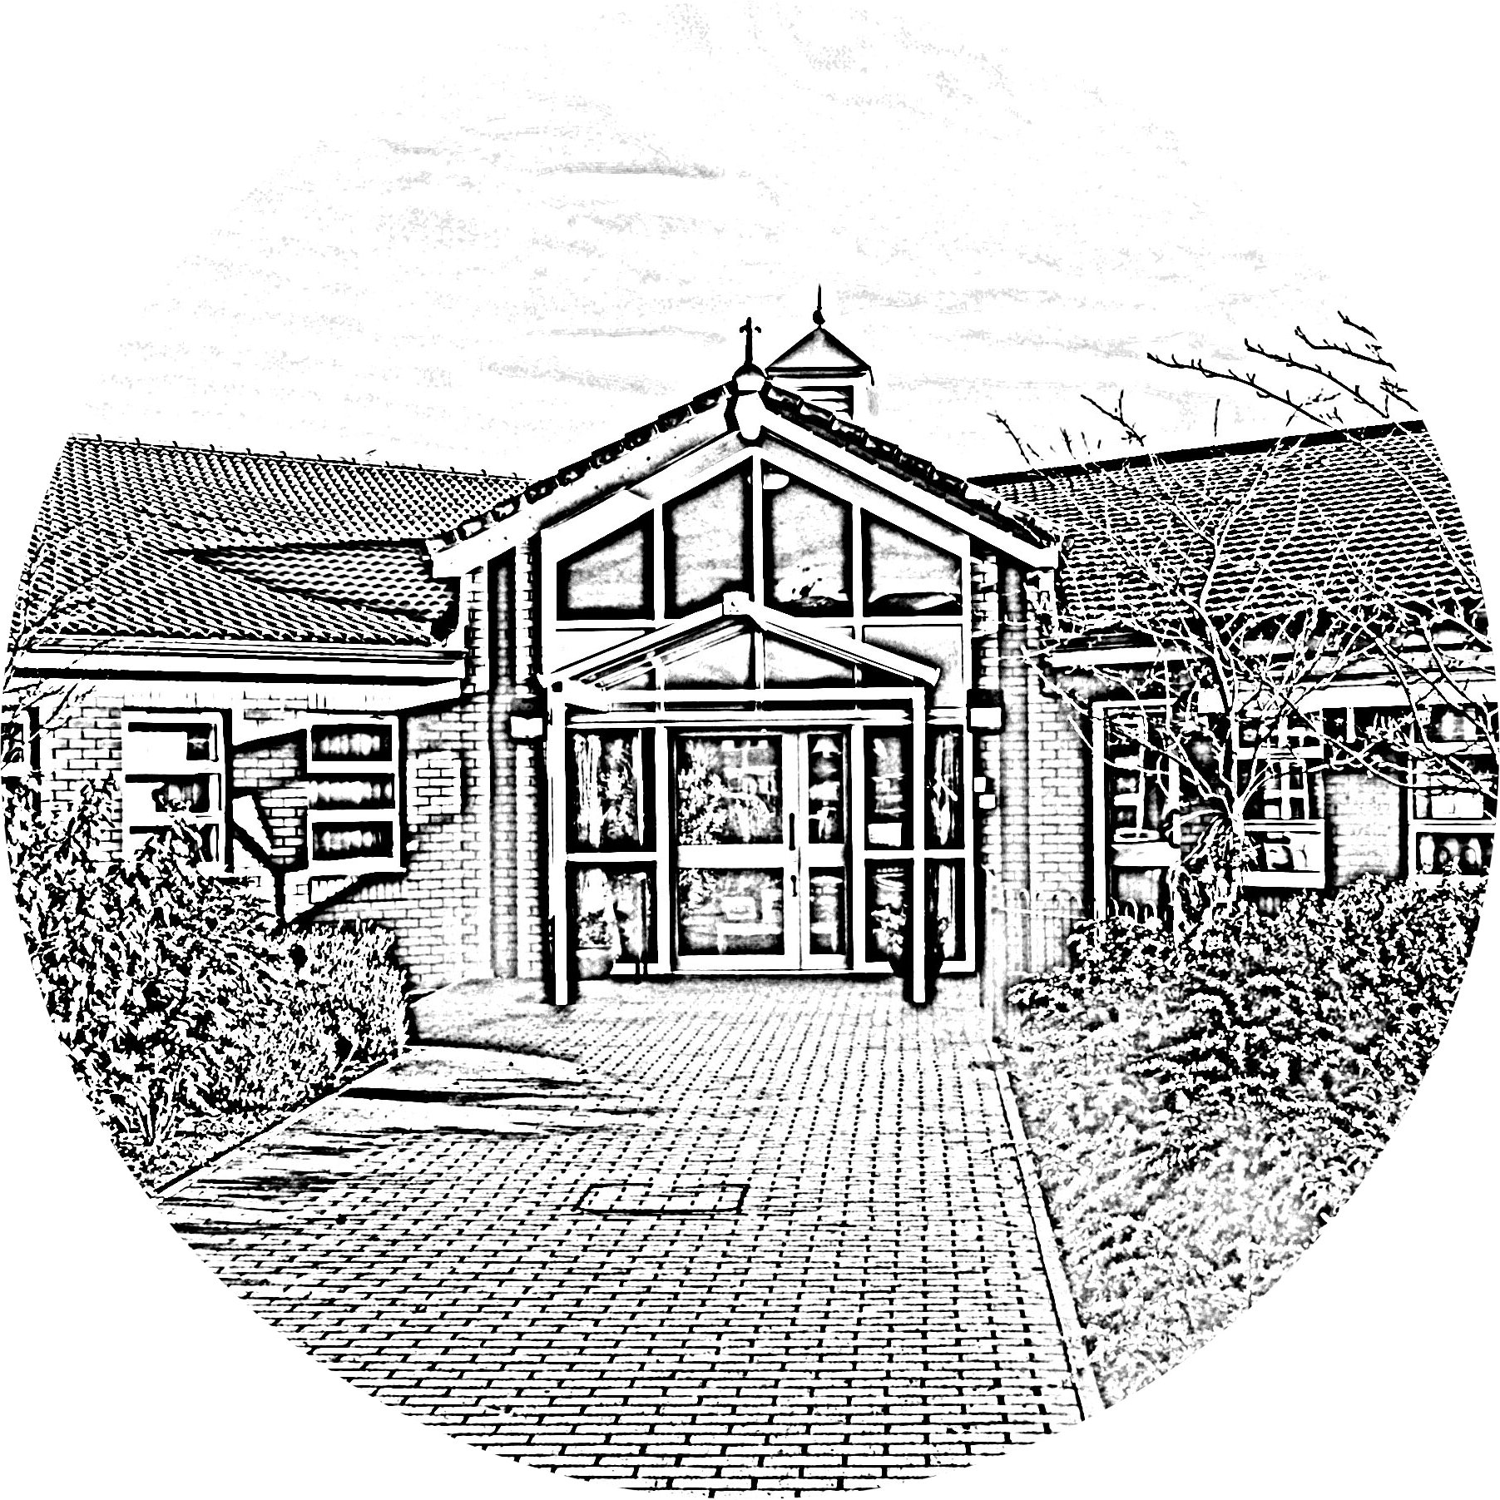

Anti-Bullying Policy

November 2023

Brookside Primary School
Anti-Bullying Policy

Rationale

Bullying can be described as being ‘a deliberate act done to cause distress solely in order to give a feeling of power, status or other gratification to the bully. It can range from ostracising, name calling, teasing, threats and extortion, through to physical assault on persons and/or their property. It is often, but not necessarily, the targeting of a child or group by others in a deliberate, repetitive attempt to undermine confidence.

Staff, parents and children work together to create a happy, caring, safe and secure learning environment within Brookside Primary School. We have developed a school ethos in which any form of bullying is regarded as unacceptable. Verbal, physical or indirect bullying is not tolerated. It is everyone’s responsibility to aim to prevent occurrences of bullying and to deal with any incidents quickly and effectively.

When children feel they are important and belong to a friendly and welcoming school, bullying is far less likely to be part of their behaviour.

Under the Equality Act 2010, discrimination on grounds of age, sexual orientation, religion or belief and gender reassignment will not be tolerated.

Consequently, the Governors have approved this policy.

Bullying can be brought to the attention of staff either by the victim(s), their parent(s) or other interested people. All parties should be encouraged to report such problems, knowing that all reported incidents will be dealt with sympathetically and thoroughly.

Strategies for dealing with Bullying

All school staff take all forms of bullying seriously, and seek to prevent it taking place. The following is a list of actions available to staff depending on the perceived seriousness of the situation.

- Discussions at length with the victim. This will require patience and understanding.
- Remember – Listen, believe, act.
- Identify the bully/bullies. Obtain witnesses if possible. Advise the Head Teacher.
- Discussions with the bully. Confront them with the details and ask them to tell the truth about the situation/incident. Make it clear that bullying is not acceptable at Brookside Primary School.
- If they own up then follow the procedure outlined below and in the Discipline Policy.
- If they do not own up, investigate further. If it is clear that they are lying, continue with the procedure. Children usually own up if presented with all the facts.
- Separate discussions with parents of bully and victim.
- All allegations will be investigated and a record kept and logged with the Headteacher
- Sanctions for the bully may include withdrawal from favoured activities, loss of
playtimes, exclusion from school during lunchtimes, exclusion from school, depending on
the perceived severity of the incident.
- Continue monitoring the situation by observing at playtimes/lunchtimes and having discussions with victim to ensure no repetition.
- As the behaviour of the bully (hopefully) improves, then favoured activities etc. can be reinstated, and the child should be praised for good behaviour. This will rebuild the child’s self-esteem, which may have been damaged after being caught bullying, or could have been low anyway, hence the bullying.

In order to identify incidents of bullying and the identities of bullies, at Brookside Primary School we have agreed to carry out the following strategies:

- All staff watch for early signs of distress in pupils.
- All staff listen, believe, act.
- Work and discussion undertaken by classes in school e.g. circle time, in personal, social and moral education can identify bullying incidents and help reduce it. Books and posters compiled by the children themselves all help to raise awareness of the anti- social nature of bullying and children participate in Anti-bullying week.

The role of parents

Parents who are concerned that their child might be being bullied, or who suspect that their child might be the perpetrator of bullying should contact their child’s class teacher. If they are not satisfied they should contact the Headteacher.

The role of pupils

Pupils are encouraged to report any incident of bullying to a member of staff.

Updated November 2023
To be reviewed October 2024

